NAME : SELUWA TEMITOPE PETER
MATIC NO: 17/MHS01/295
DEPT: MBBS
COURSE: Gross Anatomy of Head and Neck

Write an essay on the cavernous sinus

Cavernous Sinus

INTRODUCTION
The cavernous sinus, a large venous plexus, is located on each side of the sella turcica on the upper surface of the body of the sphenoid, which contains the sphenoid (air) sinus The cavernous sinus consists of a venous plexus of extremely thin-walled veins that extends from the superior orbital fissure anteriorly to the apex of the petrous part of the temporal bone posteriorly. It receives blood from the superior and inferior ophthalmic veins, superficial middle cerebral vein, and sphenoparietal sinus. The venous channels in these sinuses communicate with each other through venous channels anterior and posterior to the stalk of the pituitary gland the intercavernous sinuses and sometimes through veins inferior to the pituitary gland.
The human brain is a highly vascular organ responsible for coordinating a myriad of processes throughout the body. Therefore, it is important that a pathway exists to return blood that enters the cranium to systemic circulation. The cavernous sinuses are one of several drainage pathways for the brain that sits in the middle. In addition to receiving venous drainage from the brain, it also receives tributaries from parts of the face.

The left and right cavernous sinuses communicate by through the anterior and posterior intercavernous sinuses. The cavernous sinus drains to the superior and inferior petrosal sinuses, which then join the sigmoid sinus.

Structure

The cavernous sinuses are 1 cm wide cavities that extend a distance of 2 cm from the most posterior aspect of the orbit to the petrous part of the temporal bone. They are bilaterally paired collections of venous plexuses that sit on either side of the sphenoid bone. Although they are not truly trabeculated cavities like the corpora cavernosa of the penis, the numerous plexuses, however, give the cavities their characteristic sponge-like appearance.

The cavernous sinus is roofed by an inner layer of dura mater that continues with the diaphragma sellae that covers the superior part of the pituitary gland. The roof of the sinus also has several other attachments. Anteriorly, it attaches to the anterior and middle clinoid processes, posteriorly it attaches to the tentorium (at its attachment to the posterior clinoid process). Part of the periosteum of the greater wing of the sphenoid bone forms the floor of the sinus. The body of the sphenoid acts as the medial wall of the sinus while the lateral wall is formed from the visceral part of the dura mater.

Contents

The cavernous sinus contains the internal carotid artery and several cranial nerves. Abducens nerve (CN VI) traverses the sinus lateral to the internal carotid artery. The remainder of the cranial nerves passes through the lateral wall of the carotid sinus, and from superior to inferior they are:
- Oculomotor nerve (CN III)
- Trochlear nerve (CN IV)
- Trigeminal nerve (CN V) - ophthalmic and maxillary divisions.

Internal carotid artery

In addition to the thin walled veins that traverse the cavernous sinus, a lone arterial vessel also uses the area as a conduit. The internal carotid artery (a branch of the common carotid artery) – along with its postganglionic sympathetic plexus from the superior cervical ganglion – gains access to the cavernous sinus posteriorly.
As the petrous part of the internal carotid artery leaves the carotid canal, it curves vertically and superiorly above foramen lacerum to enter the cavernous sinus. Here the artery is also referred to as the cavernous part.
Within the sinus, the internal carotid artery travels anteriorly, in a horizontal manner until it reaches the anterior limit of the sinus. Here it curves vertically and superiorly to exit the sinus through its roof and become the cerebral part of the internal carotid artery. It is noteworthy that the cavernous part of the internal carotid artery is the only arterial vessel that is completely surrounded by venous networks. This fact is of great clinical significance.

Abducent nerve
This motor nerve leave the pons and gains access through the posterior part of the sinus after passing of the apical potion of the petrous temporal bone. It has also been known to access the cavernous sinus by way of the petrosal sinus, adjacent to the clivus.
Within the cavernous sinus, it takes an inferolateral course, relative to the internal carotid artery. It exits the sinus by way of the superior orbital fissure to gain access to the orbit, where it innervates the lateral rectus muscle of the eyeball.

Oculomotor nerve

The other nerves travelling through the cavernous sinus do so between the endothelial lining and the dura mater of its lateral wall. The most superior of the four nerves in the lateral wall is the oculomotor nerve (CN III). At the posterior aspect of the roof of the cavernous sinus, the free and attached edges of tentorium cerebelli forms a space through which CN III enters the lateral wall of the sinus. It takes an anterior, inferomedial course (relative to the other nerves in the lateral wall) towards the anterior extremity of the sinus.

Here it bifurcates into its superior and inferior rami that pass through the superior orbital fissure. Along with sympathetic fibers from the internal carotid plexus, CN III provides motor supply to inferior oblique, levator palpebrae superioris, and the inferior, medial and superior recti muscles.

Trochlear nerve
The smallest of the cranial nerves, the trochlear nerve (CN IV), enters the posterior aspect of the cavernous sinus after leaving the posterior part of the brainstem and decussating with the same nerve from the opposite side. It continues anteriorly in the lateral wall of the cavernous sinus, inferior to CN III and passes through the superior orbital fissure at the anterior aspect of the sinus. Once in the orbit, CN IV has the responsibility of innervating the muscles of the eyeball that are responsible for inferolateral motions.

Trigeminal nerve
Finally, two of the three branches of the trigeminal nerve (CN V) pass through the cavernous sinus. Prior to entering the cavernous sinus, the proximal portion of the nerve lies in Meckel’s cave, where it forms the trigeminal ganglion. After leaving the cave, the mandibular division (CN V3) courses inferiorly to pass through foramen ovale (without entering the cavernous sinus).

The other two branches, the ophthalmic and the maxillary (CN V1 and CN V2, respectively), travel through the lateral wall of the sinus. Both take courses inferior to CN III and CN IV, however, CN V2 is the most inferior of them all. Both CN V branches in the sinus travels horizontally. CN V2 leaves the sinus via foramen rotundum, while the three branches of CN V1 exit the cranial fossa via the superior orbital fissure. CN V1 and CN V2 are purely sensory and supply specific regions of the face.

Relations
There are numerous structures surrounding the cavernous sinus that are noteworthy. Medially, the sinus is adjacent to the lateral walls of the pituitary fossa with the pituitary gland, the sphenoid bone and its air sinus. The cerebral part of the internal carotid artery courses superiorly. Laterally, the medial aspect of the temporal lobe of each hemisphere lies adjacent to the sinus. And posteriosuperiorly, the uncus of the temporal lobe has a relation to the sinus.
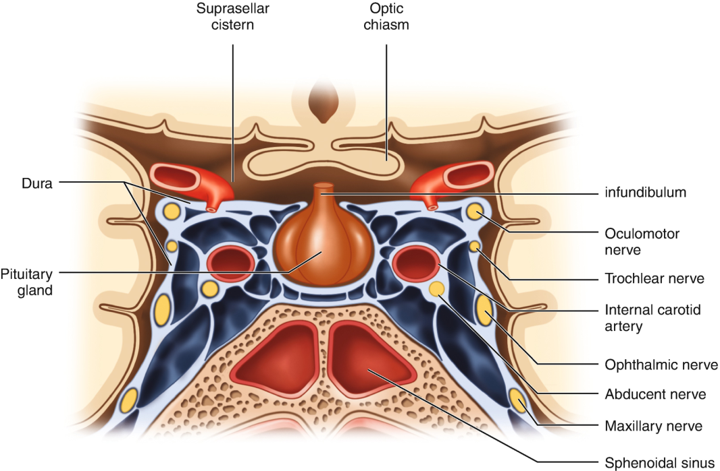

Communications
The cavernous sinus is an unconventional venous system in the sense that it does not have a unidirectional flow of blood. Owing to the fact that there are no valves in the sinus and its connected veins, the direction of blood flow is dependent on venous pressure. The veins that communicate with the cavernous sinus are:
- Superior ophthalmic vein
- Inferior ophthalmic vein
- Superficial middle cerebral vein
- Middle meningeal vein
- Hypophyseal veins
- Superior ophthalmic vein
The cavernous sinus generally has five venous tributaries. The superior ophthalmic vein receives blood from the ethmoidal, nasofrontal, vorticose (drains the ocular choroid), and central retinal veins. It drains into the anterior part of the sinus via the superior orbital fissure.
- Inferior ophthalmic vein
The inferior ophthalmic vein collects blood from the eyelids, lacrimal sac, and some vorticose contributions, as well as the anterior floor and medial wall of the orbit. In addition to draining to the cavernous sinus, it also drains to the pterygoid plexus.
- Superficial middle cerebral vein
At the point where the internal carotid artery emerges, the superficial middle cerebral vein pierces the roof of the sinus. Here, it drains blood from the cortices that are adjacent to it as it courses through the lateral sulcus.
- Middle meningeal vein
Finally, branches of the middle meningeal vein may join the sphenoparietal sinus on its way to the cavernous sinus. Before piercing the roof of the sinus, it travels along the edge of the lesser wing of the sphenoid between the layers of dura mater.
- Hypophyseal veins
Additionally, efferent hypophyseal veins of both the adenohypophysis and neurohypophysis drain to the cavernous sinus.

Intercavernous sinuses and drainage
The left and right cavernous sinuses communicate by way of the anterior and posterior intercavernous sinuses. These vessels travel anteriorly and posteriorly (respectively) around the infundibulum of the pituitary gland, deep to the diaphragma sellae, between the layers of dura mater.

The cavernous sinus in turn drains to the superior and inferior petrosal sinuses. Both sinuses join the sigmoid sinus, which then becomes the internal jugular vein. The internal jugular vein meets
with the subclavian vein to become the left (or right) brachiocephalic vein.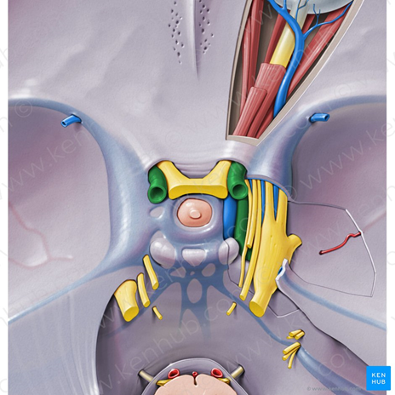

Clinical significance
- Carotid-cavernous fistula
Head trauma resulting in rupture of the cavernous part of the internal carotid artery can produce what is known as a carotid-cavernous fistula. A pulsating exophthalmos can result as the venous pressure in the sinus would increase and reverse the flow of blood in the ophthalmic veins.
- Cavernous sinus thrombosis
The sinus also has communicating branches from the sin of the face. Particularly in the ‘danger area’ (at the nasolabial crease and at the crease between the ala of the nose and the cheek), an infection can spread to the cavernous sinus, which can result in a cavernous sinus thrombosis. This condition can result in internal strabismus (crossed eyes) if the CN VI is damaged, doubled vision while looking downward if CN IV was damaged, or ophthalmoplegia (paralysis or weakness in muscles of movement of the eye).

- Discuss the walls of the nose
The nasal cavity has a roof, floor, medial wall and lateral wall.

The roof: is curved and narrow, except at its posterior end and it is divided into 3 parts. They are named from the bones forming each part.
- frontonasal
- ethmoidal
- sphenoidal .
The floor: is wider than the roof and is formed by the palatine processes of the maxilla and the horizontal plates of the palatine bone.
The medial wall: formed by the nasal septum
The lateral walls: are irregular owing to three bony plates, the nasal conchae, which project inferiorly, somewhat like louvers
The Medial Wall/ Nasal Septum
It divides the chamber of the nose into two nasal cavities. It has a bony part and a soft mobile cartilaginous part. The components of the nasal septum are:
- perpendicular plate of the ethmoid bone
- Vomer bone
- septal cartilage
- nasal crest of the maxillary bone
- nasal crest of palatine bone
The perpendicular plate of ethmoid, vomer, nasal crests of maxillary and palatine bones form the bony part of nasal septum while the septal cartilage forms the cartilagenous part
The thin perpendicular plate of the ethmoid bone: forming the superior part of the nasal septum descends from the cribriform plate and is continued superior to this plate as the crista galli which is seen in the anterior cranial fossa.
The vomer: a thin flat bone, forms the posteroinferior part of the nasal septum, with some contribution from the nasal crests of the maxillary and palatine bones.
The septal cartilage has a tongue-and-groove articulation with the edges of the bony septum.
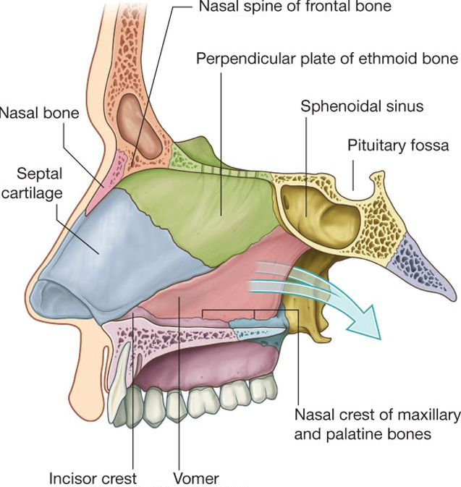
Lateral wall

We can find 3 types of nasal conchae in the nasal cavity. Those are:
- Inferior nasal concha. It is the longest and broadest of the conchae and is formed by an independent bone (of the same name, inferior concha). The concha is covered by a mucous membrane that contains large vascular spaces and is one of the three that work to both humidify and clear the air that passes into the nasopharynx.
- Superior and middle nasal conchae arise from the perpendicular plate of the ethmoid bone. The middle nasal concha is found in between the superior and inferior nasal concha and plays a role in humidifying and clearing inspired air of micro-particles such as dirt. The superior nasal concha is a bony shelf located above the middle nasal concha and below the sphenoethmoidal recess. Similar to the middle nasal concha the superior concha is itself part of the ethmoid bone.

Associated structures
- Sphenopalatine foramen (Foramen sphenopalatinum)
- The medial plate of the pterygoid process.
- Limen nasi
- The inferior nasal meatus lies beneath the inferior nasal concha and the lateral nasal wall.
- Sphenoethmoidal recess (Recessus sphenoethmoidalis)
- The sphenoidal sinus
- The nasal vestibule.

The arterial supply

The arterial supply of the medial and lateral walls of the nasal cavity is from five sources:
- Anterior ethmoidal artery (from the ophthalmic artery)
- Posterior ethmoidal artery (from the ophthalmic artery)
- Sphenopalatine artery (from the maxillary artery)
- Greater palatine artery (from the maxillary artery)
- Septal branch of the superior labial artery (from the facial artery)
- The anterior part of the nasal septum is the site (Kiesselbach area) of an anastomotic arterial plexus involving all five arteries supplying the septum

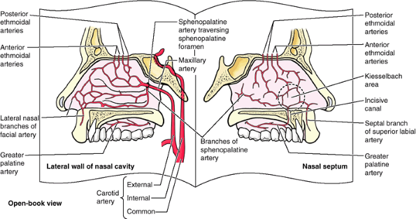

Venous drainage

A rich submucosal venous plexus deep to the nasal mucosa drains into the sphenopalatine, facial, and ophthalmic veins.

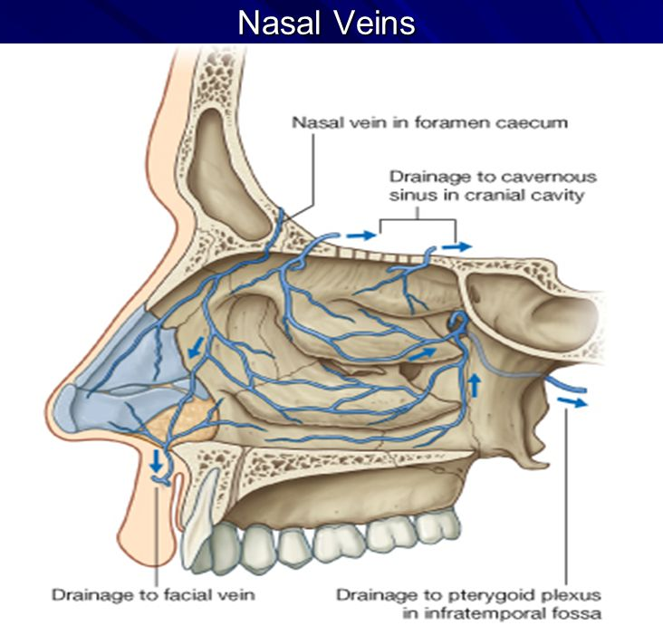

Innervation
- olfactory nerve
- branches of the ophthalmic [V₁] which include the anterior and posterior ethmoidal nerves
- maxillary [V₂] nerves which include;
- posterior superior lateral nasal nerves
- posterior superior medial nasal nerves
- nasopalatine nerve
- posterior inferior nasal nerves

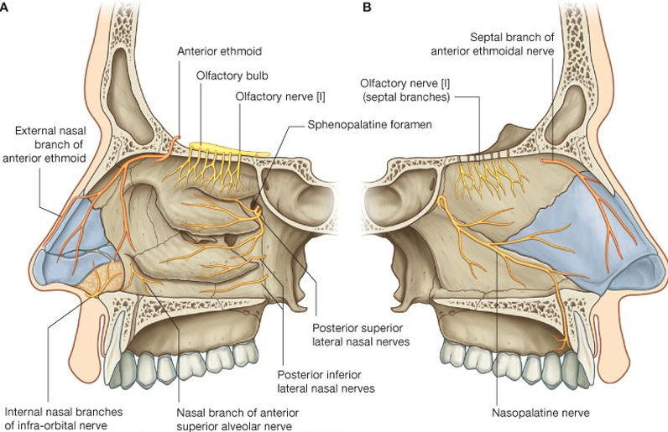

Clinical Anatomy

Epistaxis
Epistaxis (nosebleed) is relatively common because of the rich blood supply to the nasal mucosa. In most cases, the cause is trauma and the bleeding is from an area in the anterior third of the nose (Kiesselbach area). Epistaxis is also associated with infections and hypertension. Spurting of blood from the nose results from rupture of arteries. Mild epistaxis may also result from nose picking, which tears veins in the vestibule of the nose.
Rhinitis

The nasal mucosa becomes swollen and inflamed (rhinitis) during severe upper respiratory infections and allergic reactions (e.g., hayfever). Swelling of the mucosa occurs readily because of its vascularity

Sinusitis
Sinusitis is an inflammation of the different sinuses found in the head. That type of inflammation may result in different symptoms including:
- plugged nose;
- nasal mucus;
- pain in the facial region.
The frontal bone overlies the frontal lobe of the brain and lies anteriorly forming the brow, forehead and one third of the anterior scalp. The bone contains the frontal sinus, which in sinusitis and nasal infections can become filled with fluid.
.

