NAME: OBI CHUKWUDUMEBI NNAMDI
MATRIC NUMBER: 18/MHS03/008
DEPARTMENT: HUMAN ANATOMY
COURSE CODE: ANA 206
COURSE TITLE: EMBRYOLOGY OF SYSTEMS

ASSIGNMENT
Write notes on the following:
I) Development of the lungs
II) Rotation of the stomach and the formation of the Omental bursa
III) Development of the esophagus

- DEVELOPMENT OF THE LUNGS
Lung development requires integration of multiple regulatory factors that mediate patterns of cell proliferation, differentiation, migration, and death. This article would describe the morphological features that characterize the deﬁned stages of lung development and also it would address epithelial cell differentiation and vasculogenesis of the airways.

During gestation, the fetal lung undergoes signiﬁcant morphological changes to provide at birth an organ capable of maintaining respiration and gas exchange. Although lung development is continuous during embryogenesis, five developmental stages have been outlined, based on anatomic and histologic characteristics.
There are 5 stages which are involved in the development of the lungs which are;
- The embryonic stage
- The pseudo glandular stage
- The canalicular stage
- The saccular stage
- The alveolar stage

The early embryonic and pseudoglandular stages elaborate the conducting airways; the latter canalicular, saccular, and alveolar stages are characterized by reduction of mesenchyme and vascularization to form a thin air-blood barrier. Birth does not signal the end of lung development. There is a continuing complex process of lung growth after birth, permitting changing relationships of airway size, alveolar size, and surface area. At birth, the newborn infant, with approximately 50 million alveoli, has the potential to add another 250 million alveoli and increase surface area from approximately 3 to 70 m2.

STAGES INVOLVED IN DEVELOPMENT OF THE LUNGS
- The embryonic stage(3-7 weeks)
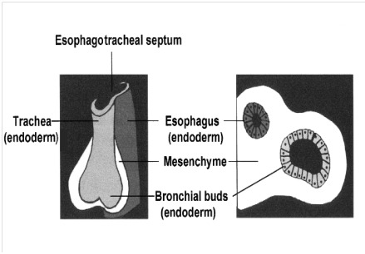
Following fertilization, the germ cells soon segregate into a cluster of trophoblastic cells to which a few embryoblastic cells adhere. The trophoblastic cells may be viewed as the future placenta, whereas the embryoblastic cells, after differentiation into the three germ layers, will form the human embryo.

At around 3–4 weeks of embryonic life, the human fetal lung develops as an outgrowth of the ventral wall of the primitive foregut, the laryngotracheal groove. The epithelial cells from the foregut endoderm invade the surrounding mesenchyme to form the trachea. During the embryonic stage, the trachea branches into the right and left main bronchi and subsequently into lobar and segmental bronchi. Lobar and segmental bronchi appear at about the 5th week and by the end of this stage, 18 major lobules are recognisable. Pulmonary arteries and veins develop as a single avascular bud from the 6th aortic arch and continue to grow by vasculogenesis around the airway buds from 4–16 weeks. The lung bud grows into adjacent splanchnic mesoderm where it is induced to branch repeatedly, giving rise to the future respiratory tree. This primitive lung bud is lined by endodermally derived epithelium, which differentiates into specialized cells that line both the conducting and respiratory airways. Mesenchymal cells condensed around the primitive airways give rise to blood vessels, smooth muscle, cartilage, and other connective tissues of the lung. This earliest stage of lung development may have a principal role in determining the postnatal mortality and morbidity of the fetus. Structural abnormalities such as tracheal or pulmonary agenesis or stenosis maybe incompatible with life whereas other forms of anomalies such as tracheomalacia or bronchomalacia, ectopic lobes and congenital lobar cysts may lead to significant respiratory morbidity. Arterio-venous malformations may also form during vasculogenesis.

- The pseudoglandular stage (7-17 weeks ) in the utero

During the pseudoglandular stage, there is rapid proliferation of the primitive airways so that all airway divisions are more or less completed by 16 weeks. This translates into 12 to 17 branches in the upper lobes, 18 to 23 branches in the middle lobes, and 14 to 23 branches in the lower lobes. The branching pattern does not change after this stage and is similar to that of the adult lung. The most peripheral structures, the terminal bronchioles, will further differentiate to form the future respiratory bronchioles and alveolar ducts. The name pseudoglandular is derived from the histologic appearance of the lung, which on cross section consists of hollow tubular-like structures (glands) surrounded by clusters of mesenchymal cells. The columnar epithelial cells that line the tubules contain cytoplasmic glycogen; a few become ciliated as early as 8 weeks while others begin to differentiate into goblet cells. During this period, cartilage begins to form around the larger airways and smooth muscle forms around airways and major blood vessels
The failure of normal division of airway structures at this stage may lead to pulmonary hypoplasia or sequestration, cystic adenomatoid malformation and crucially, failure of the pleuro-peritoneal membrane to close at this stage may result in congenital diaphragmatic hernia.

- The Canalicular stage (17–27 weeks in utero)
The canalicular stage is so named because the potential air spaces are being “canalized” and approximated by a network of capillaries. The pulmonary acinar units, which eventually contain alveolar ducts, alveolar sacs, and alveoli, develop during this period. “Acinus” is the term applied to the gas exchange unit associated with a single terminal bronchiole. It follows that primitive lung lobules will have formed by the beginning of the canalicular stage. Each lobule contains three to five terminal bronchi and, by the end of 27 weeks, approximately 25,000 terminal bronchioli. A gradual decrease in mesenchymal tissue results in close apposition of the pulmonary vasculature to the epithelium. By 20 to 22 weeks’ gestation, type I and type II alveolar cells can be differentiated from the cuboidal epithelial cells in the most peripheral parts of the lung. Lamellar bodies associated with surfactant synthesis begin to appear in the cytoplasm of type II cells. Type I alveolar lining cells, which differentiate from type II cells, begin Their flattening process and attenuate to provide an air-blood interface. The conducting airways have fully developed smooth muscle, and lymphatic structures now begin to appear. The developing pulmonary arteries and veins follow the development of the branching airways but lag behind it somewhat. By the end of the canalicular period, the potential air-blood barrier is thin enough to support gas exchange. The bronchial artery system may be as critical for lung development as the pulmonary artery although the role of the bronchial artery in pulmonary differentiation and growth is currently unknown. It has been suggested that the most peripheral parts of the developing lung are supplied only by the pulmonary arterial vasculature.

Thus, a possible platform for gas exchange is established. With advances in perinatal medicine and ever increasing survival of extremely preterm infants, this is an important landmark in lung growth and development. Surfactant deficiency leading to respiratory distress syndrome is inevitable with premature delivery at this stage.

- Saccular stage (28–36 weeks in utero)
The term “saccule” derives from the saclike appearance of the most peripheral air spaces, which represent the future alveolar ducts and alveoli. Each acinus supplied by a terminal bronchiole has three to four respiratory bronchioles that end in a transitional duct from which the saccules arise. The major changes that occur during the saccular stage are further compression of the intervening interstitium, thinning of the epithelium, and the beginning of alveolar septation, with the formation of small mesenchymal ridges. There is lengthening and widening of saccules distal to the terminal bronchioles and the addition of the last generations of future alveolar spaces. Continual differentation of type I and II alveolar cells occurs during this period, so that the alveolar epithelial cells become the most abundant epithelial cells in the lung. The flattened type I alveolar cells make up the majority of these cells. Type II cells, ultrastructurally (the use of electron microscope) distinguished by their production of lamellar bodies, expand in size and number, with increased storage of surfactant lipids and less cytoplasmic glycogen.

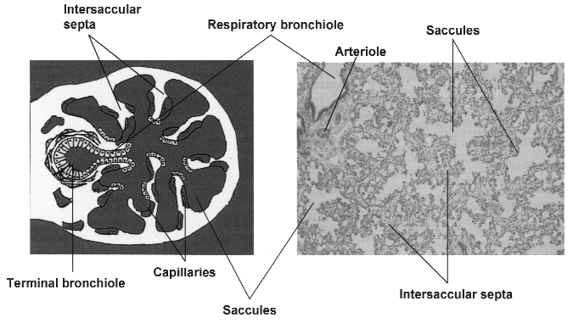

- Alveolar stage (36 weeks in utero—2 years)
Several million alveoli form before birth although this final stage of lung development primarily occurs during postnatal life. The beginning of this stage is not sharply defined; some alveolar formation probably begins a few weeks earlier. Alveolar formation is closely linked to the deposition of elastin in the saccular lung. Terminal saccules become invaginated by protrusions from the wall of epithelial cells and contain a double-walled capillary system. These protrusions elongate and thin, forming primitive alveoli that at first resemble shallow cups and then become deeper as development continues.

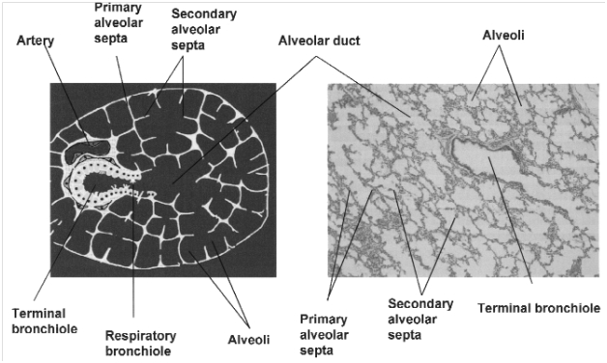

Gradually, low ridge like projections, also with double capillary network appear in the airspaces, which eventually divide the airspaces into alveoli. This process of formation of double capillary walled secondary septa and multiplication of alveoli continue rapidly up to the age of at least 2 years in humans.

Postnatal lung growth
During the postnatal phase, lung growth is geometric, and there is no increase in airway number. There is proportionately less growth in the conducting airways in comparison with alveolar-capillary tissue. Estimates of the number of alveoli at birth vary widely, but an average of 50 million is generally accepted. These alveoli provide a gas-exchanging surface of approximately 3 to 4 m2. Alveoli greatly increase in number after birth, to reach the adult range of 300 million by 2 years of age and the surface area of 75 to 100 m2 by adulthood. There is substantial remodeling of the parenchyma after birth, with morphologic changes in the septa. Alveolarization occurs through the formation of numerous short, blunt tissue crests or ridges, and their protrusion into alveolar sacs increases the internal surface of the lung. The development of the alveolar crest is closely linked with elastin deposition and the local proliferation of interstitial and epithelial cells. Post-mortem examination of lungs of children who died as a result of trauma or after short illnesses revealed that males had larger lungs than females of the same stature which resulted in greater alveolar number and greater alveolar surface area than girls for a given age and stature.
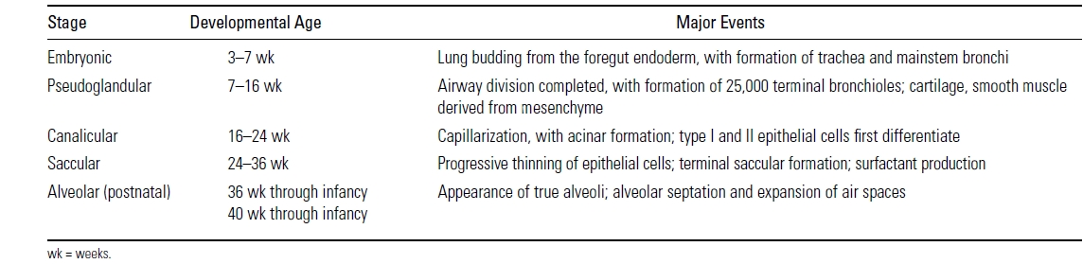

- ROTATION O THE. STOMACH AND THEE FORMATION OF THE OMMENTAL BURSA
Rotation Of The Stomach
During week 4 at the level where the stomach will form the tube begins to dilate, for an enlarged lumen. The dorsal border grows more rapidly than ventral, which establishes the greater curvature of the stomach. A second rotation (of 90 degrees) occurs on the longitudinal axis establishing the adult orientation of the stomach.
Formation Of Omental Bursa
The omental bursa or lesser sac is a hollow space that is formed by the greater and lesser omentum and its adjacent organs. It communicates with the greater sac via the epiploic foramen of winslow, which is known as the general cavity of the abdomen that sits within the peritoneum, but outside the lesser sac. This space has well-defined borders which are represented by certain organs or their parts, so they are quite easy to spot and form a mental image of the omental bursa. In addition, like anything in anatomy, the omental bursa doesn't just exist as a standalone and isolated entity, but rather it communicates with several other spaces and recesses found throughout the body. The borders of the omental bursa are are formed:
Anteriorly by the quadrate lobe of the liver, the gastrocolic ligament and the lesser omentum to the left it is limited by the left kidney and the left adrenal gland
Posteriorly it is walled off by the pancreas to the right, the epiploic foramen and lesser omentum can be found and the greater sac beyond that. The cavity itself is almost completely closed, save its communication with their greater sac and the entrance through the omental foramen and is filled with a capillary film. The greater part of the omental bursa consists of its superior recess which extends cranially between the esophagus and the inferior vena cava.

iiii). DEVELOPMENT OF THE ESOPHAGUS
The esophagus is a fibromuscular tube, about 25 centimetres long in adults, which travels behind the trachea and heart, passes through the diaphragm and empties into the uppermost region of the stomach. During swallowing, the epiglottis tilts backwards to prevent food from going down the larynx and lungs The wall of the esophagus from the lumen outwards consists of mucosa, submucosa (connective tissue), layers of muscle fibers between layers of fibrous tissue, and an outer layer of connective tissue. The mucosa is a stratified squamous epithelium of around three layers of squamous cells, which contrasts to the single layer of columnar cells of the stomach. The transition between these two types of epithelium is visible as a zig-zag line. Most of the muscle is smooth muscle although striated muscle predominates in its upper third. It has two muscular rings or sphincters in its wall, one at the top and one at the bottom. The lower sphincter helps to prevent reflux of acidic stomach content. The esophagus has a rich blood supply and venous drainage. Its smooth muscle is innervated by involuntary nerves (sympathetic nerves via the sympathetic trunk and parasympathetic nerves via the vagus nerve) and in addition voluntary nerves (lower motor neurons) which are carried in the vagus nerve to innervate its striated muscle.
DEVELOPMENT
In early embryogenesis, the esophagus develops from the endodermal primitive gut tube. The ventral part of the embryo abuts the yolk sac. During the second week of embryological development as the embryo grows, , it begins to surround parts of the sac. The enveloped portions form the basis for the adult gastrointestinal tract. The sac is surrounded by a network of vitelline arteries. Over time, these arteries consolidate into the three main arteries that supply the developing gastrointestinal tract: the celiac artery, superior mesenteric artery, and inferior mesenteric artery. The areas supplied by these arteries are used to define the midgut, hindgut and foregut. The surrounded sac becomes the primitive gut. Sections of this gut begin to differentiate into the organs of the gastrointestinal tract, such as the esophagus, stomach, and intestines. The esophagus develops as part of the foregut tube. The innervation of the esophagus develops from the pharyngeal arches.

