NAME: SUOWARI OYINEBI PASCHELIA
MATRIC NUMBER: 17/MHS01/299
DEPARTMENT: MEDICINE AND SURGERY
HEAD AND NECK ASSIGNMENT
- Discuss the anatomy of the tongue and comment on its applied anatomy
- Write an essay on the air sinuses
ANSWERS
- ANATOMY OF THE TONGUE
The tongue is a mass of muscle that is almost completely covered by a mucous membrane. It occupies most of the oral cavity and oropharynx. It is known for its role in taste, but it also assists with mastication (chewing), deglutition (swallowing), articulation (speech), and oral cleansing. Five cranial nerves contribute to the complex innervation of this multifunctional organ. The embryologic origins of the tongue first appear at 4 weeks' gestation. [1] The body of the tongue forms from derivatives of the first branchial arch. Tiny bumps called papillae give the tongue its rough texture. Thousands of taste buds cover the surfaces of the papillae. Taste buds are collections of nerve-like cells that connect to nerves running into the brain.
The tongue is anchored to the mouth by webs of tough tissue and mucosa. The tether holding down the front of the tongue is called the frenum. In the back of the mouth, the tongue is anchored into the hyoid bone. The tongue is vital for chewing and swallowing food, as well as for speech.
The four common tastes are sweet, sour, bitter, and salty. A fifth taste, called umami, results from tasting glutamate (present in MSG).
Under normal circumstances, the tongue is a pink, muscular organ located within the oral cavity proper. It is kept moist by the products of the major and minor salivary glands, which aids the organ as it facilitates deglutition, speech, and gustatory perception. While there is significant variability in the length of the tongue among individuals, on average, the organ is roughly 10 cm long. It has three main parts:
- The tip or apex of the tongue is the most anterior and most mobile aspect of the organ.
- The body of the tongue. It has a rough dorsal (superior) surface that abuts the palate and is populated with taste buds and lingual papillae, and a smooth ventral (inferior) surface that is attached to the floor of the oral cavity by the lingual frenulum.
- The base of the tongue is the most posterior part of the organ. It is populated by numerous lymphoid aggregates known as the lingual tonsils along with foliate papillae along the posterolateral surface.
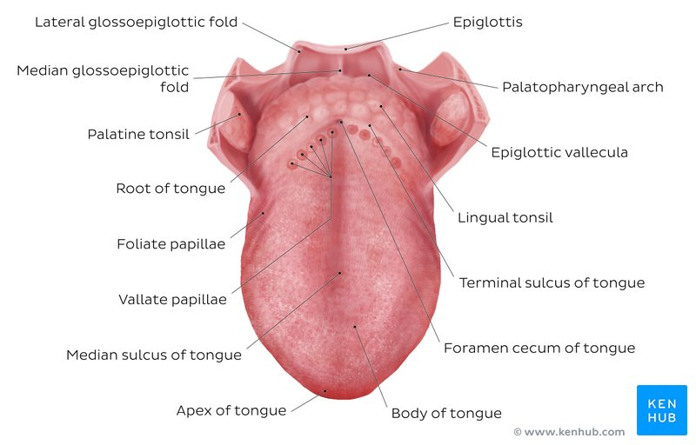
MUSCLES OF THE TONGUE
The Tongue has both Intrinsic and Extrinsic Muscles.
- Intrinsic Muscles: The intrinsic muscles only attach to other structures in the tongue. There are four paired intrinsic muscles of the tongue and they are named by the direction in which they travel: the superior longitudinal, inferior longitudinal, transverse and vertical muscles of the tongue. These muscles affect the shape and size of the tongue – for example, in tongue rolling – and have a role in facilitating speech, eating and swallowing. Motor innervation for the intrinsic muscles of the tongue is via the hypoglossal nerve (CNXII).
- Extrinsic Muscles :The extrinsic muscles are as follows:
- Genioglossus
- Attachments: Arises from the mandibular symphysis. Inserts into the body of the hyoid bone and the entire length of the tongue.
- Function: Inferior fibres protrude the tongue, middle fibres depress the tongue, and superior fibres draw the tip back and down
- Innervation: Motor innervation via the hypoglossal nerve (CNXII).
- Hyoglossus
- Attachments: Arises from the hyoid bone and inserts into the side of the tongue
- Function: Depresses and retracts the tongue
- Innervation: Motor innervation via the hypoglossal nerve (CNXII).
- Styloglossus
- Attachments: Originates at the styloid process of the temporal bone and inserts into the side of the tongue
- Function: Retracts and elevates the tongue
- Innervation: Motor innervation via the hypoglossal nerve (CNXII).
- Palatoglossus
- Attachments: Arises from the palatine aponeurosis and inserts broadly across the tongue
- Function: Elevates the posterior aspect of the tongue
- Innervation: Motor innervation via the vagus nerve (CNX).

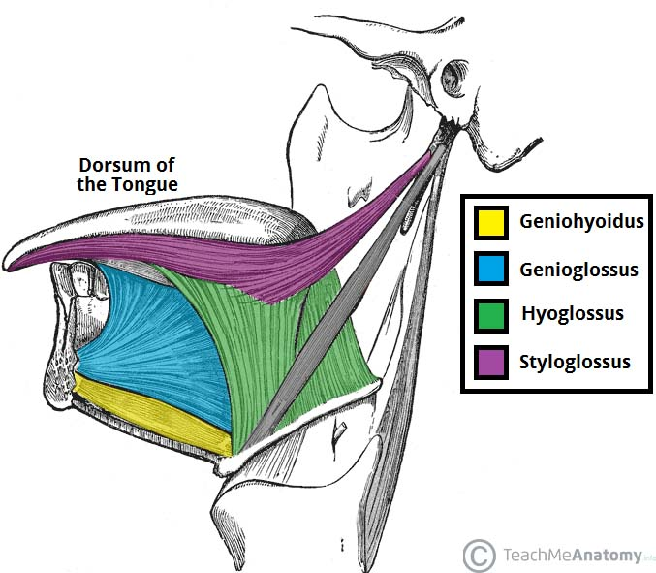

LYMPHATIC DRAINAGE
The lymphatic drainage of the tongue is as follows:
- Anterior two thirds – initially into the submental and submandibular nodes, which empty into the deep cervical lymph nodes
- Posterior third – directly into the deep cervical lymph nodes

ARTERIAL SUPPLY
Blood supply to the tongue is predominantly from the lingual artery, a branch of the external carotid artery between the superior thyroid artery and the facial artery, which departs at the level of the greater horn of the hyoid bone within the carotid triangle. After branching from the external carotid artery, the lingual artery passes deep to the hyoglossus muscle and superficial to the middle pharyngeal constrictor muscle. It then gives rise to the following four arteries:
- The suprahyoid artery
- The dorsal lingual arteries
- The sublingual artery
- The deep lingual artery

VENOUS DRAINAGE
The veins of the tongue are named similarly to the arteries that they accompany. They are formed from numerous venous tributaries that eventually coalesce. As the deep lingual vein forms adjacent to the apex of the tongue, it courses along the ventral surface of the tongue (deep to the mucosa). As the deep lingual vein anastomosis with the sublingual vein, they become the vena comitans of CN XII.
This venous network eventually drains to the lingual vein that later join the facial or the anterior division of the retromandibular veins. Here, they form the common facial vein, which is a tributary to the internal jugular vein. Alternatively, the venae comitantes may drain directly to the internal jugular vein. The dorsal lingual veins are responsible for draining the lateral margins and dorsal surface of the tongue. They travel alongside the similarly named artery as they drain into the internal jugular vein.

INNERVATION
- The hypoglossal nerve (CN XII) provides motor innervation to all of the intrinsic and extrinsic muscles of the tongue except for the palatoglossus muscle, which is innervated by the vagus nerve (CN X). It runs superficial to the hyoglossus muscle. Lesions of the hypoglossal nerve cause deviation of the tongue to the ipsilateral (i.e., damaged) side.
- Taste to the anterior two-thirds of the tongue is achieved through innervation from the chorda tympani nerve, a branch of the facial nerve (CN VII). General sensation to the anterior two-thirds of the tongue is by innervation from the lingual nerve, a branch of the mandibular branch of the trigeminal nerve (CN V3). The lingual nerve is located deep and medial to the hyoglossus muscle and is associated with the submandibular ganglion.
- On the other hand, taste to the posterior one-third of the tongue is accomplished through innervation from the glossopharyngeal nerve (CN IX), which also provides general sensation to the posterior one-third of the tongue.
- Taste perception also is performed by both the epiglottis and the epiglottic region of the tongue, which receives taste and general sensation from innervation by the internal laryngeal branch of the vagus nerve (CN X). Damage to the vagus nerve (CN X) causes contralateral deviation (i.e., away from the injured side) of the uvula.

CLINICAL SIGNIFICANCE
- Thrush (candidiasis): Candida albicans (a yeast) grows over the surface of the mouth and tongue. Thrush can occur in almost anyone, but it occurs more often in people taking steroids or with suppressed immune systems, the very young, and the elderly.
- Oral cancer: A growth or ulcer appears on the tongue and grows steadily. Oral cancer is more common in people who smoke and/or drink alcohol heavily.
- Macroglossia (big tongue): This can be broken down into various categories based on the cause. These include congenital, inflammatory, traumatic, cancerous, and metabolic causes. Thyroid disease, lymphangiomas, and congenital abnormalities are among some of the causes of an enlarged tongue.
- AIR SINUSES
It is also called paranasal sinuses; Paranasal sinuses are a group of four paired air-filled spaces that surround the nasal cavity. The sinuses are named for the facial bones in which they are located. They are air-filled spaces located within the bones of the skull and facial bones. They are centred on the nasal cavity and have various functions, including lightening the weight of the head, humidifying and heating inhaled air, increasing the resonance of speech, and serving as a crumple zone to protect vital structures in the event of facial trauma.
The paranasal sinuses are air cavities that help circulate the air that is breathed in and out of the respiratory system. They are situated around the nasal cavity and they are all paired and sometimes symmetrical, while always being bilateral. There are four different pairs of sinuses and they are called the:
- The maxillary sinuses: The maxillary sinuses are the largest of the all the paranasal sinuses. They have thin walls which are often penetrated by the long roots of the posterior maxillary teeth. The superior border of this sinus is the bony orbit, the inferior is the maxillary alveolar bone and corresponding tooth roots, the medial border is made up of the nasal cavity and the lateral and anterior border are limited by the cheekbones. Posteriorly, two anatomical spaces known as the pterygopalatine fossa and the infratemporal fossa exist.
Vascularization, innervation and lymphatics
The submandibular lymph nodes are the main destination during lymphatic drainage. The blood supply includes a contribution from the:
- anterior superior alveolar artery
- middle superior artery
- posterior superior alveolar artery
Innervation occurs through nerves of the same names as the arteries.
- The frontal sinuses: Anteriorly, the frontal sinuses are contained by the forehead and the superciliararches, superiorly and posteriorly by the anterior cranial fossa and inferiorly by the bony orbit, the anterior ethmoidal sinuses and the nasal cavity. Medially the sinuses face one another, separated by the midline. This pair of sinuses is irregular in shape when compared to one another and is underdeveloped at birth. They reach their full size and shape around seven to eight years of age.
Vascularization, innervation and lymphatics
They drain primarily into the ethmoidal infundibulum and the corresponding lymph drainage occurs via the submandibular lymph nodes. It is innervated by the ophthalmic nerve, including the supraorbital and supratrochlear branches.
The frontal sinuses are supplied by the:
- anterior ethmoidal artery
- supraorbital artery
- supratrochlear artery

- The sphenoidal sinuses: The most posterior of all the sinuses in the head, the sphenoidal sinuses are large and irregular, just like their septum, which is made by the sphenoid bone. Laterally, a cavernous sinus exists which is part of the middle cranial fossa and also the carotid artery and cranial nerves III, IV, V/I, V/II and VI can be found. The anterior wall separates this pair of sinuses from the nasal cavity, as does the hypophyseal fossa, the pituitary gland and the optic chiasm superiorly and the nasopharynx and pterygoid canal inferiorly.
Vascularization, innervation and lymphatics
The lymphatic drainage occurs in the same way as the posterior ethmoid sinus. The posterior ethmoidal artery and the posterior lateral nasal branches supply the sphenoidal sinuses.
The posterior ethmoidal nerve and the orbital branch of the pterygopalatine ganglion innervate them.
- The ethmoidal sinuses: Superior to the ethmoidal sinus is the anterior cranial fossa and the frontal bone, laterally the orbit can be found, while the nasal cavity is situated medially. The ethmoid sinuses are unique because they are the only paranasal sinuses that are more complex than just a single cavity. On each side of the midline, anywhere from three to eighteen ethmoidal air cells may be grouped together. These air cells are smaller individual sinuses grouped together to form one large one which encompass the anterior, middle and posterior nasal meatuses.
Vascularization, innervation and lymphatics
The anterior and middle ethmoid sinuses send their lymphatic drainage to the submandibular lymph nodes while the posterior ethmoid sinus sends its own to the retropharyngeal lymph nodes.
The anterior and posterior ethmoidal arteries, as well as the posterior lateral nasal branches provide an ample blood supply to this region. Meanwhile the anterior and posterior ethmoidal nerves and the posterior lateral superior and inferior nasal nerves help innervate it.
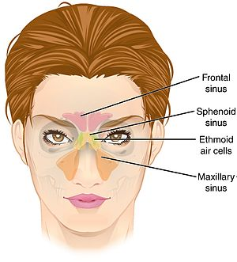
Paranasal sinuses form developmentally through excavation of bone by air-filled sacs (pneumatic diverticula) from the nasal cavity. This process begins prenatally (intrauterine life), and it continues through the course of an organism's lifetime.
The results of experimental studies suggest that the natural ventilation rate of a sinus with a single sinus ostium (opening) is extremely slow. Such limited ventilation may be protective for the sinus, as it would help prevent drying of its mucosal surface and maintain a near-sterile environment with high carbon dioxide concentrations and minimal pathogen access. Thus composition of gas content in the maxillary sinus is similar to venous blood, with high carbon dioxide and lower oxygen levels compared to breathing air.^{[3]}
At birth only the maxillary sinus and the ethmoid sinus are developed but not yet pneumatized; only by the age of seven they are fully aerated. The sphenoid sinus appears at the age of three, and the frontal sinuses first appear at the age of six, and fully develop during adulthood.
Sinuses are formed in childhood by the nasal cavity eroding into surrounding bone. As they are outgrowths of the nasal cavity, they all drain back into it – openings to the paranasal sinuses are found on the roof and lateral walls of the nasal cavity. The inner surface is lined by a respiratory mucosa.

CLINICAL SIGNIFICANCE
Sinusitis
Sinusitis is an extremely common outpatient case which presents as an inflammation of the epithelia of the sinuses. The causes can be either a viral or bacterial infection, or an allergic reaction. The inflammation can be acute or chronic and the maxillary sinuses are the most frequently affected. Antivirals, antibiotics and antihistamines are prescribed in persistent cases.

