AFONJA OYINDUNMOLA MOFEYITOLUWA
PHARMACY
19/MHS11/016
CHM 102
- HCOOH- Methanoic acid
- CH₃CH₂CH₂COOH-Butanoic acid
- CH₃(CH₂)COOH- Hexanoic acid
- HOOCCH₂-CH₂CH₂COOH- Pentan-1,5-dioic acid
- HO₂C-CO₂H- Ethanedioic acid
- CH₃CH=CHCH₂CH₂COOH- Hex-4-eneoic acid

- -Physical appearance: All simple aliphatic carboxylic acids up to C₁₀ are liquids at room temperature. Most of other carboxylic acids are solid at room temperature although acetic acid or glacial ethanoic acid freeze to an ice-like solid below room temperature.
-Boiling point: Boiling point increases with increasing relative molecular mass. Aromatic carboxylic acids are crystalline solids and have higher melting points than their aliphatic counterparts of comparable relative molecular mass.
-Solubility: Carboxylic acids are very difficult to reduce by catalytic hydrogenation or dissolving metals but lithium tetrahydridoaluminate (III) and diborane form intermediate compounds with the acids which liberate the alohol on hydrolysis.

- -From carbon (II) Oxide: Carbon(II) Oxide is added under pressure to an aqeous solution of sodium hydroxide at high temperature.The free carboxylic acid is liberated by careful reaction with tetraoxosulphate(VI) acid (H₂SO₄)

NaOH H₂SO₄
CO HCOONa HCOOH + NaHSO₄

-From Petroleum: Liquid phase air oxidation of C₅-C₇ alkanes, obtainable from petroleum at high temperature and pressure will give C₅-C₇ carboxylic acids with methanoic, propanoic, butanedioic acids as by-products.

O2/ High temperature and pressure
C₅-C₇ C₅-C₇

- Synthesis of substituted acetic acid via malonic ester
Malonic ester is an ester formed by reacting an alcohol with malonic acid (propanedicarboxylic acid). Following is the structure of diethyl malonate: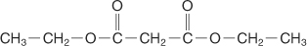

The hydrogen atoms on the methylene unit between the two carboxyl groups are acidic like those in acetoacetic ester. Strong bases can remove these acidic hydrogens.
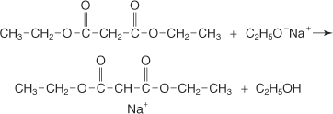
The resulting carbocation can participate in typical S _{N} reactions, allowing the placement of an alkyl group on the chain.
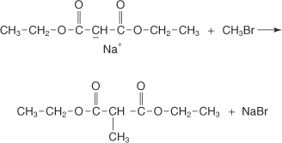
A second alkyl group can be placed on the compound by reacting the product formed in the previous step with a very strong base to form a new carbanion.

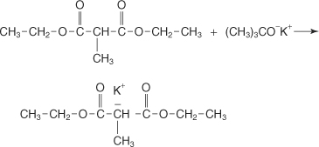
The resulting carbanion can participate in a typical S _{N} reaction, allowing the placement of a second alkyl group on the chain.
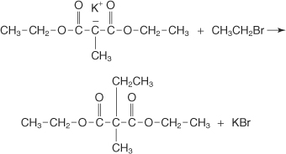
Hydrolysis of the resulting product with concentrated aqueous sodium hydroxide produces the sodium salt of the disubstituted acid.

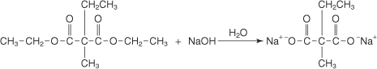
Addition of aqueous acid converts the salt into its conjugate acid.

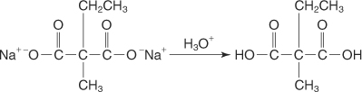
Upon heating, the β ketoacid becomes unstable and decarboxylates, forming a disubstituted acetic acid.

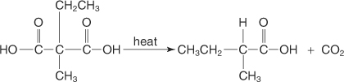

α halo acids, α hydroxy acids, and α, β unsaturated acids

The reaction of aliphatic carboxylic acids with bromine in the presence of phosphorous produces α halo acids. This reaction is the Hell‐Volhard‐Zelinski reaction.
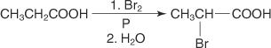

α halo acids can be converted to α hydroxy acids by hydrolysis.
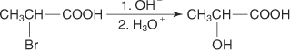
α halo acids can be converted to α amino acids by reacting with ammonia.
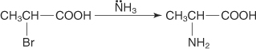

α halo acids and α hydroxy acids can be converted to α, β unsaturated acids by dehydrohalogenation and dehydration, respectively.
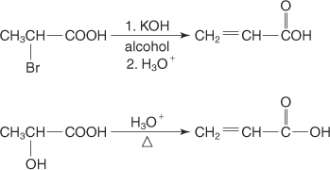

- -Decarboxylation: In decarboxylation, the carboxyl group is removed to form a hydrocarbon or its derivative, In thermal decarboxylation, carboxylic acids with a strong electron attracting group decarboxylate readily on heating to 100ºC-150ºC while others decarboxylate when their salts are heated with soda lime.
fuse
CH₃CH₂CH₂COONa CH₃CH₂CH₃ + Na₂CO₃
-Esterification: This is the process where a carboxylic acid reacts with alcohols to form esters.

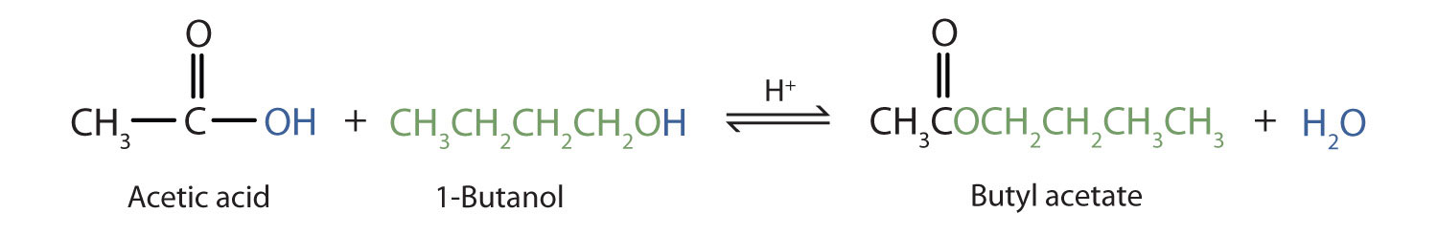
This Photo by Unknown Author is licensed under CC BY-SA-NC

