Name: Iroegbu Ugochi Miriam
Matric. number: 17/mhs01/164
Department: Medicine and Surgery
Course:Head and Neck
- Discuss the anatomy of the tongue and comment on applied anatomy
The tongue is a unique organ located in the oral cavity that not only facilitates perception of gustatory stimuli but also plays important roles in mastication and deglutition. Additionally, the tongue is an integral component of the speech pathway, as it helps with articulation. Under normal circumstances, the tongue is a pink, muscular organ located within the oral cavity proper. It is kept moist by the products of the major and minor salivary glands, which aids the organ as it facilitates deglutition, speech, and gustatory perception. While there is significant variability in the length of the tongue among individuals, on average, the organ is roughly 10 cm long. It has three main parts:
- The tip or apex of the tongue is the most anterior, and most mobile aspect of the organ.
- The tip is followed by the body of the tongue. It has a rough dorsal (superior) surface that abuts the palate and is populated with taste buds and lingual papillae, and a smooth ventral (inferior) surface that is attached to the floor of the oral cavity by the lingual frenulum.
- The base of the tongue is the most posterior part of the organ. It is populated by numerous lymphoid aggregates known as the lingual tonsils along with foliate papillae along the posterolateral surface.
- There are numerous important structures surrounding the tongue. It is limited anteriorly and laterally by the upper and lower rows of teeth. Superiorly, it is bordered by the hard (anterior part) and soft (posterior part) palates. Inferiorly, the root of the tongue is continuous with the mucosa of the floor of the oral cavity; with the sublingual salivary glands and vascular bundles being located below the mucosa of the floor of the oral cavity.

Taste buds: The coarse texture of the dorsal surface of the tongue can be attributed to the numerous lingual papillae that are found on its surface. As the 8th gestational week draws to a close, foliate and vallate papillae are the first of the four papillae to develop. These are followed by the appearance of fungiform papillae. By the 10th – 11th week of gestation, the thread-like filiform papillae can be observed on the dorsal surface of the tongue. Each type of papillae has a particular role in tongue physiology, and as such, has a unique innervation based on the nerve endings they developed closest to.

Muscles : The tongue is chiefly a muscular organ with some amount of fatty and fibrous tissue distributed throughout its substance. All the muscles of the tongue are paired structures, with each copy being found on either side of the median fibrous septum. There are muscles that extend outside of the organ to anchor it to surrounding bony structures, known as extrinsic muscles. The other set of muscles are confined to each half of the organ and contribute to altering the shape of the organ; these are the intrinsic muscles.

Intrinsic Muscles: the intrinsic muscles only attach to other structure in the tongue. There are four paird intrinsic muscles of the tongue and they are named by the direction in which they travel: the superior longitudinal, inferior longitudinal, transverse and vertical muscles of the tongue. Thse muscles affect the shape and size of the tongue- for example in tongue rolling and have a role in facilitating speech, eating and swollowig. Motor innervations for the intrinsic muscles of the tongue is via the hypoglossal nerve(CNXII)

Extrinsic Muscles
The extrinsic muscles are as follows:

Genioglossus
- Attachments: Arises from the mandibular symphsis. Inserts into the body of the hyoid bone and the entire length of the tongue.
- Function: Inferior fibres protrude the tongue, middle fibres depress the tongue, and superior fibres draw the tip back and down
- Innervation: Motor innervation via the hypoglossal nerve (CNXII).

Hyoglossus
- Attachments: Arises from the hyoid bone and inserts into the side of the tongue
- Innervation: Motor innervation via the hypoglossal nerve (CNXII).

Styloglossus
- Attachments: Originates at the styloid process of the temporal bone and inserts into the side of the tongue
- Function: Retracts and elevates the tongue
- Innervation: Motor innervation via the hypoglossal nerve (CNXII).

Palatoglossus
- Attachments: Arises from the palatine aponeurosis and inserts broadly across the tongue
- Function: Elevates the posterior aspect of the tongue
- Innervation: Motor innervation via the vagus nerve (CNX).
All of the intrinsic and extrinsic muscles are innervated by the hypoglossal nerve (CN XII), except palatoglossus, which has vagal innervation (CN X).
Innervation:
Motor supply for all intrinsic and extrinsic muscles of the tongue is supplied by efferent motor nerve fibers from the hypoglossal nerve (CN XII), with the exception of the palatoglossus, which is innervated by the vagus nerve (CN X).

Vasculature
The lingual artery (branch of the external carotid) does most of the supply, but there is a branch from the facial artery, called the tonsillar artery, which can provide some collateral circulation. Drainage is by the lingual vein.
Lymphatic Drainage: The tip of tongue drains to the submental nodes. The left and right halves of the anterior two-thirds of the tongue drains to submandibular lymph nodes, while the posterior one-third of the tongue drains to the jugulo-omohyoid nodes.
The tip of tongue drains to the submental nodes. The left and right halves of the anterior two-thirds of the tongue drains to submandibular lymph nodes, while the posterior one-third of the tongue drains to the jugulo-omohyoid nodes.

Applied anatomy:
Thrush : candida albicans grows over the surface of the mouth and tongue. Thrush can occur in almost anyone, but it occurs more often In people taking steroids or with suppressed immune systems, the very young and the elderly.
Tongue-tied: the tongue is attached anteroinferiorly by a piece of connective tissue called the frenulum which lies in the midline. The process by which the frenulum is formed in the same way by which the dingers are made and is known as sculpting apoptosis. Just as some people may have webbed fingers if this process fails, it can result in excess frenulum. This is called being tongue tied and it presents in children. There are varying degrees of severity of tongue tying and in some cases it can restrict movement of the tongue causing difficulties with breast feeding. This can be managed with simple surgery.

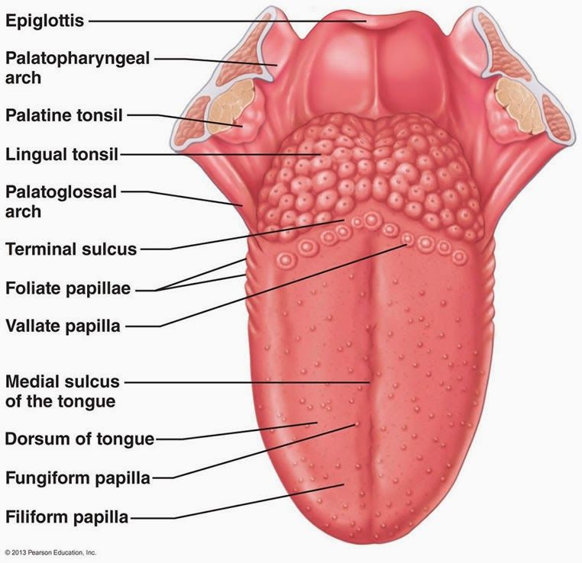

- Write an essay on air sinuses
The paranasal sinuses are air-filled spaces located within the bones of the skull and facial bones. They are centered on the nasal cavity and have various functions, including lightening the weight of the head, humidifying and heating inhaled air, increasing the resonance of speech, and serving as a crumple zone to protect vital structures in the event of facial trauma.The paranasal sinuses are cavities in the interior of the maxilla and the frontal, sphenoid and ethmoid boned. The sinuses develop as outgrowths from the nasal cavity; hence they all drain directly into the nose. Nasal infection e.g during “cold in head” may spread to the sinuses(sinusitis). The lining of the sinuses (muco-endosteum) is continuous with the nasal mucosa. The sinuses develop mostly after birth, and their degree of development varies greatly. Their function is obscure but they provide resonance to the voice, shape to the face and some degree of warmth and humidification to inspired air. The paranasal sinuses are supplied by branches of the ophthalmic and maxillary nerves. The sinuses can be examined radiographically, and a light placed agains the roof of the mouth enables the maxillary sinus to be transilluminated.] Four sets of paired sinuses are recognized: maxillary, frontal, sphenoid, and ethmoid

Maxillary sinus
The maxillary sinus, the largest of the sinuses, is within the body of the maxilla. It is shaped like a pyramid; its base is usually medial, with its apex in the zygomatic process of the maxilla. Its roof is the floor of the orbit, and its floor is the alveolar process of the maxilla. The maxillary sinusdains into the middle meatus by means of the semilunar hiatus. The floor of the maxillary sinus is slightly below the level of the nasal cavity, and it is related to the upper teeth(varying from teeth 3 to 8 to teeth 6 to 8). Maxillary sinusitis is frequently accomplished by tooth ache. Infection may be spread among the various sinuses, the nasal cavity and the teeth. The opening of the maxillary sinus can be cannulated in vivo through the nostril.

Ethmoidal sinus.

The ethmoidal sinus comprises numerous small cavities(ethmoidalcells) in the ethmoidal labyrinth. The walls of these cavities are completed by the surrounding bones. Anterior and posterior groups drain into the middle and superior meatuses, respectively

Frontal sinus

The frontal sinus may be regarde as an anterior ethmoidal cell that has invaded the frontal bone postbatal. The right and left frontal sinuses, frequently of different sizes are seperatd by a bony septum that is usually deviated to one side. The frontal sinus drains into the middle meatus in a variable manner directly or by a frontonasal duct,which opens into the frontal recess or the ethmoidal infundibulum. The frontal sinus commonly extends posterorward in the roof of the orbit

Sphenoidal sinus

The sphenoid sinus is in the body of the sphenoid bone and it varies greatly insize. Its superior aspectis related to thehypophysis(pituitary) and optic nervr and chiasma and literally to the cavernous sinus and internal carotid artery .The sphenoidal sinus drains into the spheno-ethmoidal recess superior to the superior concha. The sinus is divided into right and left parts by a bony septum.
