NAME: ERUVWETOPHURE JEMILAND
MATRIC NO: 17/MHS01/121
DEPT: MBBS
LEVEL: 300
COURSE: GROSS ANATOMY (HEAD AND NECK)

QUESTION 1(ESSAY ON CAVERNOUS SINUS)

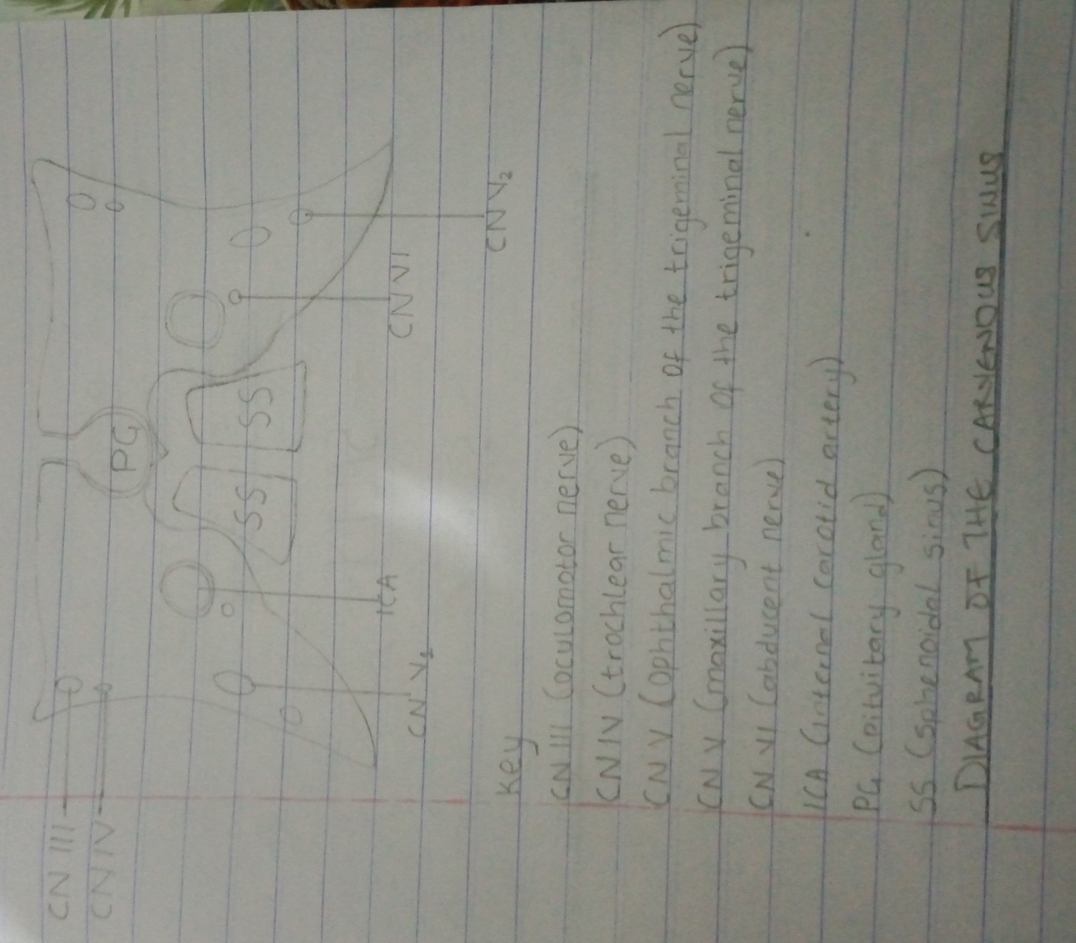

The cavernous sinuses are one of several drainage path ways for the brain that sits in the middle. In addition to receiving venous drainage from the brain, it also receives tributaries from parts of the face.
The left and right cavernous sinuses communicate through the anterior and posterior intercavernous sinuses. The cavernous sinus drains to the superior and inferior petrosal sinuses, which then join the sigmoid sinus.
STRUCTURE
The cavernous sinuses are 1cm wide cavities that extend a distance of 2cm from the most posterior aspect of the orbit to the petrous part of the temporal bone. They are bilaterally paired collections of venous plexuses that sit on either side of the sphenoid bone.
The cavernous sinus is roofed by an inner layer of Dura mater that continues with the diaphragma sellae that covers the superior part of the pituitary gland. The roof of the sinus also has several other attachments.
- Anteriorly, it attaches to the anterior and middle clinoid processes
- Posteriorly, it attaches to the tentorium (at its attachment to the posterior clinoid process)
- Part of the periosteum of the greater wing of the sphenoid bone forms the floor of the sinus.
- The body of the sphenoid acts as the medial wall of the sinus
- The lateral wall is formed from the visceral part of the Dura mater.
CONTENT
The cavernous sinus contains the internal carotid artery and several cranial nerves. Abducen nerve (CN VI) traverses the sinus lateral to the internal carotid artery. The remainder of the cranial nerves passes through the lateral wall of the carotid sinus, and from superior to inferior. They are:
- Oculomotor nerve (CN III)
- Trochlear nerve (CN IV)
- Trigeminal nerve (CN V) - ophthalmic and maxillary divisions.
RELATIONS
There are numerous structures surrounding the cavernous sinus that are noteworthy. Medially, the sinus is adjacent to the lateral walls of the pituitary fossa with the pituitary gland, the sphenoid bone and its air sinus. The cerebral part of the internal carotid artery courses superiorly. Laterally, the medial aspect of the temporal lobe of each hemisphere lies adjacent to the sinus. And posteriosuperiorly, the uncus of the temporal lobe has a relation to the sinus.
COMMUNICATIONS
The cavernous sinus is an unconventional venous system in the sense that it does not have a unidirectional flow of blood. Owing to the fact that there are no valves in the sinus and its connected veins, the direction of blood flow is dependent on venous pressure. The veins that communicate with the cavernous sinus are:
- Superior ophthalmic vein
- Inferior ophthalmic vein
- Superficial middle cerebral vein
- Middle meningeal vein
- Hypophyseal veins
INTERCAVERNOUS SINUSES AND DRAINAGE
The left and right cavernous sinuses communicate by way of the anterior and posterior intercavernous sinuses. These vessels travel anteriorly and posteriorly (respectively) around the infundibulum of the pituitary gland, deep to the diaphragma sellae, between the layers of Dura mater.

The cavernous sinus in turn drains to the superior and inferior petrosal sinuses. Both sinuses join the sigmoid sinus, which then becomes the internal jugular vein. The internal jugular vein meets with the subclavian vein to become the left (or right) brachiocephalic vein.
CLINICAL SIGNIFICANCE
Carotid-cavernous fistula
Head trauma resulting in rupture of the cavernous part of the internal carotid artery can produce what is known as a carotid-cavernous fistula. A pulsating exophthalmos can result as the venous pressure in the sinus would increase and reverse the flow of blood in the ophthalmic veins.

QUESTION 2 (THE WALLS OF THE NOSE)
The nose has two walls, a medial wall and a lateral wall.
THE LATERAL WALL
The lateral wall of the nasal cavity is a region of the nasopharynx essential for humidifying and filtering the air we breathe in nasally.

The lateral wall of the nose is irregular owing to the presence of three shelf-like projections called conchae. The conchae increases the surface area of the nose for effective air-conditioning of the inspired air.
The lateral wall separates the nose;
- From above, the ethmoidal air sinuses
- From the maxillary sinus below
- From the lacrimal groove and nasolacrimal canal in front
The lateral wall is subdivided into three parts;
- a small depressed area in the anterior part is called the vestibule, which is lined by modified skin containing short, stiff, curved hairs called vibrissae
- the middle part is known as atrium of the middle meatus
- the posterior part contains the conchae(spaces separating the conchae are known as meatuses)
- The small space above the superior concha is called the sphenoethmoidal recess.
- The middle meatus is continuous in front with a depression called the atrium
- Atrium is limited above by a ridge called agar nasi
- The skeleton of the lateral wall is partly bony, partly cartilaginous, and partly made up of soft tissues.
- The bony part is formed by;
- Nasal bone
- Frontal process of maxilla
- Lacrimal bone
- Labrininth of ethmoid with superior and middle concha
- Inferior nasal concha
- Perpendicular plate of palatine bone
- Medial pterygoid plate
- The cartilaginous part is formed by;
- Superior nasal cartilage
- Inferior nasal cartilage
- Small cartilage of ala

OSTEOMEATAL COMPLEX
Osteomeatal complex is a channel that links the frontal sinus, anterior and medial ethmoidal sinuses and the maxillary sinus to the middle meatus that allows air flow and mucociliary drainage.
ARTERIAL SUPPLY OF THE LATERAL WALL
- The antero-superior quadrant: it is supplied by the anterior ethmoidal artery, assisted by the posterior ethmoidal and facial arteries
- The antero-inferior quadrant: supplied by branches from the facial and greater palatine arteries
- The postero-superior quadrant: supplied by the sphenopalatine artery
- The postero-inferior quadrant: supplied by branches from the greater palatine artery, which pierce the perpendicular plate of the palatine bone.
VENOUS DRAINAGE OF THE LATERAL WALL
The veins form a plexus which drains;
- Anteriorly into the facial vein
- Posteriorly into the pharyngeal plexus of veins
- From the middle part to the pterygoid plexus of veins
NERVE SUPPLY
- General sensory nerves are derived from the branches of trigeminal nerve
- Anterior ethmoidal nerve branch of ophthalmic nerve
- Anterior superior alveolar nerve, branch of maxillary nerve
- Posterior superior lateral nasal branches from the pterygopalatine ganglion suspended by the maxillary nerve
- Greater palatine branch from the pterygopalatine ganglion suspended by the maxillary nerve.
- Special sensory nerves or olfactory-upper part of the lateral wall just below the cribriform plate of the ethmoid up to the superior concha.
LYMPHATIC DRAINAGE
- Anterior half of the lateral wall pass to the submandibular nodes
- The posterior half, to the retropharyngeal and upper deep cervical nodes.
APPLIED ANATOMY
- DANGER AREA OF FACE
- Infections from face can spread in a retrograde direction and cause thrombosis of cavernous sinus. This is likely to occur in presence of infection in upper lip and in the lower part of the nose. Facial vein of nose communicate with cavernous sinus.

THE MEDIAL WALL
The medial wall of the nasal cavity comprises the nasal septum, the septal cartilage and various bones of the skull.
THE NASAL SEPTUM
The nasal septum is a structure consisting of both bony and cartilaginous components. The bony components are the:
Perpendicular plate of the ethmoid superoinferiorly
The vomer posteroinferiorly
The crests of the maxillary bone anteroinferiorly
The crest of the palatine bone inferior to the vomer
NASAL CARTILAGE AND ASSOCIATED STRUCTURES
The septal cartilage is approximately 3-4mm thick. It divides the nasal cavity into two halves. The anteroinferior part of the cartilage has an expansion known as the ‘footplate’ which is 4-8mm wide. This foot plate lies in free contact with the membranous septum. The cartilage is expanded in other regions, namely the junction with the lateral nasal cartilage termed the posterior process. The cartilage is firmly adhered to the nasal bone by taut collagen fibres.
- The cartilage of the septum is also termed the ‘quadrangular cartilage’ due to its shape. The posterior nasal spine is a sharp pointed projection of the posterior border of the palatine bone. The musculus uvula gains its attachment here.
- The pharyngeal tonsil is also known as the adenoid. It is a mass of lymphatic tissue located in the roof of the nasopharynx. The structure degrades with age and is almost entirely absent at puberty. The torus tubarius is also known as the tubar tonsil. It resides at the base of the cartilaginous section of the Eustachian tube.
- The choana is an opening at the back of the nasal passage that empties into the nasopharynx, close to where the adenoids are. The passage way forms an outflow from the nasopharynx into the mouth and throat.

