NAME: AJAYI EMMANUEL OLUWASEGUN
MATRICULATION NUMBER: 17/MHS01/039
DEPARTMENT: MEDICINE AND SURGERY
COURSE: GROSS ANATOMY OF HEAD AND NECK

ANATOMY OF THE TONGUE
The tongue is a muscular organ in the mouth of most vertebrates that manipulates food for mastication and is used in the act of swallowing. It has importance in the digestive system and is the primary organ of taste in the gustatory system. Its upper surface (dorsum) is covered by taste buds housed in different lingual papillae. There are four basic taste sensations: sweet, salty, sour and bitter respectively.
- SWEETNESS is detected at the apex
- SALTINESS is detected at the anterolateral margins
- SOURNESS is detected at the posterolateral margins
- BITTERNESS is detected at the posterior part of the tongue

STRUCTURE OF THE TONGUE
The tongue is a muscular hydrostat that forms part of the floor of the oral cavity.
- The root of the tongue is directed backward, and connected with the hyoid bone by the hyoglossi and genioglossi muscles and the hyoglossal membrane, with the epiglottis by three glossoepiglottic folds of mucous membrane, with the soft palate by the glossopalatine arches and with the pharynx by the superior pharyngeal constrictor muscle and the mucous membrane. It also forms the anterior wall of the oropharynx.
- The body of the tongue is the anterior two-thirds of the tongue
- The apex (tip) of the tongue is the anterior end of the body, thin and narrow, directed forward against the lingual surfaces of the lower incisor teeth.
- The dorsum (dorsal/upper surface) of the tongue is divided by a groove into symmetrical halves called the median sulcus. It is also characterized by a V-shaped groove which divides the tongue into an anterior (oral) part and a posterior (pharyngeal) part called the terminal sulcus. Posterior to this groove is the foramen cecum. The foramen cecum is the point of attachment of the thyroglossal duct and is formed during the descent of the thyroid diverticulum in embryonic development.
On the undersurface of the tongue is a fold of mucous membrane called the frenulum that tethers the tongue at the midline to the floor of the mouth.
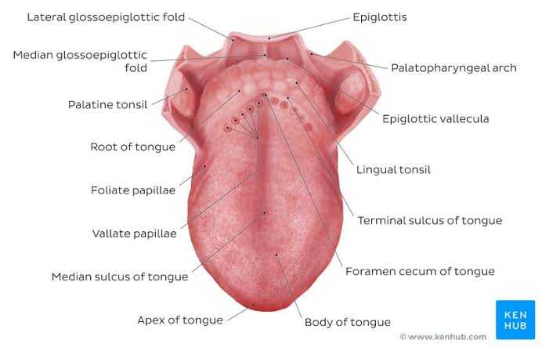
STRUCTURE OF THE HUMAN TONGUE

MUSCLES OF THE TONGUE
The eight muscles of the tongue are classified as either intrinsic or extrinsic.
Extrinsic muscles
The four extrinsic muscles originate from bone and extend to the tongue. They are the genioglossus, the hyoglossus (often including the chondroglossus), the styloglossus, and the palatoglossus. Their main functions are altering the tongue’s position allowing for protrusion, retraction, and side-to-side movement.
- The genioglossus arises from the mandible and protrudes the tongue. It is also known as the tongue’s “safety muscle” since it is the only muscle that propels the tongue forward.
- The hyoglossus arises from the hyoid bone and retracts and depresses the tongue. The chondroglossus is often included in this muscle.
- The styloglossus arises from the styloid process of the temporal bone and draws the sides of the tongue up to create a trough for swallowing.
- The palatoglossus arises from the palatine aponeurosis, and depresses the soft palate, moves the palatoglossal fold towards the midline, and elevates the back of the tongue during swallowing.

Intrinsic muscles
Four paired intrinsic muscles of the tongue originate and insert within the tongue, running along its length. They are the superior longitudinal muscle, the inferior longitudinal muscle, the vertical muscle, and the transverse muscle. These muscles alter the shape of the tongue by lengthening and shortening it, curling and uncurling its apex and edges as in tongue rolling, and flattening and rounding its surface. This provides shape and helps facilitate speech, swallowing, and eating.
- The superior longitudinal muscle runs along the upper surface of the tongue under the mucous membrane, and elevates, assists in retraction of, or deviates the tip of the tongue. It originates near the epiglottis, at the hyoid bone, from the median fibrous septum.
- The inferior longitudinal muscle lines the sides of the tongue, and is joined to the styloglossus muscle.
- The vertical muscle is located in the middle of the tongue, and joins the superior and inferior longitudinal muscles.
- The transverse muscle divides the tongue at the middle, and is attached to the mucous membranes that run along the sides.

VASCULATURE OF THE TONGUE
Arterial supply
The tongue receives its blood supply primarily from the lingual artery, a branch of the external carotid artery. On entering the tongue, the lingual artery passes deep to the hyoglossus muscle and gives rise to:
- The dorsal lingual arteries supply the posterior part (root).
- The deep lingual arteries supply the anterior part.
- The floor of the mouth also receives its blood supply from the lingual artery.
The deep lingual arteries communicate with each other near the apex of the tongue.
The dorsal lingual arteries are prevented from communicating by the lingual septum.
There is also a secondary blood supply to the root of the tongue from the tonsillar branch of the facial artery and the descending pharyngeal artery.
Venous drainage
The veins of the tongue are the dorsal lingual veins, which accompany the lingual artery.
- The deep lingual veins which begin at the apex of the tongue run posteriorly beside the lingual frenulum to join the sublingual vein.
- All these veins terminate, directly or indirectly in the Internal Jugular Vein (IJV).
Lymphatic drainage
- Lymph from the posterior one-third drains to the jugulo-omohoid nodes
- Lymph from the medial part of the anterior two-thirds drains directly to the inferior deep cervical lymph nodes
- Lymph from the lateral parts of the anterior two-thirds drains to the submandibular lymph nodes
- The apex and frenulum drain to the submental nodes
- The posterior third and the medial part of the anterior two-thirds drain bilaterally.
Nerve supply
Innervation of the tongue consists of motor fibers, special sensory fibers for taste, and general sensory fibers for sensation.
MOTOR INNERVATION:
- Motor supply for all intrinsic and extrinsic muscles of the tongue is supplied by efferent motor nerve fibers from the hypoglossal nerve (CN XII), with the exception of the palatoglossus, which is innervated by the vagus nerve (CN X) of the pharyngeal plexus.
SENSORY INNERVATION:
Innervation of taste and sensation is different for the anterior and posterior part of the tongue because they are derived from different embryological structures (pharyngeal arch 1 and pharyngeal arches 3, 4 respectively).
The anterior two-thirds of the tongue (anterior to the vallate papillae):
- Taste: Chorda tympani branch of the facical nerve (CN VII) via special visceral afferent fibers.
- Sensation: Lingual branch of the mandibular (V3) division of the trigeminal nerve (CN V) via general visceral afferent fibers

The posterior one-third of the tongue:
- Taste and sensation: Glossopharyngeal nerve (CN IX) via a mixture of special and general afferent fibers
The base of the tongue:
- Taste and sensation: Internal branch of the superior laryngeal nerve (itself a branch of the vagus nerve, CN X)

CLINICAL SIGNIFICANCE OF THE TONGUE
Disease
Ankyloglossia (A.K.A tongue-tie): The tongue is tied to the floor of the mouth by a very short, thickened lingual frenulum and interferes with tongue movements and may affect speech. In unusual cases, a frenectomy (surgical procedure of cutting the frenulum) in infants may be necessary to free the tongue for normal movement and speech.
Thyroglossal Duct Cyst: A cystic remnant of the thyroglossal duct, associated with development of the thyroid gland, may be found in the root of the tongue and connected to a sinus that opens at the foramen cecum. Surgical excision of the cyst may be necessary. Most thyroglossal duct cysts are in the neck, close or just inferior to the body of the hyoid bone.
Halitosis (A.K.A bad breath) resulting from the formation of a visible whitish-colored coating by food debris, desquamated epithelial cells and bacteria which can be managed by using a tongue cleaner.
Medication delivery
The sublingual region underneath the front of the tongue is an ideal location for the administration of certain medications into the body. The oral mucosa is very thin underneath the tongue, and is underlain by a plexus of veins. The sublingual route takes advantage of the highly vascular quality of the oral cavity, and allows for the speedy application of medication into the cardiovascular system, bypassing the gastrointestinal tract. This is the only convenient and efficacious route of administration (apart from intravenous therapy) of nitroglycerin to a patient suffering chest pain from angina pectoris.
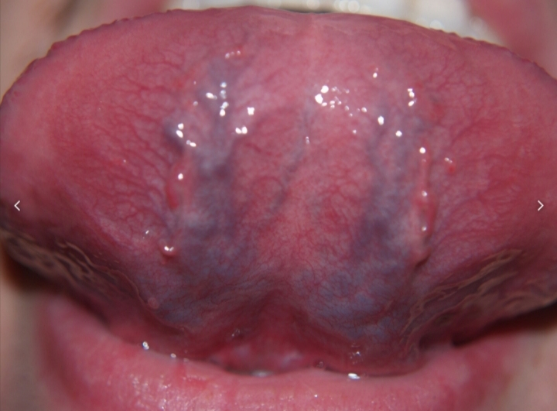
THE UNDERSIDE OF A HUMAN TONGUE, SHOWING ITS RICH BLOOD SUPPLY.

THE AIR (PARANASAL) SINUSES
The paranasal sinuses are air-filled extensions of the respiratory tract of the nasal cavity. There are four paired sinuses, named according to the bone in which they are located; maxillary, frontal, sphenoid and ethmoid.
It is thought that the sinuses may contribute to the humidifying of the inspired air. They also reduce the weight of the skull.
Sinuses are formed in childhood by the nasal cavity eroding into surrounding bone. As they are outgrowths of the nasal cavity, they all drain back into it – openings to the paranasal sinuses are found on the roof and lateral walls of the nasal cavity. The inner surface is lined by a respiratory muscosa.

FRONTAL SINUSES: These are the most superior in location, found under the forehead. The frontal sinuses are variable in size, but always triangular-shaped. They drain into the nasal cavity via the frontonasal duct, which opens out at the hiatus semilunaris on the lateral wall.

SPHENOID SINUSES: The sphenoid sinuses also lie relatively superiorly, at the level of the spheno-ethmoidal recess. They are found more posteriorly, and are related superiorly and laterally to the cranial cavity. The sphenoid sinuses drain out onto the roof of the nasal cavity. The relationships of this sinus are of clinical importance – the pituitary gland can be surgically accessed via passing the nasal roof, into the sphenoid sinus and through the sphenoid bone.

ETHMOID SINUSES: There are three ethmoidal sinuses; anterior, middle and posterior. They empty into the nasal cavity at different places:
- Anterior sinus – Hiatus semilunaris
- Middle sinus – Ethmoid bulla
- Posterior sinus – Superior meatus.

MAXILLARY SINUSES: The largest of the sinuses. It is located laterally and slightly inferiorly to the nasal cavities. It drains into the nasal cavity at the hiatus semilunaris, underneath the frontal sinus opening. This is a potential pathway for the spread of infection – fluid draining from the frontal sinus can enter the maxillary sinus.

CLINICAL RELEVANCE OF THE PARANASAL SINUSES
SINUSITIS: As the paranasal sinuses are continuous with the nasal cavity, an upper respiratory tract infection can spread to the sinuses. Infection of the sinuses causes inflammation (particularly pain and swelling) of the mucosa, and is known as sinusitis.
The maxillary nerve supplies both the maxillary sinus and maxillary teeth, and so, inflammation of that sinus can present with toothache.

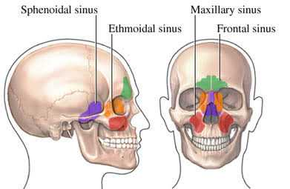
DIAGRAM SHOWING THE AIR SINUSES ON THE BONES OF THE HUMAN SKULL

