Rufus-Jegede Opemipo
GROUP 1
17/MHS01/289
Nursing Science
PHA 324

- Classify the antimalarial agents and state the mechanism of each class of drug listed

Antimalarial drugs have a variety of targets and mechanisms of action. Many, like chloroquine, amodiaquine, mefloquine, and quinine act on heme in the parasitic food vacuole. In this way, they prevent the polymerization of hemoglobin, which can be toxic to the plasmodium parasite. Others are folate antagonists. Some of the drugs in this class, like pyrimethamine and proguanil, are selective inhibitors of parasitic dihydrofolate reductase, whereas the sulfonamides and sulfones are PABA antagonists and inhibit dihydropteroate synthetase. A third group of antimalarials, such as artemether, produces free radicals that destroy the malaria parasite or inhibit parasitic electron transport. Primaquine may also generate reactive oxygen species that may interfere with electron transport in the parasite. Finally, there are antibiotics, such as doxycycline, that selectively inhibit protein synthesis in the parasite

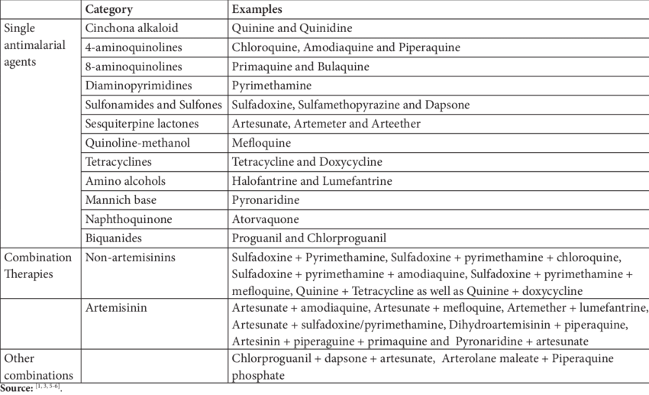

- Chlorquine and other similar quinolones (e.g. hydroxychloroquine, quinine) become concentrated in parasite food vacuoles, preventing the polymerization of the hemeoglobin product, heme, into hemozoin and thus eliciting parasite toxicity due to the build up of heme (see Figure 1).
It is not active against liver stage parasites (and primaquine must be added for the radical cure of these species).
Malarial parasites have a limited ability to synthesize amino acids, and rely upon amino acids obtained by the breakdown of host hemoglobin molecules in digestive vacuoles (Figure 1). Degradation of hemoglobin releases both amino acids as well as a toxic heme metabolite ferriprotoporphyrin IX, which is normally detoxified by a pH-dependent polymerization to an unreactive malarial pigment named hemozoin (Figure 6). When polymerization of ferriprotoporphyrin IX is inhibited, its increased concentration in the parasites food vacuole will cause oxidative damage to membranes and death of the parasite.

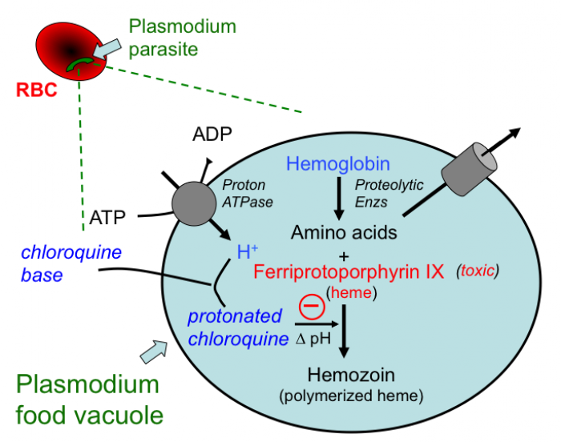

- Quinine (& Quinidine): Its precise mechanism as an antimalarial is poorly understood.
In Plasmodium falciparum quinine has been found to inhibit nucleic acid synthesis, protein synthesis, and glycolysis; it also binds with hemazoin in parasitized erythrocytes.
Quinine is effective as a malarial suppressant and in control of overt clinical attacks. Its primary action is schizontocidal, no lethal effect is exerted on sporozoites or pre-erythrocitic tissue forms.
Quinine blocks cardiac K & Na channels similar to quinidine.

- Primaquine: Its precise mechanism as an antimalarial is poorly understood.
In Plasmodium falciparum quinine has been found to inhibit nucleic acid synthesis, protein synthesis, and glycolysis; it also binds with hemazoin in parasitized erythrocytes.
Quinine is effective as a malarial suppressant and in control of overt clinical attacks. Its primary action is schizontocidal, no lethal effect is exerted on sporozoites or pre-erythrocitic tissue forms.
Quinine blocks cardiac K & Na channels similar to quinidine.
- Mefloquine: Unknown, chemically related to quinidine. Has strong blood schizonticidal activity against P. falciparum and P. vivax, but not against hepatic stages or gametocytes.

- Pyrimethamine + Sulfadoxine: Folic acid antagonists. The rationale for there combination is a synergistic effect to inhibit folic acid synthesis, and a differential requirement between host and parasite for nucleic acid precursors involved in growth.
This activity is highly selective against plasmodia and Toxoplasma gondii.
Pyrimethamine is chemically related to trimethoprim. It acts slowly against erythrocytic forms of susceptible strains of all four human malaria species. It is not adequately gametocidal or effective against liver stages.

- Artesunate & Artemether: Produces a free radical when it undergoes an iron-catalyzed cleavage of an endoperoxide bond in the parasite food vacuole.
It is a rapidly acting blood schizonticide, with some activity against gametocytes, but no activity against the hepatic stages of the malarial parasite

