Name: Obiadi Ginika
Department: Anatomy
Matric No: I8/MHS03/009
Course Code: ANA 212
Course Title: Gross Anatomy of the Pelvic and Perineum
Assignment Title: Female Perineum
Question
Write on the following:
With the aid of diagram, discuss the gross anatomy of the female external genitalia.

Female External Genitalia
Are parts of the female reproductive system, and include; mons pubis, labia majora, labia minora, clitoris, vestibule, hymen, vestibular, hymen, vestibular glands etc. Components of the external female genitalia occupy a large part of the female perineum and together they are called the vulva. The functions of the female external genitalia are many, such as reproduction and sexual pleasure, parturition and the protection of the internal of the internal genital organs.
Structure and functions:
Mons Pubis
The mons pubis is a tissue mound made up of fat located directly anterior to the pubic bones. This mound of tissue is prominent in females and is usually covered in pubic hair. The mons pubis functions as a source of cushioning during sexual intercourse. The mons pubis also contains sebaceous glands that secrete pheromones to induce sexual attraction.
Labia Majora
The labia majora are a prominent pair of cutaneous skin folds that will form the lateral longitudinal borders of the vulval clefts. The labia majora form the folds that cover the labia minora, clitoris, vulva vestibule, vestibular bulbs, Bartholin's glands, Skene's glands, urethra, and the vaginal opening. The anterior part of the labia majora folds comes together to form the anterior labial commissure directly beneath the mons pubis. While the posterior part of the labia majora comes together to form the posterior labial commissure. The labia majora engorges with blood and appears edematous during sexual arousal.
Labia Minora
The labia minor are a pair of small cutaneous folds that begins at the clitoris and extends downward. The anterior folds of the labia minora encircle the clitoris forming the clitoral hood and the frenulum of the clitoris. Then the labia minor descend obliquely and downward forming the borders of the vulva vestibule. Eventually, posterior ends of the labia minora terminate as they become linked together by a skin fold called the frenulum of the labia minora. The labia minora will encircle the vulva vestibule and terminating between the labia majora and the vulva vestibule. With sexual arousal, the labia minora will become engorged with blood and appear edematous. It is also known as smaller lips.
Clitoris
The clitoris is a sex organ in females that functions as a sensory organ. The clitoris can be divided into the glans clitoris and the body of the clitoris. The underlying tissue that makes the clitoris is the corpus cavernous. The corpus cavernous is a type of erectile tissue that merges together and protrudes to the exterior of the vulva as the glans clitoris. While proximally, the two separate ends of the tissue will form the crus of the clitoris (legs of the clitoris) and the body of the clitoris. The glans clitoris is the only visible part of the clitoris. The glans clitoris is highly innervated by nerves and perfused by many blood vessels. It is estimated that glans clitoris is innervated by roughly eight thousand nerve endings. Since the glans clitoris is so highly innervated, it becomes erected and engorged with blood during sexual arousal and stimulation.
Vagina
The vagina is an elastic, muscular tube connected to the cervix proximally and extends to the external surface through the vulva vestibule. The distal opening of the vagina is usually partially covered by a membrane called the hymen. The vaginal opening is located posterior to the urethra opening. The function of the vagina is for sexual intercourse and childbirth. During sexual intercourse, the vagina acts as a reservoir for semen to collect before the sperm ascending into the cervix to travel towards the uterus and fallopian tubes. Also, the vagina also acts as an outflow tract for menses.
Urethra
The urethra is an extension of a tube from the bladder to the outside of the body. The purpose of the urethra is for the excretion of urine. The urethra in females opens within the vulva vestibule located inferior to the clitoris, but superior to the vagina opening.
Bartholin's Glands
The Bartholin's glands also known as the greater vestibular glands are two pea-sized glands located slightly lateral and posterior to the vagina opening. These two glands function to secrete a mucus-like substance into the vagina and within the borders of the labia minora. This mucus functions as a lubricant to decrease friction during intercourse and a moisturizer for the vulva.

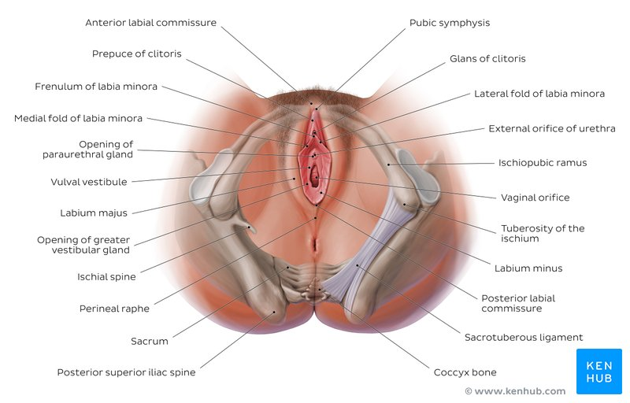

Blood Supply:
Arterial Supply
The internal pudendal artery perfuses the majority of the external female genitalia. The internal pudendal artery is a branch of the internal iliac artery. Once the pudendal artery branches from the internal iliac artery, it descends towards the external genitalia. The internal pudendal artery will then become the dominant blood supply to the female external genitalia. The labia majora also received blood from the superficial external pudendal artery. The superficial external pudendal artery is a tributary of the femoral artery.
Venous
The venous drainage of the external female genitalia is via the external and internal pudendal veins. The external pudendal vein will drain towards the great saphenous vein. The saphenous vein will drain back into the femoral vein. As the femoral vein ascends pass the inguinal ligament, it becomes the external iliac vein. While the internal pudendal vein drains back into the internal iliac vein. Both the external and internal iliac veins will ascend and merge to form the common iliac veins. The common iliac veins from both sides of the body will ascend to about the level of the fourth lumbar vertebra. At the level of the fourth lumbar vertebra, the common iliac veins merge to drain venous blood back into the inferior vena cava. The inferior vena cava will ascend towards the heart. Upon reaching the heart, the inferior vena cava drains its venous blood back into the right atrium.
Hymen
Most females (but not all) are born with a hymen, which is generally in the form of an elliptical/oval-shaped membranous ring around the vaginal orifice . The remnants of this membranous ring in adult females in known as hymenal caruncles, which appear as small thin elevations of mucous membrane around the vaginal opening. When the hymen completely covers the vaginal orifice, it is known as an imperforate hymen. An imperforate hymen may rupture naturally during various types of physical activity (aside from intercourse).
Lymphatic Drainage
Lymphatic drainage of the external female genitalia is via the superficial and deep inguinal lymph nodes. Lymph from the clitoris, vestibular bulb and anterior labia minora can alternatively drain into the internal iliac lymph nodes.
Innervations
The vulva is innervated from a variety of sources. The mons pubis and anterior labia is innervated via the anterior labial nerves, which derive from the lumbar plexus. The posterior aspect of the vulva is innervated via the pudendal nerve and its branches (posterior labial nerves), together with branches from the posterior cutaneous nerve of the thigh. Sensitive innervations to the clitoris is provided by the dorsal nerve of the clitoris.

Surgical Consideration
- Vaginoplasty
Vaginoplasty is a surgical procedure used to reconstruct or construct the vagina. Vaginoplasties are necessary for several reasons, such as pelvic organ prolapse, congenital defects, neoplasms, sex reassignments, and cosmetics. The goal of the vaginoplasty is to surgically make a vagina that is desirable for the patient.
- Labioplasty
Labioplasty is a surgical procedure with emphasize on altering the size and shape of the labia majora and labia minora. Indications for labioplasty include multiple reasons, such as congenital defects, aging, cancers, and cosmetics. The focus of this procedure is to create a more desirable appearance of the labial folds.

Clinical Significances
- Foley Catheter: One common procedure that is routinely due in healthcare is the catheterization of the female urethra. This procedure involves the introduction of a flexible tube into the urethra and securing it in place with a saline-filled balloon. This procedure is done to assist in the excretion of urine from the bladder. This method can be used to collect urine for surveillance monitoring of the amount of urine produced or to collect urine used for the analysis of other pathologies.
- Urinary Tract Infection: In urinary tract infections, the patient classically complains of dysuria, increased urination, foul-smelling urination, and cloudy urine. This condition commonly affects females due to their urethrae are shorter than males' urethrae. The short urethra in females allows the bacteria to ascend the urethra more readily, and the anatomical location of the urethra, vagina, and anus allows for cross-contamination between the vaginal and anal bacteria into the urethra. The most common bacteriologic etiology of urinary tract infections is gram-negative rods, with the most common bacteria
- Haemophilus ducreyi: Infection of the vulva region may manifest as a rash or ulcer-like lesion. One bacteria that present as an ulcerative lesion is Haemophilus ducreyi also known as chancroid. This bacteria causes painful ulcerative lesions described as having irregular, jagged borders with exudative drainage. This condition also presents with inguinal adenopathy. The treatment for this infection is third-generation cephalosporins, macrolides, or fluoroquinolones.
- Lichen simplex chronicus: In lichen simplex chronicus, the vulvar region undergoes hyperplasia of the epithelium. This condition presents as a thick, leathery vulvar skin due to chronic scratching and rubbing. This condition is not associated with an increased risk of cancer.

