Name: Ayemobuwa Omotayo
Matric Number: 17/MHS03/007
Course Name: ANIMAL HANDLING AND COMPARATIVE MAMMALIAN GROSS ANATOMY
Course Code: ANA 314
Assignment Title: ASSIGNMENT
- Comparative anatomy is an important tool that helps determine evolutionary relationships between organisms and whether or not they share common ancestors. However, it is also important evidence for evolution. Anatomical similarities between organisms support the idea that these organisms evolved from a common ancestor.

- HOMOLOGOUS STRUCTURES: These are structures that are similar in two organisms because they have a common ancestor. These structures may or may not have similar functions. For example, birds, humans, bats, and even whales all have a similar arm bone structure. New species were created, and even newer species evolved from those species. However, the arm bone structure was advantageous to all the species, and so it remained in all the descendant species. Now, although we all look different, birds, bats, whales and humans all retain the arm bone structure from our ancestors.
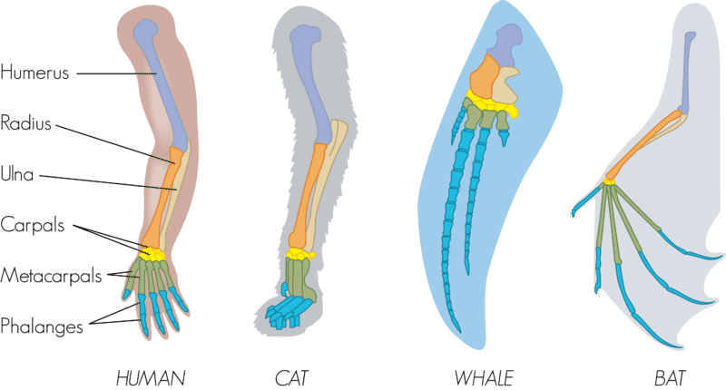

- ANALOGOUS STRUCTURES: These are the opposite of homologous structures. Analogous structures are anatomical features of two species that look similar, or serve the same purpose, but the species are not closely related. For example, the wings of bats and birds, shown in the picture below, look similar on the outside. They also have the same function. However, wings evolved independently in the two groups of animals. This is apparent when you compare the pattern of bones inside the wings. 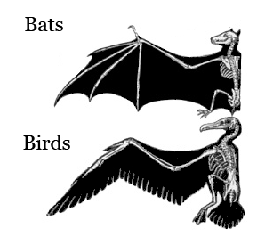
- VESTIGIAL STRUCTURES: Structures like the human tail bone and whale pelvis are called vestigial structures. Evolution has reduced their size because the structures are no longer used. The human appendix is another example of a vestigial structure. It is a tiny remnant of a once-larger organ. In a distant ancestor, it was needed to digest food. It serves no purpose in humans today.

