Gross Anatomy of the Head and neck
Name: Ayenor Eruvwuhoghene Christabel
Matric no: 17/Mhs01/076
1.) Discuss the Anatomy of the tongue and comment on its applied anatomy
Introduction
The tongue is a muscular organ in the mouth. It is also a unique organ located in the oral cavity that not only facilitates the perception of gustatory stimuli but also plays important roles in mastication and deglutition. It is an integral component of speech pathway, as it helps with articulation. The tongue has 2 surfaces, the Dorsal or Superior face and the Ventral or Inferior surface. It is covered with moist, pink tissue called mucosa. It is sensitive and kept moist by saliva and is richly supplied with nerves and blood vessels. The tiny bumps called the Papillae give the tongue its rough texture. Thousands of taste buds cover the surfaces of the papillae. The taste buds are collections of nerve-like cells that connect to nerves running into the brain. The tongue is anchored to the mouth by webs of tough tissue and mucosa. The tether holding down the front of the tongue is called the frenum. In the back of the mouth, the tongue is anchored into the hyoid bone.
The four common tastes are sweet, sour, bitter, and salty. A fifth taste, called umami, results from tasting glutamate (present in MSG). The tongue has many nerves that help detect and transmit taste signals to the brain.
Relations of the tongue
- Anteriorly and Laterally- Teeth
- Superiorly- Hard and Soft palates
- Inferiorly- Mucosa of the floor of the oral cavity, Sublingual Salivary glands, Posterior wall of oropharynx
- Posteriorly- Epiglottis, Pharyngeal inlet
- Laterally- Palatoglossal and palatopharyngeal arches
The tongue is divided into three main parts which are:
- The tip or apex; This is the most anterior and most mobile aspect of the organ.
- Body; This has a rough dorsal (superior) surface that abuts the palate and is populated with taste buds and lingual papillae and a smooth ventral(inferior) surface that is attached to the floor of the oral cavity by the lingual frenulum.
- Base; This is the most posterior part of the organ. It is populated by numerous lymphoid aggregates known as the lingual tonsils along with foliate papillae along the posterolateral surface
Anatomy of the Tongue
Anterior two thirds
The presulcal tongue includes the apex and body of the organ. It terminates at the sulcus terminalis; which can be seen extending laterally in an oblique direction from the foramen cecum towards the palatoglossal arch. The mucosa of the dorsal surface of the oral tongue is made up of circumvallate, filiform, and fungiform papillae. There is also a longitudinal midline groove running in an anteroposterior direction from the tip of the tongue to the foramen cecum. This marks the embryological point of fusion of the lateral lingual swellings that formed the oral tongue. It also represents the location of the median lingual (fibrous) septum of the tongue that inserts in the body of the hyoid bone. On the lateral surface of the oral tongue are foliate papillae arranged as a series of vertical folds. The ventral mucosa of the oral tongue is comparatively unremarkable. It is smooth and continuous with the mucosa of the floor of the mouth and the inferior gingiva. The lingual veins are relatively superficial and can be appreciated on either side of the lingual frenulum. Lateral to the lingual veins are pleated folds of mucosa known as the plica fimbriata. They are angled anteromedially toward the apex of the tongue. This part of the tongue receives general sensory innervation from the lingual nerve and taste sensation from the chorda tympani.
Posterior third
The remainder of the tongue that lies posterior to the sulcus terminalis is made up by the base of the organ. It lies behind the palatoglossal folds and functions as the anterior wall of the oropharynx. Unlike the oral tongue, the pharyngeal tongue does not have any lingual papillae. Instead, its mucosa is populated by aggregates of lymphatic tissue known as the lingual tonsils. The mucosa is also continuous with the mucosa of the laterally located palatine tonsils, the lateral oropharyngeal walls, and the posterior epiglottis and glossoepiglottic folds. This part of the tongue and the Vallate papillae receive both general and taste innervation from the glossopharyngeal nerve
Lingual Papillae of the tongue:- These are small, nipple-shaped projections on the anterior two-thirds of the dorsum of the tongue. Its divided into:
- Vallate Papillae:- They are arranged in the form of a V in front of the sulcus terminalis. They are studded with numerous taste buds and are innervated by the glossopharyngeal nerve
- Fungiform Papillae: They are mushroom shaped projections with red heads and are scattered on the sides and the apex of the tongue
- Filiform Papillae:- Are numerous, slender, conical projections that are arranged in rows parallel to the sulcus terminialis.
- Foliate Papillae:- Are found in certain animals but are rudimentary in humans
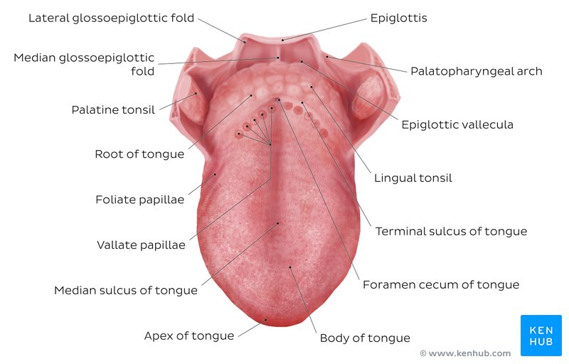
DIAGRAM OF LINGUAL PAPILLAE

Muscles of the tongue
- Intrinsic Muscles
The intrinsic tongue muscles operate independently or sometimes in combination with each other to give rise to numerous shapes. The intrinsic muscles only attach to other structures in the tongue. There are four paired intrinsic muscles of the tongue and they are named by the direction in which they travel:
- The superior longitudinal muscles:- They are made up of a thin layer of muscle fibers traveling in a mixture of oblique and longitudinal axes just deep to the superior mucosal surface of the organ. The fibers arise from the median fibrous septum and the fibrous layer of submucosa from the level of the epiglottis. They insert along the lateral and apical margins of the organ. These muscles are responsible for retracting and broadening the tongue and elevating the tip of the tongue.
- Vertical muscles of the tongue:- They lie deep to the superior longitudinal muscles. They arise from the root of the organ and genioglossus muscle and insert into the median fibrous septum. These muscles facilitate flattening and widening of the tongue
- Transverse muscles:- They lie deep to the ventral muscles and take a lateral route and extend from either side of the median lingual septum (origin) to the fibrous submucosa along the lateral margins of the tongue (insertion). As these muscles contract, they cause the tongue to narrow and elongate.
- Inferior longitudinal muscles:- They travel above the ventral submucosa of the tongue. The fibres travel between hypoglossus and genioglossus as it arises from the base of the tongue and body of the hyoid bone and is joined. The fibres end in the apex of the tongue, allowing the muscle to pull the tip of the tongue inferiorly and shortening the organ. These muscles affect the shape and size of the tongue – for example, in tongue rolling – and have a role in facilitating speech, eating, and swallowing. It is innervated by hypoglossal nerve and its supplied by lingual branch
Motor innervation for the intrinsic muscles of the tongue is via the hypoglossal nerve (CNXII) and they are supplied by the lingual branch of external carotid artery.
- Extrinsic Muscles
There are four pairs extrinsic muscles, the styglossus and palatoglossus arise from above while the genioglossus and Hyoglossus arise from below. The extrinsic muscles play an important role in pressing and molding the food bolus in preparation for the initial phase of swallowing. They are also used to move the bolus posteriorly into the oropharyngeal inlet and they are as follows:
- Genioglossus:- It is also known as the tongue’s ‘’safety muscle’’ since it is the only muscle that propels the tongue forward.
- Attachments: Arises from the mandibular symphysis and inserts into the body of the hyoid bone and the entire length of the tongue.
- Function: Inferior fibres protrude the tongue, middle fibres depress the tongue, and superior fibres draw the tip back and down
- Blood Supply: It is supplied by the Sublingual branch of lingual artery and submental branch of facial artery.
- Hyoglossus:- It is often accompanied by chondroglossus, which may sometimes be considered as part of the hyoglossus and it arises form the base of the lesser cornu of the hyoid bone
- Attachments: Arises from the body and greater horn of the hyoid bone as a slender, quadrilateral muscle and inserts into the side of the tongue, i.e., the inferior/ventral pats of lateral tongue
- Function: Depresses and retracts the tongue
- Blood Supply: Sublingual branch of lingual artery and submental branch of facial artery
- Styloglossus:- This is the smallest and shortest of the three styloid muscles
- Attachments: Originates at the anterolateral aspect of styloid process of the temporal bone, stylomandibular ligament and for its insertion, it longitudinal part blends with inferior longitudinal muscle and it oblique part blends with hypoglossus muscle.
- Function: Retracts and elevates the tongue
- Blood Supply: Sublingual branch of lingual artery
- Palatoglossus
- Attachments: Arises from the palatine aponeurosis of soft palate and inserts broadly across the tongue at the lateral margins of the tongue and blends with intrinsic muscles of the tongue.
- Function: Elevates the posterior aspect or the root of the tongue and it acts as a sphincter at the oropharyngeal isthmus by preventing food from moving cranially during swallowing
- Innervation: Motor innervation via the vagus nerve (CNX).
- Blood Supply:- Ascending palantine branch of facial artery, ascending pharyngeal artery
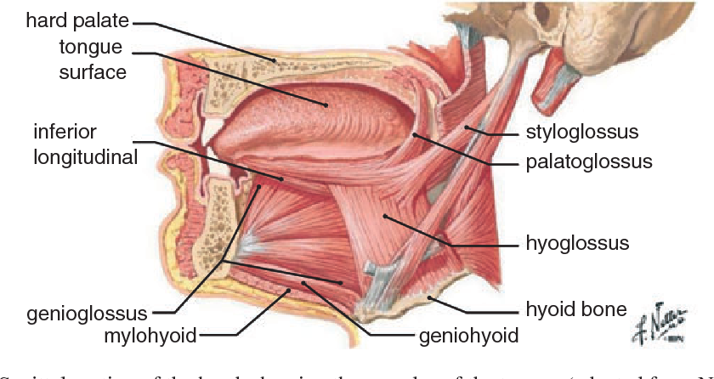
Diagram of the Muscles of the Tongue
All of the intrinsic and extrinsic muscles are innervated by the hypoglossal nerve (CN XII), except palatoglossus, which has vagal innervation (CN X). There are other muscles in the tongue which are the Glossopharyngeus muscle, which is a muscle arising from the tongue and inserting in the pharynx and the Hypoglossus muscle which is originating from the hyoid bone and inserting into the tongue.

Applied Anatomy
- Thrush (candidiasis): Candida albicans (a yeast) grows over the surface of the mouth and tongue. Thrush can occur in almost anyone, but it occurs more often in people taking steroids or with suppressed immune systems, the very young, and the elderly.
- Oral cancer: A growth or ulcer appears on the tongue and grows steadily. Oral cancer is more common in people who smoke and/or drink alcohol heavily.
- Macroglossia (big tongue): This can be broken down into various categories based on the cause. These include congenital, inflammatory, traumatic, cancerous, and metabolic causes. Thyroid disease, lymphangiomas, and congenital abnormalities are among some of the causes of an enlarged tongue.
- Geographic tongue: This is also known as Migratory Glossitis. Ridges and colored spots migrate over the surface of the tongue, periodically changing its appearance. Geographic tongue is a harmless condition.
- Burning mouth/burning tongue syndrome: This is a relatively common problem. The tongue feels burned or scalded, or strange tastes or sensations develop. Apparently harmless, burning mouth syndrome may be caused by a mild nerve problem.
- Atrophic glossitis (bald tongue): The tongue loses its bumpy texture, becoming smooth. Sometimes this is due to anemia or a B vitamin deficiency.
- Canker sores (aphthous ulcers): Small, painful ulcers appear periodically on the tongue or mouth. A relatively common condition, the cause of canker sores is unknown; they are unrelated to the cold sores caused by herpes viruses. Canker sores are not contagious.
- Oral leukoplakia: White patches appear on the tongue that can’t be scraped off. Leukoplakia may be benign, or it can progress to oral cancer.
- Hairy tongue: Papillae can overgrow the surface of the tongue, giving it a white or black appearance. Scraping off the papillae corrects this harmless condition.
- Herpes stomatitis: The herpes virus can uncommonly cause cold sores on the tongue. Herpes virus cold sores are usually on the lip.
- Lichen planus: A harmless condition that can affect the skin or the mouth. The cause is unknown; however, it is believed to be caused by the immune system attacking the skin and lining of the mouth.
- Tongue-tie (Ankyloglossia):- This is an abnormal shortness of frenulum linguae resulting in limitation of its movement and thus a severe speech impediment It can be corrected surgically by correcting the frenulum.
2.) Write an essay on the air sinuses
Air Sinuses or Paranasal sinuses are a group of four paired air-filled spaces that surround the nasal cavity. They are involved in a reduction of weight and resonance for voice. Consists of:-
a.) Ethmoidal Sinus:- These pair of sinuses are located between the eyes. It consists of numerous ethmoidal air cell, which are numerous small cavities within the ethmoidal labyrinth between the orbit and the nasal cavity. They are innervated by the ethmoidal nerves, which branch from the nasociliary nerve of the trigeminal nerve. It can be subdivided into the following
i.) Posterior ethmoidal air cells, drain into the superior nasal meatus
ii.) Middle ethmoidal air cells, drain into the summit of the ethmoidal bulla of the middle nasal meatus
iii.) Anterior ethmoidal air cells, drain into the anterior aspect of the hiatus semilunaris in the middle nasal meatus.
Clinically, Ethmoidal Sinusitis is an inflammation of the ethmoidal sinuses that may erode the medial wall of the orbit, causing and orbital cellulitis that may spread to the cranial cavity.
b.) Frontal Sinus:- It is located above the eyes. It lies in the frontal bone which forms the hard part of the forehead. It opens into the hiatus semilunaris of the middle nasal meatus by way of the frontonasal duct. It is innervated by the supraorbital branch of the ophthalmic nerve. Clinically, Frontal sinusitis is an inflammation in the frontal sinus that may erode the thin bone of the anterior cranial fossa, producing meningitis or brain abscess.
c.) Maxillary Sinus:- They are located under the eyes in the maxillary bones. It also lies lateral to the lateral wall of the nasal cavity and inferior to the floor of the orbit and drains into the posterior aspect of the hiatus semilunaris in the middle nasal meatus. It is the largest of the paranasal sinuses and it is the only paranasal sinus that may be present at birth. Clinically, Maxillary Sinusitis mimics the clinical signs of maxillary tooth abscess. The infection spreads from the maxillary sinus to the upper teeth and irritate the nerves to these teeth causing toothache. It may be confused with toothache because only a thin layer of bone separates the roots of the maxillary teeth from the sinus cavity. Its innervated by the trigeminal nerve( CN Vb)
d.) Sphenoidal Sinus:- It is located behind the eyes within the body of the sphenoid bone. It opens into the sphenoethmoidal recess of the nasal cavity. It is innervated by branches from the maxillary nerve and by the posterior ethmoidal branch of the nasociliary nerve. NB:- The pituitary gland lies above this sinus and can be reached by the transsphenoidal approach, which follows the nasal septum through the body of the sphenoid. Care must be taken not to damage the cavernous sinus and the internal carotid artery. Clinically, Sphenoidal Sinusitis is an infection in the sphenoidal sinus that may spread, may come from the nasal cavity or from the nasopharynx and may erode the sinus walls to reach the cavernous sinuses, pituitary gland, optic nerve or brain stem. Close relationships of the sphenoidal sinus with other surrounding structures are clinically important because of potential injury during pituitary surgery and the possible spread of infection to other structures.