Name : Amao Gabriel
Matric number: 17/mhs01/058
Medicine and Surgery
ANA 301: Gross Anatomy of Head and Neck
TONGUE
It is attached by muscles of the hyoid bone, mandible, styoid process, palate and pharynx. It is divide by a V shaped sulcus terminalis into parts. An anterior one thirds and a posterior one third which differ developmentally, structurally and in innervation.
- The Lingual papillae of the tongue.
They are small, nipple-shaped projection on the anterior two thirds of the dorsum of the tongue. They are divided into the vallate, fungiform, filiform and foliate papillae.
The vallate papillae are arranged in front of the sulcus terminalis and are studded with numerous taste buds and are innervated by the glossopharyngeal nerve.
The fungiform papillae are mushroom shaped projections with red heads and are scattered on the sides and apex of the tongue.
The filiform papillae are numerous, slender, conical projections that are arranged in rows parallel to the sulcus terminalis.
The foliate papillae are found in certain animals but are rudimentary in humans.
- The lingual tonsil
It is the collection of nodular masses of lymphoid follicles on the posterior one third of the dorsal of the tongue.
- Lingual innervation
The extrinsic and intrinsic muscles of the tongue are innervated by the hypoglossal nerve except for thr palatoglossus, which is innervated by the vagus nerve. A lesion of the hypoglossal nerve deviates the tongue toward the injured side.
- Lingual artery
It arises from the external carotid artery at the level of the tip of the greater horn of the hyoid bone the carotid triangle. It passes deep to thehyoglossus and lies on the middle pharyngeal contrictor muscles. It gives rise to the suprahyoid, dorsal lingual and sublingual arteries and terminates as the deep lingual artery, which ascends between the inferior longitudinal muscles.

DEVELOPMENT OF THE TONGUE
The anterior two thirds of the tongue
The anterior two thirds of the tongue develop from one median lingual swelling (tongue bud) and two lateral lingual swellings ( tongue bud) in the pharyngeal arch. Overgrowth of the lateral swellings forms the anterior two thirds of the tongue.
The anterior two thirds of the tongue receives general sensation (GSA) carried by the lingual branch of CN V and taste sensation carried by the chorda tympani branch of CN VII

The posterior one third of the tongue
The posterior one third of the tongue develops from the copula or hypobranchail eminence that is formed by mesoderm of the pharyngeal arches 3and 4.
The posterior one third of the tongue receives general sensation and taste sensation carried by CN IX.

MUSCLES OF THE TONGUE
Intrinsic and extrinsic muscles (styloglossus, hyoglossus, genioglossus and palatoglossus) are derived from myoblasts that migrate to the tongue region from occipital somites. Motor innervation is supplied by CN XII, except for the palatoglossus muscle, which is innervated by CN X.
Muscles of the tongue are innervate by the hypoglossal nerve except the palatoglossus, which is innervated by the vagus nerve. The anterior two third of the tongue is innervated by the lingual nerve for general sensation and by chorda tympani of the facial nerve for taste (SVA) sensation. The posterior one third of the tongue is supplied by the glossopharyngeal nerve for both general and taste sensations.
Muscle | Origin | Insertion | Nerve action
Styloglossus  Hyoglossus  Genioglossus  Palatoglossus | Styloid process  Body and greater horn of hyoid bone  Genial tubercle of the mandible Aponeurosis of the soft palate | Side and inferior aspect of the tongue  Side and inferior aspect of the tongue  Inferior aspect of tongue; body of hyoid bone  Dorsolateral side of the tongue | Hypoglossal nerve – retract and elevate the tongue  Hypoglossal nerve- depresses and retract the tongue  Hypoglossal nerve – protrudes and depresses tongue  Vagus nerve via pharyngeal plexus – elevate the tongue

Clinical correclate
- TONGUE-TIE (ankyloglossia): is an abnormal shortness of frenulum linguae, resulting in limitation of its movement and thus a severe speech impediment. It can be corrected surgically cutting the frenulum.
- The tongue tends to fall posteriorly, thus obstructing the airway. Paralysis or total relaxation of the genioglossus muscle presents a risk of suffocation, which can occur during general anesthesia. An artificial airway is made using intubation, which prevents the tongue from falling backward and blocking the airway.
Ludwig angina infection, once established, evolves to include the tongue. The tongue may enlarge to two or three times its usual size and tends to distend posteriorly into the hypopharynx, superiorly against the palate, and anteriorly out of the oral cavity. Any immediate posterior extension of this process will ultimately involve the epiglottis. The styloglossus muscle creates the connection between the submandibular parapharyngeal spaces, otherwise known as the buccopharyngeal gap, as it leaves the tongue and passes in between the middle and superior constrictor muscles before attaching to the styloid process. Cellulitis of the submandibular space may spread into the pharyngeal space and, from there, into the retropharyngeal space of the mediastinum.
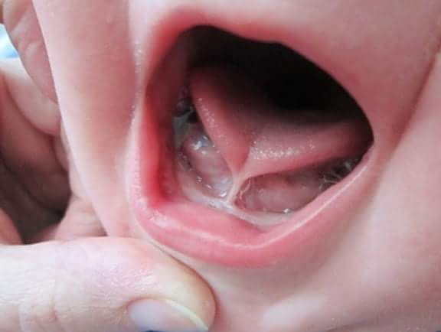
Ankyloglossia or tongue-tie occurs due to an abnormal length of the frenulum linguae which causes limited manipulation of the tongue during speech and results in a speech impediment. In the most common form of ankyloglossia, the frenulum extends to the tip of the tongue. Ankyloglossia can be corrected by surgically severing the lingual frenulum.

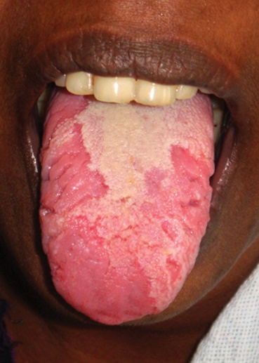
Geographic tongue or migratory glossitis is a benign, asymptomatic condition characterized by the presence of large red patches with a greyish-white border covering the dorsum of an otherwise normal tongue. It is caused by inflammation of the mucous membrane of the tongue, which results in loss of lingual papillae. The lesions are known to migrate over time. The name arises from the map-like appearance of the tongue in this condition.

WRITE AN ESSAY ON THE AIR SINUSES
The air sinus can be called the paranasal sinus. It consist of the ethmoidal, frontal, maxillary and sphenoidal sinuses. They are involve in a reduction of weight and resonance for voice.
Ethmoidal sinus
It consist of numerous ethmoidal air cells which are numerous small cavities within the ethmoid labyrinth between the orbit and the nasal cavity. Its infection may erode through the thin orbital plate of the ethmoid bone (lamina papyracea) into the orbit. It can be subdivided into the following groups
- Posterior ethmoidal air cells- it drain into the superior nasal mestus
- Middle ethmoidal air cells - it drain into the summit of the ethmoidal bulla of the middle nasal meatus.
- Anterior ethmoidal air cells – it drain into the anterior aspect of thr hiatus semilunaris at the middle nasal meatus.
Frontal sinus
It lies in the frontal bone and opens into the hiatus semilunaris of the middle nasal meatus by way of the frontonasal duct (or infidibulum). It is innervated by the supraorbital branch of the ophthalmic nerve.
Maxillary sinus
It is the largest of the paranasal air sinus it is the only paranasal sinus that may be present at birth. It lies in the maxilla on each side, lateral to the lateral wall of the nasal cavity and inferior to the floor of the orbit and drains into the posterior aspect of the hiatus semilunaris in the middle nasal meatus.
Sphenoidal sinus
It contain within the body of the sphenoidbone. It opens into the sphenoethmoidal recess of the nasal cavity. It is innervated by branches from the maxillary nerve and by the posterior ethmoidal branch of the nasociliary nerve. The pituitary gland lies above this sinus and can be reached by the transspenoidal approach which follows the nasal septum through the body of the sheniod. So care must be taken not to damage the cavernous sinus and the internal carotid artery.
CLINICAL CORRECLATE
- Ethmoidal sinusitis: it is an inflammation in the ethmoidal sinuses that may erode the medial wall of the orbit, causing an orbital that may spread to the cranial cavity.
- Frontal sinusitis: it is an inflammation in the frontal sinus that may erode the thin bone of the anterior cranial fossa, producing meningitis or brain abscess
- Maxillary sinusitis: mimics the clinical signs of the maxillary tooth abscess. In most cases, it is related to an infected tooth. Infection may spread from the maxillary sinus to the upper teeth and irritate the nerves to these teeth, causing toothache. It maybe confused with toothache because only a thin layer of bone seperates the roots of the maxillary teeth from the sinus cavity.
- Sphenoidal sinusitis: is an infection in the sphenoidal sinus that may spread. It msy come from the nasal cavity or from thr nasopharynx nad may erode the sinus walls to reach the cavernous sinuses, pituitary gland, optic nerve or brainstem. Close relationships of the sphenoidal sinus from other surrounding structures are climically important because of potential injury during pituitary surgery and the possible spread of infection to other structures.

