NAME: Ibezim Emily Chika
MATRIC NUMBER: 17/mhs01/143
COLEEGE: Medicine and Health Sciences
DEPARTMENT: Medicine and Surgery
COURSE TITLE: Gross Anatomy of the Head and Neck
COURSE CODE: ANA 301

QUESTION
1. Write an essay on the cavernous sinus
2. Discuss the walls of the nose.

SOLUTION
1. THE CAVERNOUS SINUS
The cavernous sinus is a paired dural venous sinus located within the cranial cavity. It is divided by septa into small ‘caves’ – from which it gets its name. It is a large channel of venous blood creating a "sinus" cavity bordered by the sphenoid bone and the temporal bone of the skull.
However, the cavernous sinus is more than just a compartment filled with venous blood; in fact, it is a complex neurovascular structure in which fibrous and adipose tissues fill the space.
Each cavernous sinus has a close anatomical relationship with several key structures in the head, and is arguably the most clinically important venous sinus.
Anatomical Location and Borders
The cavernous sinuses are located within the middle cranial fossa, on either side of the sella turcica of the sphenoid bone (which contains the pituitary gland). They are enclosed by the endosteal and meningeal layers of the dura mater.

The borders of the cavernous sinus are as follows:
Anterior – superior orbital fissure.
Posterior – petrous part of the temporal bone.
Medial – body of the sphenoid bone.
Lateral – meningeal layer of the dura mater running from the roof to the floor of the middle cranial fossa.
Roof – meningeal layer of the dura mater that attaches to the anterior and middle clinoid processes of the sphenoid bone.
Floor – endosteal layer of dura mater that overlies the base of the greater wing of the sphenoid bone.

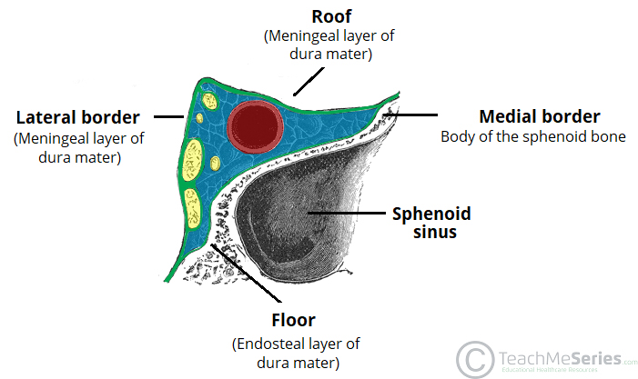
Coronal section demonstrating the borders of the right cavernous sinus.

Contents
Several important structures pass through the cavernous sinus to enter the orbit. The can be sub-classified by whether they travel through the sinus itself, or through its lateral wall:
Travels through cavernous sinus | Travels through lateral wall of cavernous sinus
Abducens nerve (CN VI) | Oculomotor nerve (CN III)
Carotid plexus (post-ganglionic sympathetic nerve fibres) | Trochlear nerve (CN IV)
Internal carotid artery (cavernous portion) | Ophthalmic (V1) and maxillary (V2) branches of the trigeminal nerve

The cavernous sinus is the only site in the body where an artery (internal carotid) passes completely through a venous structure. This is thought to allow for heat exchange between the warm arterial blood and cooler venous circulation.
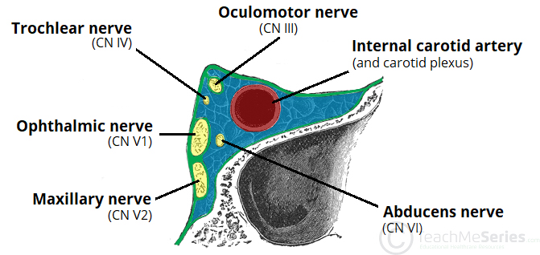
Coronal section demonstrating the contents of the right cavernous sinus.

Dural Venous Sinus System
Each cavernous sinus receives venous drainage from:
- Ophthalmic veins (superior and inferior) – these enter the cavernous sinus via the superior orbital fissure.
- Central vein of the retina – drains into the superior ophthalmic vein, or directly into the cavernous sinus.
- Sphenoparietal sinus – empties into the anterior aspect of the cavernous sinus.
- Superficial middle cerebral vein – contributes to the venous drainage of the cerebrum
- Pterygoid plexus – located within the infratemporal fossa.
It is important to note that the superior ophthalmic vein forms an anastomosis with the facial vein. Therefore, the ophthalmic veins represent a potential route by which infection can spread from an extracranial to an intracranial site.
The cavernous sinuses empty into the superior and inferior petrosal sinuses, and ultimately, into the internal jugular vein. The left and right cavernous sinuses are connected in the midline by the anterior and posterior intercavernous sinuses. They travel through the sella turcica of the sphenoid bone.
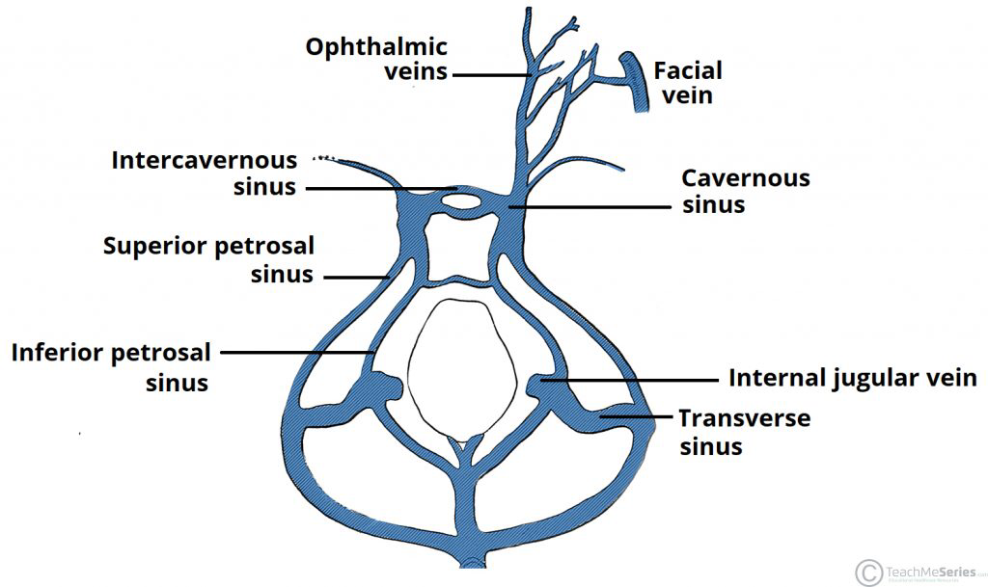
(The diagram above shows a Schematic of the dural venous system relating to the cavernous sinus also showing the anastomosis between the ophthalmic veins and the facial vein).

Clinical Significance - Cavernous Sinus Thrombosis
Cavernous sinus thrombosis (CST) refers to the formation of a clot within the cavernous sinus.
This most common cause of CST is infection; which typically spreads from an extracranial location such as the orbit, paranasal sinuses, or the ‘danger zone’ of the face. Infection is able to spread in this manner due to the anastomosis between the facial vein and superior ophthalmic veins.
Common clinical features include headache, unilateral periorbital oedema, proptosis (eye bulging), photophobia and cranial nerve palsies. The abducens nerve (CN VI) is most commonly affected.
Treatment is typically with antibiotic therapy. Where the cause is infection, thrombosis of the cavernous sinus can rapidly progress to meningitis.

2. WALLS OF THE NOSE
The nose is an olfactory and respiratory organ. It consists of the (external nose) nasal skeleton, which houses the nasal cavity. The nasal cavity is the most superior part of the respiratory tract.

NASAL CAVITY
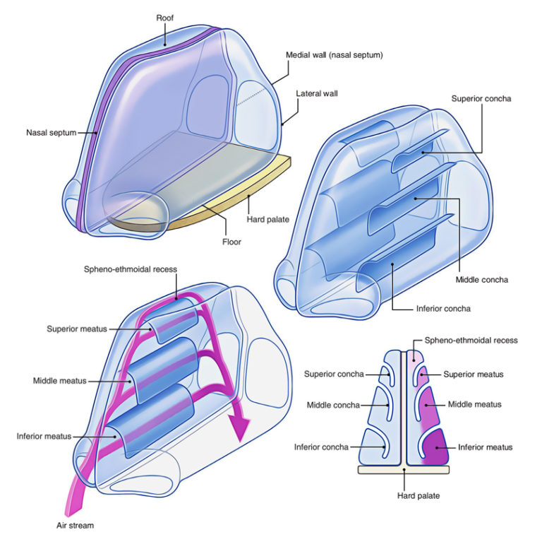
This cavity is divided into two separate cavities by the septum and kept patent by a bone and cartilaginous framework. Each cavity consists of a roof, floor, medial wall, and lateral wall.
MEDIAL WALL
The medial wall of the nasal cavity comprises the nasal septum, the septal catilage and various bones of the skull.
Nasal Septum
The nasal septum partitions the nasal cavity into two equal but separate compartments. Cartilage and bone comprise the nasal septum. It is covered by squamous epithelium, which differs from the lateral walls of the nasal cavity. A portion of the anterior septum is covered in erectile tissue. It also contributes to lateral projections called the upper lateral cartilages, which makes up the middle third of the nose. The bony segment of the septum is pneumatized, and when it over expands, it has the potential to obstruct airflow. Below are the components of the septum.
Quadrangular (septal) cartilage: This is the most anterior portion of the septum. It contains the Kiesselbach plexus.
Attachments:
•Superior: nasal bone
•Inferior: anterior nasal spine of the maxilla
•Posterior-Superior: perpendicular plate of the ethmoid
•Posterior-Inferior: vomer and maxillary crest
Perpendicular Plate of the Ethmoid: This is a vertical projection from the cribriform plate of the ethmoid inferiorly to the septal cartilage.
Vomer: Located inferior and slightly posterior to the perpendicular plate of the ethmoid. It is attached inferiorly to the nasal crest of the maxilla and palatine bone.
Nasal Crest of the Maxilla and Palatine Bone: Together these bones form the inferior support for the septal cartilage.
Anterior Nasal Spine of the Maxilla: This is a bony projection formed by the paired maxillary bones. It located anterior to the piriform aperture and are palpable at the superior portion of the philtrum of the upper lip.
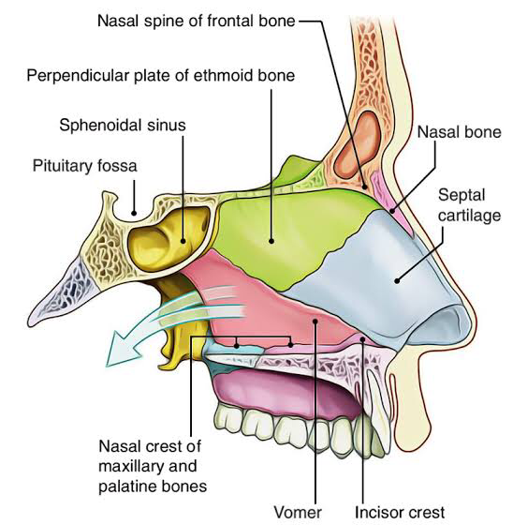
Diagram showing medial wall of Nasal cavity.

Three cartilages contribute to the nasal septum:
•lesser alar cartilages are paired cartilages suspended in the fibro-fatty tissue that forms the lateral aspect of the nostril. The structures lie free from the other cartilages and provide the nostril with stability and form.
•greater alar cartilages are paired cartilages that form part of the antero-superior nostril as well as the nasal tip. The structures give the tip of the nose stability and flexibility and are a crucial element of the cartilaginous apparatus of the nose.
•Lateral nasal cartilages are structures that articulate inferiorly with the greater alar cartilages and superiorly with the anterior nasal aperture formed by both the nasal bone superiorly and for a short part of its border with the perpendicular plate of the ethmoid bone. These structures form the cartilaginous part of the bridge of the nose and form in conjunction with the greater alar cartilages, the major structural appearance of the nose.

Lateral Wall of the Nasal Cavity
The lateral wall of the nose is complicated. It’s created by a number of bones and cartilages.
The bones creating the lateral wall are:
•Nasal
•Frontal process of maxilla
•Lacrimal
•Conchae and maze of ethmoid
•Inferior nasal concha
•Perpendicular plate of palatine
•Medial pterygoid plate of sphenoid
The cartilages creating the lateral wall are:
•Lateral nasal cartilage (upper nasal cartilage)
•Major alar cartilage (lower nasal cartilage)
•3 to 4 miniature cartilages of the alae (small alar cartilages)
Features: The lateral wall is split into the following 3 regions:
Anterior part presents a small depressed area, the vestibule. It’s lined by the skin including vibrissae (short, stiff curved hair).
Middle part is called atrium of the middle meatus. Itis restricted above by a faint ridge of mucous membrane, the agger nasi. The curved mucocutaneous junction between the atrium and vestibule is called limen nasi.
Posterior part presents 3 scroll-like projections, the conchae or turbinates. The spaces dividing the conchae are referred to as meatuses.
The conchae and meatuses create the primary features of the lateral wall:
Conchae (also named turbinates) are the curved bony projections pointed downwards and medially. Below and lateral to every concha is a corresponding meatus. From above downwards the conchae are superior, middle and inferior nasal conchae. Occasionally a 4th concha, the concha suprema is also present.
Conchae:
Superior and middle nasal conchae are the projections from the medial surface of the ethmoidal labyrinth.
Inferior concha is a separate bone.
The superior concha is smallest and inferior concha is largest in size.
Meatuses:
Meatuses are the passages (recesses) below the overhanging conchae. They’re visualized once conchae are removed.
Inferior meatus is the largest and is located underneath the inferior nasal concha.
Middle meatus is located underneath the middle concha. It presents subsequent features:
•Ethmoidal bulla (bulla ethmoidalis), a round elevation generated by the underlying middle ethmoidal sinuses.
•Hiatus semilunaris, a deep semicircular sulcus below the bulla ethmoidalis.
•Infundibulum, a short passage in the anterior end of middle meatus.
•Superior meatus is the smallest and is located below the superior concha.
•A triangular depression, above and behind the superior concha is called the sphenoethmoidal recess.

Openings: The lateral wall of the nose has number of openings.
The openings in the lateral wall of the nose.

SITES | OPENINGS
Sphenoethmoidal recess | Opening of the sphenoidal air sinus
Superior meatus | Opening of the posterior ethmoidal air sinuses
MIDDLE MEATUS
On bulla | Opening of the middle ethmoidal air sinuses
In hiatus semilunaris
Anterior part | Opening of the frontal air sinus
Middle part | Opening of the anterior ethmoidal air sinuses
Posterior part | Opening of the maxillary air sinus
Inferior meatus | Opening of the nasolacrimal duct (in the anterior part of meatus)

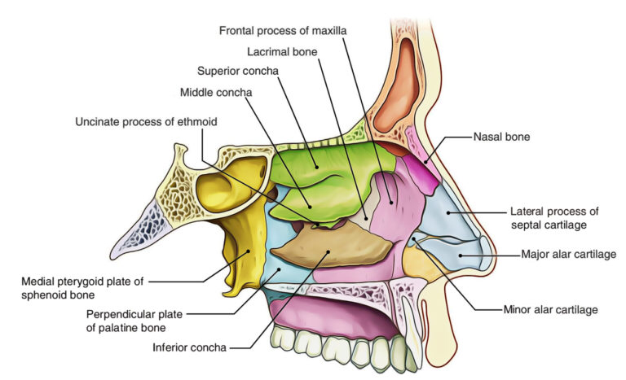
Diagram of the Nasal Cavity showing the Lateral Wall

ARTERIAL SUPPLY OF NASAL CAVITY
The nasal cavity has abundant arterial supply.
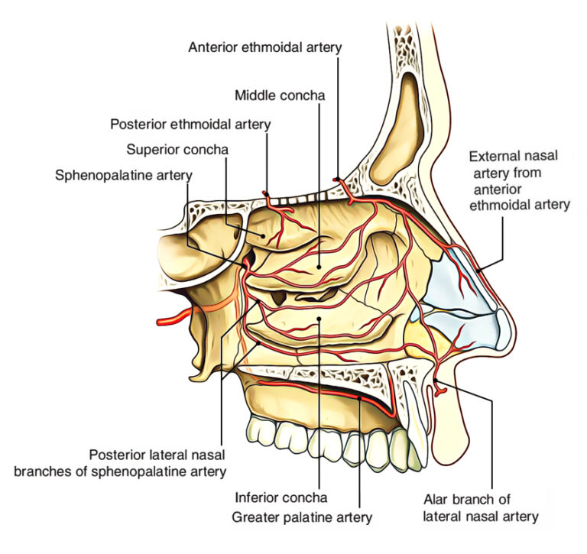
Diagram of the Nasal Cavity showing the arterial supply

ARTERIAL SUPPLY OF NASAL SEPTUM
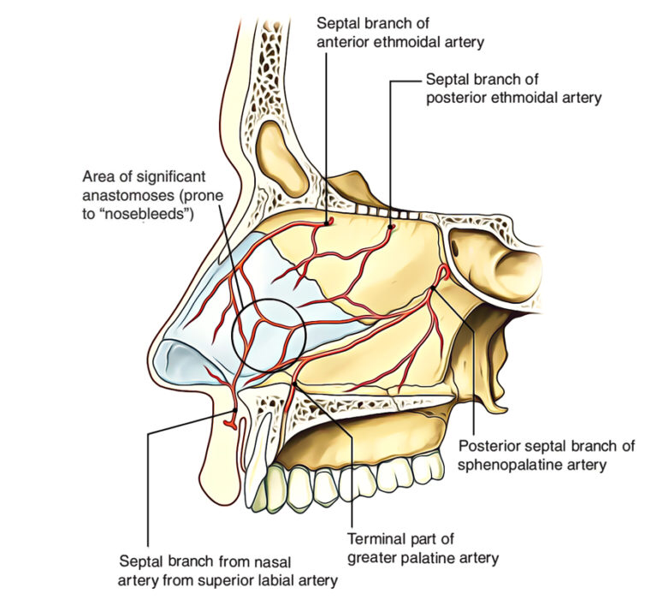

The nasal septum is supplied by these arteries:
•Septal branch of the anterior ethmoidal artery (a branch of ophthalmic artery).
•Septal branch of the posterior ethmoidal artery (a branch of ophthalmic artery).
•Septal branch of the sphenopalatine artery (a branch of maxillary artery).
•Septal branch of the greater palatine artery (a branch of maxillary artery).
•Septal branch of the superior labial artery (a branch of facial artery)
CLINICAL SIGNIFICANCE
- LITTLE’S AREA
It’s an area in the anteroinferior part of the nasal septum just above the vestibule. It’s highly vascular. Here the septal branches of the anterior ethmoidal sphenopalatine, greater palatine and superior labial arteries anastomose to create a vascular plexus referred to as Kiesselbach’s plexus. This area of nasal septum is the commonest site of epistaxis (nose bleeding) in kids and young adults generally because of finger nail trauma following deciding of the nose.

ARTERIAL SUPPLY OF LATERAL WALL
The arterial supply of the different parts of the lateral wall is as follows:
•Anterosuperior quadrant, by the anterior ethmoidal artery, a branch of ophthalmic artery.
•Anteroinferior quadrant, by branches of facial and greater palatine arteries.
•Posterosuperior quadrant, by sphenopalatine artery, a branch of maxillary artery.
•Posteroinferior quadrant, by branches of greater palatine artery, which pierces the perpendicular plate of palatine.
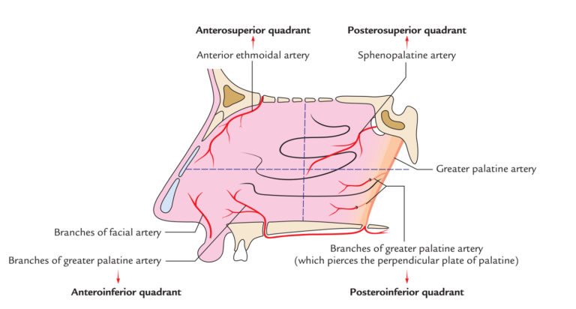
Diagram sowing the arterial supply to the lateral wall of the Nasal cavity.

VENOUS DRAINAGE OF NASAL CAVITY
The veins draining the nasal cavity create plexus below the mucosa and in general follow the arteries. The veins of nasal cavity drain into facial vein, pterygoid venous plexus and pharyngeal venous plexus.
The submucous venous plexus is more marked in the region of little’s area.
The retrocolumellar vein runs vertically downwards, crosses the floor of nasal cavity to join the venous plexus on the lateral wall. This is the common site of venous bleeding in young people.
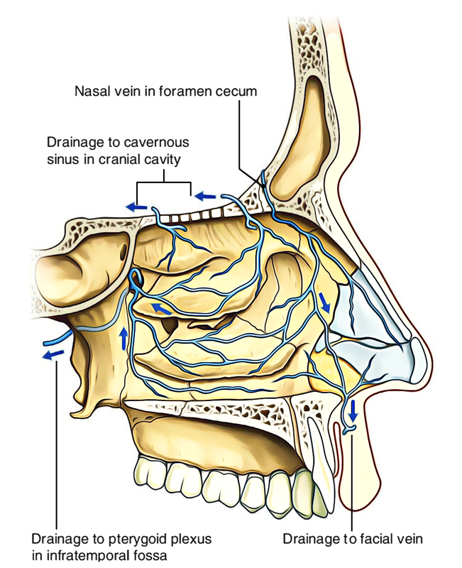
Diagram showing the venous drainage of the Nasal cavity.

LYMPHATIC DRAINAGE OF NASAL CAVITY
Lymph from anterior half of nasal cavity (both medial and lateral walls) is emptied into submandibular lymph nodes and from posterior half into retropharyngeal lymph nodes.
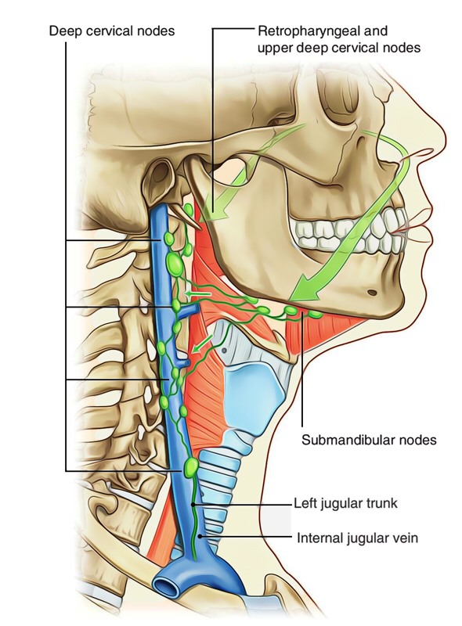

NERVE SUPPLY OF NASAL CAVITY
The nasal cavity is supplied by the following nerves:
•Olfactory nerves: They carry sense of smell from olfactory region of nasal cavity.
•Nerves of general sense. These are:
- anterior ethmoidal nerve,
- branches of sphenopalatine ganglion and
- branches of infraorbital nerve
They carry sensations of pain, feel and temperature from respiratory region and vestibule of nasal cavity.
•Autonomic nerves: Both parasympathetic andsympathetic fibres furnishing nasal cavity are originated from Vidian’s nerve (nerve of pterygoid canal) via pterygopalatine ganglion.
The parasympathetic fibres supply nasal glands and restrain nasal secretion.
The sympathetic fibres, on stimulation, cause vasoconstriction.
CLINICAL SIGNIFICANCE
•RHINITIS
It’s the inflammation of mucus membrane lining the nasal cavity. The hypertrophy of mucosa over inferior concha is a familiar characteristic of allergic rhinitis. Medically it presents as: nasal blockage, sneezing and water discharge from nose (rhinorrhea).
The excessive rhinorrhea on account of vasomotor and allergic rhinitis can be restrained by sectioning the Vidian nerve.

NERVE SUPPLY OF NASAL SEPTUM
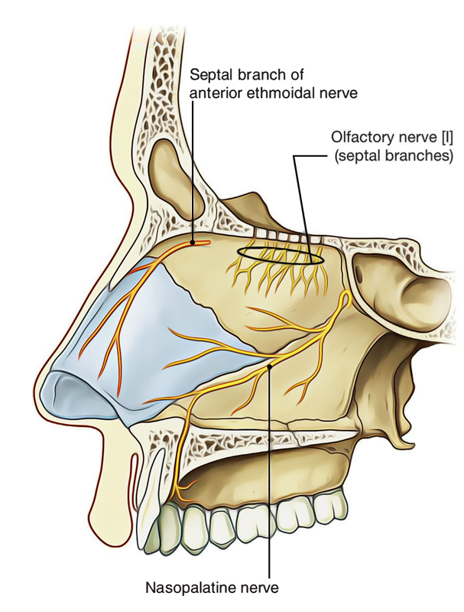Diagram showing the nerve supply to Nasal septum

The nasal septum gets supply from the following nerves:
•Olfactory nerves-supply the upper part (one-third) just below the cribriform plate.
•Internal nasal branch of the anterior ethmoidal nerve, a branch from nasociliary-supplies the anterosuperior part.
•Nasopalatine nerve, a branch of pterygopalatine ganglion-supplies the posteroinferior part.
•Medial posterior superior nasal branches of pterygopalatine ganglion-supply the posterosuperior part.
•Nasal branch of greater palatine nerve-supplies the posterior part.
•Anterior superior alveolar nerve, a branch of maxillary nerve-supplies the anteroinferior part.

NERVE SUPPLY OF LATERAL WALL
The following nerves supply the different partsof the lateral wall:
•Olfactory nerves-supply the upper part (one-third) just below the cribriform plate of ethmoid up to the superior concha.
•Anterior ethmoidal nerve (from ophthalmic)-supplies the anterosuperior quadrant.
•Anterior superior alveolar nerve, a branch of infraorbital nerve (from maxillary)-supplies the anteroinferior quadrant.
•Posterior superior lateral branches, of pterygopalatine ganglion-supply posterosuperior quadrant.
•Nasal branches of greater palatine nerve, (from pterygopalatine ganglion)-supply posteroinferior quadrant.
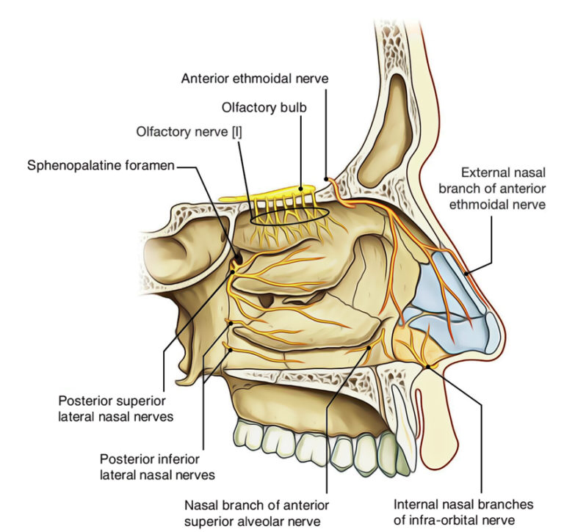
Diagram showing nerve supply to lateral wall of Nasal cavity

CLINICAL SIGNIFICANCE
•EVALUATION OF THE NASAL CAVITY (RHINOSCOPY)
The nasal cavity can be analyzed in the living individual either via the nostril (anterior rhinoscopy) or via the pharynx (posterior rhinoscopy).
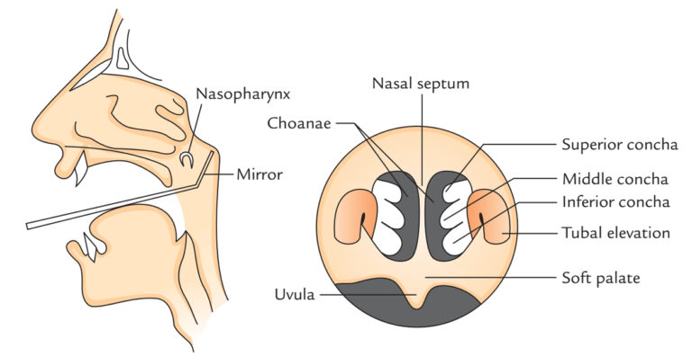
Diagram showing Rhinoscopy

Anterior rhinoscopy: It’s performed by fitting a nasal speculum via a nostril. These features are visualized by this approach:
•Middle and inferior conchae.
•Superior middle and inferior meatuses.
•Nasal septum.
•Floor of the nasal cavity.
Posterior Rhinoscopy: It’s performed by adding a mirror into the pharyx. These features can be visualized by this procedure:
•Choanae.
•Conchae.
•Posterior border of the nasal septum.

