Okoye Nwabufo Chukwuekezie
17/MHS01/249
Medicine and Surgery
ANA 301: Gross Anatomy of Head and Neck
Assignment

Question 1
Write an essay on the cavernous sinus
The cavernous sinus is part of the brain’s dural venous sinus and contains multiple neuro-vasculatures. It is situated bilaterally to the sella turcica and extends from the superior orbital fissure anteriorly to the petrous part of the temporal bone posteriorly, and is about 1 cm wide and 2 cm long. The venous blood that flows to the cavernous sinus is from the superior and anterior ophthalmic veins, superficial middle cerebral vein, and sphenoparietal sinus. The communication between the left and right cavernous sinuses is made by the intercavernous sinuses anterior and posterior to the infundibulum of the pituitary gland.
Location and structure
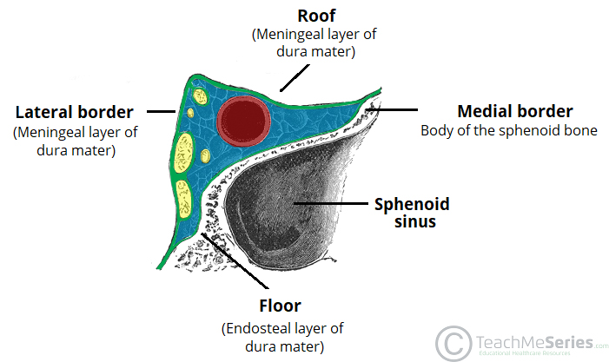
The cavernous sinuses are 1 cm wide cavities that extend a distance of 2 cm from the most posterior aspect of the orbit to the petrous part of the temporal bone. They are bilaterally paired collections of venous plexuses that sit on either side of the sphenoid bone. Although they are not truly trabeculated cavities like the corpora cavernosa of the penis, the numerous plexuses, however, give the cavities their characteristic sponge-like appearance. The cavernous sinuses are located within the middle cranial fossa, on either side of the sella turcica of the sphenoid bone, which contains the pituitary gland. They are enclosed by the endosteal and meningeal layers of the dura mater.

The borders of the cavernous sinus are as follows:
- Anterior: superior orbital fissure.
- Posterior: petrous part of the temporal bone.
- Medial: body of the sphenoid bone.
- Lateral: meningeal layer of the dura mater running from the roof to the floor of the middle cranial fossa.
- Roof: meningeal layer of the dura mater that attaches to the anterior and middle clinoid processes of the sphenoid bone.
- Floor: endosteal layer of dura mater that overlies the base of the greater wing of the sphenoid bone.
Venous system of cavernous sinus
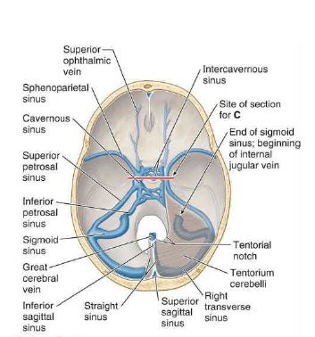
The cavernous sinus works as a conduit. Cranial nerves leaving the brainstem travel through the cavernous sinus before entering the orbit to innervate extraocular and intrinsic eye muscles. Also, different venous tributaries drain into the cavernous sinus.
- The superior ophthalmic vein collects venous blood from the ethmoidal, vorticose, central retinal, and nasofrontal veins before draining into the anterior part of the cavernous sinus through the superior orbital fissure.
- The inferior ophthalmic vein, receives blood from the lacrimal sac, eyelids, the inferior rectus and inferior oblique muscles, the vorticose vein, and from the anterior and medial wall of the orbit. It then runs posteriorly toward the lower part of the orbit and divides into two branches. One of these branches joins the cavernous sinus, while the other one drains into the pterygoid plexus.
- The superficial middle cerebral vein originates on the lateral surface of the hemisphere, runs in the lateral sulcus, and drains most of the temporal lobe into the cavernous sinus.
- Some branches of the middle meningeal vein drain into the sphenoparietal sinus before draining into the cavernous sinus.
- The efferent hypophyseal veins also drain into the cavernous sinus, after collecting venous blood from these different veins.
The cavernous sinus drains to the superior and inferior petrosal sinuses, which then join the sigmoid sinus to form the internal jugular vein. The internal jugular vein exits the brain through the jugular foramen and connects with the subclavian vein to become the right or left brachiocephalic vein.
Contents of the cavernous sinus
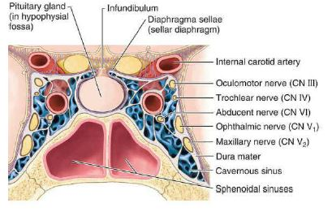
The cavernous sinus contains the internal carotid artery and several cranial nerves. The internal carotid artery, a branch of the common carotid artery, along with its postganglionic sympathetic plexus from the superior cervical ganglion, enters the cavernous sinus posteriorly. The internal carotid artery travels superiorly and enters the skull via the carotid canal. After entering the carotid canal, the internal carotid makes a 90-degree turn and travels horizontally in the petrous part of the temporal bone, this is the petrous part of the internal carotid artery. The artery then leaves the carotid canal, it curves vertically and superiorly to enter the cavernous sinus via the foramen lacerum. Here the artery is also referred to as the cavernous part. Within the sinus, the internal carotid artery travels anteriorly, in a horizontal manner until it reaches the anterior limit of the sinus. Here it curves vertically and superiorly to exit the sinus through its roof and become the cerebral part of the internal carotid artery. It is important to mention that the cavernous part of the internal carotid artery is the only artery in the body that is surrounded completely by venous blood.
The nerves of the cavernous sinus are
- The oculomotor nerve (CN III)
- The trochlear nerve (CN IV)
- The ophthalmic division of the trigeminal nerve (CN V1)
- The maxillary division of the trigeminal nerve (CN V2)
- The abducens nerve (CN VI)
- The sympathetic plexus around the internal carotid artery.
The CN III exits the midbrain ventrally at the interpeduncular fossa, pierces the dura, and enters the cavernous sinus, where it runs on the roof and lateral wall. After exiting the cavernous sinus, it goes through the superior orbital fossa. Within the superior orbital fossa, it splits into the superior and inferior division.
The CN IV is the only nerve exiting the midbrain dorsally. It originates from the trochlear nerve nucleus; it crosses the midline and emerges inferior to the inferior colliculus, situated in the posterior part of the midbrain. It then travels anteriorly around the midbrain, pierces and enters the dura mater near the tentorium cerebelli, and continues its course in the lateral wall of the cavernous sinus. After exiting the cavernous sinus, it enters the orbit through the superior orbital fissure to innervate the superior oblique muscle.
The ophthalmic nerve (V1) and the maxillary nerve (V2) are divisions of the trigeminal nerve (CN V). The CN V exits the brainstem from the ventrolateral pons and enters the Meckel’s cave, where the trigeminal ganglion lies. The V1 branches of the trigeminal ganglion pass through the inferior part of the cavernous sinus and after exiting the cavernous sinus, they enter the orbit via the superior orbital fissure. Also, the V2 branches of the trigeminal ganglion enter the cavernous sinus and exit the skull via the foramen rotundum.
The CN VI exits the brainstem ventrally at the pontomedullary junction, pierces the dura, and travels the longest intracranial distance of all the cranial nerves. After its long intracranial course, it enters the cavernous sinus, where it is surrounded by venous blood, like the internal carotid artery.
The sympathetic plexus around the internal carotid artery originates from the superior cervical ganglion, travels with the internal carotid artery, enters the skull through the carotid canal, and enters the cavernous sinus through the jugular foramen. Within the cavernous sinus, it gives sympathetic fibers to the CN III and V1.
Clinical significance
- Cavernous Sinus Thrombosis
Cavernous sinus thrombosis (CST) refers to the formation of a clot within the cavernous sinus. This most common cause of CST is infection; which typically spreads from an extracranial location such as the orbit, paranasal sinuses, or the danger zone of the face; this consists the area from the corners of the mouth to the bridge of the nose, including the nose and maxilla. Infection is able to spread in this manner due to the anastomosis between the facial vein and superior ophthalmic veins. Common clinical features include headache, unilateral periorbital oedema, proptosis (eye bulging), photophobia and cranial nerve palsies. The abducens nerve (CN VI) is most commonly affected. Treatment is typically with antibiotic therapy. Where the cause is infection, thrombosis of the cavernous sinus can rapidly progress to meningitis.
- Carotid-cavernous fistula
Head trauma resulting in rupture of the cavernous part of the internal carotid artery can produce what is known as a carotid-cavernous fistula. A pulsating exophthalmos can result as the venous pressure in the sinus would increase and reverse the flow of blood in the ophthalmic veins.
- Cavernous Sinus Syndrome
Cavernous sinus syndrome is a medical emergency and life-threatening disorder that presents with different symptoms depending on what structure is affected. A severe lesion involving the entire sinus will present with total ophthalmoplegia, due to CN III, IV, and VI injury, accompanied with fixed and dilated pupils due to compression of the superficial parasympathetic fibers of the CN III. Cavernous sinus syndrome can lead to Horner’s syndrome. Horner’s syndrome occurs when the sympathetic plexus around the internal carotid is damaged. When CN V1 and CN V2 are involved, sensory loss in the face, scalp, maxilla, nasal cavity, sinuses, and palate occurs. There are several causes of cavernous sinus syndrome, including metastatic tumor, meningioma, pituitary tumor, extension of nasopharyngeal tumors, granulomatous diseases, cavernous sinus thrombosis, and aneurysms of the cavernous part of the internal carotid artery. In case of rupture of a cavernous aneurysm, a carotid-cavernous fistula is created, leading to a pulsating exophthalmos on physical examination.
Question 2
Discuss the walls of the nose.
The nose is an olfactory and respiratory organ. It consists of nasal skeleton, which houses the nasal cavity. The nasal cavity has four functions; Warms and humidifies the inspired air, removes and traps pathogens and particulate matter from the inspired air, responsible for sense of smell and drains and clears the paranasal sinuses and lacrimal ducts
The internal part of the nose is the nasal cavity. The two nasal cavities sit within the external nose and the adjacent skull. The cavities open anteriorly to the face through the two nostrils. Posteriorly the cavities communicate with the nasopharynx by two apertures called choanae. Each nasal cavity has a roof, floor, and lateral and medial walls. There are 12 cranial bones in total that contribute to the nasal cavity structure, which include the paired nasal, maxilla, palatine and lacrimal bones, as well as the unpaired ethmoid, sphenoid, frontal and vomer bones. Among all of them, the ethmoid bone is the most important element, for two reasons: first, it makes the greatest portion of the nasal skeletal framework by forming the roof and walls of the nasal cavities; and second, it contains ethmoidal cells which, as a group, are one of the four paranasal sinuses.
The roof of the Nasal Cavity
The mucosa of the roof of the nasal cavity contains perforations that communicate with the cribriform plate. Within these perforations are the olfactory axons. The anterior is made up of the nasal spine of the frontal bone and nasal bone, the posterior is made up of cribriform plate of the ethmoid and the body of the sphenoid.
The floor of the Nasal Cavity
The floor of the nasal cavity is broader than that of the roof. Anterior it constitutes the palatine process of the maxilla, posterior it constitutes the horizontal plate of the palatine bone.

Lateral Wall of the Nasal Cavity
The nasal cavity's lateral wall has three medially projecting inferiorly curved bones called conchae. The middle and superior conchae are part of the ethmoid bone, whereas the inferior concha is a separate bone altogether. These conchae, when covered by mucosa, are termed turbinates. The turbinates augment the surface area of the nasal cavity to aid in its functions of humidifying, warming, and humidifying the air. The turbinates create four channels. Three of these channels are termed meatuses, and the fourth is the sphenoethmoidal recess. Bones that make up the lateral wall include: the ethmoid bone, perpendicular plate of the palatine bone, the medial plate of the pterygoid process of the sphenoid bone, the medial surface of the lacrimal and maxillary bones and the inferior concha.
The sphenoethmoidal recess is located superior to the superior turbinate and inferior to the nasal cavity roof, which is the drainage site of the sphenoid sinus.
Meatuses
- Superior Meatus: located inferior to the superior turbinate and superior to the middle turbinate; this is the drainage site of the posterior ethmoid sinus.
- Middle Meatus: located inferior to the middle turbinate and superior to the inferior turbinate - there are several structures within this meatus. This is the drainage site of the frontal, anterior ethmoid, and maxillary sinuses.
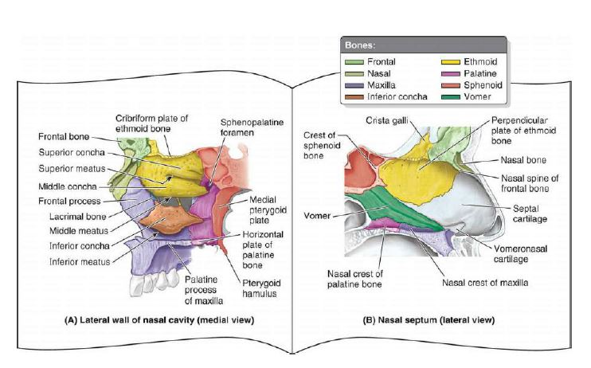
- Inferior Meatus: Located inferior to the inferior turbinate and superior to the floor of the nasal cavity. The nasolacrimal duct drains tears from the lacrimal sac at the medial aspect of the eye into the anterior portion of this meatus via Hasner's valve.

Medial wall/Nasal Septum
The nasal septum partitions the nasal cavity into two equal but separate compartments. Cartilage and bone comprise the nasal septum. It is covered by squamous epithelium, which differs from the lateral walls of the nasal cavity. A portion of the anterior septum is covered in erectile tissue. It also contributes to lateral projections called the upper lateral cartilages, which makes up the middle third of the nose. The bony segment of the septum is pneumatized, and when it over expands, it has the potential to obstruct airflow. Below are the components of the septum:
- Quadrangular (septal) cartilage: This is the most anterior portion of the septum. It contains the Kiesselbach plexus. It attaches superior to the nasal bone, inferiorly to the anterior nasal spine of the maxilla, postero-superiorly to the perpendicular plate of the ethmoid, postero-inferiorly to the vomer and maxillary crest.
- Perpendicular Plate of the Ethmoid: This is a vertical projection from the cribriform plate of the ethmoid inferiorly to the septal cartilage.
- Vomer: Located inferior and slightly posterior to the perpendicular plate of the ethmoid. It is attached inferiorly to the nasal crest of the maxilla and palatine bone.
- Nasal Crest of the Maxilla and Palatine Bone: Together these bones form the inferior support for the septal cartilage.
- Anterior Nasal Spine of the Maxilla: This is a bony projection formed by the paired maxillary bones. It located anterior to the piriform aperture and are palpable at the superior portion of the philtrum of the upper lip.
Vasculature of the nasal cavity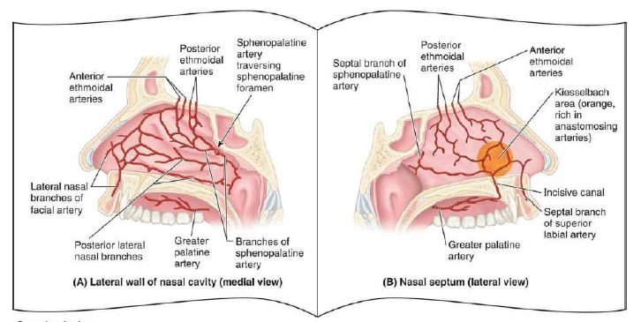
Arterial Supply
The nasal cavity has an abundant supply of vasculature to aid in functions of warming and humidifying inhaled air. It allows the mucosa to enlarge and shrink, under the influence of sympathetic innervation. The arterial supply to the nose and nasal cavity originates from the internal and external carotid arteries.
Internal Carotid Artery (ICA)
The primary branch off of the ICA that supplies the nasal cavity is the ophthalmic artery. Coming off of the ophthalmic artery are the anterior and posterior ethmoid arteries, as well as the dorsal nasal artery. The anterior ethmoid artery supplies the lateral nasal wall and the nasal septum. The posterior ethmoid artery supplies the superior turbinate and the nasal septum. The dorsal nasal artery supplies the dorsal aspect of the external nose.
External Carotid Artery (ECA)
The ECA gives rise to the maxillary artery and the facial artery. These two significant arteries then branch into smaller vessels.
- Maxillary Artery
The maxillary branches into the descending palatine artery that then travels through the pterygopalatine fossa down the palatine canal and then branches into the greater and lesser palatine arteries. The greater palatine artery then enters the greater palatine foramen on the posterior aspect of the palate before traversing the palate anteriorly to enter the nasal cavity via the incisive canal. It supplies the septum and the floor of the nasal cavity.
Like the descending palatine artery, the sphenopalatine artery is a branch of the maxillary artery. It branches off of the maxillary artery near the pterygopalatine fossa where it then enters the lateral wall of the nasal cavity through the sphenopalatine foramen, located just posterior to the medial turbinate. The sphenopalatine artery then branches into the posterior lateral nasal branches and the posterior septal branch. The posterior lateral branches supply the middle and inferior turbinates, while the posterior septal branch supplies the posterior septum.
- Facial Artery
The facial artery gives rise to the superior labial artery, the lateral nasal artery, and the angular artery. The superior labial artery gives off an alar branch and a septal branch that supply the same structures as their name. The lateral nasal artery supplies the alar cartilage on the external nose and also supplies the nasal vestibule. The angular artery supplies the external nasal tip, dorsum, and lateral wall.
Kiesselbach's Plexus
Kiesselbach's plexus is a vascular anastomosis between the anterior ethmoid artery, superior labial artery, greater palatine artery, and the terminal branch of the posterior septal branch of the sphenopalatine artery. This vascular plexus is located in the anterior nasal septum and is the most common site of epistaxis.
Woodruff's Plexus
Woodruff's plexus is a vascular anastomosis between the sphenopalatine artery and the ascending pharyngeal artery. Located on the lateral wall of the nasal cavity in the area posterior to the middle and inferior turbinates.
Venous Drainage
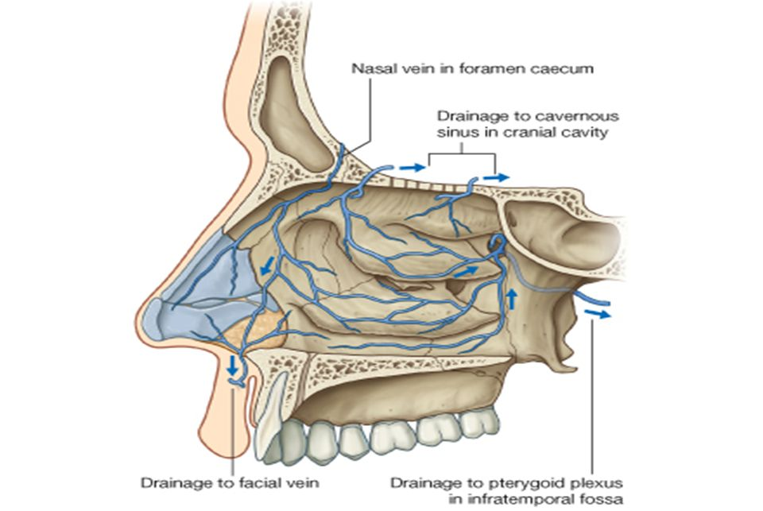
The names of the veins that drain the nose and nasal cavity follow that of the arteries with which they pair. The maxillary branches drain either into the cavernous sinus or the pterygoid plexus located in the infratemporal fossa. The veins of the anterior nasal cavity drain into the facial vein. Of note, infections located between the oral commissure and nasal bridge, have the potential to become intracranial infections. These must be treated promptly to prevent the extension of infection.
Lymphatics
The anterior nasal cavity drains anteriorly to the face that then makes its way to the submandibular lymph nodes in level IB. The lymphatics of the posterior nasal cavity and paranasal sinuses drain into the upper cervical lymph nodes and retropharyngeal lymph nodes.
Innervation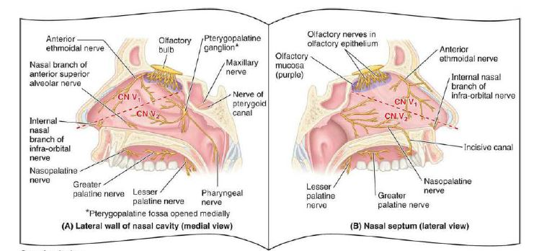
Olfactory Nerve (CNI)
The olfactory nerve transmits signals from the nasal cavity to the brain to give the sense of olfaction. The olfactory epithelium is in the superior portion of the nasal cavity. Within this epithelium are sensory cilia that project up through the cribriform plate to the olfactory bulb. From the olfactory bulb, signals are sent through the olfactory nerve proper to a network of secondary neurons for processing before ending up in the brain.
Trigeminal Nerve (CNV)
The trigeminal nerve is the sensory innervation to the external and internal nose. The branches are the ophthalmic (V1), maxillary (V2), and mandibular (V3). Sympathetic and parasympathetic fibers run with these branches to supply their target tissues. The ophthalmic and maxillary branches innervate the nose and nasal cavity.
- Ophthalmic Branches (V1): As the ophthalmic nerve begins to branch, it gives off a nasociliary branch, which then provides the anterior and posterior ethmoid nerves. The anterior ethmoid gives off an external branch that supplies the nasal tip, an internal branch that supplies the anterosuperior nasal cavity and a septal branch that supplies the anterior superior nasal septum. The posterior ethmoid supplies the posterosuperior nasal cavity. Two other branches of the ophthalmic branch of the trigeminal nerve are the supratrochlear and infratrochlear nerves that supply the nasal dorsum.
- Maxillary Branches (V2): The maxillary branches of the trigeminal nerve that innervate the nose and nasal cavity branch in or near the pterygopalatine fossa then enter the nasal cavity. The only external nasal branch is the infraorbital nerve, which supplies the malar and lateral nose. The nasopalatine nerve traverses the nasal septum from posterior to anterior in a downward projection to enter the incisive canal. It supplies the posterior and inferior nasal septum as well as mucosa just posterior to the incisors. The greater palatine nerve follows the greater palatine artery down the palatine canal, giving off posterior inferior lateral nasal nerves that supply the posterior lateral wall of the nasal cavity. Three other nerves come off the maxillary branch (V2). Two of these are the posterior superior lateral nasal nerve and posterior superior medial nasal nerve, both of which pass through the sphenopalatine foramen to supply the lateral and medial walls of the nasal cavity, respectively. The superior alveolar nerve is the last branch of V2, and it supplies the anterior septum and the area near the nasal vestibule.
Clinical Significance
- Sinusitis is an inflammation of the different sinuses found in the head. That type of inflammation may result in different symptoms including; plugged nose, nasal mucus, pain in the facial region.The frontal bone overlies the frontal lobe of the brain and lies anteriorly forming the brow, forehead and one third of the anterior scalp. The bone contains the frontal sinus, which in sinusitis and nasal infections can become filled with fluid.
- Epistaxis (nosebleed) is relatively common because of the rich blood supply to the nasal mucosa. In most cases, the cause is trauma and the bleeding is from an area in the anterior third of the nose (Kiesselbach area). Epistaxis is also associated with infections and hypertension. Spurting of blood from the nose results from rupture of arteries. Mild epistaxis may also result from nose picking, which tears veins in the vestibule of the nose.
- The nasal mucosa becomes swollen and inflamed (rhinitis) during severe upper respiratory infections and allergic reactions (e.g., hayfever). Swelling of the mucosa occurs readily because of its vascularity.

