Name: Adeyemo Sinmiloluwa Crystal
Matric no: 17/MHS01/025
Course: Gross anatomy of the head and neck
Department: Medicine and Surgery

ASSIGNMENT
Gross anatomy of the tongue
The tongue is a mobile muscular organ covered with mucous membrane. It can assume for a variety of shapes and positions. It is partly in the oral cavity and partly in the oropharynx. The tongue's main function are articulation (forming words during speaking) and squeezing food into the oropharynx as part of deglutition(swallowing). The tongue is also involved with mastication (chewing), taste and oral cleansing. While there is significant variability in the length of the tongue among individuals, on average, the organ is roughly 10 cm long. It has three main parts:
- The tip or apex of the tongue is the most anterior, and most mobile aspect of the organ.
- The tip is followed by the body of the tongue. It has a rough dorsal (superior) surface that abuts the palate and is populated with taste buds and lingual papillae, and a smooth ventral (inferior) surface that is attached to the floor of the oral cavity by the lingual frenulum.
- The base of the tongue is the most posterior part of the organ. It is populated by numerous lymphoid aggregates known as the lingual tonsils along with foliate papillae along the posterolateral surface
The tongue features two surfaces. The more extensive, superior and posterior surface is the dorsum of the tongue (“top” of the tongue). The inferior surface of the tongue (commonly referred to as its underside) usually rests against the floor or the mouth. The margin of the tongue separating the two surfaces is related on each side to the lingual gingivae and lateral teeth. The dorsum of the tongue is characterized by a V-shaped groove, the terminal sulcus of the tongue, the angle of which points posteriorly to the foramen cecum. This small pit frequently and frequently absent, is the nonfunctional remnant of the proximal part of the embryonic thyroglossal duct from which the thyroid land developed. The terminal sulcus divides the dorsum of the tongue transversely into a presulcal anterior part in the oral cavity proper and a postsulcal posterior part in the oropharynx. A midline groove divides the anterior part of the tongue into right and left parts. The mucosa of the anterior part of the tongue is relatively thin and closely attached to the underlying muscle. It has a rough texture because of numerous small lingual papillae:
Vallate papillae: large and flat topped, lie directly anterior to the terminal sulcus and are arranged in a V-shaped row. They are surrounded by deep circular trenches, the walls of which are studded with taste buds. The ducts of the serous glands of the tongue open into the trenches.
Foliate papillae: small lateral folds of the lingual mucosa. They are poorly developed in humans.
Filiform papillae: long and numerous, contain afferent nerve endings that are sensitive to touch. These scaly, conical projections are pinkish gray and are arranged in V-shaped rows that are parallel to the terminal sulcus, except at the apex, where they tend to be arranged transversely.
Fungiform papillae: mushroom-shaped pink or red spots scattered among the filiform papillae, but most numerous at the apex and margins of the
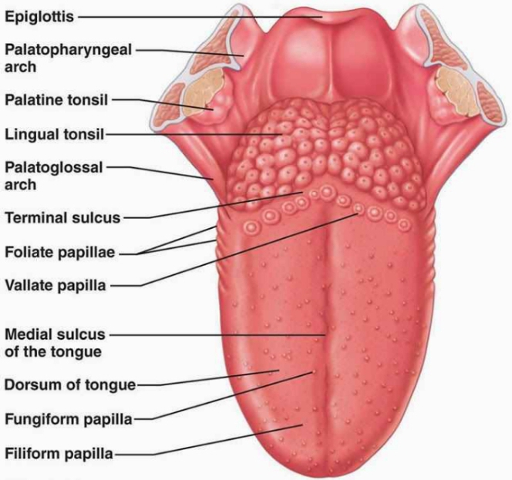
diagram showing parts of the tongues

MUSCLES OF TONGUE

The tongue is essentially a mass of muscles that is mostly covered by mucosa(mucous membrane). As with the orbital muscles, it is traditional to provide descriptions of the actions of tongue muscles (1) ascribing a single action to a specific muscle or (2) implying that a particular movement is the consequence of a single muscle acting. This approach facilitates learning but greatly oversimplifies the actions of the tongue. The muscles of the tongue do not act in isolation, and some muscles perform multiple actions. Parts of a single muscle are capable of acting independently, producing different, even antagonistic actions. In general, extrinsic muscles alter the position of the tongue, and intrinsic muscles alter its shape. The four intrinsic and four extrinsic muscles in each half of the tongue are separated by a median fibrous lingual septum, which merges posteriorly with the lingual aponeurosis (a tough sheet of connective tissue, the lamina propria, deep to the dorsal mucous membrane of the tongue, into which lingual muscles insert.
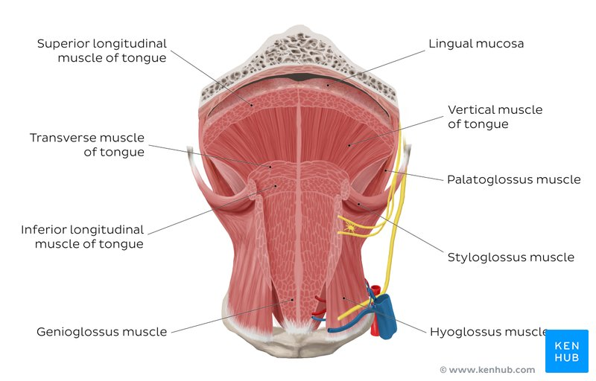

Diagram showing extrinsic and intrinsic muscles of the tongue

Extrinsic Muscles
The extrinsic muscles of the tongue (genioglossus, hypoglossus, styloglossus an palatoglossus) originate outside the tongue but they can alter its shape as well. They are as follows:

Genioglossus
- Attachments: Arises from the mandibular symphysis. Inserts into the body of the hyoid bone and the entire length of the tongue.
- Function: Inferior fibers protrude the tongue, middle fibers depress the tongue, and superior fibres draw the tip back and down
- Innervation: Motor innervation via the hypoglossal nerve (CNXII).

Hypoglossus
- Attachments: Arises from the hyoid bone and inserts into the side of the tongue
- Function: Depresses and retracts the tongue
- Innervation: Motor innervation via the hypoglossal nerve (CNXII).

Styloglossus
- Attachments: Originates at the styloid process of the temporal bone and inserts into the side of the tongue
- Function: Retracts and elevates the tongue
- Innervation: Motor innervation via the hypoglossal nerve (CNXII).

Palatoglossus
- Attachments: Arises from the palatine aponeurosis and inserts broadly across the tongue
- Function: Elevates the posterior aspect of the tongue
- Innervation: Motor innervation via the vagus nerve (CNX).
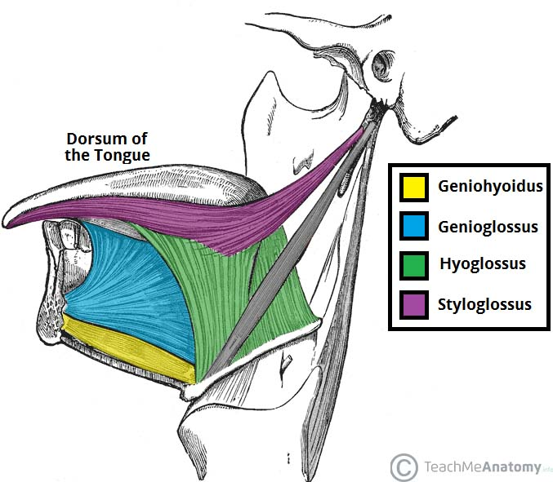
Diagram showing extrinsic muscles
Intrinsic muscles
The intrinsic muscles only attach to other structures in the tongue. There are four paired intrinsic muscles of the tongue and they are named by the direction in which they travel; the superior longitudinal, inferior longitudinal, transverse and vertical muscles of the tongue. These muscles affect the shape and size of the tongue.
Superior longitudinal
- Origin: submucosa of posterior tongue, lingual septum
- Insertion: apex/anterolateral margins of tongue
- Innervation: hypoglossal nerve (CN XII)
- Action: retracts and broadens the tongue, elevates apex of the tongue
Inferior longitudinal
- Origin: submucosa of posterior tongue, lingual septum
- Insertion: apex/anterolateral margins of tongue
- Innervation: hypoglossal nerve(CN XII)
- Action: retracts and Broadway the tongue, lowers apex of tongue
Transverse muscle
- Origin: root of tongue, body of hyoid bone
- Insertion: apex of tongue
- Innervation: hypoglossal nerve (CN XII)
- Action: retracts and broadens tongue, lowers apex of the tongue
Vertical muscle
- Origin: root of tongue, genioglossus muscle
- Insertion: lingual aponeurosis
- Innervation: hypoglossal nerve (CN XII)
- Action: broadens bad elongates the tongue
INNERVATION
All muscles of the tongue, except the palatoglossus, receive motor innervation from CN XII, the hypoglossal nerve. Palatoglossus is a palatine muscle supplied by the pharyngeal plexus. For general sensation (touch and temperature), the mucosa of the anterior two thirds of the tongue is supplied by the lingual nerve, a branch of CN V3 . For special sensation (taste), this part of the tongue, except for the Vallate papillae, is supplied the chorda tympani nerve, a branch of CN VII. The chorda tympani joins the lingual nerve in the infratemporal fossa and runs anteriorly in its sheath. The mucosa of the posterior third of the tongue and the Vallate papillae are supplied by the lingual branch of the glossopharyngeal nerve (CNIX) for both general and special sensation. Twigs of the internal laryngeal nerve, a branch of the vagus nerve (CN X), supply mostly general but some special sensation to a small area of the tongue just anterior to the epiglottis. These mostly sensory nerves also carry parasympathetic secretomotor fibers to the serous gland.
VASCULATURE
The arteries of the tongue are derived from the lingual artery, which arises from the external carotid artery. On entering the tongue, the lingual artery passes deep to the hyoglossus muscle. The dorsal lingual arteries supply the root of the tongue; the deep lingual arteries supply the body of the tongue. The deep lingual arteries communicate with each other near the apex of the tongue. The dorsal lingual arteries are prevented from communicating by the lingual septum.
VENOUS DRAINAGE
The veins of the tongue are the dorsal lingual veins, which accompany the lingual artery. The deep lingual veins, which begin at the apex of the tongue, run posteriorly beside the lingual frenulum to join the sublingual vein. The sublingual veins in elderly people are often varicose (enlarged and tortuous). Some or all of the veins may drain into the IJV, or they may do so indirectly, joining first to form a lingual vein that accompanies the initial part of the lingual artery.
LYMPHATIC DRAINAGE
The lymphatic drainage of the tongue is exceptional. Most of the lymphatic drainage converges toward and follows the venous drainage; however, lymph from the tip of the tongue, frenulum, and central lower lip runs an independent course.
APPLIED ANATOMY
- Pierre- Robinson syndrome: it is a pharyngeal arch defect that causes glossoptosis among other symptoms. This particular defect causes the tongue to be displaced posteriorly and my cause air-way blockage or apnea.
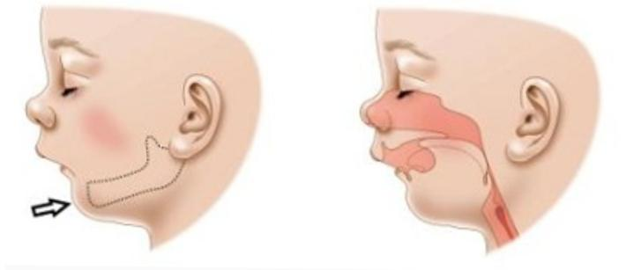
- Thrush (candidiasis): Candida albicans (a yeast) grows over the surface of the mouth and tongue. Thrush can occur in almost anyone, but it occurs more often in people taking steroids or with suppressed immune systems, the very young, and the elderly.
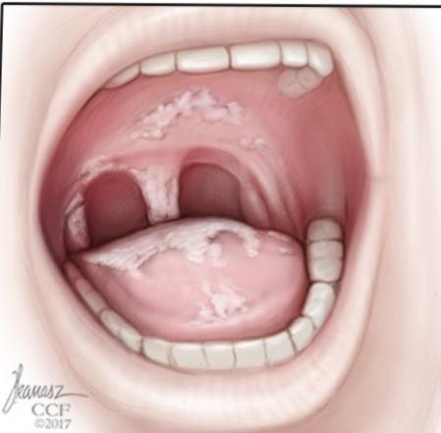

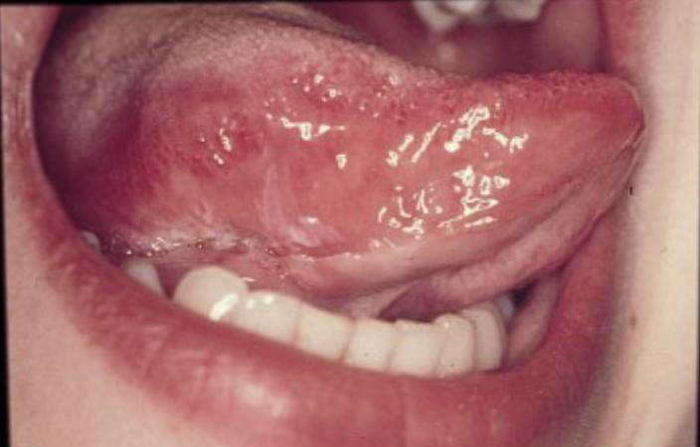
- Oral cancer: A growth or ulcer appears on the tongue and grows steadily. Oral cancer is more common in people who smoke and/or drink alcohol heavily.

- Macroglossia (big tongue): This can be broken down into various categories based on the cause. These include congenital, inflammatory, traumatic, cancerous, and metabolic causes. Thyroid disease, lymphangiomas, and congenital abnormalities are among some of the causes of an enlarged tongue.
- Geographic tongue: Ridges and colored spots migrate over the surface of the tongue, periodically changing its appearance. Geographic tongue is a harmless condition.
- Burning mouth/burning tongue syndrome: a relatively common problem. The tongue feels burned or scalded, or strange tastes or sensations develop. Apparently harmless, burning mouth syndrome may be caused by a mild nerve problem.
- Atrophic glossitis (bald tongue): The tongue loses its bumpy texture, becoming smooth. Sometimes this is due to anemia or a B vitamin deficiency.
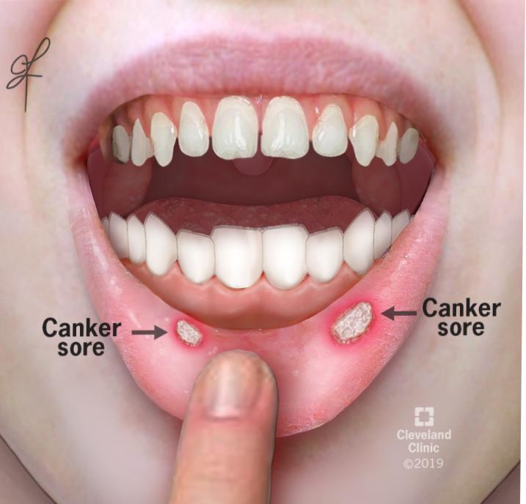
- Canker sores (aphthous ulcers): Small, painful ulcers appear periodically on the tongue or mouth. A relatively common condition, the cause of canker sores is unknown; they are unrelated to the cold sores caused by herpes viruses. Canker sores are not contagious.

- Oral leukoplakia: White patches appear on the tongue that can’t be scraped off. Leukoplakia may be benign, or it can progress to oral cancer.
- Hairy tongue: Papillae can overgrow the surface of the tongue, giving it a white or black appearance. Scraping off the papillae corrects this harmless condition.
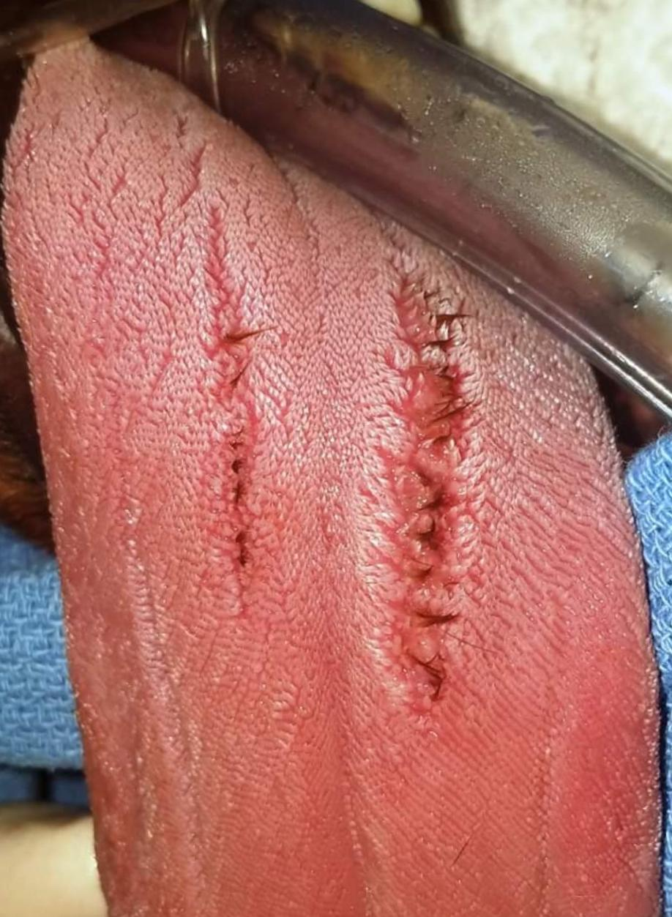
- Herpes stomatitis: The herpes virus can uncommonly cause cold sores on the tongue. Herpes virus cold sores are usually on the lip.
- Lichen planus: A harmless condition that can affect the skin or the mouth. The cause is unknown; however, it is believed to be caused by the immune system attacking the skin and lining of the mouth.

ASSIGNMENT 2
ESSAY ON AIR SINUSES
The air sinuses or paranasal sinuses are air-filled extensions of the respiratory part of the nasal cavity. There are four paired sinuses, named according to the bone in which they are located; maxillary, frontal, sphenoid and ethmoid.
The function of the sinuses is not clear. It is thought that they may contribute to the humidifying of the inspired air. They also reduce the weight of the skull.
Sinuses are formed in childhood by the nasal cavity eroding into surrounding bone. As they are outgrowths of the nasal cavity, they all drain back into it – openings to the paranasal sinuses are found on the roof and lateral walls of the nasal cavity. The inner surface is lined by a respiratory mucosa.
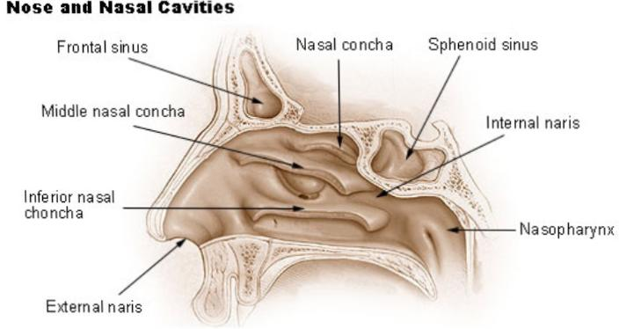
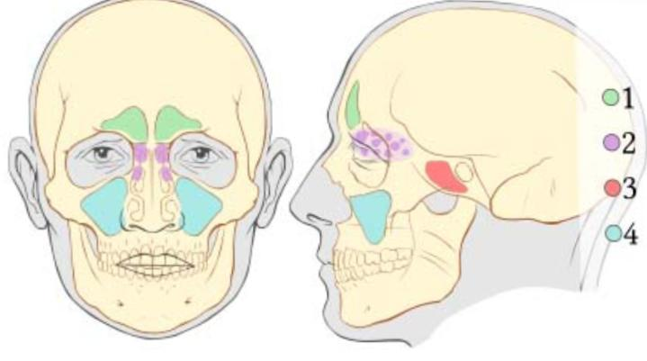
Diagram showing Air sinuses
The sinuses include:
- Frontal sinuses
- Sphenoid sinuses
- Ethmoidal sinuses
- Maxillary sinuses
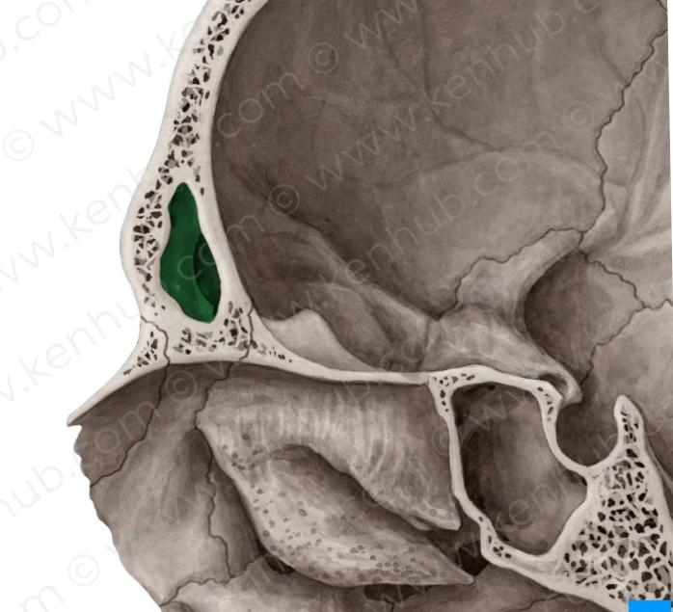
Image showing frontal sinuses
Frontal Sinuses: These are the most superior in location, found under the forehead. The frontal sinuses are variable in size, but always triangular-shaped. They drain into the nasal cavity via the frontonasal duct, which opens out at the hiatus semilunaris on the lateral wall.
Vascularization, innervation and lymphatics
They drain primarily into the ethmoidal infundibulum and the corresponding lymph drainage occurs via the submandibular lymph nodes. It is innervated by the ophthalmic nerve, including the supraorbital and supratrochlear branches.
The frontal sinuses are supplied by the:
- anterior ethmoidal artery
- supraorbital artery
- supratrochlear artery
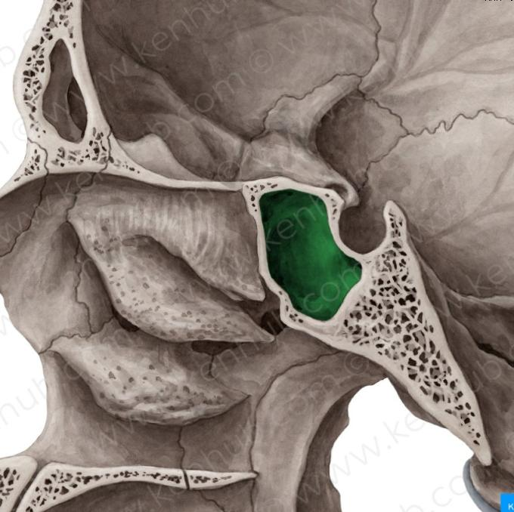
image showing Sphenoid sinus
Sphenoid Sinuses: The sphenoid sinuses also lie relatively superiorly, at the level of the spheno-ethmodial recess. They are found more posteriorly, and are related superiorly and laterally to the cranial cavity. The sphenoid sinuses drain out onto the roof of the nasal cavity. The relationships of this sinus are of clinical importance – the pituitary gland can be surgically accessed via passing through the nasal roof, into the sphenoid sinus and through the sphenoid bone.

Vascularization, innervation and lymphatics
The lymphatic drainage occurs in the same way as the posterior ethmoid sinus. The posterior ethmoidal artery and the posterior lateral nasal branches supply the sphenoidal sinuses.
The posterior ethmoidal nerve and the orbital branch of the pterygopalatine ganglion innervate them.
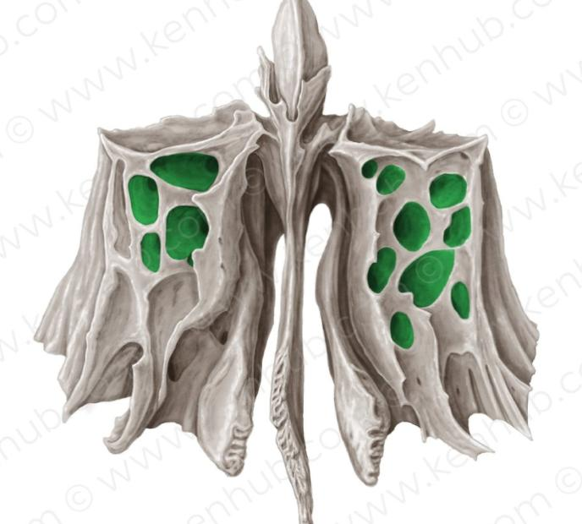
Image showing ethmoidal sinus
Ethmoidal Sinuses: There are three ethmoidal sinuses; anterior, middle and posterior. They empty into the nasal cavity at different places:
- Anterior – Hiatus semilunaris
- Middle – Ethmoid bulla
- Posterior – Superior meatus

Vascularization, innervation and lymphatics
The anterior and middle ethmoid sinuses send their lymphatic drainage to the submandibular lymph nodes while the posterior ethmoid sinus sends its own to the retropharyngeal lymph nodes.
The anterior and posterior ethmoidal arteries, as well as the posterior lateral nasal branches provide an ample blood supply to this region. Meanwhile the anterior and posterior ethmoidal nerves and the posterior lateral superior and inferior nasal nerves help innervate it.
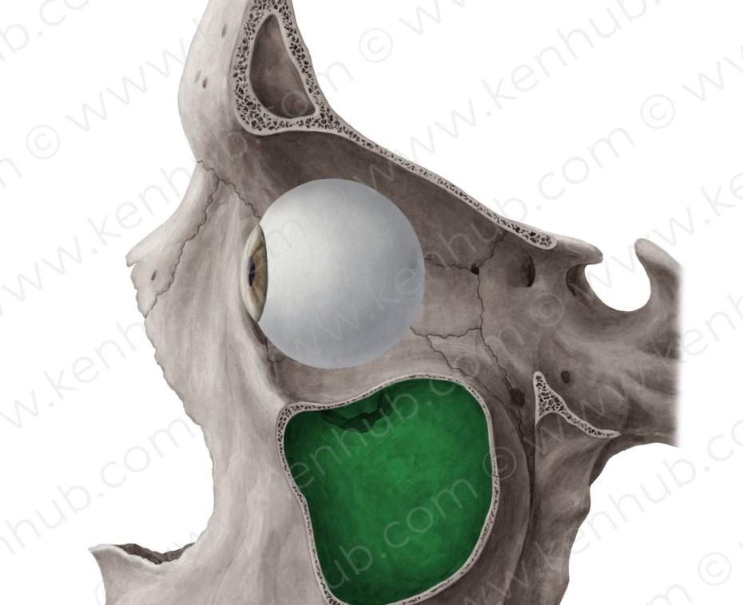
Image showing maxillary sinuses
Maxillary Sinuses: The largest of the sinuses. It is located laterally and slightly inferiorly to the nasal cavities. It drains into the nasal cavity at the hiatus semilunaris, underneath the frontal sinus opening. This is a potential pathway for spread of infection – fluid draining from the frontal sinus can enter the maxillary sinus.
Vasculature, innervation and lymphatics
The submandibular lymph nodes are the main destination during lymphatic drainage. The blood supply includes a contribution from the:
- anterior superior alveolar artery
- middle superior artery
- posterior superior alveolar artery
Innervation occurs through nerves of the same names as the arteries.

APPLIED ANATOMY
Sinusitis: as the paranasal Air sinuses are continuous with the nasal cavity an upper respiratory tract infection can spread to the sinuses. Infection of the sinuses causes inflammation (particularly pain and selling it the mucosa). And it is known as sinusitis, if more than one sinus is affected it is called pan sinusitis.

