Name: Ayenor E. Christabel
Matric No: 17/MMHS01/076
Course: Gross Anatomy of head and neck
1.) Write an essay on the cavernous sinus
The Cavernous Sinus is one of the several drainage pathways or a network of veins among the Dural venous sinuses creating a cavity called the Lateral Sellar Component bordered by the temporal bone of the skull and the sphenoid bone, lateral to the sella turcica. The Cavernous sinus in the brain sits in the middle, it is roofed by an inner layer of dura mater that continues with the diaphragma sellae that covers the superior part of the pituitary gland. It receives venous drainage from the brain and receives tributaries from parts of face.
Contents of the cavernous sinus
The carotid siphon of the internal carotid artery and the remainder of the cranial nerves pass through the lateral wall of the carotid sinus, and from superior to inferior they are: Oculomotor Nerve (CN III), Trochlear nerve (CN IV), Ophthalmic branch of Trigeminal nerve (CNV₁), Maxillary Branch of Trigeminal Nerve (CNV₂), Abducens Nerve(CN VI) all pass through this blood filled space. The Abducens nerve transverses the sinus lateral to the internal carotid artery.
- Internal Carotid Artery :- This is a branch of the common carotid artery along with its postganglionic sympathetic plexus from the superior cervical region gains access to the cavernous sinus posteriorly. Within the sinus, the internal carotid artery travels anteriorly in a horizontal manner until it reaches the anterior limit of the sinus then it curves vertically and superiorly to exit the sinus through its roof and become the cerebral part of the internal carotid artery.
- Abducent nerve :- It access the cavernous sinus by way of the petrousal sinus, within the cavernous sinus it takes an inferolateral course relative to the internal carotid artery. It exits the sinus by the way of the superior orbital fissure to gain access to the orbit where it innervates the lateral rectus muscle of the eyeball
- Oculomotor nerve :- This is the most superior of the four nerves in the lateral wall, it passes through the space formed by the tentorium cerebelli entering the lateral wall of the sinus then takes an anterior inferomedial course towards the anterior extremity of the sinus.
- Trochlear nerve :- This is the smallest, it enters the posterior aspect of the cavernous sinus after leaving the posterior part of the brainstem and decussating with the same nerve from the opposite side. It continues anteriorly in the lateral wall of the cavernous sinus, inferior to CN III and passes through the superior orbital fissure at the anterior aspect of the sinus.
- Trigeminal nerve:- Two of the three branches of the trigeminal nerve (CN V) pass through the cavernous sinus. Prior to entering the cavernous sinus, the proximal portion of the nerve lies in Meckel’s cave, where it forms the trigeminal ganglion. The ophthalmic and the maxillary (CN V1 and CN V2, respectively), travel through the lateral wall of the sinus. Both take courses inferior to CN III and CN IV, however, CN V2 is the most inferior of them all. Both CN V branches in the sinus travels horizontally. CN V2 leaves the sinus via foramen rotundum, while the three branches of CN V1 exit the cranial fossa via the superior orbital fissure.

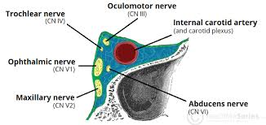
Contents of the cavernous sinus
Relations
Above: Foramen lacerum and the junction of the body and greater wing of sphenoid bone
Medially: Hypophysis cerebri or pituitary gland and sphenoidal air sinus
Laterally:- Temporal lobe with uncus
Anteriorly: Superior orbital fissure and the apex of the orbit
Posteriorly: Apex of Petrous temporal bone
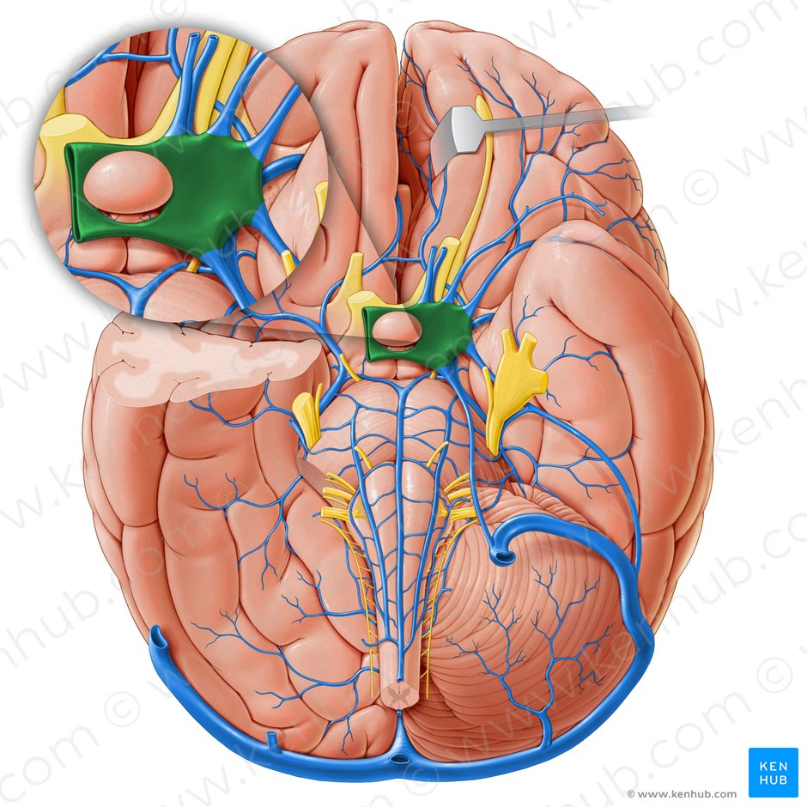
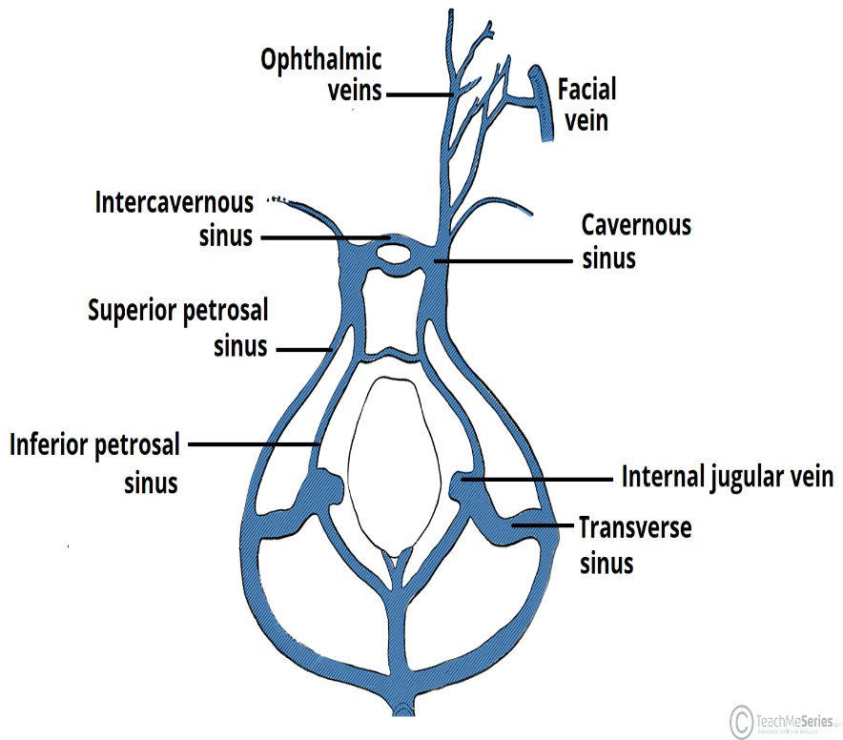
Diagram of Cavernous sinus
Venous connections:- The Cavernous sinus receives blood from; Superior and Inferior Ophthalmic veins, Sphenoparietal sinus, Superficial middle cerebral veins, Inferior cerebral veins, Middle meningeal vein, Hypophyseal sinus and drains into the Superior petrousal sinus and Inferior petrousal sinus.
- Superior ophthalmic vein:- The cavernous sinus generally has five venous tributaries. The superior ophthalmic vein receives blood from the ethmoidal, nasofrontal, vorticose (drains the ocular choroid), and central retinal veins. It drains into the anterior part of the sinus via the superior orbital fissure.
- Inferior ophthalmic vein:- It collects blood from the eyelids, lacrimal sac, and some vorticose contributions, as well as the anterior floor and medial wall of the orbit. In addition to draining to the cavernous sinus, it also drains to the pterygoid plexus.
- Superficial middle cerebral vein:- It pierces the roof of the sinus. Here, it drains blood from the cortices that are adjacent to it as it courses through the lateral sulcus.
- Middle meningeal vein:- Branches of the middle meningeal vein may join the sphenoparietal sinus on its way to the cavernous sinus. Before piercing the roof of the sinus, it travels along the edge of the lesser wing of the sphenoid between the layers of dura mater.
- Hypophyseal sinus:- Efferent hypophyseal veins of both the adenohypophysis and neurohypophysis drain to the cavernous sinus.
The left and right cavernous sinuses communicate by way of the anterior and posterior intercavernous sinuses. These vessels travel anteriorly and posteriorly (respectively) around the infundibulum of the pituitary gland, deep to the diaphragma sellae, between the layers of dura mater. The cavernous sinus in turn drains to the superior and inferior petrosal sinuses. Both sinuses join the sigmoid sinus, which then becomes the internal jugular vein. The internal jugular vein meets with the subclavian vein to become the left (or right) brachiocephalic vein.
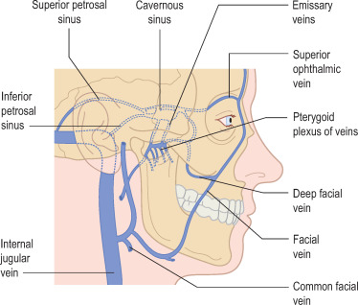
Clinical Significance
It is the only anatomic location in the body in which artery travels completely through a venous structure.
- Carotid-cavernous fistula:- It results from an abnormal communication between the arterial and venous systems within the cavernous sinus in the skull. It is a type of arteriovenous fistula, this is when the Internal Carotid Artery ruptures into the Cavernous sinus. As arterial blood under high pressure enters the cavernous sinus, the normal venous return to the cavernous sinus is impeded and this causes engorgement of the draining veins, manifesting most dramatically as a sudden engorgement and redness of the eye of the same side.
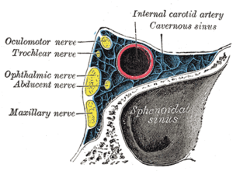
b.) Cavernous sinus syndrome:- This may result from mass effect of these tumors and cause ophthalmoplegia (from compression of the oculomotor nerve, trochlear nerve, and abducens nerve), ophthalmic sensory loss (from compression of the ophthalmic nerve), and maxillary sensory loss (from compression of the maxillary nerve). A complete lesion of the cavernous sinus disrupts CN III, IV, and VI, causing total ophthalmoplegia, usually accompanied by a fixed, dilated pupil. Involvement of CN V (V₁ and variable involvement of V₂) causes sensory loss in these divisions of the trigeminal nerve. Horner’s syndrome can also occur due to involvement of the carotid ocular sympathetics but may be difficult to appreciate in the setting of a complete third nerve injury.
Because of its connections with the facial vein via the superior ophthalmic vein, it is possible to get infections in the cavernous sinus from an external facial injury within the danger area of the face.
2.) Discuss the walls of the nose
There are 2 walls of the nose and they are:-
a.) Medial Wall (Nasal Septum):- It Is formed primarily by the perpendicular plate of the ethmoid bone, vomer, and septal cartilage. It Is also formed by processes of the palatine, maxillary, frontal, sphenoid, and nasal bones.
b.) Lateral Wall:- is formed by the superior and middle conchae of the ethmoid bone and the inferior conchae. This is also formed by the nasal bone, frontal process and nasal surface of the maxilla, lacrimal bone, perpendicular plate of the palatine bone, and medial pterygoid plate of the sphenoid bone. Contains the following structures and their openings:
1. Sphenoethmoidal recess: opening of the sphenoid sinus.
2. Superior meatus: opening of the posterior ethmoidal air cells.
3. Middle meatus: opening of the frontal sinus into the infundibulum, openings of the middle ethmoidal air cells on the ethmoidal bulla, and openings of the anterior ethmoidal air cells and maxillary sinus in the hiatus semilunaris.
4. Inferior meatus: opening of the nasolacrimal duct.
5. Sphenopalatine foramen: opening into the pterygopalatine fossa; transmits the sphenopalatine artery and nasopalatine nerve.

