PHYSIOLOGY (PSH 202) ASSIGNMENT 2

ABU ANGEL ANONE

18/MHS02/006

NURSING SCIENCE (200L)

FEMALE REPRODUCTIVE PHYSIOLOGY
QUESTIONS:
- Briefly discuss the cyclic changes in any two of the following;
- CERVIX
- VAGINA
- BREAST
- Explicate any one of the following;
- Menstrual cycle
- Hormonal regulation of the menstrual cycle.

ANSWERS:
1.a CERVIX
Cervix is the lowest region of the uterus; it attaches the uterus to the vagina and provides a passage between the vaginal cavity and the uterine cavity. The cervix, only about 4 centimeters (1.6 inches) long, projects about 2 centimeters into the upper vaginal cavity. The cervical opening into the vagina is called the external os; the cavity running the length of the cervix is the endocervical canal; the opening of the endocervical canal into the uterine cavity, the internal os. The endocervical canal transports sperm into the uterine cavity, allows the escape of blood from the uterus during menstruation, and supplies mucus (a thick lubricating protein) to the female reproductive tract. During childbirth the canal is greatly stretched.

The endocervical canal is lined with a moist mucous membrane. Cells within this tissue layer secrete fluids and project minute hair like structures called cilia that help to move sperm through the canal. The fluids given off consist mainly of water, sugars, starches, and proteins. During ovulation (when the ovaries release an egg) the mucous secretions are plentiful and watery; before and after ovulation the secretions are thick and relatively scant. The mucus is arranged in a mesh like pattern of filaments and spaces. During ovulation the openings in the meshwork of filaments become larger so that sperm may freely pass through. Lysozyme, also present in cervical mucus, is an enzyme that helps to destroy certain types of bacteria and acts as a defense against infections.
Covering the mucous membrane is a thick layer of collagen and elastic fibers. There is also some muscle tissue, but the quantity is considerably less than in the rest of the uterus. The cervix is densely fibrous and, consequently, more rigid than the other uterine tissue. During pregnancy the cervix is the only part of the uterus that does not expand to house the developing child; the mucus inside the endocervical canal becomes very thick at this time and acts as a plug that helps to seal off the rest of the uterus from infection. Shortly before childbirth, the mucus thins, and the cervical walls relax to permit delivery.

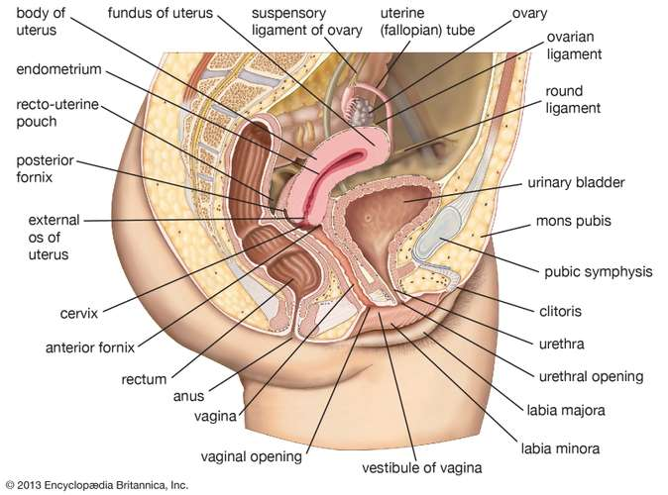

Afflictions pertaining to the cervix include chronic inflammation, laceration and hemorrhaging during childbirth, malignant and benign tumors, and any of the many infectious venereal diseases.

CYCLIC CHANGES:
Thirty parous ewes were divided into six groups and sacrificed on day 0 (first day of estrus), 1, 2, 10, 15 or 16 of the estrous cycle. The cervices were removed immediately and processed for examination with the scanning electron microscope. Observation of the tissues reveals that the surface of the cervix is highly convoluted, which results in the formation of numerous folds or crypts. Two forms of columnar epithelial cells, a ciliated and a non-ciliated cell with microvilli, line the luminal surface of the cervix in the day 10, luteal-phase ewes. However, on day 15, 2 days before estrus, the non-ciliated cells differentiate into two morphologically distinct types of secretory cells. One type forms when the apex of the non-ciliated cell dilates outward into the lumen of the cervix. Concurrent with apical enlargement, the microvilli are lost and the limiting cell membrane becomes smooth. The other type of cell is characterized by only a slight apical swelling. Consequently, remnants of microvilli along with secretory granules can be observed on the limiting membrane of this cell. Both cells release a particulate component, which is believed to be a precursor of mucus, into the lumen of the cervix. These particles undergo a series of morphological transformations to form a fibrillar layer, generally referred to as 'cervical mucus', that covers the epithelial surface at estrus. One to 2 days following the onset of estrus, the fibers become more closely associated with amorphous material that begins to coagulate, thereby revealing the underlying ciliated and non-ciliated cells that characterize the cervix of the luteal-phage ewe. The cyclical variation in secretory cells and factors that may influence that structural transformations which occur in mucus are discussed.

1.b BREAST.
The breast is the tissue overlying the chest (pectoral) muscles. Women's breasts are made of specialized tissue that produces milk (glandular tissue) as well as fatty tissue. The amount of fat determines the size of the breast.
The milk-producing part of the breast is organized into 15 to 20 sections, called lobes. Within each lobe are smaller structures, called lobules, where milk is produced. The milk travels through a network of tiny tubes called ducts. The ducts connect and come together into larger ducts, which eventually exit the skin in the nipple. The dark area of skin surrounding the nipple is called the areola.
Connective tissue and ligaments provide support to the breast and give it its shape. Nerves provide sensation to the breast. The breast also contains blood vessels, lymph vessels, and lymph nodes.

Some Breast Conditions include:
- Breast cancer: Malignant (cancer) cells multiplying abnormally in the breast, eventually spreading to the rest of the body if untreated. Breast cancer occurs almost exclusively in women, although men can be affected. Signs of breast cancer include a lump, bloody nipple discharge, or skin changes.
- Ductal carcinoma in situ (DCIS): Breast cancer in the duct cells that has not invaded deeper or spread through the body. Women diagnosed with DCIS have a high likelihood of being cured.
- Lobular carcinoma in situ (LCIS): Although called a carcinoma LCIS, which occurs in the milk-producing lobule cells, does not invade or spread and is not a true cancer. However, women with LCIS have an increased likelihood of developing invasive breast cancer in the future.
- Invasive ductal carcinoma: Breast cancer that begins in the duct cells but then invades deeper into the breast, carrying the potential of spreading to the rest of the body (metastasizing). Invasive ductal carcinoma is the most common type of invasive breast cancer.
- Invasive lobular carcinoma: Breast cancer that begins in the milk-producing lobule cells, but then invades deeper into the breast, carrying the potential of spreading to the rest of the body (metastasizing). Invasive lobular carcinoma is an uncommon form of breast cancer.
- Simple breast cyst: A benign (noncancerous), fluid-filled sac that commonly develops in women in their 30s or 40s. Breast cysts may cause tenderness and may be drained.
- Breast fibroadenoma: A very common noncancerous solid tumor of the breast. A typical fibroadenoma creates a painless, mobile lump in the breast and most commonly occurs in women in their 20s or 30s.
- Fibrocystic breast disease: A common condition in which noncancerous breast lumps may become uncomfortable and change in size throughout the menstrual cycle.
- Usual hyperplasia of the breast: A breast biopsy may show normal-appearing, noncancerous ductal cells multiplying abnormally. The presence of usual hyperplasia may slightly increase a woman's lifetime risk of breast cancer.
- Atypical hyperplasia of the breast: Abnormal-appearing cells multiplying either in the breast ducts (atypical ductal hyperplasia) or lobules (atypical lobular hyperplasia), sometimes discovered by a breast biopsy. Although the condition is noncancerous, women with atypical hyperplasia are at four to five times higher risk of developing breast cancer compared to women with no breast abnormalities.
- Intraductal papilloma: A noncancerous, wart-like breast mass that grows inside the breast ducts. Intraductal papillomas may be felt as a lump or cause clear or bloody fluid to leak from the nipple.
- Adenosis of the breast: A noncancerous enlargement of the breast lobules. Adenosis can look like breast cancer on mammograms, so a biopsy may be needed to rule out breast cancer.
- Phyllodes tumor: A rare, usually large, rapidly growing breast tumor that looks like a fibroadenoma on ultrasound. Phyllodes tumors may be benign or malignant and most commonly develop in women in their 40s.
- Fat necrosis: In response to an injury in the fatty part of the breast, a lump of scar tissue may develop. This mass can seem like breast cancer on examination or in mammograms.
- Mastitis: Inflammation of the breast, causing redness, pain, warmth, and swelling. Nursing mothers are at higher risk for mastitis, which is usually the result of infection.
- Breast calcifications: Calcium deposits in the breast are a common finding on mammograms. The pattern of calcium might suggest cancer, leading to further tests or a biopsy.
- Gynecomastia: Overdevelopment of male breasts. Gynecomastia can affect newborns, boys, and men.

CYCLIC CHANGES:
The volumes and spin‐lattice (T₁) relaxation times of breast tissues and parenchymal water content were measured non‐invasively by magnetic resonance imaging (MRI) in eight healthy women during four to eight consecutive menstrual cycles. Total breast volume, and parenchymal volume, T₁ relaxation time and water content were lowest between days 6 and 15. Between days 16 and 28, parenchymal volume, T₁ relaxation time and water content rose sharply by 38·9%, 15·1% and 24·5%, respectively, and peaked after day 25. Within 5 days of the onset of menses, parenchymal volume fell sharply by 30·3%, while water content declined by 17·5%. Rising parenchymal volume in the second half of the menstrual cycle is not solely due to increased tissue water content and provides in vivo evidence for both growth and increased tissue fluid at this time

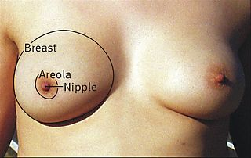
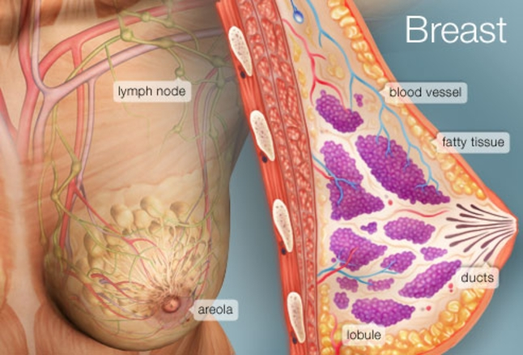

2.a MENSTRUAL CYCLE
Everyone (adolescent boys and girls) who is about to enter puberty (the process of body changes that cause a child’s body to become an adult body capable of reproduction) should be taught or know the basic medical definition of menstruation and that it is a normal process that females go through as their bodies prepare themselves for potential pregnancy. It is a part of the monthly menstrual cycle (regular cycling of hormones) that occur in the female reproductive system that makes pregnancy possible.
Medically, menstruation (also termed period or bleeding) is the process in a woman of discharging (through the vagina) blood and other materials from the lining of the uterus at about one monthly interval from puberty until menopause (ceasing of regular menstrual cycles), except during pregnancy. This discharging process lasts about 3-5 days.

What are the signs and symptoms of menstruation?
Beside the bleeding, other signs and symptoms of menstruation may include headache, acne, bloating, pains in the low abdomen, tiredness, mood changes, food cravings, breast soreness, and diarrhea.

When does menstruation begin? When does it end?
The menstrual cycle is the hormonal driven cycle; Day 1 is the first day of your period (bleeding) while day 14 is the approximate day you ovulate and if an egg is not fertilized, hormone levels eventually drop and at about day 25; the egg begins to dissolve and the cycle begins again with the period at about day 30. Menstruation begins day 1 and normally ends days 3-5 of the menstrual cycle.
At what age do girls go through puberty and begin and start their period (begin to menstruate)?
The average age for a girl to get her first period in the US is 12, but the range of age is about 8 to 15 years old. Women usually have periods until about ages 45 to 55.

At what age do girls go through puberty and begin and start their period (begin to menstrate)?
The average age for a girl to get her first period in the US is 12, but the range of age is about 8 to 15 years old. Women usually have periods until about ages 45 to 55.

How long does a period last?
The menstrual cycle is the hormonal driven cycle. Day 1 is the first day of your period (bleeding) while day 14 is the approximate day you ovulate and if an egg is not fertilized, hormone levels eventually drop and at about day 25. The egg then begins to dissolve and the cycle begins again with the period at about day 30.
Most periods vary somewhat, the flow may be light, moderate or heavy and can vary in length from about 2 to 7 days; with age, the cycle usually shortens and becomes more regular.

What is the treatment for pain and other symptoms caused by menstruation?
Treatment for the causes of menstrual pain depend on what the cause is, and may include birth control pills, heavy or prolonged periods, IUDs, noninflammatory steroid drugs (NSAIDs), for example, ibuprofen (Advil, ), aspirin, naproxen (Aleve), and other-the-counter pain (OTC) medications to relive pain and cramping.

What is toxic shock syndrome? Is it life threatening?
Women should change the pad/tampon before it becomes soaked with blood (about every 4 to 8 hours); follow directions on the box to help avoid TSS (toxic shock syndrome), a potentially deadly disease. Call your doctor or other health professional if you have any abnormalities in your period, for example, excessive bleeding, no periods, severe pain, fever with tampon use, sudden irregularities, and other problems.
.

What is menstruation? What is the menstrual cycle?
Menstruation is bleeding from the vagina that happens about once a month, as a normal part of the menstrual cycle. It is also known as having a period.
During this cycle, your hormones make the lining of the uterus become thicker, getting ready in case of pregnancy. Hormones also cause an egg to be released from an ovary, which is known as ovulation.
If you don’t become pregnant, your periods start about two weeks after you ovulate. The lining of the uterus falls away and, along with some blood, flows out through the vagina. Periods can be light or heavy, and the blood can range from bright red to dark brown. You might also notice small clots.
The menstrual period (menstrual cycle, periods) refers to the monthly vaginal bleeding that is experienced by women of reproductive age (and ovulate). Most women know that their period is approaching.
During each menstrual cycle, an egg develops and is released from the ovaries. The lining of the uterus builds up. If a pregnancy doesn’t happen, the uterine lining sheds during a menstrual period. Then the cycle starts again.
A woman’s menstrual cycle is divided into four phases:
- menstrual phase
- follicular phase
- ovulation phase
- luteal phase
The length of each phase can differ from woman to woman, and it can change over time.

Menstrual phase
The menstrual phase is the first stage of the menstrual cycle. It’s also when you get your period.
This phase starts when an egg from the previous cycle isn’t fertilized. Because pregnancy hasn’t taken place, levels of the hormone’s estrogen and progesterone drop.
The thickened lining of your uterus, which would support a pregnancy, is no longer needed, so it sheds through your vagina. During your period, you release a combination of blood, mucus, and tissue from your uterus.
You may have period symptoms like these:
- cramps (try these home remedies)
- tender breasts
- bloating
- mood swings
- irritability
- headaches
- tiredness
- low back pain
On average, women are in the menstrual phase of their cycle for 3 to 7 days. Some women have longer periods than others.

Follicular phase
The follicular phase starts on the first day of your period (so there is some overlap with the menstrual phase) and ends when you ovulate.
It starts when the hypothalamus sends a signal to your pituitary gland to release follicle-stimulating hormone (FSH). This hormone stimulates your ovaries to produce around 5 to 20 small sacs called follicles. Each follicle contains an immature egg.
Only the healthiest egg will eventually mature. (On rare occasions, a woman may have two eggs mature.) The rest of the follicles will be reabsorbed into your body.
The maturing follicle sets off a surge in estrogen that thickens the lining of your uterus. This creates a nutrient-rich environment for an embryo to grow.
The average follicular phase Trusted Source lasts for about 16 days. It can range from 11 to 27 days, depending on your cycle.

Ovulation phase
Rising estrogen levels during the follicular phase trigger your pituitary gland to release luteinizing hormone (LH). This is what starts the process of ovulation.
Ovulation is when your ovary releases a mature egg. The egg travels down the fallopian tube toward the uterus to be fertilized by sperm.
The ovulation phase is the only time during your menstrual cycle when you can get pregnant. You can tell that you’re ovulating by symptoms like these:
- a slight rise in basal body temperature
- thicker discharge that has the texture of egg whites
Ovulation happens at around day 14 if you have a 28-day cycle — right in the middle of your menstrual cycle. It lasts about 24 hours. After a day, the egg will die or dissolve if it isn’t fertilized.
NOTE: Because sperm can live up to five days, pregnancy can occur if a woman has sex as much as five days prior to ovulation.

Luteal phase
After the follicle releases its egg, it changes into the corpus luteum. This structure releases hormones, mainly progesterone and some estrogen. The rise in hormones keeps your uterine lining thick and ready for a fertilized egg to implant.
If you do get pregnant, your body will produce human chorionic gonadotropin (hCG). This is the hormone pregnancy tests detect. It helps maintain the corpus luteum and keeps the uterine lining thick.
If you don’t get pregnant, the corpus luteum will shrink away and be resorbed. This leads to decreased levels of estrogen and progesterone, which causes the onset of your period. The uterine lining will shed during your period.
During this phase, if you don’t get pregnant, you may experience symptoms of premenstrual syndrome (PMS). These include:
- bloating
- breast swelling, pain, or tenderness
- mood changes
- headache
- weight gain
- changes in sexual desire
- food cravings
- trouble sleeping
The luteal phase lasts for 11 to 17 days. The average lengthTrusted Source is 14 days.

Identifying common issues
Every woman’s menstrual cycle is different. Some women get their period at the same time each month. Others are more irregular. Some women bleed more heavily or for a longer number of days than others.
Your menstrual cycle can also change during certain times of your life. For example, it can get more irregular as you get close to menopause.
One way to find out if you’re having any issues with your menstrual cycle is to track your periods. Write down when they start and end. Also record any changes to the amount or number of days you bleed, and whether you have spotting between periods.
Any of these things can alter your menstrual cycle:
- Birth control. The birth control pill may make your periods shorter and lighter. While on some pills, you won’t get a period at all.
- Pregnancy. Your periods should stop during pregnancy. Missed periods are one of the most obvious first signs that you’re pregnant.
- Polycystic ovary syndrome (PCOS). This hormonal imbalance prevents an egg from developing normally in the ovaries. PCOS causes irregular menstrual cycles and missed periods.
- Uterine fibroids. These noncancerous growths in your uterus can make your periods longer and heavier than usual.
- Eating disorders. Anorexia, bulimia, and other eating disorders can disrupt your menstrual cycle and make your periods stop.
Here are a few signs of a problem with your menstrual cycle:
- You’ve skipped periods, or your periods have stopped entirely.
- Your periods are irregular.
- You bleed for more than seven days.
- Your periods are less than 21 days or more than 35 days apart.
- You bleed between periods (heavier than spotting).

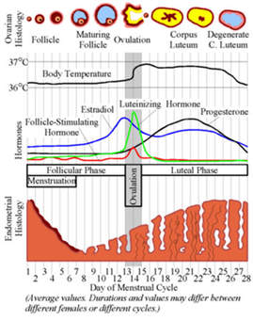

When do girls start their period?
Girls have their first period during puberty. Most often that is around the age 12 or 13 years old, but girls can start menstruating as young as 9, or as late as 16.
bleeding. When you menstruate, your body sheds the lining of the uterus (womb). Menstrual blood flows from the uterus through the small opening in the cervix and passes out of the body through the vagina. Most menstrual periods last from 3 to 5 days.

How long do periods last?
Menstruation affects every woman, but the experience can differ between women. When periods (menstruations) come regularly, this is called the menstrual cycle. Having regular menstrual cycles is a sign that important parts of your body are working normally. The menstrual cycle provides important body chemicals, called hormones, to keep you healthy. It also prepares your body for pregnancy each month. A cycle is counted from the first day of 1 period to the first day of the next period. The average menstrual cycle is 28 days long. Cycles can range anywhere from 21 to 35 days in adults and from 21 to 45 days in young teens. The rise and fall of levels of hormones during the month control the menstrual cycle.

What are the signs and symptoms of menstruation?
Some women get symptoms leading up to and during menstruation, for example, cramps or pains low in the abdomen, bloating or swelling in the abdomen, constipation before your period, diarrhea when your period starts, acne, tiredness, and mood changes.

When do periods stop?
Women usually have periods until menopause. Menopause occurs between the ages of 45 and 55, usually around age 50. Menopause means that a woman is no longer ovulating (producing eggs) or having periods and can no longer get pregnant. Like menstruation, menopause can vary from woman to woman and these changes may occur over several years.
For the first few years after menstruation begins, longer cycles are common. A woman's cycle tends to shorten and become more regular with age. Most of the time, periods will be in the range of 21 to 35 days apart.
Periods stop during pregnancy, and often while you are breastfeeding. Some women find their periods stop for a time because of long-term illness, low body weight, stress, lots of strenuous exercise and hormone problems. Some medications, such as contraceptives, might stop your period. This can be helpful for some women, especially if their periods are heavy or painful. Sometimes after stopping the pill or other contraceptive, it can take a while for your periods to come back. Periods stop altogether when women reach menopause - the average age is 51-52.

How long is the menstrual cycle? How long do periods last?
The menstrual cycle is the hormonal driven cycle. Day 1 is the first day of your period (bleeding) while day 14 is the approximate day you ovulate and if an egg is not fertilized, hormone levels eventually drop and at about day 25. The egg then begins to dissolve and the cycle begins again with the period at about day 30.
Most periods vary somewhat, the flow may be light, moderate or heavy and can vary in length from about 2 to 7 days; with age, the cycle usually shortens and becomes more regular.

What is the treatment for pain and other symptoms caused by menstruation?
Treatment for the causes of menstrual pain depend on what the cause is, and may include birth control pills, heavy or prolonged periods, IUDs, noninflammatory steroid drugs (NSAIDs), for example, ibuprofen (Advil), aspirin, naproxen (Aleve), and other-the-counter pain (OTC) medications to relive pain and cramping.

What problems occur during menstruation?
Problems with periods can include heavy bleeding, period pain (also called dysmenorrhoea), unpredictable or irregular periods, and premenstrual syndrome, or PMS, which makes some women feel irritable and sad and can cause bloating, tender breasts and aching.

