NAME: IMAM, MAIMUNAT NNA
MATRIC NO: 18/MHS01/183
LEVEL: 200L MEDICINE AND SURGERY
LECTURER: DR. OGEDENGBE OLUWATOSIN OLALEKAN
COUSE NAME: ANATOMY (EMBRYOLOGY)
DATE: April 30, 2020

QUESTIONS
- Discuss Ovulation
- Difference between Meiosis I and Meiosis II
- Discuss the stages involved in fertilization
- Differentiate between monozygotic twins and dizygotic twins.

ANSWERS
Discuss Ovulation
Ovulation is the release of the secondary oocyte from the ovarian (vesicular) follicle which occurs on the day 14 of a 28-day ovarian cycle. Prior to ovulation, the secondary oocyte grows rapidly to a diameter of about 25 mm to become mature vesicular/ mature secondary or Graafian follicle. Coincidentally with the final development of the vesicular follicle, there is an abrupt increase in LH that cause the primary oocyte to complete meiosis I and the follicles to enter the preovulatory mature vesicular stage. This also initiates meiosis II but the secondary oocyte is then arrested in metaphase II for approximately 3 hours before ovulation by cytostatic factor. While on the surface on the ovary a stigma appears, an avascular spot.
The abrupt increase in LH surge cause two important events to occur which are:
- it increases collagenase activity, resulting in digestion of collagen fibers (connective tissue) surrounding the follicle
- Prostaglandin levels also increase in response to the LH surge and cause local muscular contractions in the ovarian wall
This contractions pushes the oocyte along with the granulosa cells out of the region of the cumulus oophorus; causing the oocyte to float out of the ovary. However some of the cumulus oophorus rearrange themselves around the zona pellucida as the corona radiata.
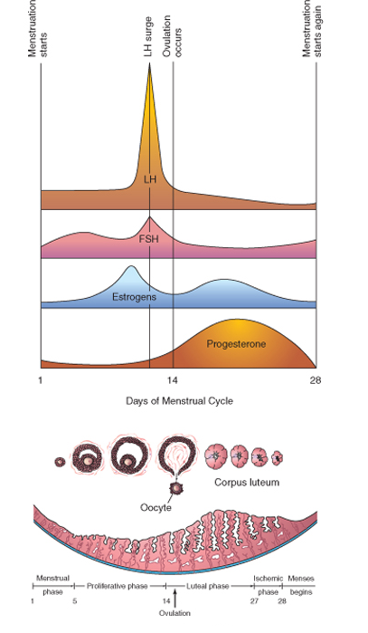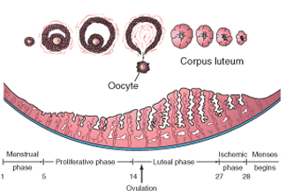

CLINICAL CORRELATION
- ANOVULATION: This is the cessation of ovulation due to an inadequate release of gonadotropins. Ovulation can be induced by the administration of gonadotropins.
- MITTELSCHMERZ: This the abdominal pain that accompanies ovulation in some women. This may result into slight bleeding into the peritoneal cavity which causes sudden constant pain in the lower abdomen.

Difference between Meiosis I and Meiosis II
Meiosis is the cell division that starts off with a diploid parent cell and ends haploid daughter cells called gametes.
 | MEIOSIS I | MEIOSIS II
Type of division | Reduction division | Equational division
Homologous chromosomes | Present | Absent
Phases | 4 | 4
Interphase | Preceded by interphase | No interphase
Crossing over | Present | Absent
Synapsis | Present | Absent
Chiasma Formation | Present | Absent
Metaphase | Alignment of 46 homologous duplicated chromosomes at the metaphase plate | alignment of 23 duplicated chromosomes at the metaphase plate
Anaphase | Separation of the 46 homologous duplicated chromosome | Separation of the 23 duplicated chromosomes
Gametes | 2 gamates | 4 gametes
Chromosomes of the daughter cells | 23 duplicated chromosomes (2N) – Diploid | 23 single chromosomes (1N) – Haploid
Centromere | Do not split | split
Duration | Longer | shorter
Telophase | Homologous chromosomes separate and move towards the opposite poles of the cell | Sister chromatids separate and move towards the opposite poles of the cell
CLINICAL CORRELATION
- The meiotic divisions increase genetic variability through crossing over which helps to redistributes genetic material and through random distribution of the homologous chromosomes to the daughter cells.
- It helps in producing germ cells which contains a haploid number of the chromosomes which also help in restoring the diploid number of 26 chromosomes.
- Nondisjunctions: This is the failure of the chromosomes to separate properly which could occur either in meiosis I or meiosis II resulting into members of the homologous chromosome pair to move into the one cell or both sister chromatids move into one cell. This could lead to genetic abnormalities such as:
  - Trisomy: This is when a nondisjunction occurs and the gametes receives one extra chromosome. When fertilization occurs with a normal gamete, this will produce an individuals with 47 chromosomes. This could result into trisomy 13 (patau syndrome); trisomy 18 (Edwards syndrome); and trisomy 21 (Down syndrome).

  - Monosomy: This is when a nondisjunction occurs and the gametes loses one chromosome. When fertilization occurs with a normal gamete, this will produce an individuals with 45 chromosomes. The only monosomy compatible with life is monosomy X chromosome (Turner syndrome).

Discuss the stages involved in fertilization
Fertilization is the union of sperm and oocyte which usually occurs in the ampulla of the uterine tube. The process of fertilization takes place at approximately 24 hours. There are series of coordinated events that occurs which leads to the formation of the zygote as a result of fertilization.
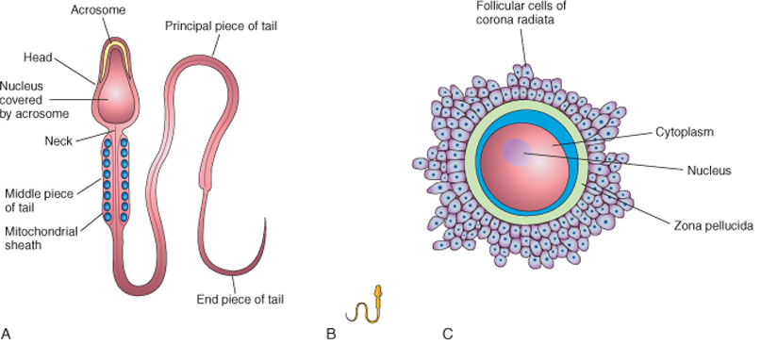

The stages involved in fertilization are:
  - Passage of a sperm through the corona radiata
  - Penetration of the zona pellucida;
  - Fusion of plasma membranes of the oocyte and sperm;
  - Completion of the second meiotic division of oocyte and formation of female pronucleus;
  - Formation of the male pronucleus;
  - The formation of the zygote
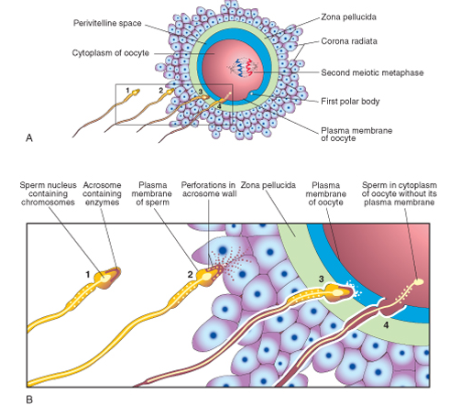
- Passage of a sperm through the corona radiata: For the sperm to pass through the corona radiata, the cell must be capacitated. This means that the glycoprotein coat and seminal plasma proteins from the plasma membrane that overlies the acrosomal region of the spermatozoa must be removed before it can pass through the cororna radiata.

- Penetration of the zona pellucida: once the sperm pass through the corona radiate, it has to penetrate the second layer which is the zona pellucida. The zona pellucida is amorphous, acellular glycoprotein that surrounds the plasma membrane of the oocyte which facilitates and maintains sperm binding and induces the acrosome reaction. The glycoprotein has a binding protein receptors on its surface called the ZP3/zona protein 3. The acrosome of the sperm binds to the receptors which causes an acrosomal reaction, which is the release of the acrosine,which are lysosomal enzymes, to allow the sperm to swim to the plasma membrane. Once the head of the sperm comes in contact with the plasma membrane, the permeability of the zona pellucida changes which prevents other sperms from penetrating the zona pellucida. This response from the zona pellucida is as a result of the lysosomal enzymes released from cortical granules lining the plasma membrane of the oocyte, once the sperm comes in contact with the oocyte. This cortical granules send signals to the zona pellucida to close their binding site; thereby preventing polyspermy (Block to polyspermy).
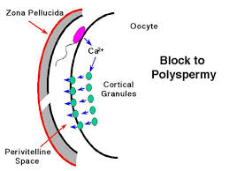

- Fusion of plasma membranes of the oocyte and sperm: Once the head of sperm comes in contact with the plasma membrane of the oocyte, the plasma membrane of the sperm and that of the oocyte fuses and break down at the area of fusion. The head and tail of the sperm enter the cytoplasm of the oocyte, but the sperm's plasma membrane remains behind.
- Completion of the second meiotic division of oocyte and formation of female pronucleus: As soon as the sperm enters that region of the cytoplasm of the oocyte, the second meiotic division is complete and a mature oocyte and a second polar body are formed. The nucleus of the mature ovum/oocyte is now called the female pronucleus.
- Formation of the male pronucleus: The tail of the sperm degenerates in the cytoplasm of the oocyte and the nucleus of the sperm enlarges and become the male pronucleus.
- The formation of the zygote: The male and female pronuclei fuse into a single diploid aggregation of chromosomes, the ootid which becomes a zygote. The chromosomes in the zygote becomes arranged on a cleavage spindle in preparation for cleavage of the zygote.
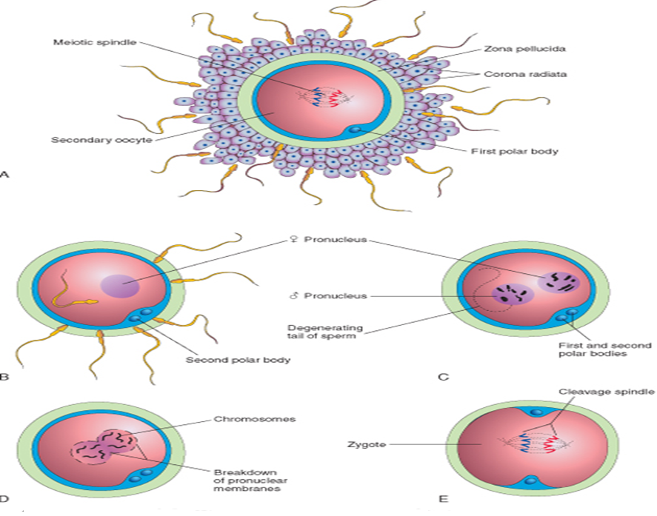
CLINICAL CORRELATION OF FERTILIZATION
- Ectopic Pregnancy: This is when the fertilized egg or blastocyst implants within the uterine tube due to delayed transport. The common site of an ectopic pregnancy is the ampulla causing tubal pregnancy. It may also in the abdomen causing abdominal pregnancy.
- Assisted reproductive technologies:
  - In vitro fertilisation (IVF): is a process by which an egg is fertilised by sperm outside the body: in vitro (outside) in a glass. The fertilised egg (zygote) is cultured for 2–6 days in a growth medium and is then implanted in the same or another woman's uterus, with the intention of establishing a successful pregnancy. This provides women who are sterile with the opportunity to bear children.
  - Intracytoplasmic sperm injection: The sperm is injected directly into the cytoplasm of the mature oocyte. This is used in the cases where IVF fails or too few sperm for in vitro insemination.
  - Surrogate Mothers: This is the transfer of embryo to another woman’s uterus for development and delivery.
  - Cryopreservation of embryo: This is the use of cryoprotectant to freeze the early embryo as a result of In vitro fertilization for a long time.

Differentiate between monozygotic twins and dizygotic twins.
Twinning is the process of having two or more conceptus.

 | MONOZYGOTIC TWINS | DIZYGOTIC TWINS
Definition | They are twins that develop from a single zygote as a result of the splitting of fertilized embryo into the two | They are twins that developed from two different zygotes due to two separate simultaneous fertilization events
Features | Identical | Non-identical
Sex | Same (both males or females) | Different (one girl and one boy)
Fertilization | One sperm fertilizes one oocytes | Two sperms fertilizes two oocytes
Amniotic sac | Same | Different
Chronion Sac | Same | Different
Placenta | Same but two umbilical cords | Different
Twin-to-Twin transfusion syndrome (TTS) risk | There is a high TTS risk | There is a much lower TTS in the dizygotic twins
Blood Types | Same | Different

Clinical Correlation
- Twin-Twin Transfusion Syndrome: This is a disease of the placenta which causes one of the twin to be a donor, causing it to become dehydrated; while the other is recipient whose system is overwhelmed with fluids. This might result into an enlarged bladder and excess amniotic fluid.

- Superfecundation: This is the fertilization of two or more oocytes at the different times. This is the presence of two fetuses in the uterus caused by fertilization at different times.

- Conjoined Monozygotic Twins: These are two babies who are born physically connected to each other. The conjoined twins develop when an early embryo only partially separates to form two individuals. The twin phenotype is named according to the regions that are attached, for instance thoracopagus, which indicates that there is an anterior union of the thoracic regions.

