NAME: Osakwe Chukwuweike Jesse
DEPT: Medicine and Surgery
LEVEL: 300L
MATRIC NO: 17/mhs01/273

- Discuss the anatomy of the tongue and comment on its applied anatomy.

ANSWER
The tongue is a muscular organ in the mouth of most vertebrates that manipulates food for mastication and is used in the act of swallowing. It has importance in the digestive system and is the primary organ of taste in the gustatory system. The tongue's upper surface (dorsum) is covered by taste buds housed in numerous lingual papillae. It is sensitive and kept moist by saliva and is richly supplied with nerves and blood vessels. The tongue also serves as a natural means of cleaning the teeth. A major function of the tongue is the enabling of speech in humans and vocalization in other animals.
The tongue is anchored to the mouth by webs of tough tissue and mucosa. The tether holding down the front of the tongue is called the frenum. In the back of the mouth, the tongue is anchored into the hyoid bone. The tongue is vital for chewing and swallowing food, as well as for speech.
The tongue is a muscular hydrostat that forms part of the floor of the oral cavity. The left and right sides of the tongue are separated by a vertical section of fibrous tissue known as the lingual septum. This division is along the length of the tongue save for the very back of the pharyngeal part and is visible as a groove called the median sulcus. The human tongue is divided into anterior and posterior parts by the terminal sulcus which is a V-shaped groove. The apex of the terminal sulcus is marked by a blind foramen, the foramen cecum, which is a remnant of the median thyroid diverticulum in early embryonic development. The anterior oral part is the visible part situated at the front and makes up roughly two-thirds the length of the tongue. The posterior pharyngeal part is the part closest to the throat, roughly one-third of its length. These parts differ in terms of their embryological development and nerve supply.
The anterior tongue is, at its apex, thin and narrow. It is directed forward against the lingual surfaces of the lower incisor teeth. The posterior part is, at its root, directed backward, and connected with the hyoid bone by the hyoglossi and genioglossi muscles and the hyoglossal membrane, with the epiglottis by three glossoepiglottic folds of mucous membrane, with the soft palate by the glossopalatine arches, and with the pharynx by the superior pharyngeal constrictor muscle and the mucous membrane. It also forms the anterior wall of the oropharynx.
The average length of the human tongue from the oropharynx to the tip is 10 cm. The average weight of the human tongue from adult males is 70g and for adult females 60g.
UPPER SURFACE OF THE TONGUE
Features of the tongue surface
The upper surface of the tongue is called the dorsum, and is divided by a groove into symmetrical halves by the median sulcus. The foramen cecum marks the end of this division (at about 2.5 cm from the root of the tongue) and the beginning of the terminal sulcus. The foramen cecum is also the point of attachment of the thyroglossal duct and is formed during the descent of the thyroid diverticulum in embryonic development.
The terminal sulcus is a shallow groove that runs forward as a shallow groove in a V shape from the foramen cecum, forwards and outwards to the margins (borders) of the tongue. The terminal sulcus divides the tongue into a posterior pharyngeal part and an anterior oral part. The pharyngeal part is supplied by the glossopharyngeal nerve and the oral part is supplied by the lingual nerve (a branch of the mandibular branch (V3) of the trigeminal nerve) for somatosensory perception and by the chorda tympani (a branch of the facial nerve) for taste perception.
Both parts of the tongue develop from different pharyngeal arches.
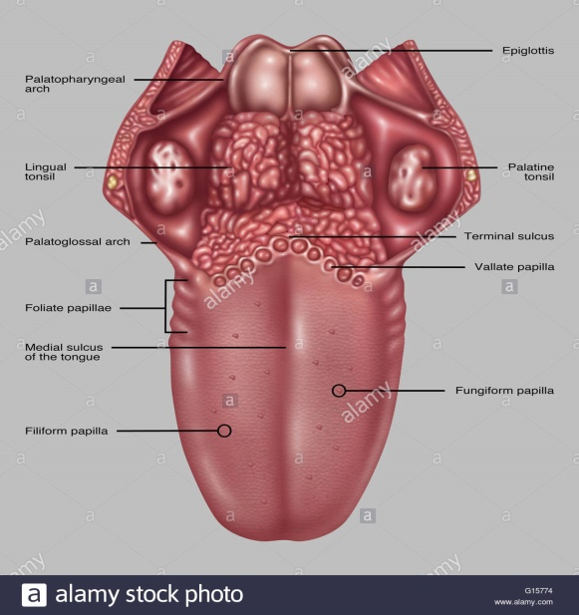
UNDERSURFACE OF THE TONGUE
On the undersurface of the tongue is a fold of mucous membrane called the frenulum that tethers the tongue at the midline to the floor of the mouth. On either side of the frenulum are small prominences called sublingual caruncles that the major salivary submandibular glands drain into.
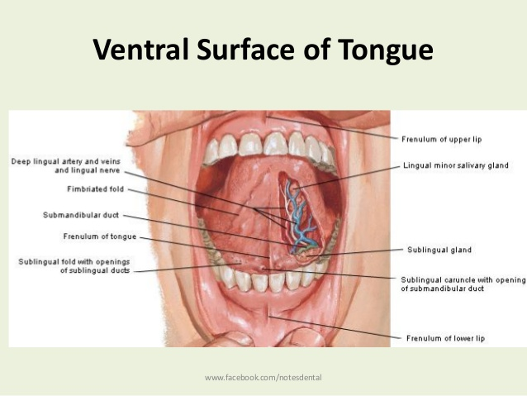
MUSCLES OF THE TONGUE
The eight muscles of the human tongue are classified as either intrinsic or extrinsic. The four intrinsic muscles act to change the shape of the tongue, and are not attached to any bone. The four extrinsic muscles act to change the position of the tongue, and are anchored to bone.
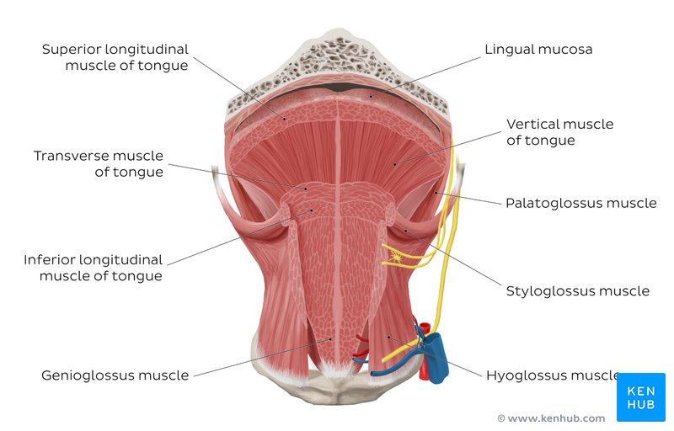

EXTRINSIC MUSCLES OF THE TONGUE
The four extrinsic muscles originate from bone and extend to the tongue. They are the genioglossus, the hyoglossus (often including the chondroglossus) the styloglossus, and the palatoglossus. Their main functions are altering the tongue's position allowing for protrusion, retraction, and side-to-side movement.
The genioglossus arises from the mandible and protrudes the tongue. It is also known as the tongue's "safety muscle" since it is the only muscle that propels the tongue forward.
The hyoglossus, arises from the hyoid bone and retracts and depresses the tongue. The chondroglossus is often included with this muscle.
The styloglossus arises from the styloid process of the temporal bone and draws the sides of the tongue up to create a trough for swallowing.
The palatoglossus arises from the palatine aponeurosis, and depresses the soft palate, moves the palatoglossal fold towards the midline, and elevates the back of the tongue during swallowing.
INTRINSIC MUSCLES OF THE TONGUE
Four paired intrinsic muscles of the tongue originate and insert within the tongue, running along its length. They are the superior longitudinal muscle, the inferior longitudinal muscle, the vertical muscle, and the transverse muscle. These muscles alter the shape of the tongue by lengthening and shortening it, curling and uncurling its apex and edges as in tongue rolling, and flattening and rounding its surface. This provides shape and helps facilitate speech, swallowing, and eating.[5]
The superior longitudinal muscle runs along the upper surface of the tongue under the mucous membrane, and elevates, assists in retraction of, or deviates the tip of the tongue. It originates near the epiglottis, at the hyoid bone, from the median fibrous septum.
The inferior longitudinal muscle lines the sides of the tongue, and is joined to the styloglossus muscle.
The vertical muscle is located in the middle of the tongue, and joins the superior and inferior longitudinal muscles.
The transverse muscle divides the tongue at the middle, and is attached to the mucous membranes that run along the sides.
BLOOD SUPPLY OF THE TONGUE
The tongue receives its blood supply primarily from the lingual artery, a branch of the external carotid artery. The lingual veins drain into the internal jugular vein. The floor of the mouth also receives its blood supply from the lingual artery. There is also a secondary blood supply to the root of tongue from the tonsillar branch of the facial artery and the ascending pharyngeal artery.The lingual artery is a good place to stop severe hemorrhage from the tongue.
NERVE SUPPLY TO THE TONGUE
Innervation of the tongue consists of motor fibers, special sensory fibers for taste, and general sensory fibers for sensation.
Motor supply for all intrinsic and extrinsic muscles of the tongue is supplied by efferent motor nerve fibers from the hypoglossal nerve (CN XII), with the exception of the palatoglossus, which is innervated by the vagus nerve (CN X).
Innervation of taste and sensation is different for the anterior and posterior part of the tongue because they are derived from different embryological structures (pharyngeal arch 1 and pharyngeal arches 3 and 4, respectively).
Anterior two thirds of tongue (anterior to the vallate papillae):
Taste: chorda tympani branch of the facial nerve (CN VII) via special visceral afferent fibers
Sensation: lingual branch of the mandibular (V3) division of the trigeminal nerve (CN V) via general visceral afferent fibers
Posterior one third of tongue:
Taste and sensation: glossopharyngeal nerve (CN IX) via a mixture of special and general visceral afferent fibers
Base of tongue
Taste and sensation: internal branch of the superior laryngeal nerve (itself a branch of the vagus nerve, CN X)
LYMPHATIC DRAINAGE
The tip of tongue drains to the submental nodes. The left and right halves of the anterior two-thirds of the tongue drains to submandibular lymph nodes, while the posterior one-third of the tongue drains to the jugulo-omohyoid nodes.

MICROANATOMY OF THE TONGUE
The upper surface of the tongue is covered in masticatory mucosa a type of oral mucosa which is of keratinized stratified squamous epithelium. Embedded in this are numerous papillae that house the taste buds and their taste receptors. The lingual papillae consist of filiform, fungiform, vallate and foliate papillae and only the filiform papillae are not associated with any taste buds.
The tongue can also divide itself in dorsal and ventral surface. The dorsal surface is a stratified squamous keratinized epithelium which is characterized by numerous mucosal projections called papillae. The lingual papillae covers the dorsal side of the tongue towards the front of the terminal groove . The ventral surface is stratified squamous non-keratinized epithelium which is smooth.

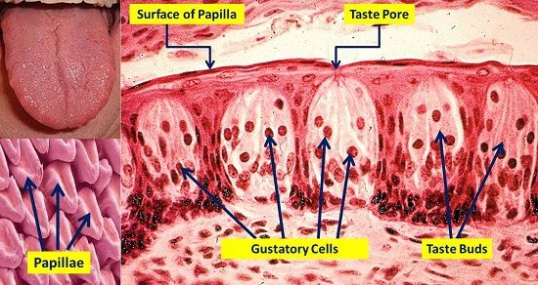

DEVELOPMENT OF THE TONGUE
The tongue begins to develop in the fourth week of embryonic development from a median swelling. In the fifth week a pair of lateral lingual swellings, one on the right side and one on the left, form on the first pharyngeal arch. These lingual swellings quickly expand and cover the median tongue bud. They form the anterior part of the tongue that makes up two thirds of the length of the tongue, and continue to develop through prenatal development. The line of their fusion is marked by the median sulcus.
In the fourth week a swelling appears from the second pharyngeal arch, in the midline, called the copula. During the fifth and sixth weeks the copula is overgrown by a swelling from the third and fourth arches (mainly from the third arch) called the hypopharyngeal eminence, and this develops into the posterior part of the tongue (the other third). The hypopharyngeal eminence develops mainly by the growth of endoderm from the third pharyngeal arch. The boundary between the two parts of the tongue, the anterior from the first arch and the posterior from the third arch is marked by the terminal sulcus. The terminal sulcus is shaped like a V with the tip of the V situated posteriorly. At the tip of the terminal sulcus is the foramen cecum, which is the point of attachment of the thyroglossal duct where the embryonic thyroid begins to descend.
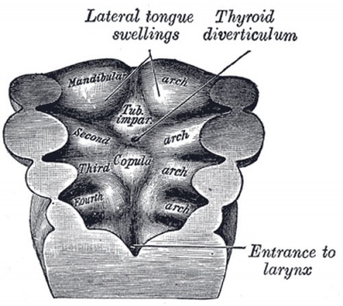
FUNCTION OF THE HUMAN TONGUE
- TASTE
Chemicals that stimulate taste receptor cells are known as tastants. Once a tastant is dissolved in saliva, it can make contact with the plasma membrane of the gustatory hairs, which are the sites of taste transduction.The tongue is equipped with many taste buds on its dorsal surface, and each taste bud is equipped with taste receptor cells that can sense particular classes of tastes. Distinct types of taste receptor cells respectively detect substances that are sweet, bitter, salty, sour, spicy, or taste of umami. Umami receptor cells are the least understood and accordingly are the type most intensively under research.
- MASTICATION
The tongue is an important accessory organ in the digestive system. The tongue is used for crushing food against the hard palate, during mastication and manipulation of food for softening prior to swallowing. The epithelium on the tongue's upper, or dorsal surface is keratinised. Consequently, the tongue can grind against the hard palate without being itself damaged or irritated.
- SPEECH
The intrinsic muscles of the tongue enable the shaping of the tongue which facilitates speech.
- INTIMACY
The tongue plays a role in physical intimacy and sexuality. The tongue is part of the erogenous zone of the mouth and can be used in intimate contact, as in the French kiss and in oral sex. It is used for pleasuring of the vagina.

APPLIED ANATOMY OF THE TONGUE
Thrush (candidiasis): Candida albicans (a yeast) grows over the surface of the mouth and tongue. Thrush can occur in almost anyone, but it occurs more often in people taking steroids or with suppressed immune systems, the very young, and the elderly.
Oral cancer: A growth or ulcer appears on the tongue and grows steadily. Oral cancer is more common in people who smoke and/or drink alcohol heavily.
Macroglossia (big tongue): This can be broken down into various categories based on the cause. These include congenital, inflammatory, traumatic, cancerous, and metabolic causes. Thyroid disease, lymphangiomas, and congenital abnormalities are among some of the causes of an enlarged tongue.
Geographic tongue: Ridges and colored spots migrate over the surface of the tongue, periodically changing its appearance. Geographic tongue is a harmless condition.
Burning mouth/burning tongue syndrome: a relatively common problem. The tongue feels burned or scalded, or strange tastes or sensations develop. Apparently harmless, burning mouth syndrome may be caused by a mild nerve problem.
Atrophic glossitis (bald tongue): The tongue loses its bumpy texture, becoming smooth. Sometimes this is due to anemia or a B vitamin deficiency.
Canker sores (aphthous ulcers): Small, painful ulcers appear periodically on the tongue or mouth. A relatively common condition, the cause of canker sores is unknown; they are unrelated to the cold sores caused by herpes viruses. Canker sores are not contagious.
Oral leukoplakia: White patches appear on the tongue that can’t be scraped off. Leukoplakia may be benign, or it can progress to oral cancer.
Hairy tongue: Papillae can overgrow the surface of the tongue, giving it a white or black appearance. Scraping off the papillae corrects this harmless condition.
Herpes stomatitis: The herpes virus can uncommonly cause cold sores on the tongue. Herpes virus cold sores are usually on the lip.
Lichen planus: A harmless condition that can affect the skin or the mouth. The cause is unknown; however, it is believed to be caused by the immune system attacking the skin and lining of the mouth.

- Write an essay on the air sinuses.

ANSWER
Paranasal sinuses are a group of four paired air-filled spaces that surround the nasal cavity.[1] The maxillary sinuses are located under the eyes; the frontal sinuses are above the eyes; the ethmoidal sinuses are between the eyes and the sphenoidal sinuses are behind the eyes. The sinuses are named for the facial bones in which they are located.
STRUCTURE OF PARANASAL SINUSES
Humans possess four paired paranasal sinuses, divided into subgroups that are named according to the bones within which the sinuses lie:
The maxillary sinuses, the largest of the paranasal sinuses, are under the eyes, in the maxillary bones (open in the back of the semilunar hiatus of the nose). They are innervated by the trigeminal nerve CN Vb(maxillary nerve).
The frontal sinuses, superior to the eyes, in the frontal bone, which forms the hard part of the forehead. They are also innervated by the trigeminal nerve (CN Va(ophthalmic nerve).
The ethmoidal sinuses, which are formed from several discrete air cells within the ethmoid bone between the nose and the eyes. They are innervated by the ethmoidal nerves, which branch from the nasociliary nerve of the trigeminal nerve CN Va(ophthalmic nerve).
The sphenoidal sinuses, in the sphenoid bone. They are innervated by the trigeminal nerve CN Va & Vb(ophthalmic and maxillary nerve)
The paranasal air sinuses are lined with respiratory epithelium (ciliated pseudostratified columnar epithelium).
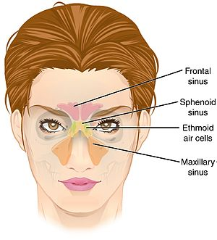

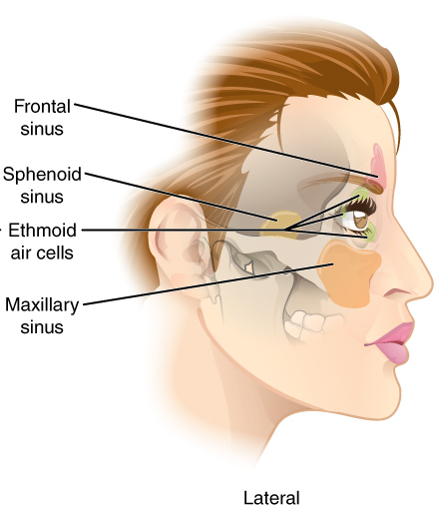

DEVELOPMENT OF PARANASAL SINUSES
Paranasal sinuses form developmentally through excavation of bone by air-filled sacs (pneumatic diverticula) from the nasal cavity. This process begins prenatally (intrauterine life), and it continues through the course of an organism's lifetime.
The results of experimental studies suggest that the natural ventilation rate of a sinus with a single sinus ostium (opening) is extremely slow. Such limited ventilation may be protective for the sinus, as it would help prevent drying of its mucosal surface and maintain a near-sterile environment with high carbon dioxide concentrations and minimal pathogen access. Thus composition of gas content in the maxillary sinus is similar to venous blood, with high carbon dioxide and lower oxygen levels compared to breathing air.
At birth only the maxillary sinus and the ethmoid sinus are developed but not yet pneumatized; only by the age of seven they are fully aerated. The sphenoid sinus appears at the age of three, and the frontal sinuses first appear at the age of six, and fully develop during adulthood.
CLINICAL ANATOMY
Sinusitis
The paranasal sinuses are joined to the nasal cavity via small orifices called ostia. These become blocked easily by allergic inflammation, or by swelling in the nasal lining that occurs with a cold. If this happens, normal drainage of mucus within the sinuses is disrupted, and sinusitis may occur. Because the maxillary posterior teeth are close to the maxillary sinus, this can also cause clinical problems if any disease processes are present, such as an infection in any of these teeth. These clinical problems can include secondary sinusitis, the inflammation of the sinuses from another source such as an infection of the adjacent teeth.[5]

These conditions may be treated with drugs such as decongestants, which cause vasoconstriction in the sinuses; reducing inflammation; by traditional techniques of nasal irrigation; or by corticosteroid.
Cancer
Malignancies of the paranasal sinuses comprise approximately 0.2% of all malignancies. About 80% of these malignancies arise in the maxillary sinus. Men are much more often affected than women. They most often occur in the age group between 40 and 70 years. Carcinomas are more frequent than sarcomas. Metastases are rare. Tumours of the sphenoid and frontal sinuses are extremely rare.

