NAME: ADEKUNLE USMAN.O
MATRIC NO.: 18/MHS01/017

1. Ovulation is the release of eggs from the ovaries. In women, this event occurs when the ovarian follicles rupture and release the secondary oocyte ovarian cells. Ovulation occurs about midway through the menstrual cycle, after the follicular phase, and is followed by the luteal phase if the oocyte is not fertilized. It should be noted that ovulation is characterized by a sharp spike in levels of luteinizing hormone (LH) and follicle-stimulating hormone (FSH) which lasts for 12 to 24hours, resulting from the peak of estrogen levels during the follicular phase. The increase in LH act as a trigger for two important event for ovulation which are;
(i) It increases collagenase activity, resulting in digestion of collagen fibers surrounding the follicle.
(i) Prostaglandin level aldo increase causing local muscular contractions in the ovarian wall, these contractions extrude the oocyte, which together with its surrounding follicular cells from the region of cumulus oophorus which causes ovulation in which oocyte floats out of the ovary. 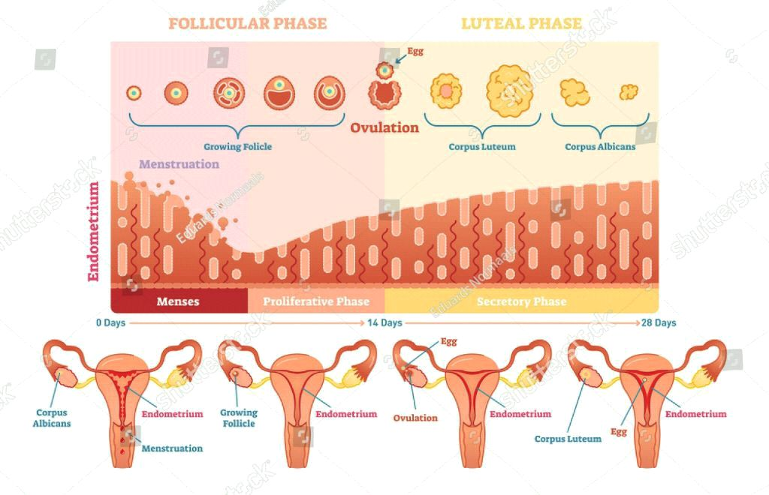
CLINICAL CORRELATE AND DISORDERS
Females near ovulation experience changes in the cervical mucus, and in their basal body temperature. Furthermore,many females experience secondary fertility signs including Mittelschmerz (pain associated with ovulation) and a heightened sense of smell, and can sense the precise moment of ovulation. Many females experience heightened sexual desire in the several days immediately before ovulation. One study concluded that females subtly improve their facial attractiveness during ovulation.
Disorders of ovulation are classified as menstrual disorders and include oligoovulation and anovulation:
-Oligoovulation is infrequent or irregular ovulation (usually defined as cycles of greater than 36 days or fewer than 8 cycles a year)Anovulation is absence of ovulation when it would be normally expected (in a post-menarchal, premenopausal female). Anovulation usually manifests itself as irregularity of menstrual periods, that is, unpredictable variability of intervals, duration, or bleeding.
-Anovulation can also cause cessation of periods (secondary amenorrhea) or excessive bleeding (dysfunctional uterine bleeding).
2.
Meiosis I | Meiosis II
There is crossing over | Absence of crossing over
Synapses is present | Synapses is absent
Homologous chromosomes separate | Sister chromatids separate
It's also called reduction | It's also called division
Presence of chiasma | Absence of chiasma
Produces two daughter cells | Produces four daughter cells
Daughter cells are diploid | Daughter cells are haploid
Centromeres do not split | Centromeres split.
A complex division and takes more time | Comparatively less simple and takes less time

3.Fertilization is the process by which make and female gametes fusion occur in the ampullary region of the uterine tube which is the widest part of the tube and it's close to the ovary. It occurs in six various steps which are;
- Penetration of sperm through corona radiata: Of the millions of spermatozoa normally deposited in the female genital tract, 300 to 500 reach the site of fertilization where only one fertilize the egg. For sperm to penetrate the barrier, they must undergo capacitation. It is thought that the other sperm aid the fertilizing sperm in penetrating the barriers protecting the female gamete.
- Penetration of the zona pellucida: The zona is a glycoprotein shell surrounding the egg that facilitates and maintains sperm binding and induces the acrosome reaction which is necessary for sperms that pass through the zona pellucida. Acrosomal enzymes are released which help in the Penetration. It should be noted that the permeability of the zona pellucida changes when the head of the sperm comes in contact with the oocyte surface, this contact results in the release of lysosomal enzymes from cortical granules which prevent other sperm penetration.
- Fusion of the Oocyte and sperm cell membranes: The plasma membrane of the egg and sperm fuses together, though both head and tail of the spermatozoon enter the cytoplasm of the oocyte but the plasma membrane is left behind on the oocyte surface.
- Completion of second meiotic division and formation of female pronucleus: The oocyte finishes it's second meiotic division immediately after the entry of thr spermatozoon. One of the daughter cells which receives hardly any cytoplasm is known as second polar body and the other daughter cell is the definitive oocyte. Its chromosomes arrange themselves in a vesicular nucleus known as the female pronucleus.
- Formation of male pronucleus: The spermatozoon moves forward untill it lies close to the female pronucleus. Its nucleus becomes swollen and forms the male pronucleus, its tail detaches and degenerates. Morphologically, male and female pronucleus are in distinguishable and eventually they come into close contact and lose their nuclear envelopes.
- Formation of Ootid: The two pronuclei fuse into a single diploid aggregation of chromosomes.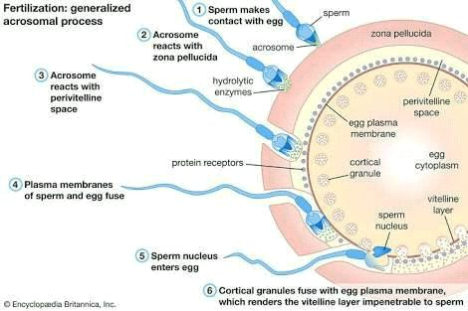

4.
Monozygotic Twins | Dizygotic Twins
The cause is unknown | Caused either by IVF, certain fertility drugs or herrditary predisposition.
Developed by the splitting of a fertilized embryo | Developed by two separate simultaneous fertilization events
Genetic codes are nearly identical | Gender is different
Blood types are the same | Blood types are different
Appearance is extremely similar but may be affected by environmental factors. | Appearance is similar as any other siblings
One third of the twins in the world are monozygotic | Two thirds of the twins in the world are dizygotic
Can be either Di-Di, Mono-Di or Mono-Mono twins | Only Di-Di twins
Bear a high risk for TTTS | Bear a low risk for TTS

