MY FEEDBACK FORM

S/N | PARAMETER | RESPONSE LEVEL
 |  | YES  (5 points) | NO  (0 points) | NOTSURE  (3points)
1 | Are you learning valuable information? |  |  | Notsure
2 | Are the explanations of concepts clear? | Yes
3 | Is the Instructor’s delivery engaging? | Yes
4 | Are there enough helpful practice activities? | Yes
5 | Was the course description accurate? | Yes
6 | Is the instructor knowledgeable about the topic? | Yes
TOTAL SCORE
FINAL REMARKS
EXCELLENT (5POINTS)
FAIR (3 POINT)
POOR (0 POINTS)
Thursday 30th April, 2020
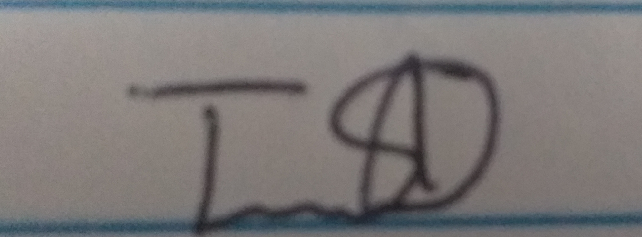
Tawfiq Azimazi
NAME/SIGNATURE/DATE: ………………………………………………; …………………………………….; …………………………..

