NAME: MAXWELL TEMILOLUWA
MATRIC NUMBER: 17/MHS01/186
COLLEGE: MEDICINE AND HEALTH SCIENCES
DEPARTMENT: MEDICINE AND SURGERY
COURSE: GROSS ANATOMY OF THE HEAD AND NECK
ASSIGNMENT: 1. WRITE AN ESSAY ON THE CAVERNOUS SINUS
2. DISCUSS THE WALLS OF THE NOSE
- The cavernous sinus is a paired dural venous sinus located within the cranial cavity. It is divided by septa into small ‘caves’ – from which it gets its name. Each cavernous sinus has a close anatomical relationship with several key structures in the head, and is arguably the most clinically important venous sinus. The dural venous sinuses are channels between the two layers of dura mater which are responsible for the venous drainage of the brain, skull, orbit and internal ear.
The cavernous sinuses are located within the middle cranial fossa, on either side of the sella turcica of the sphenoid bone (which contains the pituitary gland). They are enclosed by the endosteal and meningeal layers of the dura mater. The borders of the cavernous sinus are as follows:
- Anterior – superior orbital fissure.
- Posterior – petrous part of the temporal bone.
- Medial – body of the sphenoid bone.
- Lateral – meningeal layer of the dura mater running from the roof to the floor of the middle cranial fossa.
- Roof – meningeal layer of the dura mater that attaches to the anterior and middle clinoid processes of the sphenoid bone.
- Floor – endosteal layer of dura mater that overlies the base of the greater wing of the sphenoid bone.

Fig 1 – Coronal section demonstrating the borders of the right cavernous sinus.
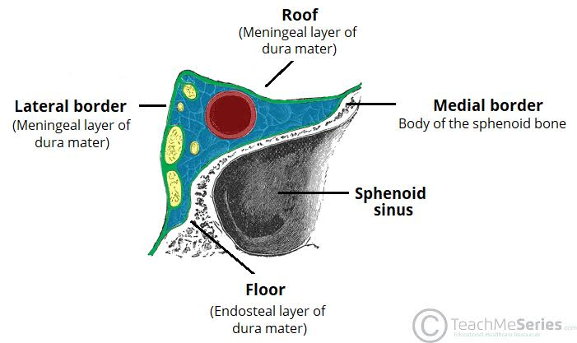

Contents
Several important structures pass through the cavernous sinus to enter the orbit. The can be sub-classified by whether they travel through the sinus itself, or through its lateral wall:
Travels through cavernous sinus | Travels through lateral wall of cavernous sinus
- Abducens nerve (CN6) | - Occulomotor nerve (CN3)
- Carotid plexus (post-ganglionic sympathetic nerve fibres) | - Trochlear nerve (CN4)
- Internal carotid artery (cavernous portion) | - Ophthalmic (V1) and maxillary (V2) branches of trigerminal nerve (CN5)

The cavernous sinus is the only site in the body where an artery (internal carotid) passes completely through a venous structure. This is thought to allow for heat exchange between the warm arterial blood and cooler venous
Fig 2 – Coronal section demonstrating the contents of the right cavernous sinus.
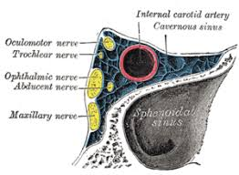

Dural Venous Sinus System
Each cavernous sinus receives venous drainage from:
- Ophthalmic veins (superior and inferior) – these enter the cavernous sinus via the superior orbital fissure.
- Central vein of the retina – drains into the superior ophthalmic vein, or directly into the cavernous sinus.
- Sphenoparietal sinus – empties into the anterior aspect of the cavernous sinus.
- Superficial middle cerebral vein – contributes to the venous drainage of the cerebrum
- Pterygoid plexus – located within the infratemporal fossa.
It is important to note that the superior ophthalmic vein forms an anastomosis with the facial vein. Therefore, the ophthalmic veins represent a potential route by which infection can spread from an extracranial to an intracranial site.
The cavernous sinuses empty into the superior and inferior petrosal sinuses, and ultimately, into the internal jugular vein. The left and right cavernous sinuses are connected in the midline by the anterior and posterior intercavernous sinuses. They travel through the sella turcica of the sphenoid bone.

Fig 3 – Schematic of the dural venous system relating to the cavernous sinus. Note the anastomosis between the ophthalmic veins and the facial vein.
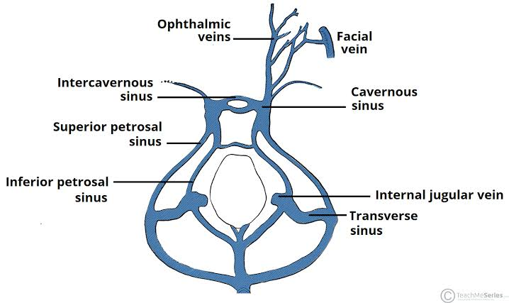
Clinical Significance - Cavernous Sinus Thrombosis
Cavernous sinus thrombosis (CST) refers to the formation of a clot within the cavernous sinus. This most common cause of CST is infection; which typically spreads from an extracranial location such as the orbit, paranasal sinuses, or the ‘danger zone’ of the face. Infection is able to spread in this manner due to the anastomosis between the facial vein and superior ophthalmic veins.
Common clinical features include headache, unilateral periorbital oedema, proptosis (eye bulging), photophobia and cranial nerve palsies. The abducens nerve (CN VI) is most commonly affected.
Treatment is typically with antibiotic therapy. Where the cause is infection, thrombosis of the cavernous sinus can rapidly progress to meningitis.

The lateral wall of the nasal cavity is a region of the nasopharynx essential for humidifying and filtering the air we breathe in nasally.
Here we can find a structure called agger nasi. The agger nasi is also referred to as the ‘nasoturbinal concha’ or ‘nasal ridge.’ It can be described as a small mound or ridge found in the lateral side of the nasal cavity. The structure is located midway along the anterior aspect of the middle nasal concha. An abnormally enlarged form may restrict the drainage of the frontal sinus by obstructing the frontal recess area.
Key facts about the lateral wall of the nasal cavity
Parts | Nasal septum  - Cartilages: lesser alar cartilages, greater alar cartilages, lateral nasal cartilages  - Bones: anterior nasal aperture (piriform aperture) formed by maxilla and nasal bones  Nasal conchae  - Superior nasal concha  - Middle nasal concha  - Inferior nasal concha
Bony framework of the nasal cavity | Ethmoid bone  Frontal bone  Lacrimal bone  Nasal bones  Palatine bones  Sphenoid bone
Clinical relation | Sinusitis
The lateral wall of the nasal cavity is a region of the nasopharynx essential for humidifying and filtering the air we breathe in nasally.
Here we can find a structure called agger nasi. The agger nasi is also referred to as the ‘nasoturbinal concha’ or ‘nasal ridge.’ It can be described as a small mound or ridge found in the lateral side of the nasal cavity. The structure is located midway along the anterior aspect of the middle nasal concha. An abnormally enlarged form may restrict the drainage of the frontal sinus by obstructing the frontal recess area.

- Key facts about the lateral wall of the nasal cavity
- Parts
- Nasal septum
- - Cartilages: lesser alar cartilages, greater alar cartilages, lateral nasal cartilages

- - Bones: anterior nasal aperture (piriform aperture) formed by maxilla and nasal bones

- Nasal conchae

- - Superior nasal concha

- - Middle nasal concha

- - Inferior nasal concha

- Bony framework of the nasal cavity
- Ethmoid bone

- Frontal bone

- Lacrimal bone

- Nasal bones

- Palatine bones

- Sphenoid bone

- Clinical relation
- Sinusitis

