OSE OGHENERUONA
18/MHS03/013

FEMALE EXTERNAL GENITALIA
External female genitalia are a part of the female reproductive system, and include: mons pubis, labia majora, labia minora, clitoris, vestibule, hymen, vestibular bulb and vestibular glands.
Components of the external female genitalia occupy a large part of the female perineum and together they are called the vulva. The functions of the external female genitalia are many, such as reproduction and sexual pleasure, parturition and the protection of the internal genital organs.

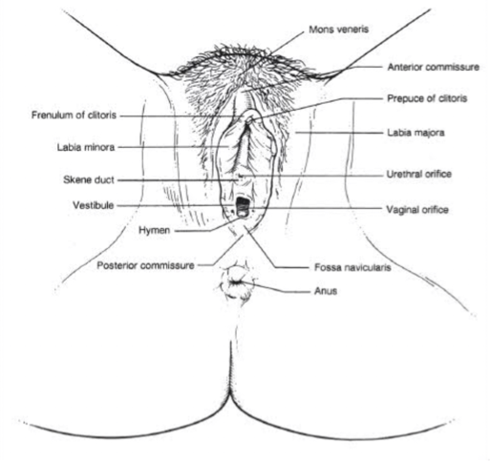

Components
External genitalia of a female occupy much of the perineum and are collectively referred to as the vulva(pudendum).

Mons pubis
The mons pubis consists of a mass of subcutaneous adipose tissue anterior to the pubic symphysis, and bears most of the pubic hair.

Labia majora
The labia majora (singular, labium majus) are a pair of thick folds of skin and adipose tissue found inferior to the mons. The fissure between the folds is called the pudendal cleft. Pubic hair can be found on the lateral surfaces of the labia majora once puberty hits, while the medial/internal surfaces will remain hairless. The round ligament of the uterus passes through the inguinal canaland continues into the labia majora, where the nerve fibers spread and mix with the tissue of the mons pubis. The labia majora are thicker in the front where they form by joining the anterior commisure, and is found below the mons pubis. The posterior commisure of the labia majora is the rear joining of the labia majora, and is located above the perineum.

Labia minora
Found medial to the labia majora are the labia minora (singular, labium minus), which are much thinner devoid of fat and entirely hairless. Their frontal ends split to form upper and lower layers. The upper layer goes superior to the clitoris and forms a fold called prepuce. The lower layer passes inferior to clitoris and forms the frenulum of the clitoris.

Clitoris
The clitoris is analogous to the structure of the penis but it does not contain urethra and has no urinary role. It is richly supplied with autonomic efferent motor nerve endings via the cavernosal nerve of the clitoris and is highly sensitive to sexual stimulation. Also unlike the penis, the clitoris is nearly entirely internal and does not have a corpus spongiosum or enclose the urethra.
The clitoris has a pair of corpora cavernosa which consist of erectile tissue enclosed in dense fibrous tissue. Each corpus (body) passes internally, and is attached to the ischiopubic ramus by a crus. The suspensory ligament and two small muscles (ischiocavernosi) are attached to the crura just like the penis. The glans (head) of the clitoris is a small tubercle, which protrudes slightly from the prepuce. Arteries here include the dorsal and clitoral cavernosal arteries, which arise from the iliohypogastric pudendal bed.

Vestibule
The labia minora enclose an area called the vestibule, which contains the urinary and vaginal orifices along with the openings of the greater and lesser vestibular glands. The prepuce is found at the anterior margin of the vestibule.

Hymen
Most females (but not all) are born with a hymen, which is generally in the form of an elliptical/oval-shaped membranous ring around the vaginal orifice (It is generally perforated to some degree, most often in the centre, kind of like a 'donut' shape). The remnants of this membranous ring in adult females in known as hymenal caruncles, which appear as small thin elevations of mucous membrane around the vaginal opening. When the hymen completely covers the vaginal orifice, it is known as an imperforate hymen. An imperforate hymen may rupture naturally during various types of physical activity (aside from intercourse).
Some females may undergo a hymenotomy, which involves the surgical removal, or opening of the hymen, most often to facilitate menstruation, or relieve discomfort during intercourse. This procedure may also be undertaken in the instance when the hymen is abnormally thick, and/or when the opening is small, limiting access to the vaginal orifice.

Vestibular bulbs
Vestibular bulbs are located on each side of the vestibule. They consist of a pair of subcutaneous erectile tissues which correspond to the penile bulb and corpus spongiosum. Both bulbs join in front of urethral orifices under the vestibule of the vagina. Each one is covered with bulbospongiosus muscles.

Vestibular glands
Bartholin’s (greater vestibular) glands are pea-sized with a short duct that opens into the vestibule or lower vagina. One is found on each side of the vagina. Bartholin’s glands are homologous to the bulbourethral glands in the male, and function to keep the vulva moist, providing lubrication for sexual intercourse during sexual excitement. Additionally, lesser vestibular glands lubricate the vestibule. Finally, a pair of Skene’s (paraurethral) glands, homologous to the male prostate, open into the vestibule nears the external urethral orifice.

Blood supply
Vasculature of the external female genitalia is primarily supplied by the internal pudendal arteries, which are branches of the anterior division of the internal iliac artery.

Lymphatic drainage
Lymphatic drainage of the external female genitalia is via the superficial and deep inguinal lymph nodes. Lymph from the clitoris, vestibular bulb and anterior labia minora can alternatively drain into the internal iliac lymph nodes.

Innervation
The vulva is innervated from a variety of sources. The mons pubis and anterior labia is innervated via the anterior labial nerves, which derive from the lumbar plexus. The posterior aspect of the vulva is innervated via the pudendal nerve and its branches (posterior labial nerves),together with branches from the posterior cutaneous nerve of the thigh. Sensitive innervation to the clitoris is provided by the dorsal nerve of the clitoris

