NAME: Ibezim Emily Chika
MATRIC NUMBER: 17/mhs01/143
COLEEGE: Medicine and Health Sciences
DEPARTMENT: Medicine and Surgery
COURSE TITLE: Gross Anatomy of the Head and Neck
COURSE CODE: ANA 301

QUESTION
1. Discuss the anatomy of the tongue and comment on it’s applied anatomy
2. Write an essay on the air sinuses

SOLUTION
1. ANATOMY OF THE TONGUE
The tongue is a muscular organ situated in the floor of the mouth. It is associated with functions of speech, mastication and deglutition. This muscular organ has an oral part that lies in the mouth and a pharyngeal part that lies in the pharynx.
Under normal circumstances, the tongue is a pink, muscular organ located within the oral cavity proper. It is kept moist by the products of the major and minor salivary glands, which aids the organ as it facilitates deglutition, speech, and gustatory perception. While there is significant variability in the length of the tongue among individuals, on average, the organ is roughly 10 cm long. It has three main parts:
•The tip or apex of the tongue is the most anterior, and most mobile aspect of the organ.
•The tip is followed by the body of the tongue. It has a rough dorsal (superior) surface that abuts the palate and is populated with taste buds and lingual papillae, and a smooth ventral (inferior) surface that is attached to the floor of the oral cavity by the lingual frenulum.
•The base of the tongue is the most posterior part of the organ. It is populated by numerous lymphoid aggregates known as the lingual tonsils along with foliate papillae along the posterolateral surface.
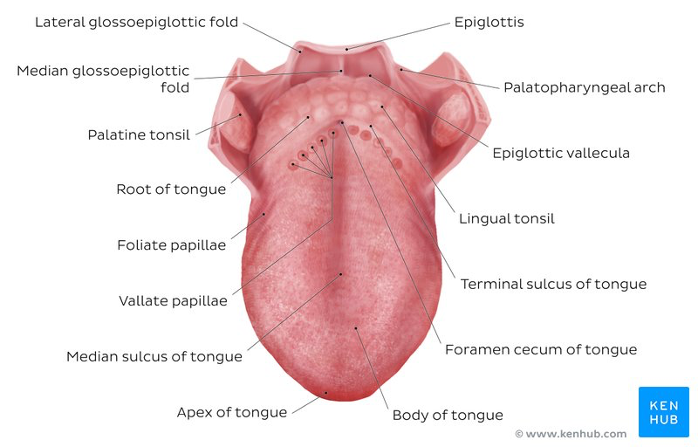
Overview of the structure of the tongue (superior view)

There are numerous important structures surrounding the tongue. It is limited anteriorly and laterally by the upper and lower rows of teeth. Superiorly, it is bordered by the hard (anterior part) and soft (posterior part) palates. Inferiorly, the root of the tongue is continuous with the mucosa of the floor of the oral cavity; with the sublingual salivary glands and vascular bundles being located below the mucosa of the floor of the oral cavity.
The palatoglossal and palatopharyngeal arches (along with the palatine tonsils) have lateral relations to the posterior third of the tongue. Posterior to the base of the tongue is the dorsal surface of the epiglottis and laryngeal inlet, and the posterior wall of the oropharynx.

Anterior two thirds
The presulcal tongue includes the apex and body of the organ. It terminates at the sulcus terminalis; which can be seen extending laterally in an oblique direction from the foramen cecum towards the palatoglossal arch. The mucosa of the dorsal surface of the oral tongue is made up of circumvallate, filiform, and fungiform papillae. There is also a longitudinal midline groove running in an anteroposterior direction from the tip of the tongue to the foramen cecum. This marks the embryological point of fusion of the lateral lingual swellings that formed the oral tongue. It also represents the location of the median lingual (fibrous) septum of the tongue that inserts in the body of the hyoid bone.
On the lateral surface of the oral tongue are foliate papillae arranged as a series of vertical folds. The ventral mucosa of the oral tongue is comparatively unremarkable. It is smooth and continuous with the mucosa of the floor of the mouth and the inferior gingiva. The lingual veins are relatively superficial and can be appreciated on either side of the lingual frenulum. Lateral to the lingual veins are pleated folds of mucosa known as the plica fimbriata. They are angled anteromedially toward the apex of the tongue.

Posterior third
The remainder of the tongue that lies posterior to the sulcus terminalis is made up by the base of the organ. It lies behind the palatoglossal folds and functions as the anterior wall of the oropharynx. Unlike the oral tongue, the pharyngeal tongue does not have any lingual papillae. Instead, its mucosa is populated by aggregates of lymphatic tissue known as the lingual tonsils. The mucosa is also continuous with the mucosa of the laterally located palatine tonsils, the lateral oropharyngeal walls, and the posterior epiglottis and glossoepiglottic folds.
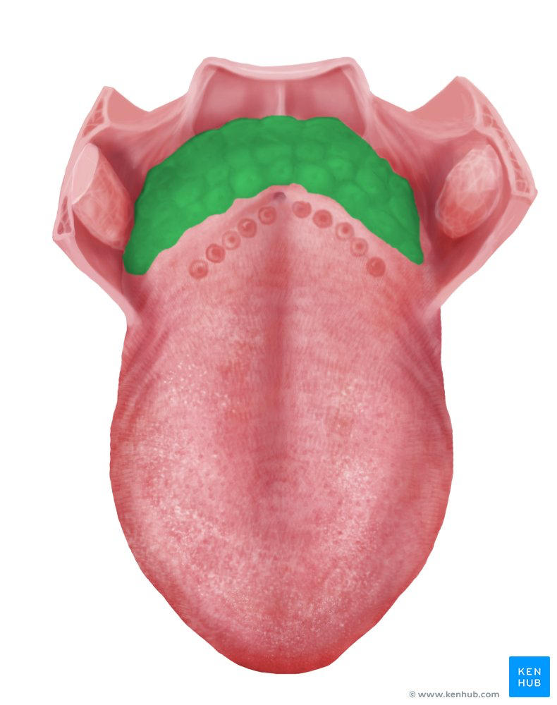
Diagram showing the Lingual tonsil (superior view)

Muscles of the Tongue
Most muscles serve to attach one bone, usually via a tendon, to another. There are a few places where that is not entirely true: the ocular muscles, the scapulothoracic joint, the diaphragm and perineum are all good exceptions. However, the tongue is extraordinary. A boneless mass that you can protrude at will, fold, invert, lay flat or fill the mouth.
The tongue is chiefly a muscular organ with some amount of fatty and fibrous tissue distributed throughout its substance. All the muscles of the tongue are paired structures, with each copy being found on either side of the median fibrous septum. There are muscles that extend outside of the organ to anchor it to surrounding bony structures, known as extrinsic muscles. The other set of muscles are confined to each half of the organ and contribute to altering the shape of the organ; these are the intrinsic muscles.
INTRINSIC MUSCLES
The intrinsic muscles only attach to other structures in the tongue. There are four paired intrinsic muscles of the tongue and they are named by the direction in which they travel: the superior longitudinal, inferior longitudinal, transverse and vertical muscles of the tongue. These muscles affect the shape and size of the tongue – for example, in tongue rolling – and have a role in facilitating speech, eating and swallowing.
Motor innervation for the intrinsic muscles of the tongue is via the hypoglossal nerve (CNXII).

EXTRINSIC MUSCLES
The extrinsic muscles are as follows:
•Genioglossus
- Attachments: Arises from the mandibular symphsis. Inserts into the body of the hyoid bone and the entire length of the tongue.
- Function: Inferior fibres protrude the tongue, middle fibres depress the tongue, and superior fibres draw the tip back and down
- Innervation: Motor innervation via the hypoglossal nerve (CNXII).
•Hyoglossus
- Attachments: Arises from the hyoid bone and inserts into the side of the tongue
- Function: Depresses and retracts the tongue
- Innervation: Motor innervation via the hypoglossal nerve (CNXII).
•Styloglossus
- Attachments: Originates at the styloid process of the temporal bone and inserts into the side of the tongue
- Function: Retracts and elevates the tongue
- Innervation: Motor innervation via the hypoglossal nerve (CNXII).
•Palatoglossus
- Attachments: Arises from the palatine aponeurosis and inserts broadly across the tongue
- Function: Elevates the posterior aspect of the tongue
- Innervation: Motor innervation via the vagus nerve (CNX).
All of the intrinsic and extrinsic muscles are innervated by the hypoglossal nerve (CN XII), except palatoglossus, which has vagal innervation (CN X).

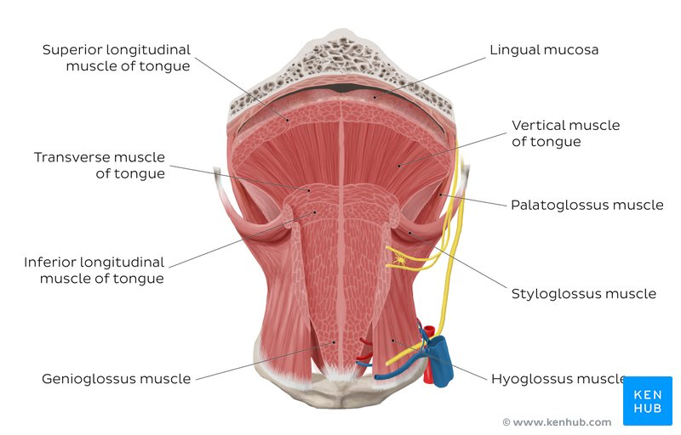
Overview of the tongue muscles (anterior view)

Blood Supply and Lymphatics
Blood supply to the tongue is predominantly from the lingual artery, a branch of the external carotid artery between the superior thyroid artery and the facial artery, which departs at the level of the greater horn of the hyoid bone within the carotid triangle. After branching from the external carotid artery, the lingual artery passes deep to the hyoglossus muscle and superficial to the middle pharyngeal constrictor muscle. It then gives rise to the following four arteries:
The suprahyoid artery supplies the omohyoid, sternothyroid, and thyrohyoid muscles. They anastomose with the corresponding vessels from the opposite side.
The dorsal lingual arteries arise beneath the hyoglossus muscle and pass to the posterior part of the dorsum of the tongue. They supply the mucous membrane of this region as well as the glossopalatine arch, lingual tonsils, soft palate, and epiglottis. They anastomose with their corresponding vessels on the opposite side.
The sublingual artery branches at the anterior border of the hyoglossus muscle before passing between the genioglossus muscle and mylohyoid muscle to the sublingual gland. It supplies the sublingual gland before giving branches to the mylohyoid muscle. One branch from the sublingual artery passes posterior to the alveolar process of the mandible and anastomoses with the corresponding artery from the other side. A second branch of the sublingual artery pierces the mylohyoid muscle and anastomoses with the submental branch of the facial artery.
The deep lingual artery, which is the termination of the lingual artery, passes between the genioglossus muscle and inferior longitudinal muscle.
Venous Drainage is by the lingual vein.
Nerves
The hypoglossal nerve (CN XII) provides motor innervation to all of the intrinsic and extrinsic muscles of the tongue except for the palatoglossus muscle, which is innervated by the vagus nerve (CN X). It runs superficial to the hyoglossus muscle. Lesions of the hypoglossal nerve cause deviation of the tongue to the ipsilateral (i.e., damaged) side.
Taste to the anterior two-thirds of the tongue is achieved through innervation from the chorda tympani nerve, a branch of the facial nerve (CN VII). General sensation to the anterior two-thirds of the tongue is by innervation from the lingual nerve, a branch of the mandibular branch of the trigeminal nerve (CN V3). The lingual nerve is located deep and medial to the hyoglossus muscle and is associated with the submandibular ganglion.
On the other hand, taste to the posterior one-third of the tongue is accomplished through innervation from the glossopharyngeal nerve (CN IX), which also provides general sensation to the posterior one-third of the tongue.
Taste perception also is performed by both the epiglottis and the epiglottic region of the tongue, which receives taste and general sensation from innervation by the internal laryngeal branch of the vagus nerve (CN X). Damage to the vagus nerve (CN X) causes contralateral deviation (i.e., away from the injured side) of the uvula.
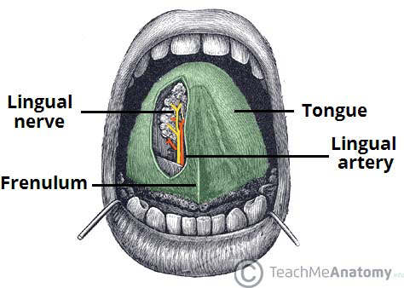
The lingual nerve provides sensory innervation to the 2/3 of the tongue.

Lymphatic Drainage
The lymphatic drainage of the tongue is as follows:
•Anterior two thirds – initially into the submental and submandibular nodes, which empty into the deep cervical lymph nodes
•Posterior third – directly into the deep cervical lymph nodes

PHYSIOLOGIC VARIANTS
•Ankyloglossia ("tongue-tie") occurs due to an abnormal length of the frenulum linguae which causes limited manipulation of the tongue during speech and results in a speech impediment. In the most common form of ankyloglossia, the frenulum extends to the tip of the tongue. Ankyloglossia can be corrected by surgically severing the lingual frenulum.
•Fissured tongue ("scrotal tongue," "plicated tongue") occurs when several small furrows present on the dorsal surface of the tongue. It can be an oral manifestation of psoriasis. It is generally painless and benign, and is often associated with other syndromes (e.g., Down syndrome).
•Geographic tongue ("migratory glossitis") is a benign, asymptomatic condition characterized by the presence of large red patches with a greyish-white border covering the dorsum of an otherwise normal tongue. It is caused by inflammation of the mucous membrane of the tongue, which results in loss of lingual papillae. The lesions are known to migrate over time. The name arises from the map-like appearance of the tongue in this condition.

Surgical Considerations
Thyroglossal duct cysts can develop when there is a remnant at the point of embryologic origin of the thyroid gland, the foramen cecum. The thyroid gland begins to develop in the floor of the embryologic pharynx at the point called the foramen cecum, which is located at the dorsum of the posterior tongue. The developing gland then relocates to its ultimate destination in the anterior neck by migrating down the thyroglossal duct anterior to the hyoid cartilage and thyroid cartilage before stopping anterolateral to the superior aspect of the trachea. The thyroglossal duct ordinarily disappears, but remnants of its epithelium may remain, allowing for the potential development of a thyroglossal duct cyst in this area. These cysts generally occur in the neck, close to or inferior to the body of the hyoid bone. They form a swelling at the anterior midline of the neck that is painless, fluctuant, and moves upon swallowing. Thyroglossal ducts cysts typically are removed surgically.

Clinical Significance
The tongue tends to fall posteriorly, thus obstructing the airway. Paralysis or total relaxation of the genioglossus muscle presents a risk of suffocation, which can occur during general anesthesia. An artificial airway is made using intubation, which prevents the tongue from falling backward and blocking the airway.
Ludwig angina infection, once established, evolves to include the tongue. The tongue may enlarge to two or three times its usual size and tends to distend posteriorly into the hypopharynx, superiorly against the palate, and anteriorly out of the oral cavity. Any immediate posterior extension of this process will ultimately involve the epiglottis. The styloglossus muscle creates the connection between the submandibular parapharyngeal spaces, otherwise known as the buccopharyngeal gap, as it leaves the tongue and passes in between the middle and superior constrictor muscles before attaching to the styloid process. Cellulitis of the submandibular space may spread into the pharyngeal space and, from there, into the retropharyngeal space of the mediastinum.
Dysgeusia, or a pure taste disorder, is rare and is usually associated with olfactory disorders.

2. AIR SINUSES
The bones of the face and skull near the nose contain four pairs of air-filled pockets, which are called the paranasal sinuses. Thus, The paranasal sinuses are air-filled extensions of the respiratory part of the nasal cavity.
Furthermore, They are centered on the nasal cavity and have various functions, including lightening the weight of the head, humidifying and heating inhaled air, increasing the resonance of speech, and serving as a crumple zone to protect vital structures in the event of facial trauma.
Sinuses are formed in childhood by the nasal cavity eroding into surrounding bone. As they are outgrowths of the nasal cavity, they all drain back into it – openings to the paranasal sinuses are found on the roof and lateral walls of the nasal cavity. The inner surface is lined by a respiratory mucosa.
There are four paired sinuses, named according to the bone in which they are located; maxillary, frontal, sphenoid and ethmoid.

THE MAXILLARY SINUSES
Maxillary sinus
The maxillary sinuses are the largest of the all the paranasal sinuses. They have thin walls which are often penetrated by the long roots of the posterior maxillary teeth. The superior border of this sinus is the bony orbit, the inferior is the maxillary alveolar bone and corresponding tooth roots, the medial border is made up of the nasal cavity and the lateral and anterior border are limited by the cheekbones.
Posteriorly, two anatomical spaces known as the pterygopalatine fossa and the infratemporal fossa exist. It is located laterally and slightly inferiorly to the nasal cavities. It drains into the nasal cavity at the hiatus semilunaris, underneath the frontal sinus opening. This is a potential pathway for spread of infection – fluid draining from the frontal sinus can enter the maxillary sinus.

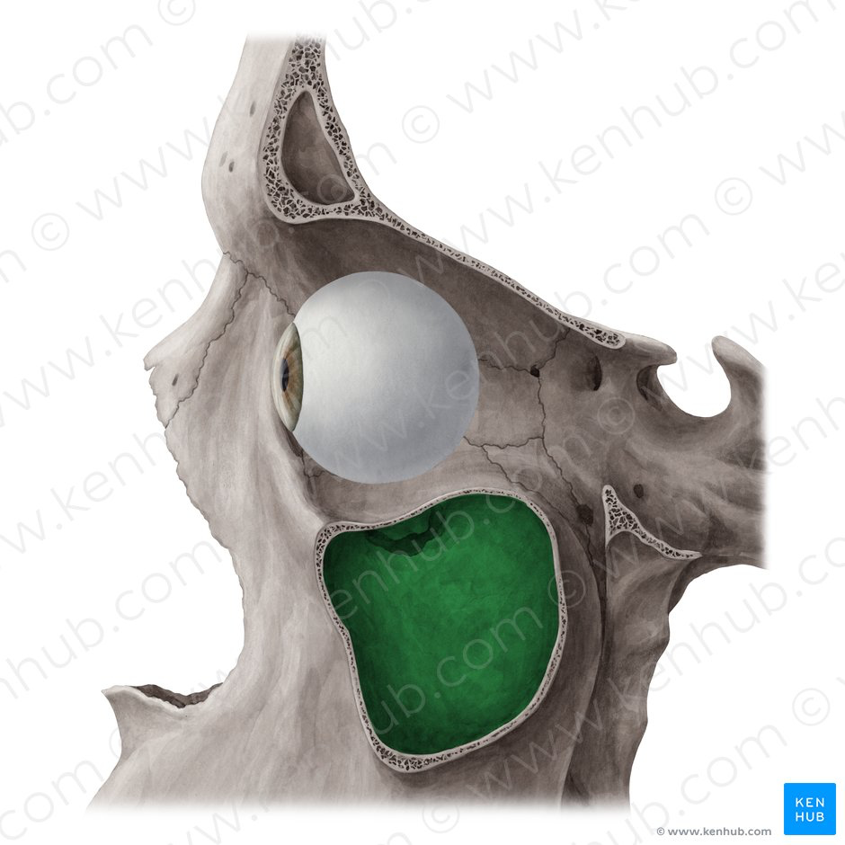
Maxillary sinus (Sinus maxillaris)

- Vascularization, innervation and lymphatics
The submandibular lymph nodes are the main destination during lymphatic drainage. The blood supply includes a contribution from the:
•anterior superior alveolar artery
•middle superior artery
•posterior superior alveolar artery
•Innervation occurs through nerves of the same names as the arteries.i.e - anterior superior alveolar nerve, middle superior nerve, posterior superior nerve.

The frontal sinuses
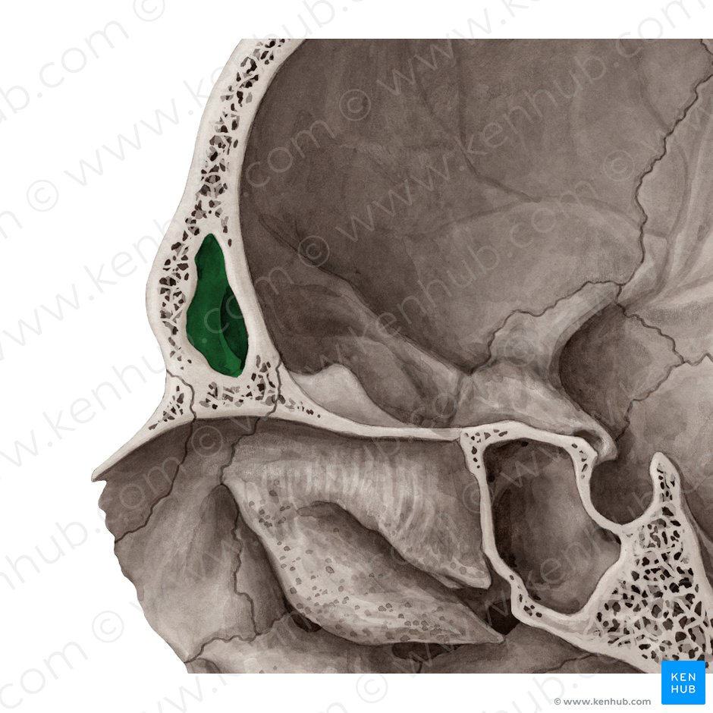
Anteriorly, the frontal sinuses are contained by the forehead and the superciliary arches, superiorly and posteriorly by the anterior cranial fossa and inferiorly by the bony orbit, the anterior ethmoidal sinuses and the nasal cavity. Medially the sinuses face one another, separated by the midline.

This pair of sinuses are irregular in shape when compared to one another and is underdeveloped at birth. They reach their full size and shape around seven to eight years of age.
- Vascularization, innervation and lymphatics
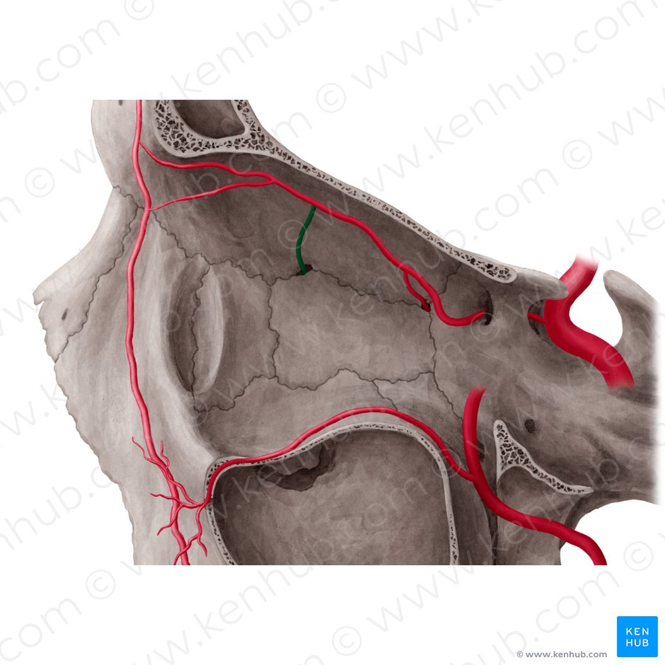
Diagram showing the Anterior ethmoidal artery

They drain primarily into the ethmoidal infundibulum and the corresponding lymph drainage occurs via the submandibular lymph nodes. It is innervated by the ophthalmic nerve, including the supraorbital and supratrochlear branches.
The frontal sinuses are supplied by the:
•anterior ethmoidal artery
•supraorbital artery
•supratrochlear artery

The sphenoidal sinuses
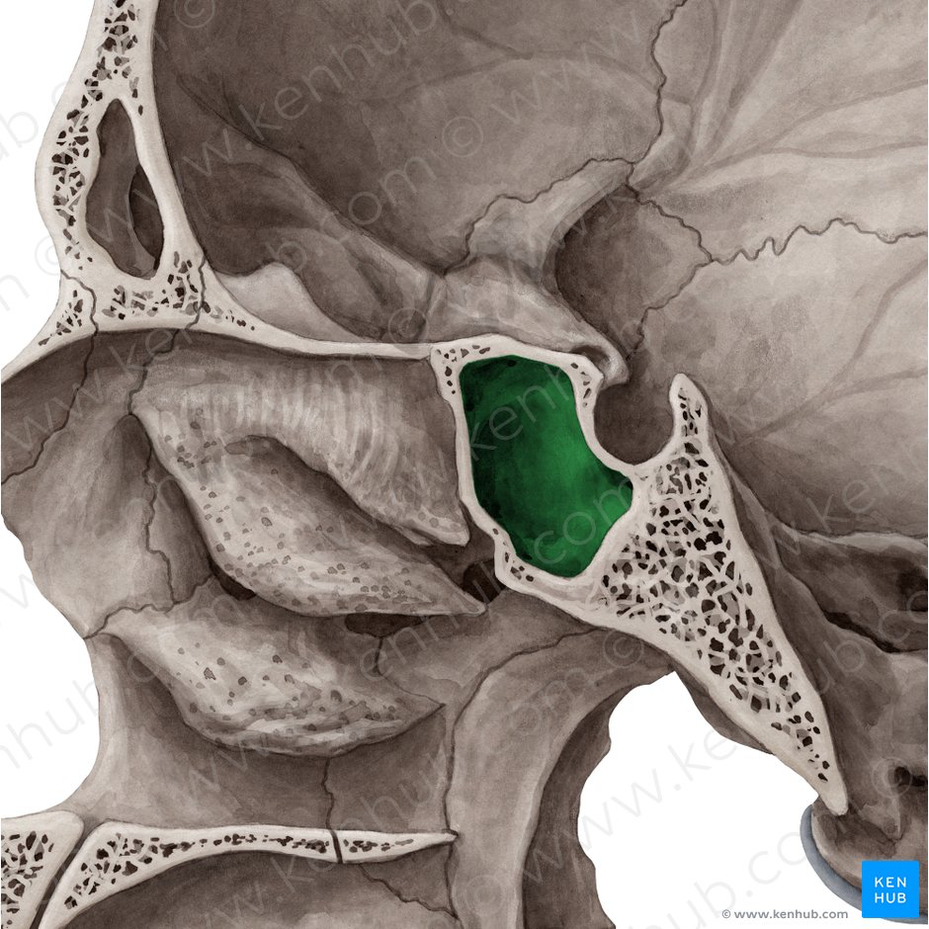
Diagram showing the sphenoidal sinus.

The most posterior of all the sinuses in the head, the sphenoidal sinuses are large and irregular, just like their septum, which is made by the sphenoid bone. Laterally, a cavernous sinus exists which is part of the middle cranial fossa and also the carotid artery and cranial nerves III, IV, V/I, V/II and VI can be found.
The anterior wall separates this pair of sinuses from the nasal cavity, as does the hypophyseal fossa, the pituitary gland and the optic chiasm superiorly and the nasopharynx and pterygoid canal inferiorly.
The relationships of this sinus are of clinical importance – the pituitary gland can be surgically accessed via passing through the nasal roof, into the sphenoid sinus and through the sphenoid bone.

- Vascularization, innervation and lymphatics
The lymphatic drainage occurs in the same way as the posterior ethmoid sinus. The posterior ethmoidal artery and the posterior lateral nasal branches supply the sphenoidal sinuses.
The posterior ethmoidal nerve and the orbital branch of the pterygopalatine ganglion innervate them.

The ethmoidal sinuses
Superior to the ethmoidal sinus is the anterior cranial fossa and the frontal bone, laterally the orbit can be found, while the nasal cavity is situated medially. The ethmoid sinuses are unique because they are the only paranasal sinuses that are more complex than just a single cavity.
On each side of the midline, anywhere from three to eighteen ethmoidal air cells may be grouped together. These air cells are smaller individual sinuses grouped together to form one large one which encompass the anterior, middle and posterior nasal meatuses. These meatuses empty into the nasal cavity at different places:
•Anterior – Hiatus semilunaris
•Middle – Ethmoid bulla
•Posterior – Superior meatus
- Vascularization, innervation and lymphatics
The anterior and middle ethmoid sinuses send their lymphatic drainage to the submandibular lymph nodes while the posterior ethmoid sinus sends its own to the retropharyngeal lymph nodes.
The anterior and posterior ethmoidal arteries, as well as the posterior lateral nasal branches provide an ample blood supply to this region. Meanwhile the anterior and posterior ethmoidal nerves and the posterior lateral superior and inferior nasal nerves help innervate it.

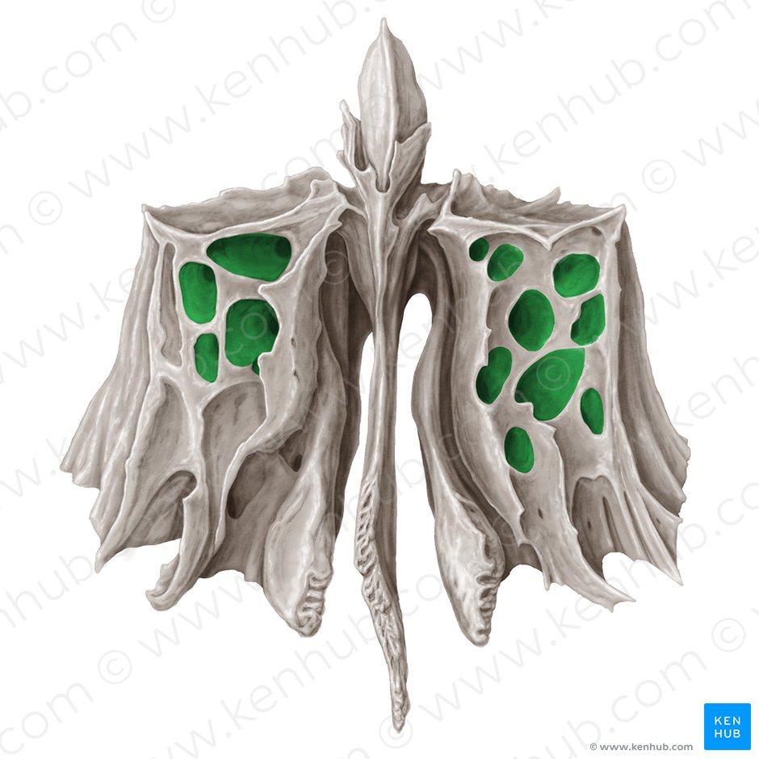
Diagram showing the ethmoidal cells

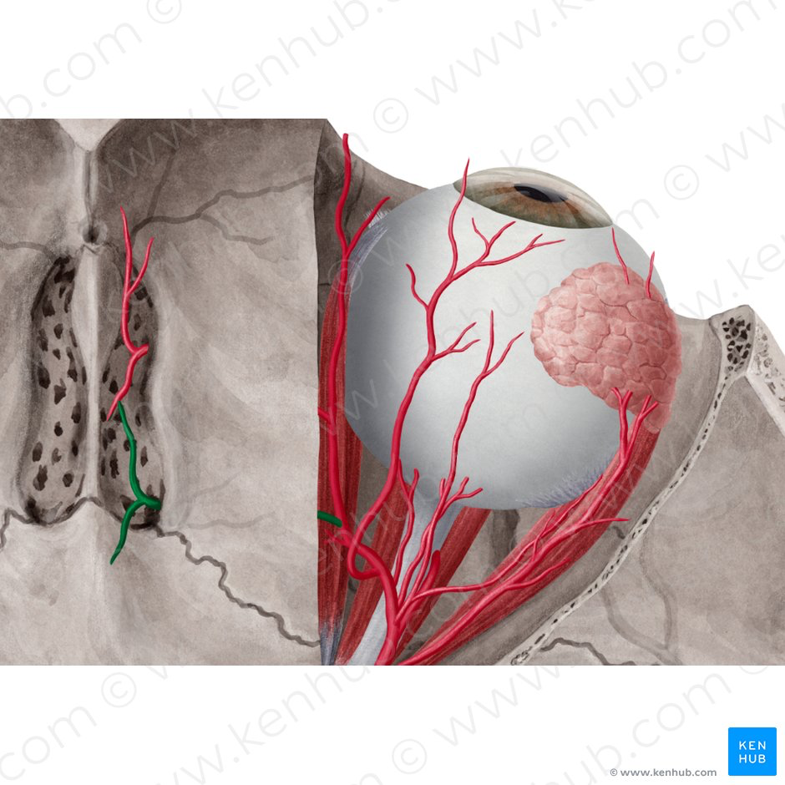
Diagram showing the posterior ethmoidal artery.

Clinical Significance:
- Sinusitis
As the paranasal sinuses are continuous with the nasal cavity, an upper respiratory tract infection can spread to the sinuses. Infection of the sinuses causes inflammation (particularly pain and swelling) of the mucosa, and is known as sinusitis. If more than one sinus is affected, it is called pansinusitis.
The maxillary nerve supplies both the maxillary sinus and maxillary teeth, and so inflammation of that sinus can present with toothache.

