NAME; NWOYE CHINONYELUM MATRIC NUMBER: 17/MHS01/212
HEAD AND NECK ASSIGNMENT BY DR. O.G
LEVEL; 300LVL
ASSIGNMENT TWO
- WRITE AN ESSAY ON THE CARVANOUS SINUS
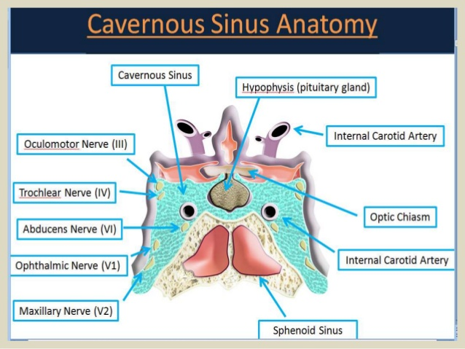

The cavernous sinus is a paired Dural venous sinus located within the cranial cavity. It is divided by septa into small ‘caves’ – from which it gets its name. Each cavernous sinus has a close anatomical relationship with several key structures in the head, and is arguably the most clinically important venous sinus.
The Dural venous sinuses are channels between the two layers of dura mater which are responsible for the venous drainage of the brain, skull, orbit and internal ear.

Anatomical Location and Borders
The cavernous sinuses are located within the middle cranial fossa, on either side of the Sella turcica of the sphenoid bone (which contains the pituitary gland). They are enclosed by the endosteal and meningeal layers of the dura mater.
The borders of the cavernous sinus are as follows:
- Anterior – superior orbital fissure.
- Posterior – petrous part of the temporal bone.
- Medial – body of the sphenoid bone.
- Lateral – meningeal layer of the dura mater running from the roof to the floor of the middle cranial fossa.
- Roof – meningeal layer of the dura mater that attaches to the anterior and middle clinoid processes of the sphenoid bone.
- Floor – endosteal layer of dura mater that overlies the base of the greater wing of the sphenoid bone. Contents
Several important structures pass through the cavernous sinus to enter the orbit. They can be sub-classified by whether they travel through the sinus itself, or through its lateral wall:
Travels through cavernous sinus: | Travels through lateral wall of cavernous sinus:
Abducens nerve (CN VI)  Carotid plexus (post-ganglionic sympathetic nerve fibres)  Internal carotid artery (cavernous portion) | Oculomotor nerve (CN III)  Trochlear nerve (CN IV)  Ophthalmic (V1) and maxillary (V2) branches of the trigeminal nerve
The cavernous sinus is the only site in the body where an artery (internal carotid) passes completely through a venous structure. This is thought to allow for heat exchange between the warm arterial blood and cooler venous circulation.
Dural Venous Sinus System
Each cavernous sinus receives venous drainage from:
- Ophthalmic veins (superior and inferior) – these enter the cavernous sinus via the superior orbital fissure.
- Central vein of the retina – drains into the superior ophthalmic vein, or directly into the cavernous sinus.
- Sphenoparietal sinus – empties into the anterior aspect of the cavernous sinus.
- Superficial middle cerebral vein – contributes to the venous drainage of the cerebrum
- Pterygoid plexus – located within the infratemporal fossa.
It is important to note that the superior ophthalmic vein forms an anastomosis with the facial vein. Therefore, the ophthalmic veins represent a potential route by which infection can spread from an extracranial to an intracranial site.
The cavernous sinuses empty into the superior and inferior petrosal sinuses, and ultimately, into the internal jugular vein. The left and right cavernous sinuses are connected in the midline by the anterior and posterior intercavernous sinuses. They travel through the Sella turcica of the sphenoid bone.
Clinical Significance - Cavernous Sinus Thrombosis
Cavernous sinus thrombosis (CST) refers to the formation of a clot within the cavernous sinus.
This most common cause of CST is infection; which typically spreads from an extracranial location such as the orbit, paranasal sinuses, or the ‘danger zone’ of the face. Infection is able to spread in this manner due to the anastomosis between the facial vein and superior ophthalmic veins.
Common clinical features include headache, unilateral periorbital oedema, proptosis (eye bulging), photophobia and cranial nerve palsies. The abducens nerve (CN VI) is most commonly affected.
Treatment is typically with antibiotic therapy. Where the cause is infection, thrombosis of the cavernous sinus can rapidly progress to meningitis.

- Discuss the walls of the nose
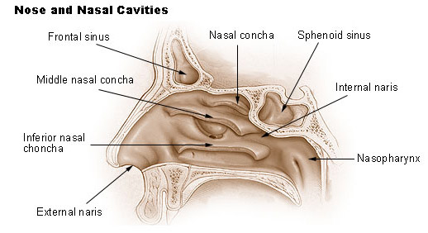
The nose is the part of the respiratory tract that sits front and center on your face. You use it to breathe air in and to stop and smell the roses. The nose’s exterior anatomy includes the nasal cavity, paranasal sinuses, nerves, blood supply, and lymphatics. The external part of the nose includes the root (between the eyes), the dorsum that runs down the middle, and the apex at the tip of the nose. Two openings called nostrils (nares) allow air in. They’re divided by the nasal septum (dividing wall of cartilage and bone), and the parts that surround the nostrils are called the alae (ala singular).

The nose has a bony part that’s formed by the bony nasal septum, the nasal bones, and parts of the maxillae, palatine, and frontal bones. The cartilaginous part of the nose is formed by two lateral cartilages, two alar cartilages, and a septal cartilage.

The nasal cavity
The nares serve as the entryway to the nasal cavities, which open posteriorly into the nasopharynx via the choanae. The walls of the nasal cavity include the following features:
- Roof: The roof is divided into three parts: frontonasal, ethmoidal, and sphenoidal. Each part corresponds to the underlying bone of the same name.
- Floor: The floor consists of the palatine process of the maxilla and the horizontal plate of the palatine bone.
- Medial wall: This wall is the nasal septum, which is formed by the perpendicular plate of the ethmoid bone, the vomer, cartilage, and the nasal crests of the maxillary and palatine bones.
- Lateral wall: This wall is hallmarked by three nasal conchae (superior, middle, and inferior) that project inferiorly from the wall. They divide the nasal cavity into four passages that have openings to the paranasal sinuses:
- The sphenoethmoid recess lies posterior to the superior concha and has the opening for the sphenoidal sinus.
- The superior nasal meatus lies between the superior and middle conchae and has openings to the posterior ethmoidal sinuses.
- The middle nasal meatus is longer and deeper than the superior nasal meatus. The frontal sinus communicates with the middle nasal meatus via the infundibulum, a passageway that opens into the semilunar hiatus (groove in the ethmoid bone). The maxillary sinus opens into the semilunar hiatus. An ethmoidal bulla (a round swelling formed by the middle ethmoidal cells, or air-filled cavities) is formed just above the semilunar hiatus. The middle and anterior ethmoidal sinuses drain into the middle nasal meatus.
- The inferior nasal meatus is found below the inferior nasal concha. The nasolacrimal duct opens into this meatus.
The nasal cavity is lined with nasal mucosa, except for the nasal vestibule, which is lined with skin. The mucosa over the superior one-third of the nasal cavity is the olfactory area. Air is drawn past the specialized mucosal cells called the olfactory epithelium as air is sniffed though the nose. The olfactory epithelium contains receptors of olfactory neurons that detect smells. Olfactory neurons (from CN I) join together to form nerve bundles that run up through the cribriform plate of the ethmoid bone to the olfactory bulb. The olfactory tract transmits the sensory information about smell from

