NAME: BAMGBOYE ATINUKE
MATRIC NUMBER: 17/SCI05/003
COURSE TITLE: MICROBIAL ECOLGY
DEPARTMENT: MICROBIOLOGY
TOPIC: 10 COMPONENTS OF THE AERIAL ENVIRONMENT

ABSTRACT
This term paper is written to give details on the different components of the aerial environment.

INTRODUCTION
The components of the aerial environment are varied and mostly include gases, pollen grains, fungal spores, bacterial spores, hyphal fragments, actinomycetes, spores of bryophytes and pteridophytes , suspended dust particles, etc.

Components of aerial environment

ATMOSPHERIC GASES
Air is the commercial source for many of the gases it contains. The air around us is a mixture of gases, mainly nitrogen and oxygen, but containing much smaller amounts of water vapor, argon, and carbon dioxide, and very small amounts of other gases.
Gases %volume
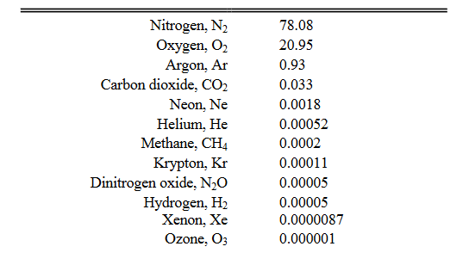

WATER VAPOR/WATER DROPLETS
Water vapor is also used as a "lifting gas" as its density is lower than that of air. Water vapor can be produced from the evaporation or boiling of liquid water or from the sublimation of ice. Water vapor is transparent, like most constituents of the atmosphere. Under typical atmospheric conditions, water vapor is continuously generated by evaporation and removed by condensation. It is less dense than most of the other constituents of air and triggers convection currents that can lead to clouds.
Water vapor is a highly variable part of the atmosphere and is a major component of the hydrologic cycle. Atmospheric water vapor is characterized by various parameters, including vapor pressure, relative humidity, dew point temperature, water vapor density, and specific humidity. Relative humidity is probably the most familiar. It is defined as the ratio of the actual vapor pressure to the saturation vapor pressure of the air, which is solely a function of air temperature.

DUST PARTICLES
Fine solid particles are known as dust particles. Atmospheric dust is also known as Aeolian. These particles comprise of particles which originate from volcanic eruptions, pollution or soil. These dust particles also contain pollens, hair of humans and animals, soot particles, in small amounts. Dust settled on the roads also become airborne due to the constant movement of vehicles. Coal dust is responsible for respiratory diseases. The dust particles also have allergic effects on some people. If a large number of dust particles are present in the atmosphere, then it can also reduce visibility and is a safety hazard.
Given the wide variety of pollutants and chemical compositions involved, dust particles play a role in many air pollution issues. These include:
- human health effects of particles; respiratory and heart problems caused by inhalation of small particles has been related to the mass concentration of particles below 10 µm diameter (PM10, e.g. Prescott et al., 1998)
- localised effects of dusts covering vegetation (Farmer, 1993)
- deposition of regional pollutants causing acidification and eutrophication
- deposition of heavy metals with toxic effects on plants, animals and humans
- transboundary transport of air pollutants as fine particles
- light scattering leading to the potential to offset global warming.
- climate change will affect PM concentrations in polluted environments by ±0.1-1μg m⁻³ over the coming decades. Wildfires fuelled by climate change could become an increasingly important PM source (RoTAP, 2012)
- light scattering leading to reductions in visibility

POLLEN GRAINS
Pollen grains have been present in the air since the beginning of flowering plants (~130 million years ago). They are the fertilizing agent in plant reproduction. So they are classed separately from airborne pollutants. A pollen grain is a microscopic body that contains the male reproductive cell of a plant. It is crucial in a plant's fertilization process. ollen grains are microscopic structures that vary in size and shape. Some are tiny orbs, while others are egg-shaped. Although too small to see individually, they can be seen by the naked eye in large quantities. Pollen grains (from the greek palynos for dust or pollen) contain the male gametophyte (microgametophyte) phase of the plant. Pollen grains are produced by meiosis of microspore mother cells that are located along the inner edge of the anther sacs (microsporangia). The outer part of the pollen is the exine, which is composed of a complex polysaccharide, sporopollenin. Inside the pollen are two (or, at most, three) cells that comprise the male gametophyte. The tube cell (also referred to as the tube nucleus) develops into the pollen tube. The germ cell divides by mitosis to produce two sperm cells. Division of the germ cell can occur before or after pollination. Plant pollen is considered as the main aeroallergen causing allergic reactions.
Pollen is in the air seasonally, with the amount varying from one area to another, depending on the types of wind pollinating plants in the region and the weather conditions. During and after the rain some grains of pollen bursts releasing its allergen and starch granules and are dispersed in the air.
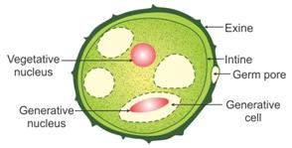
Figure 1: Structure of pollen grain

FUNGAL SPORES
fungi and fungus-like organisms, spores are often classified by the structure in which meiosis and spore production occurs. Since fungi are often classified according to their spore-producing structures, these spores are often characteristic of a particular taxon of the fungi.
- Sporangiospores: spores produced by a sporangium in many fungi such as zygomycetes.
- Zygospores: spores produced by a zygosporangium, characteristic of zygomycetes.
- Ascospores: spores produced by an ascus, characteristic of ascomycetes.
- Basidiospores: spores produced by a basidium, characteristic of basidiomycetes.
- Aeciospores: spores produced by an aecium in some fungi such as rusts or smuts.
- Urediniospores: spores produced by a uredinium in some fungi such as rusts or smuts.
- Teliospores: spores produced by a telium in some fungi such as rusts or smuts.
- Oospores: spores produced by an oogonium, characteristic of oomycetes.
Spores are special reproductive cells used for asexual reproduction. Fungi produce spores in astronomical quantities, for example the giant puffball (Calvatia gigantea) produces 20 billion spores, which get into the air and are dispersed over vast areas. A very common type of spores found in air is that of conidia.
Fungal spores gain entry in to the respiratory tract of warm blooded animals with the rhythmical inhalation of the air through nostrils. Size, shape and surface structure of air borne fungi are important factor in the inhalation, retention and exhalation of man.
FIGURE 2: FUNGAL SPORES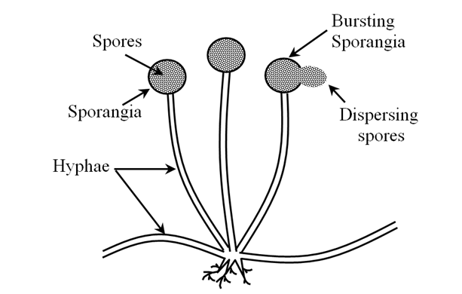

BACTERIAL SPORES
Bacterial spores are highly resistant, dormant structures (i.e. no metabolic activity) formed in response to adverse environmental conditions. They help in the survival of the organisms during adverse environmental conditions; they do not have a role in reproduction.
Endospores can survive environmental assaults that would normally kill the bacterium. These stresses include high temperature, high UV irradiation, desiccation, chemical damage and enzymatic destruction. The extraordinary resistance properties of endospores make them of particular importance because they are not readily killed by many antimicrobial treatments. A variety of different microorganisms form "spores" or "cysts", but the endospores of low G+C Gram-positive bacteria are by far the most resistant to harsh conditions.
Another type of resting form is produced by very common soil bacteria, the actinomycetes. Their special vertical, filiform cells, of the so-called air mycelium, undergo fragmentation producing numerous ball-shaped formations. Due to the fact that their production is similar to the formation of fungal, they are also called conidia. Contrary to endospores, the conidia are used for reproduction. There are also other bacterial resting forms, among others, the cysts produced by azotobacters - soil bacteria capable of molecular nitrogen assimilation.
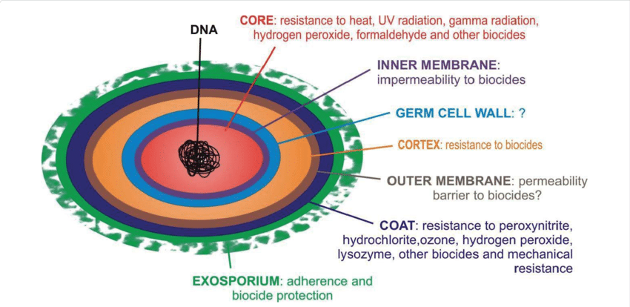
FIGURE 3: DIAGRAM OF BACTERIAL ENDOSPORES

FUNGAL HYPHAL FRAGMENTS
Hyphal fragments: refer to fragments of the filamentous structures (hyphae) that make up the body of moulds by branching extensively to form a complex network called mycelium. Hyphal fragments or mycelia are components of fungal growth (similar to the roots and branches of a tree); Hyphal fragments or hyphae may be color or colorless(mycologists report colorless spores or hyphae as hyaline. It is normal to find a few hyphal fragments in aerial environments. At high levels or in some circumstances, these particles might tell us something more about the environment( an active growth nearby).
In some fungi hyphal fragments may be allergenic or may even contain mycotoxins. (In our terminology, fungal material may be harmless-cosmetic, allergenic, toxic, or pathogenic, depending on the genera/species and on its growth conditions.)
But the hyphal fragments or pieces found in air or dust samples are usually quite large and not likely to be inhaled deeply into the lungs. We report hyphal fragments in air or dust samples (where it is common to find at least some) for these reasons:
- a high level of hyphal fragments can mean a high level of allergenic particles
- a high level of hyphal fragments is often corroboration of active nearby fungal growth (though absence of them does not affirm absence of fungal growth)

ACTINOMYCETES AND THEIR SPORES
Actinomycetes are a diverse group of gram-positive bacteria. They resemble fungi because they are adapted to life on solid surfaces and they can produce mycelium and dry spores like most fungi . Actinomycete spores are known to be important air contaminants in occupational environments, such as agriculture and waste composting facilities , and have recently gained special attention as indicators of mold problems in buildings . They do not belong to the normal microbial flora in indoor air but have been found in buildings suffering from moisture and mold problems . In addition, airborne spores of several actinomycete species (e.g., Saccharopolyspora rectivirgula, Micropolyspora faeni, Thermoactinomyces vulgaris, and Streptomyces albus) have been related to the incidence of allergic alveolitis and other severe health effects. Actinomycete spores are formed either by subdivision of existing hyphae by fragmentation or swelling or by endogenous spore formation. The hyphae that subdivide into spores can be sheathless or have a sheath, which partly remains in the spores after fragmentation . This leads to three main spore types: arthrospores (subdivision of sheathed hypha), aleuriospores (subdivision of sheathless hypha), and endospores. The significance of the differences in the spore structure is not known, but these differences are expected to cause differences in the survival and airborne behavior of these spores.
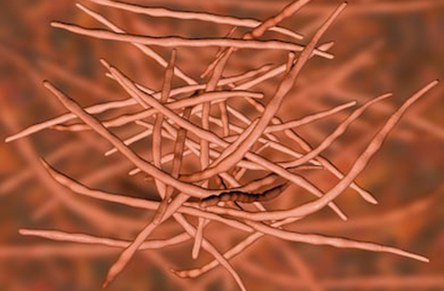
FIGURE 4: ACTINOMYCETES

SPORES OF BRYOPHYTES AND PTERIDOPHYTES
Bryophytes are small, non-vascular plants, such as mosses, liverworts and hornworts. They play a vital role in regulating ecosystems because they provide an important buffer system for other plants, which live alongside and benefit from the water and nutrients that bryophytes collect. Some bryophyte species are amongst the first to colonise open ground. Bryophytes are also very good indicators of habitat quality as many plant species in this group are sensitive to levels of moisture in the atmosphere, which are lower in disturbed habitats because there is less shade. Bryophytes do not have seeds or flowers. Instead they reproduce via spores. There are around 20,000 species of Bryophytes.

A pteridophyte is a vascular plant (with xylem and phloem) that disperses spores. Because pteridophytes produce neither flowers nor seeds, they are sometimes referred to as "cryptogams", meaning that their means of reproduction is hidden. Ferns, horsetails (often treated as ferns), and lycophytes (clubmosses, spikemosses, and quillworts) are all pteridophytes. All pteridophytes have a true alternation of generations, in which a dominant sporophyte generation produces spores through meiosis , and a free-living gametophyte generation forms gametes (egg and sperm) by mitosis .

REFERENCES
- Afzal, M. and F.S. Mehdi, 2002. Atmospheric fungi of Karnchi city. Pak. J. Bio. Sci., 5: 707-709.
- Cross T. Growth and examination of actinomycetes—some guidelines. In: Williams S T, Sharpe M E, Holt J G, editors. Bergey’s manual of systematic bacteriology. Vol. 4. Baltimore, Md: Williams & Wilkins; 1989. pp. 2340–2343.
- Cole E C, Foarde K K, Leese K E, Green D A, Franke D L, Berry M A. Assessment of fungi in carpeted environments. In: Samson R A, Flannigan B, Flannigan M E, Verhoeff A P, Adan O C G, Hoekstra E S, editors. Health implications of fungi in indoor environments. Air quality monographs. Vol. 2. Amsterdam, The Netherlands: Elsevier; 1994. pp. 103–128.
- Derwent, R.G.; Witham, C. ; Redington, A. ; Jenkin, M.E. ; Stedman, J.R. ; Yardley, R. ; Hayman, G. 2009 Particulate matter at a rural location in southern England during 2006: Model sensitivities to precursor emissions Atmospheric Environment 43 689-696
- http://naei.defra.gov.uk/overview/pollutants?pollutant_id=PMFINE
- https://science.howstuffworks.com/nature/climate-weather/storms/dust-storm.htm> 1 March 2020
- Tilak, S.T., 1982. Aerobiology. Vaijayanti Prakashan Publisher, Aurangabad, India, pp: 212.

