NAME: CHIKA CHIEZE
MAT.NO: 17/MHS03/011
LEVEL: 300
DEPT: ANATOMY
COURSE: ANA 314(Animal Handling & Comparative Mammalian Gross Anatomy)
ASSIGNMENT: Comparative Anatomy

Questions

- What is comparative anatomy
- Highlight the criteria necessary to caring for laboratory animals
- Highlight the similarities and differences in the digestive system anatomy of amphibians and man

Answers

- Comparative anatomy is the study of similarities and differences in the anatomy of different species. It is the comparative study of the body structures of different species of animals in order to understand the adaptive changes they have undergone in the course of evolution from common ancestors.
- The criteria necessary for caring for laboratory animals are:
- Room temperature
- Humidity
- Ventilation
- Illumination and light schedule
- Noise moderation

Temperature and Humidity
Maintenance of body temperature within normal circadian variation is necessary for animal well-being. Animals should be housed within temperature and humidity ranges appropriate for the species, to which they can adapt with animal stress and physiologic alteration. Regulation of body temperature within normal variation is necessary for the well-being of homeotherms. Generally, exposure of unadapted animals to temperature above 85 ◦F(29.4◦C) or below 40◦F(4.4◦C). without access to shelter or other productive mechanisms, might produce clinical effects(Gordon 1990). Temperature of 65-75 fahrenheit with 40-60% humidity recommended.
Ventilation
Optimum air quality in laboratory animal facilities is essential for the general health and well-being of researchers, animal care givers, and the animal as well as for the integrity of the studies. Since both genetic heritage and the environment influence biological responses, researchers must always be aware of the influence of the environment on the animal’s biological responses.
Illuminating and light schedule
Light can affect the physiology, morphology and behavior of various animals. Potential photostressors include appropriate photoperiod, photointensity and spectral quality of the light. For practical considerations due to common work hours, researchers should be aware of lighting schedules used in rodent housing rooms( commonly 12 hours light : 12 hours dark). If the researchers turn on the light during the animals dark period the disruption of the light schedule may cause animals to be perturbed, which may have effects on the breeding performance and on circadian rhythms.
Noise Moderation
Because changes in patterns of sound exposure have different effects on different animals, personnel should try to minimize the production of unnecessary noise. Excessive and intermittent noise can be minimized by training personnel in alternatives to noisy practices, the use of cushioned casters and bumpers on carts, trucks and racks, and proper equipment maintenance (e.g castor lubrication). Radios, alarms and other sound generators should not be used in animal rooms unless they are part of an approved protocol or enrichment program. Any radios or sound generators used should be switched off at the end of the working day minimize to associated adverse physiologic changes(Baldwin 2007).

- Similarities in the digestive system anatomy of amphibians e.g frog and man

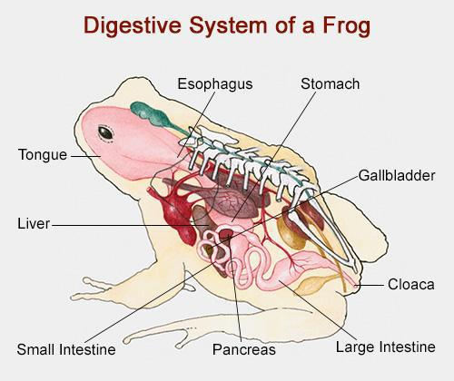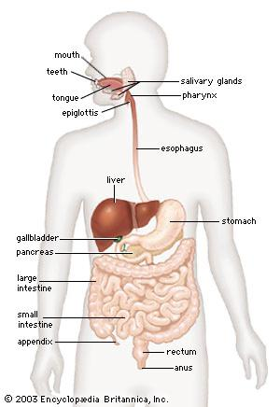

- Presence of mouth
- Presence of tongue
- Presence of esophagus
- Presence of teeth
- Presence of small intestine
- Presence of stomach
- Presence of liver
- Presence of gallbladder
- Presence of large intestine
Differences in the digestive system anatomy of amphibians e.g frog and man

Frog | Man
- The tongue is very sticky | The tongue is not sticky
- Frogs have shorter intestine and the two parts of the intestine are the duodenum and ileum | Man has a longer small intestine and the three parts of the intestine are ileum, duodenum and jejunum
- Absorption of nutrients in frogs occurs in the ileum | Absorption of nutrients in man occurs in the jejunum
- Elimination of indigested food occurs through the cloaca | Elimination of indigested food occurs through the rectum
- Frogs have two sets of teeth; maxillary teeth and vomerine teeth | Man has one set of teeth in their oral cavity
- Frogs don’t have strong teeth, they use their teeth to hold their prey | Man has strong teeth. Man can use their teeth to chew their food
- The top of the tongue is folded backwards | The top of the tongue is straight

