DUNMOYE AKEEM
17/ENG03/016
1a.) Height of Collimation Method
This method is simple and easy.

Reduction of levels is easy.

Visualization is not necessary regarding the nature of the ground.

There is no check for intermediate sight readings;

This method is generally used where more number of readings can be taken with less number of change poi
Rise and Fall Method
This method is complicated and is not easy to carry out.

Reduction of levels takes more time.

Visualization is necessary regarding the nature of the ground.

Complete check is there for all readings.

This method is preferable for check levelling where number of change points are more.nts for constructional work and profile levellings.

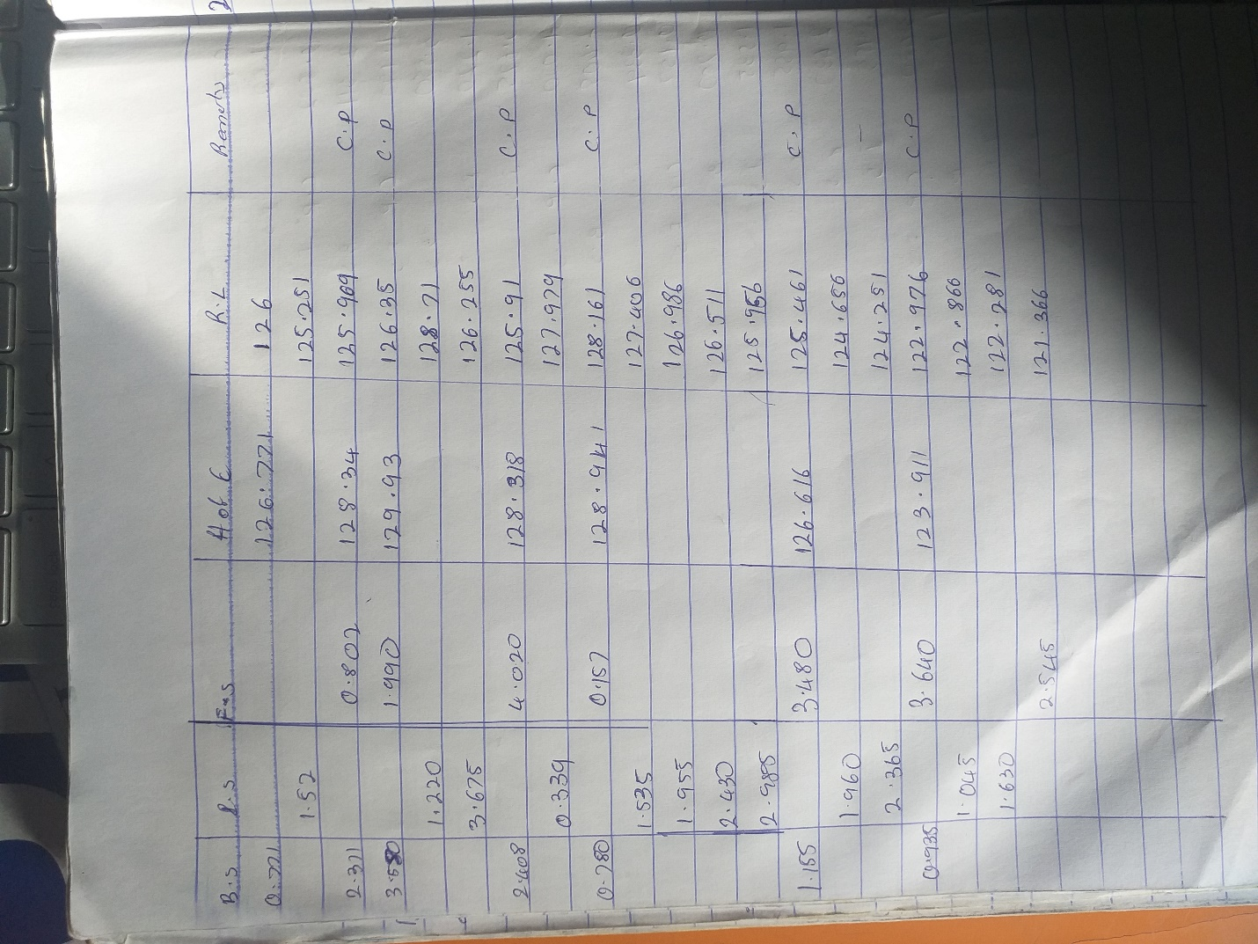
QUESTION 2

Chainage(m) | 0 | 30 | 60 | 90 | 120 | 150 | 180 | 210 | 240 | 270
Offset length(m) | 0 | 2.65 | 3.80 | 3.75 | 4.65 | 3.60 | 5.00 | 5.80 | 6.10 | 5.85

Using Mid-ordinate rule:
A=$Σ$hd

h1= $\frac{0+2.65}{2}$=1.325m

h2= $\frac{2.65+3.80}{2}$=3.225m

h3= $\frac{3.80+3.75}{2}$=3.775m

h4= $\frac{3.75+4.65}{2}$=4.2m

h5= $\frac{4.65+3.60}{2}$=4.125m

h6= $\frac{3.60+5.00}{2}$=4.3m

h7= $\frac{5.00+5.80}{2}$=5.4m

h8= $\frac{5.80+6.00}{2}$=5.9m

h9= $\frac{6.00+5.85}{2}$=5.925m

$$Σh=1.325+3.225+3.775+4.2+4.125+4.3+5.4+5.9+5.925$$
$Σh=$38.175m

d=30m
A=$Σhd$
= $38.175×30$
A= $1145.25m{}^{2}$

Using average ordinate rule

A=$\frac{ndΣO}{n+1}$

n=9

d=30
$$ΣO=0+2.65+3.80+3.75+4.65+3.60+5.00+5.80+6.10+5.85$$
$ΣO=$41.2m

A=$\frac{9×30×41.2}{9+1}$

A=$112.4m{}^{2}$

Using trapezoidal rule

A=$d(\frac{0{}_{1}+0{}_{n }}{2}+0{}_{2}+0{}_{3}+0{}_{4}............0{}_{n-1})$

$$d=30$$

A=$30(\frac{0+5.85}{2}+2.65+3.80+3.75+4.65+3.60+5.00+5.80+6.10)$

A=$30(38.275)$
A=$1148.25m{}^{2}$

Using Simpson's rule
$$A=\frac{d }{3 }\left[\left(0{}_{1}+0{}_{n}\right)+4\left(0{}_{2}+0{}_{4}+.........0{}_{n-1}\right)+2\left(0{}_{3}+0{}_{5}........0{}_{n-1}\right)\right]$$

$$d=30$$

Note: Last offset was removed because number of offsets were even

$$A=\frac{30}{3 }\left[\left(0+6.10\right)+4\left(2.65+3.75+3.60+5,80\right)+2\left(3.80+4.65+5.00\right)\right]$$
$$A=962m{}^{2}$$

Calculating for last offset using trapezoidal rule

A=$d(\frac{0{}_{1}+0{}_{n }}{2}+0{}_{2}+0{}_{3}+0{}_{4}............0{}_{n-1})$

$$A=30\left[\frac{6.40+5.85}{2}\right]$$
$$A=183.75m{}^{2}$$

Therefore $ΣA=962+183.75$

$$A=1145.75m{}^{2}$$

3.) 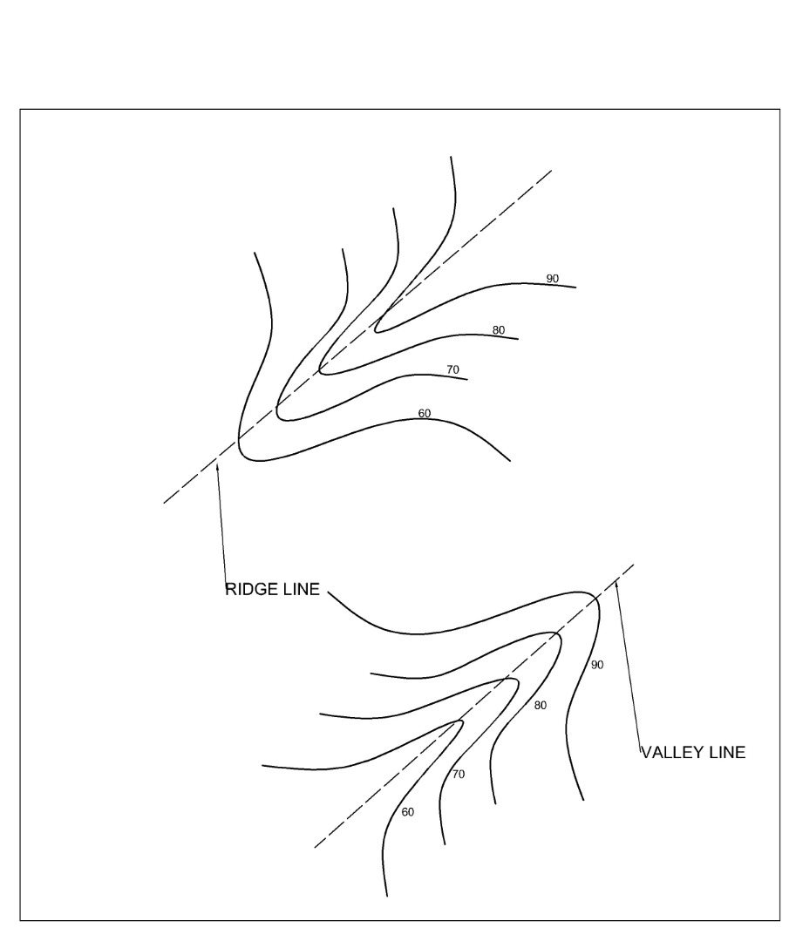
a.) Contour line crosses a bridge or a valley at right angle . If the higher values are inside the bend or loop in the contour , it represents a ridge and if they are outside the bend it represents a valley
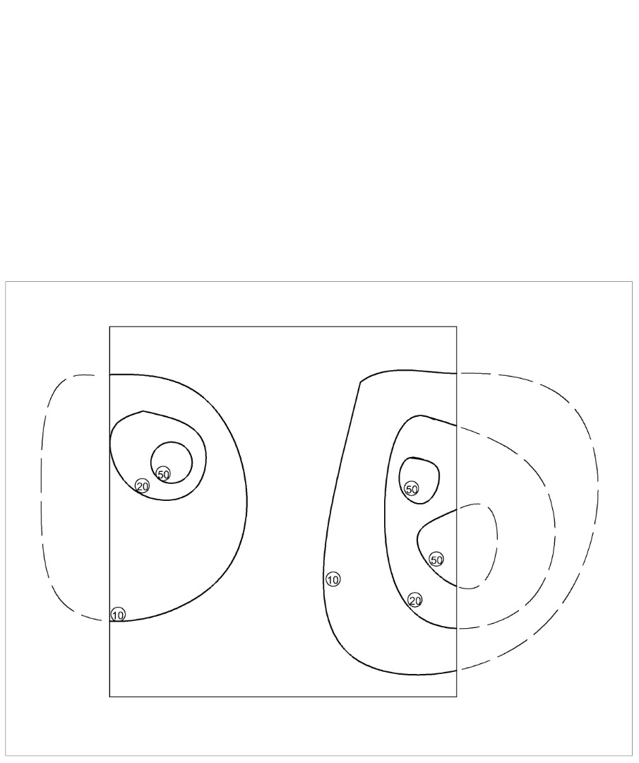
B.) Contour lines can not end anywhere but close on themselves either within or outside the limitof the map
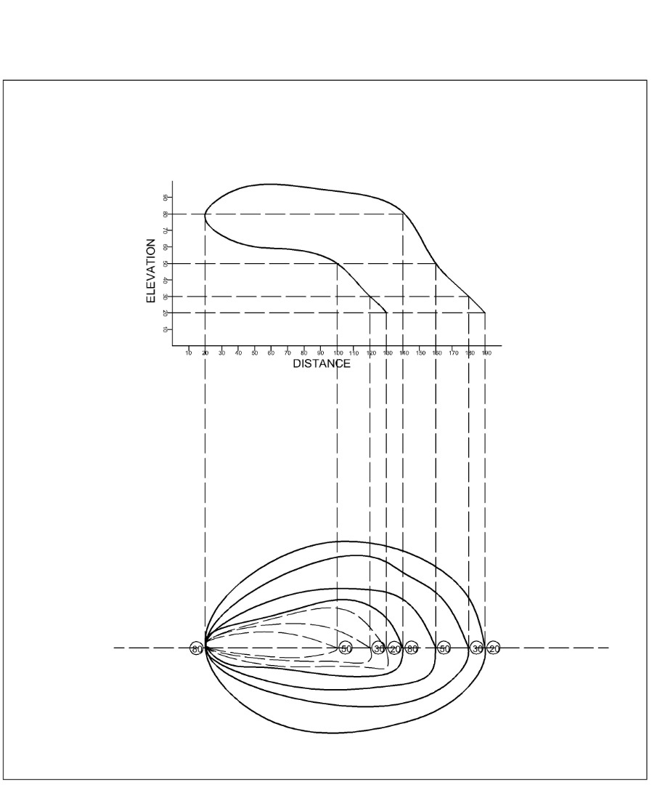
c.) Contour lines cannot merge or cross one another on a map except in a case of an overhanging cliff
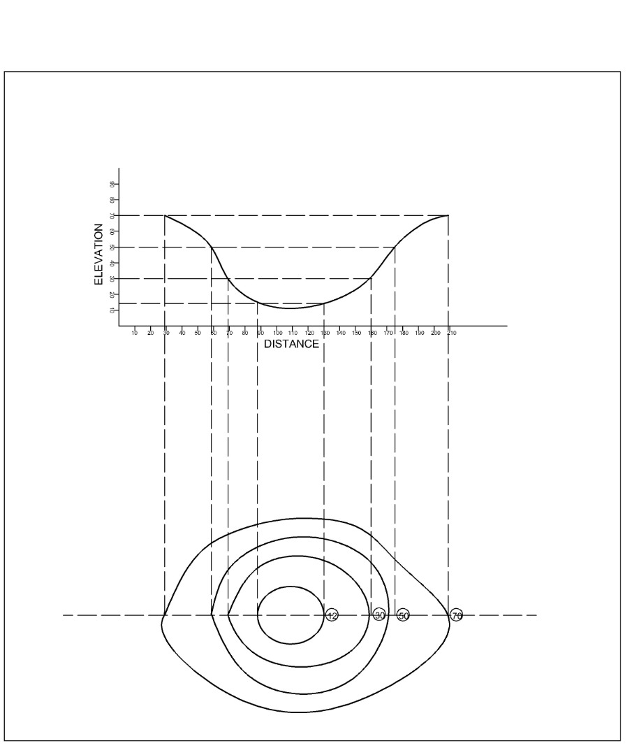
d.) A series of closed contours on a map indicate a depression if the higher values are outside as shown
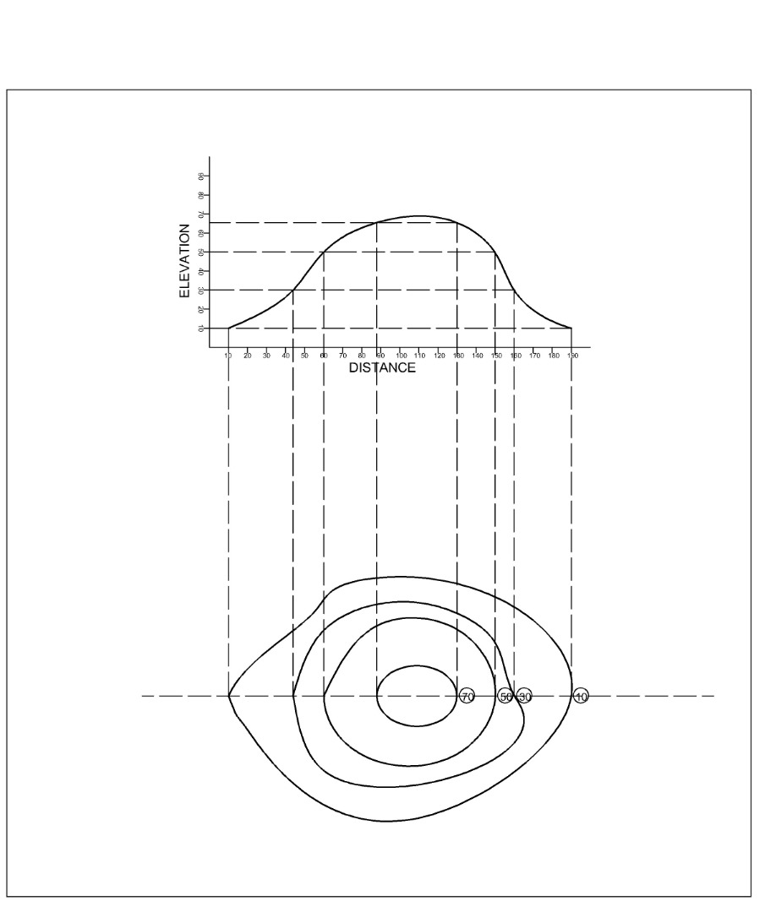
e.) A series of closed contour on a map represent a hill if the higher values are inside as shown

