- A Zener diode is one of the specially designed diodes that predominately works in reverse biased conditions. They are more heavily doped than ordinary diodes, due to which they have narrow depletion region. When we apply a reverse voltage to a Zener diode, a negligible amount of current flows through the circuit. When a voltage higher than Zener breakdown voltage is applied, Zener breakdown occurs. Zener breakdown is a phenomenon where a significant amount of current flows through the diode with a negligible drop in voltage.When we increase the reverse voltage further, the voltage across the diode remains at the same value of Zener breakdown voltage whereas the current through it keeps on rising as seen in the graph below. Due to this phenomena zener diodes with particular zener breakdown voltages can be used to regulate the voltage of a circuit preventing the voltage from exceeding that particular breakdown voltage.

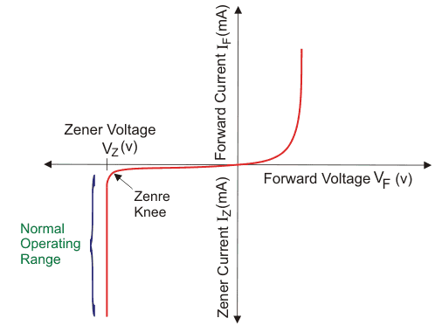

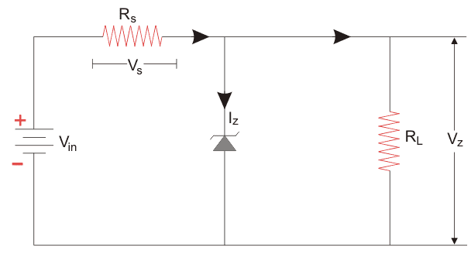

2. Values:
P= 5W
Is= 500mA = 0.5A
Vs= 20Vmax
i) Using; maximum current= Power(Watts)/Voltage(volts)

0.5A = 5W/Vz
Vz = 10V

using; minimum value of resistors(Rs) = (Vs-Vz)/Is

Rs = (20-10)/0.5
Rs = 20 Ohms

ii) I(load) = ?
Vz = 10V
Using; V = IR
10 = 500*I
I = 0.02A

