NAME: AJAYI EMMANUEL OLUWASEGUN
MATRICULATION NUMBER: 17/MHS01/039
DEPARTMENT: MEDICINE AND SURGERY
COURSE: GROSS ANATOMY OF HEAD AND NECK

THE CAVERNOUS SINUS
The cavernous sinus within the human head is one of the dural venous sinuses creating a cavity called the lateral sellar compartment bordered by the temporal bone of the skull and the sphenoid bone, lateral to the sella turcica.
The cavernous sinus is one of the dural venous sinuses of the head. It is a network of veins that sit in a cavity, approximately 1 x 2 cm in size in an adult. The carotid siphon of the internal carotid artery, and cranial nerves III, IV, V (branches V₁ and V₂) and VI all pass through this blood filled space.

ANATOMICAL LOCATION AND BORDERS
The cavernous sinuses are located within the middle cranial fossa, on either side of the sella turcica of the sphenoid bone (which contains the pituitary gland). They are enclosed by the endosteal and meningeal layers of the dura mater.
The borders of the cavernous sinus are as follows:
- Roof - Meningeal layer of the dura mater that attaches itself to the anterior and middle clinoid processes of the sphenoid bone.
- Floor - Endosteal layer of the dura mater that overlies the base of the greater wing of the sphenoid bone.
- Medial - Body of the sphenoid bone (sphenoidal air sinus).
- Lateral - Meningeal layer of the dura mater running from the roof to the floor of the middle cranial fossa.
- Anterior - Superior orbital fissure and the apex of the orbit.
- Posterior - Apex of petrous part of the temporal bone.

CONTENTS
Apart from the blood which passes through a venous sinus, several anatomical structures, including some cranial nerves and their branches, also pass through the sinus to enter the orbit. They can be sub-classified by whether they travel through the sinus itself, or through its lateral wall;
Travels through cavernous sinus: | Travels through lateral wall of cavernous sinus (from superior to inferior):
- Abducens nerve (CN VI) | - Oculomotor nerve (CN III)
- Carotid plexus (post ganglionic sympathetic nerve fibers) | - Trochlear nerve (CN IV)
- Internal carotid artery (cavernous portion) | - Ophthalmic (V₁) and maxillary (V₂) branches of the trigeminal nerve
These nerves with the exception of CN V₂, pass through the cavernous sinus to enter the orbital apex through the superior orbital fissure. The maxillary nerve, division V₂ of the trigeminal nerve travels through the lower portion of the sinus and exits via the foramen rotundum. The maxillary branch passes external to, but immediately adjacent to, the lateral wall of the sinus.
The optic nerve lies just above and outside the cavernous sinus, superior and lateral to the pituitary gland on each side, and enters the orbital apex via the optic canal.
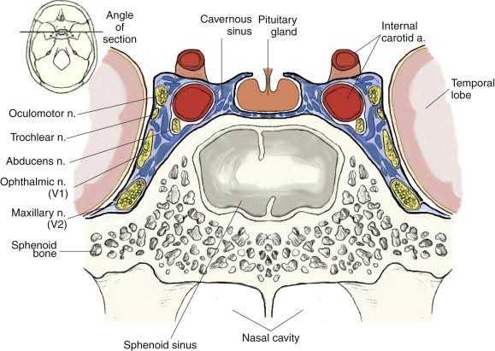
Diagram demonstrating the contents of the cavernous sinuses
VENOUS CONNECTIONS
Each cavernous sinus receives drainage from:
- Ophthalmic veins (superior and inferior) – these enter the cavernous sinus via the superior orbital fissure.
- Central vein of the retina – drains into the superior ophthalmic vein, or directly into the cavernous sinus.
- Sphenoparietal sinus – empties into the anterior aspect of the cavernous sinus.
- Superficial middle cerebral veins
- Inferior cerebral veins
As a venous sinus, the cavernous sinus receives blood from the superior and inferior ophthalmic veins and from superficial cortical veins, and is connected to the basilar plexus of veins posteriorly.
The cavernous sinus empties into the superior and inferior petrosal sinuses, and ultimately, into the internal jugular vein via the sigmoid sinus, also draining with emissary vein to pterygoid plexus. The left and right cavernous sinuses are connected in the midline by the anterior and posterior intercavernous sinuses. They travel through the sella turcica of the sphenoid bone.
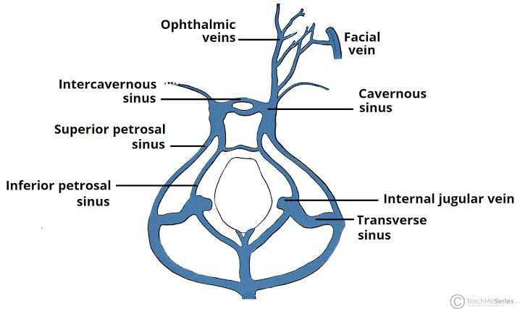
Schematic of the dural venous system relating to the cavernous sinus

CLINICAL SIGNIFICANCE
The cavernous sinus is the only anatomical site in the body in which an artery (internal carotid) travels completely through a venous structure (this is thought to allow for heat exchange between the warm arterial blood and cooler venous circulation). If the internal carotid artery ruptures within the cavernous sinus, an atriovenous fistula is created (more specifically, a carotid-cavernous fistula). Lesions affecting the cavernous sinus may affect isolated nerves or all the nerves traversing from it.
Cavernous Sinus Thrombosis: Cavernous sinus thrombosis (CST) refers to the formation of a clot within the cavernous sinus.
The most common cause of CST is infection; which typically spreads from an extracranial location such as the orbit, paranasal sinuses, or the ‘danger zone’ of the face. Infection is able to spread in this manner due to the anastomosis between the facial vein and superior ophthalmic veins.
Common clinical features include headache, unilateral periorbital oedema, proptosis (eye bulging), photophobia and cranial nerve palsies. The Abducens nerve (CN VI) is most commonly affected.
Treatment is typically with antibiotic therapy. Where the cause is infection, thrombosis of the cavernous sinus can rapidly progress to meningitis.

THE WALLS OF THE NOSE
The nose is the part of the respiratory tract superior to the hard palate. It contains the peripheral organ of smell.
Composition of the nose
It is made up of the external nose and nasal cavity.
Functions of the nose
- Olfaction (Smelling)
- Respiration (Breathing)
- Filtration of dust
- Humidification of inspired air
- Reception and elimination of secretions from the paranasal sinuses and nasolacrimal ducts

THE NASAL CAVITY
The nasal cavity is divided into right and left halves by the nasal septum. It is entered anteriorly through the nares. It opens posteriorly into the nasopharynx through the choanae.
Boundaries or Walls of the Nasal Cavity
The nasal cavity has a:
- Roof
- Floor
- Medial wall
- Lateral wall
The roof is curved and narrow, except at its posterior end and it is divided into three (3) parts: the frontonasal, ethmoidal and sphenoidal parts. They are named from the bones forming each part.
The floor is wider than the roof and is formed by the palatine processes of the maxilla and horizontal plates of the palatine bone.
The medial wall is formed by the nasal septum.
The lateral walls are irregular owing to three bony plates, the nasal conchae, which project inferiorly, somewhat like louvers.

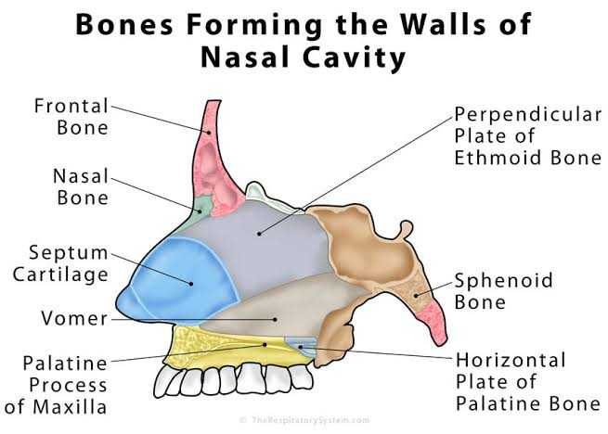
Features on the lateral wall of the nasal cavity
There is the presence of nasal conchae and they curve inferomedially
The nasal conchae include;
- Superior nasal concha
- Middle nasal concha
- Inferior nasal concha
The conchae or turbinates of many mammals (especially running mammals and those existing in extreme environments) are highly convoluted, scroll-like structures that offer a vast surface area for heat exchange.
Underneath each concha in both humans with simple nasal conchae and animals with complex turbinates is a recess or meatus (passages in the nasal cavity).
The inferior concha is the longest and broadest and is formed by an independent bone (of the same name, inferior concha) covered by a mucous membrane that contains large vascular spaces that can enlarge to control the caliber of the nasal cavity. When infected or irritated, the mucosa may swell rapidly, blocking the nasal passages on that side.

The Arterial supply of the Walls of the nose
The arterial supply of the medial and lateral walls of the nasal cavity is from five sources:
- Anterior ethmoidal artery (from the ophthalmic artery)
- Posterior ethmoidal artery (from the ophthalmic artery)
- Sphenopalatine artery (from the maxillary artery)
- Septal branch of the superior labial artery (from the facial artery)

Venous drainage
A rich submucosal venous plexus deep to the nasal mucosa drains into the sphenopalatine, facial, and ophthalmic veins.

Innervation
- Olfactory nerve
- Branches of the ophthalmic (V₁) nerve which include the anterior and posterior ethmoidal nerves
- Maxillary (V₂) nerves which include;
  - Posterior superior lateral nasal nerves
  - Posterior superior medial nasal nerves
  - Nasopalatine nerve
  - Posterior inferior nasal nerves

