NAME: AYENI OPEYEMI
MATRIC NO: 17/MHS01/075
DEPARTMENT: MEDICINE AND SURGERY
LEVEL: 300L
COURSE: GROSS ANATOMY

GROSS ANATOMY OF THE TONGUE
The tongue is a mobile muscular organ covered with mucous membrane. It can assume a variety of shapes and position. It is partly in the oral cavity and partly in the oropharynx. The tongue’s main functions are articulation (forming words during speaking) and squeezing food into the oropharynx as part of deglutition (swallowing). The tongue is also involved in mastication (chewing), taste and oral cleansing.
Parts and surfaces of the tongue
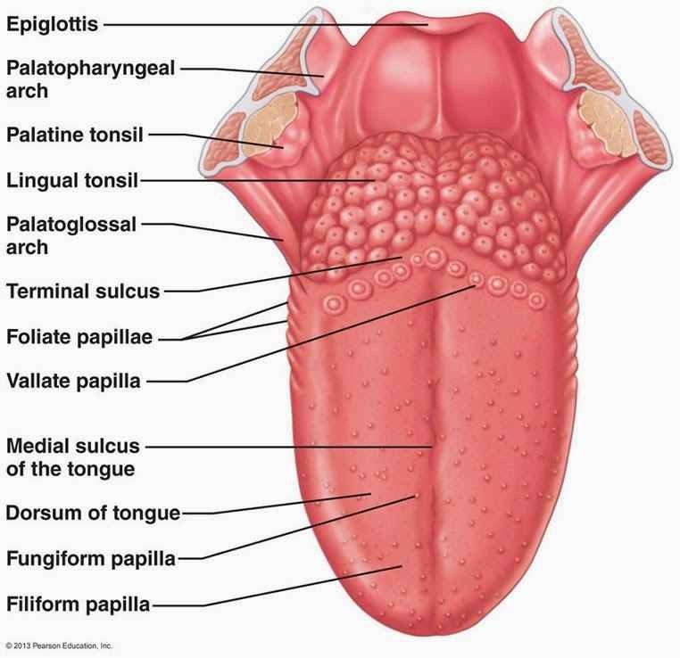
The tongue has:
- A root: it is the part of the tongue that rests on the floor of the mouth. It is the attached posterior portion, extending between the mandible, hyoid, and the nearly vertical posterior surface of the tongue.
- A body: it is the anterior two third of the tongue between the root and the apex
- An apex: it is the anterior end of the body, which rests against the incisor teeth. The body and the apex of the tongue are extremely mobile.
- A curved dorsum (dorsal surface): it is the posterior-superior surface which is located partly in the oral cavity and partly in the oropharynx. The dorsum of the tongue is characterized by a V-shaped groove, the terminal sulcus of the tongue, the angle of which points posteriorly to the foramen cecum. Posterior to this groove is the foramen cecum. This small pit, frequently absent, is the nonfunctional remnant of the proximal part of the embryonic thyroglossal duct from which the thyroid gland developed.
- And an inferior surface: it rests against the floor of the mouth. The margin of the tongue separating the two surfaces is related on each side to the lingual gingivae and lateral teeth.
The terminal sulcus divides the dorsum of the tongue into the;
- An anterior (oral) part in the oral cavity proper
- Posterior (pharyngeal) part in the oropharynx.
A midline groove divides the anterior part of the tongue into right and left parts. The mucosa of the anterior part of the tongue is relatively thin and closely attached to the underlying muscle. It has a rough texture because of numerous small lingual papillae:
- Vallate papillae: large and flat topped, lie directly anterior to the terminal sulcus and are arranged in a V-shaped row. They are surrounded by deep circular trenches, the ducts of the serous glands of the tongue open into the trenches.
- Foliate papillae: small lateral folds of the lingual mucosa. They are poorly developed in humans.
- Filiform papillae: long and numerous, contains afferent nerve endings that are sensitive to touch. These scaly, conical projections are pinkish gray and are arranged in V-shaped rows that are parallel to the terminal sulcus, except at the apex where they tend to be arranged transversely.
- Fungiform papillae: mushroom shaped pink or red spots scattered along the filiform papillae, but most numerous at the apex and margins of the tongue.
The vallate, foliate and most of the fungiform papillae contain taste receptors in the taste buds.
The mucosa of the posterior part of the tongue is thick and freely movable. It has no lingual papillae, but underlying lymph nodules give this part of the tongue an irregular cobblestone appearance. The lymphoid nodules are known collectively as LINGUAL TONSIL. The pharyngeal part of the tongue constitutes the anterior wall of the oropharynx. It can be inspected only with a mirror or downward pressure on the tongue with a tongue depressor.
The inferior surface o the tongue is covered with a thin, transparent mucous membrane. This surface is connected to the floor of the mouth by a midline fold called FRENULUM OF THE TONGUE. The frenulum allows the anterior part of the tongue to move freely. On each side of the frenulum, a deep lingual vein is visible through the thin mucous membrane. A SUBLINGUAL CARUNCLE (papilla) is present on each side of the base of the frenulum of the tongue that includes the opening of the submandibular duct from the submandibular salivary gland.

MUSCLES OF THE TONGUE

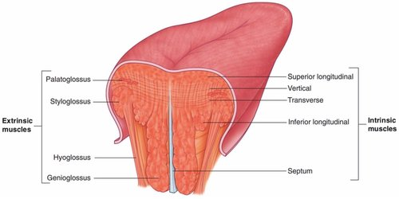
The tongue is essentially a mass of muscle that is mostly covered by mucous membrane. The four intrinsic and four extrinsic muscles in each half of the tongue are separated by a median fibrous lingual septum, which merges posteriorly with the lingual aponeurosis.
The extrinsic muscles alter the position of the tongue, while the intrinsic muscles alter the shape.
EXTRINSIC MUSCLES OF THE TONGUE
Muscles | Shape and position | Proximal attachment | Distal attachment | Main action(s)
Genioglossus | Fan-shaped muscle; constitute bulk of the tongue | Via a short tendon from superior part of mental spine of mandible | Entire dorsum of tongue; inferiormost and posteriormost fibers attach to the body of hyoid bone | Bilateral activity depresses tongue, especially central part creating a longitudinal furrow; posterior part pulls the tongue anteriorly for protrusion; most anterior part retracts apex of protruded tongue
Hyoglossus | Thin, quadrilateral muscle | Body and greater horn of hyoid bone | Inferior aspects of lateral part of tongue | Depresses tongue, especially pulling its sides inferiorly; helps shorten (retrude) tongue
Styloglossus | Small, short triangular muscle | Anterior boarder of distal styloid processes; stylohyoid ligament | Sides of tongue posteriorly, interdigitating with hyoglossus | Retrudes tongue and curls (elevates) its sides, working with genioglossus to form a central trough during swallowing
Palatoglossus | Narrow crescent-shaped palatine muscle; forms posterior column of isthmus of fauces | Palatine aponeurosis of soft palate | Enters posterolateral tongue transversely, blending with intrinsic transverse muscles | Capable of elevating posterior tongue or depressing soft palate; most commonly acts to constrict isthmus of fauces

INSTRNSIC MUSCLES OF THE TONGUE
Muscles | Shape and position | Proximal attachment | Distal attachment | Main action(s)
Superior longitudinal | Thin layer deep to mucous membrane of dorsum | Submucosal fibrous layer and median fibrous septum | Margins of tongue and mucous membrane | Curls tongue longitudinally upward, elevating apex and sides of tongue; shortens (Retrudes) tongue
Inferior longitudinal | Narrow band close to inferior surface | Root of tongue and body of hyoid bone | Apex of tongue | Curls tongue longitudinally downwards, depressing apex; shortens (retrudes) tongue
Transverse | Deep to superior longitudinal muscle | Median fibrous septum | Fibrous tissue at lateral lingual margins | Narrow and elongates (protrudes) tongue
Vertical | Fibers intersect transverse muscle | Submucosal fibrous layer of dorsum of tongue | Inferior surface of borders of tongue | Flattens and broadens tongue
The extrinsic muscles originate outside the tongue and attach to it, they mainly move the tongue, but they can alter the shape as well.
The intrinsic muscles have their attachments entirely within the tongue, and are not attached to bone.

ARTERIAL SUPPLY TO THE TONGUE
The arteries of the tongue are derived from the lingual artery, which arise from the external carotid arteries. On entering the tongue, the lingual artery passes deep to the hyoglossus muscle and gives rise to;
- The dorsal lingual arteries which supply the root of the tongue
- The deep lingual arteries which supply the body of the tongue
The deep lingual arteries communicate with each other near the apex of the tongue. The dorsal lingual arteries are prevented from communicating by the lingual septum.

VENOUS DRAINAGE OF THE TONGUE
The veins of the tongue are the dorsal lingual veins which accompany the lingual artery. The deep lingual veins, which begin at the apex of the tongue, run posteriorly beside the lingual frenulum to join the sublingual vein. The sublingual veins in elderly people are often varicose (enlarged and torturous). Some or all the veins may drain into the IJV (Internal jugular vein), or they may do so indirectly, joining first to form a lingual vein that accompanies the initial part of the lingual artery.
LYMPHATIC DRAINAGE TO THE TONGUE
The lymphatic drainage of the tongue is exceptional. Most of the lymphatic drainage converges towards and follows the venous drainage; however, lymph from the tip of the tongue, frenulum, and central lower lip runs an independent course. Lymph from different areas of the tongue drains via four routes:
- Lymph from the root of the tongue drains bilaterally into the SUPERIOR DEEP CERVICAL LYMPH NODES.
- Lymph from the medial part of the body drains bilaterally and directly to the INFERIOR DEEP CERVICAL LYMPH NODES.
- Lymph from the right and left lateral parts of the body drains to the submandibular LYMPH NODES ON THE IPSILATERAL SIDE.
- The apex and frenulum drain to the SUBMENTAL LYMPH NODES, the medial portion draining bilaterally.

INNERVATION OF THE TONGUE
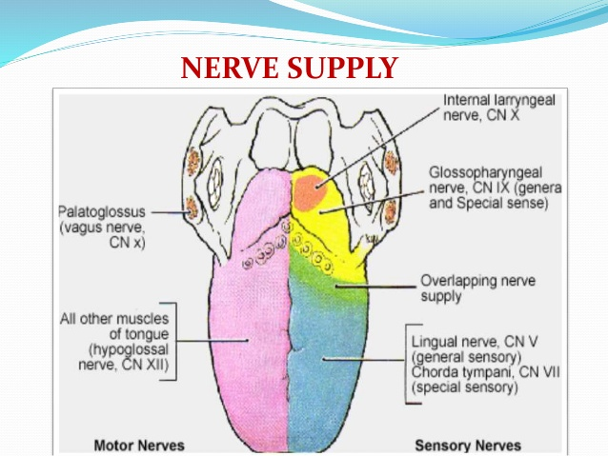
Motor innervations: all muscles of the tongue except the palatoglossus muscle are innervated by the HYPOGLOSSAL NERVE (CNXII). The palatoglossus muscle is innervated by the PHARYNGEAL BRANCH OF THE VAGUS NERVE (CNX).
Sensory innervations: for general sensation the anterior tow third is innervated by the LINGUAL BRANCH OF THE MANDIBULAR DIVISION OF THE TRIGEMINAL NERVE (CNV), while the posterior third is innervated by the GLOSSOPHARYNGEAL NERVE (CVIX). For special sense of taste, the anterior third is innervated by the CHORDA TYMPANI which is a branch of the FACIAL NERVE (CNVII). Although the vallate papillae is part of the anterior two third, it is not innervated by the chorda tympani, instead, it is innervated by the GLOSSOPHARYNGEAL NERVE.

APPLIED ANATOMY
- Injury to the hypoglossal nerve: trauma such as a fractured mandible, may injure the hypoglossal nerve, resulting in paralysis and eventually atrophy of one side of the tongue. The tongue deviates to the paralyzed side during protrusion because of the action of the unaffected genioglossus muscle on the other side.
- Lingual carcinoma: a lingula carcinoma in the posterior part of the tongue metastasizes to the superior deep cervical lymph nodes on both sides. However, a tumor in the anterior part usually does not metastasize to the inferior deep cervical lymph nodes until late in the disease. Because the nodes are closely related to the internal jugular vein, metastases from the tongue may be distributed through the submental and submandibular regions and along the internal jugular veins in the neck.
- Lingual frenectomy: a frenulum (frenum) of the tongue extending farther anteriorly towards the apex (tongue tie) interferes with tongue movements and may affect speech. In unusual cases, a frenectomy (cutting the frenulum) in infants may be necessary to free the tongue for normal movements and speech.

AIR SINUSES
Air sinuses or paranasal sinuses are air-filled extensions of the respiratory part of the nasal cavity into the following cranial bones: frontal, ethmoid, sphenoid and maxilla. They are named according to the bones in which they are located. The sinuses continue to invade the surrounding bone, and marked extensions are common in the crania of older people.
FRONTAL SINUS:
The right and left frontal sinuses are between the outer and inner tables of the frontal bone, posterior to the superciliary arches and the root of the nose. The right and left sinuses each drain trough a FRONTONASAL DUCT into the ETHMOID INFUNDIBULUM, which opens into the SEMILUNAR HIATUS of the middle nasal meatus. The frontal sinuses are innervated by branches of the supra orbital nerves (CNV1).
The right and left frontal sinuses are rarely of equal size, and the septum between them is not usually situated entirely in the median plane. The frontal sinuses vary in size from approximately 5mm to large spaces extending laterally into the greater wing of sphenoid. Often, a frontal sinus has two parts: a vertical part in the squamous part of the frontal bone, and a horizontal part in the orbital part of the frontal bone. One or both parts may be large or small. When the supra-orbital part is large, its roof forms the floor of the anterior cranial fossa and its roof forms the roof of the orbit.
ETHMOID SINUS:
The ethmoidal cells (sinuses) are small invaginations of the mucous membrane of the middle and superior nasal meatus into the ethmoid bone between the nasal cavity and the orbit. The ethmoidal cells usually are not visible in plane radiographs before 2 years of age; however, they are recognizable in CT scans. The anterior ethmoidal cells drain directly or indirectly into the middle nasal meatus through the ethmoidal infundibulum. The middle ethmoidal cells open directly into the middle meatus and are sometimes called “bullar cells” because they form ethmoidal bulla, a swelling on the superior border of the semilunar hiatus. The posterior ethmoidal cells open directly into the superior meatus. The ethmoidal cells are supplied by the anterior and posterior ethmoidal branches of the nasociliary nerves (CNV1).
SPHENODIAL SINUS:
The sphenoidal sinuses are located in the body of the sphenoid, but they may extend into the wings of this bone. They are unevenly divided and separated by a bony septum. Because of this extensive pneumatization (formation of air cells), the body of the sphenoid is fragile. Only thin plates of bones separate the sinuses from several important structures: the optic nerves and optic chiasm, the pituitary gland, internal carotid arteries, and the cavernous sinuses. The sphenoidal sinuses are derived from a posterior ethmoidal cell that begins to invade the sphenoid at approximately 2 years of age. In some people, several posterior ethmoidal cells invade the sphenoid, giving rise to multiple sphenoidal sinuses that open separately into spheno-ethmoidal recess. The posterior ethmoidal arteries and posterior ethmoidal nerves that accompany the arteries supply the sphenoidal sinuses.
MAXILLARY SINUS:
The maxillary sinuses are the largest paranasal sinuses. They occupy the bodies of the maxillae and communicate with the middle nasal meatus.
- The apex of the maxillary sinus extends toward and often into the zygomatic bone.
- The base of the maxillary sinus forms the inferior part of the lateral wall of the nasal cavity.
- The roof of the maxillary sinus is formed by the floor of the orbit.
- The floor of the maxillary sinus is formed by the alveolar part of the maxilla. The roots of the maxillary teeth, particularly the first two molars, often produce conical elevations in the floor of the sinus.
Each maxillary sinus drains by one or more openings, the MAXILLARY OSTIUM, into the middle nasal meatus of the nasal cavity by way of the semilunar hiatus.
The arterial supply of the maxillary sinuses is mainly from the superior alveolar branches of the maxillary artery. However, branches of the descending and greater palatine arteries supply the floor of the sinus. Innervation of the maxillary sinus is from the anterior, middle, and posterior superior alveolar nerves, which are branches of the maxillary nerve.

