Name: Idaye Tamunonengiofori Peniel.
Department: Mechanical Engineering.
Matric No: 19/ENG06/027.
Course Code: CHM 102.
Question
1) Give the IUPAC names of the following compounds.
- HCOOH
- HOOCCH₂CH₂CH₂COOH
- CH₃CH₂CH₂COOH
- HO₂C—CO₂H
- CH₃(CH₂)₄COOH
- CH₃CH=CHCH₂CH₂COOH
2) Discuss briefly the physical properties of carboxylic acids under the following headings
- Physical Appearance
- Boiling Point
- Solubility
3) Write two industrial preparations of carboxylic acids.
4) With equations and brief explanation discuss the synthesis preparation of carboxylic.
5) With chemical equation only, outline the reduction, decarboxylation and esterification of carboxylic acid.
Answers
(1)
- HCOOH — Methanoic Acid
- HOOCCH₂CH₂CH₂COOH — Pentanedibic Acid
- CH₃CH₂CH₂COOH — Butanoic Acid
- HO₂C—CO₂H — Ethanedioic Acid
- CH₃(CH₂)₄COOH — Hexanoic Acid
- CH₃CH=CHCH₂CH₂COOH — hex - 4 – enoic acid or 4 – hexenoic acid
(2)
I) Physical Appearance
The smaller members of the aliphatic carboxylic acid series are colorless, volatile liquids with strong odors. Ethanoic acid is commonly known as acetic acid and common household vinegar is a 5% solution of acetic acid. Larger carboxylic acids are solids with low melting points. There are a great many aromatic carboxylic acids, which are all crystalline solids. Carboxylic acids can form intermolecular hydrogen bonds and thus have relatively high melting and boiling points compared to other organic compounds that cannot hydrogen bond. Carboxylic acids with shorter carbon chains are very soluble in water, while those with longer carbon chains are less soluble.
(II) Solubility in water
Carboxylic acids are soluble in water. Carboxylic acids do not dimerise in water, but forms hydrogen bonds with water. Carboxylic acids are polar and due to the presence of the hydroxyl in the carboxyl group, they are able to form hydrogen bonds with water molecules. Smaller carboxylic acids (C1 to C5) are soluble in water, whereas larger carboxylic acids (C6 and above) are less soluble due to the increasing hydrophobic nature of the hydrocarbon chains.
The boiling points of carboxylic acids increases as the molecules get bigger. Carboxylic acids have even higher boiling points then alkanes and alcohols. Carboxylic acids, similar to alcohols, can form hydrogen bonds with each other as well as van der Waals dispersion forces and dipole-dipole interactions. However, unique to carboxylic acids, hydrogen bonding can occur between two molecules to produce a dimer.
The presence of dimers increases the strength of the van der Waals dispersion forces, resulting in the high boiling points of carboxylic acids.
(3)
- Alkenes are oxidized to acids by heating them with solutions of potassium permanganate (KMnO ₄) or potassium dichromate (K ₂Cr ₂O ₇).
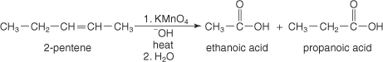
- The ozonolysis of alkenes produces aldehydes that can easily be further oxidized to acids.

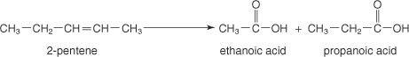
(4)

Hydrolysis of acid derivatives
All acid derivatives can be hydrolyzed (cleaved by water) to yield carboxylic acids; the conditions required range from mild to severe, depending on the compound involved.

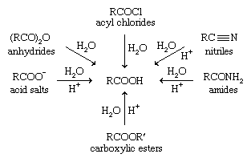
Grignard reagents
Grignard reagents react with carbon dioxide (either in the gaseous form, which is bubbled through the solution, or as the solid dry ice) to give magnesium salts of carboxylic acids, which are converted to the acids themselves upon treatment with acid:
RMgBr + CO₂→ RCOO⁻ +MgBr + HCl → RCOOH.
Unlike the methods previously mentioned, this method adds one carbon atom to the carbon skeleton. A Grignard reagent is prepared from an alkyl or aryl halide;
e.g., RBr + Mg → RMgBr
An alternative way to accomplish the same result is to treat the halide with potassium cyanide (KCN) or sodium cyanide (NaCN) and then hydrolyze the resulting nitrile, as mentioned above; e.g.,
RBr + KCN → RCN → RCOOH
The two procedures are complementary. Although all nitriles can be hydrolyzed to the corresponding acid and all Grignard reagents react with carbon dioxide, the halide reactions are more limited. Many types of halides (including aromatic halides) do not react with NaCN or KCN. On the other hand, while Grignard reagents can be made from many of the halides that do not react with NaCN or KCN (including aryl halides), they cannot be made from halides that contain certain other functional groups, such as alcohol, carboxylic ester, aldehyde, or ketone groups.

(5)
- Reduction of carboxylic acid

Reductions of carboxylic acid derivatives
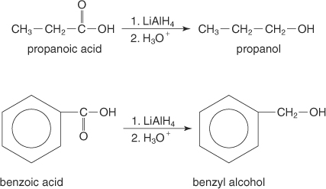
You can also use diborane (B ₂H ₆) to reduce carboxylic acids to alcohols.

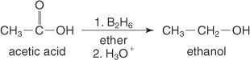
Reduction of esters
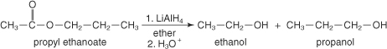
Reduction of acid halides
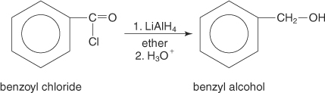.
Reduction of amides
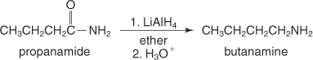

- Decarboxylation and of carboxylic acid.
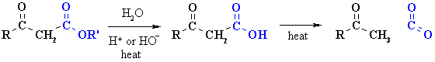
- Esterification of carboxylic acid.
