SURVEYING ASSIGNMENT 2
RISE AND FALL METHOD
- A merit of this is that it is easy to spot errors
- One of its demerits is that it is tedious
HEIGHT OF COLLIMATION METHOD
- A merit is that it is faster than rise and fall method
- A demerit is that it is fairly susceptible to errors

- The following readings are successfully taken with an instrument in a leveling work on a peculiar gradient: 0.771, 1.52, 0.802, 2.311, 1.990, 3.580, 1.220, 3.675, 4.020, 2.408, 0.339, 0.157, 0.780, 1.535, 1.955, 2.430, 2.985, 3.480, 1.155, 1.960, 2.365, 3.640, 0.935, 1.045, 1.630 and 2. 545. The position of the instrument was changed after taking the 2nd, 5th, 9th and 12th readings. As from the 13th reading, the road gradient was continuously sloping till the last reading. If the reduced level initially was (110 + your matriculation number) m, calculate the reduced level of all points by height of collimation method. Produce the gradient if the readings were taken at an interval of 10 m.
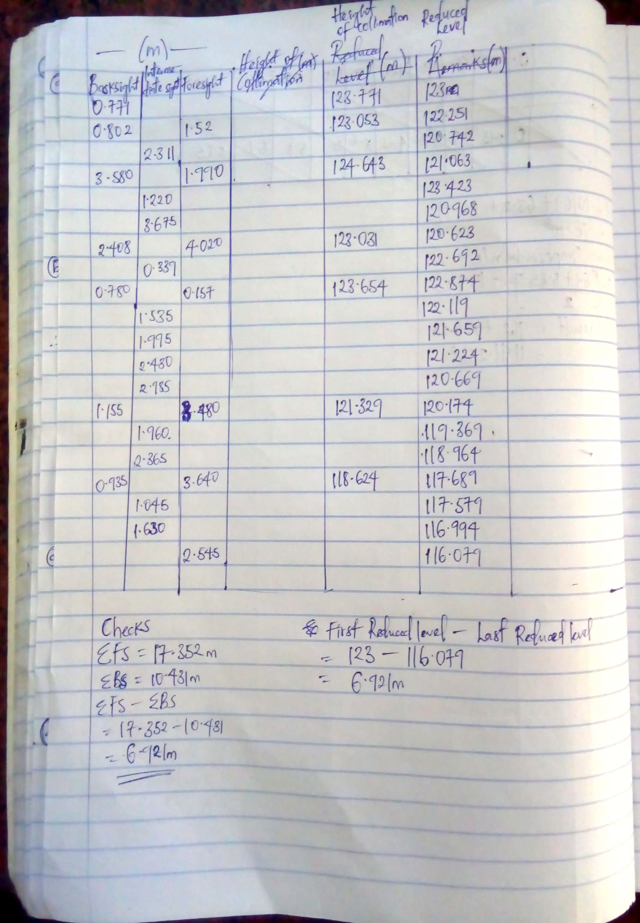

- The following perpendicular offsets were taken from a chain line to an irregular boundary
Chainage (m) | 0 | 30 | 60 | 90 | 120 | 150 | 180 | 210 | 240 | 270
Offset length (m) | 0 | 2.65 | 3.80 | 3.75 | 4.65 | 3.60 | 5.00 | 5.80 | 6.10 | 5.85
Calculate the area between the chain line and the irregular boundary by average ordinate rule, mid-ordinate rule, trapezoidal rule and Simpson’s rule.
SOLUTION
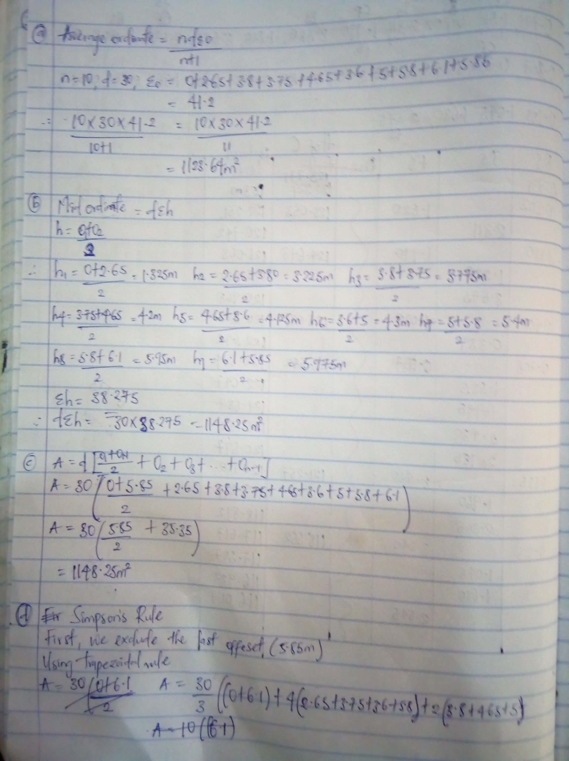
Scanned by CamScanner
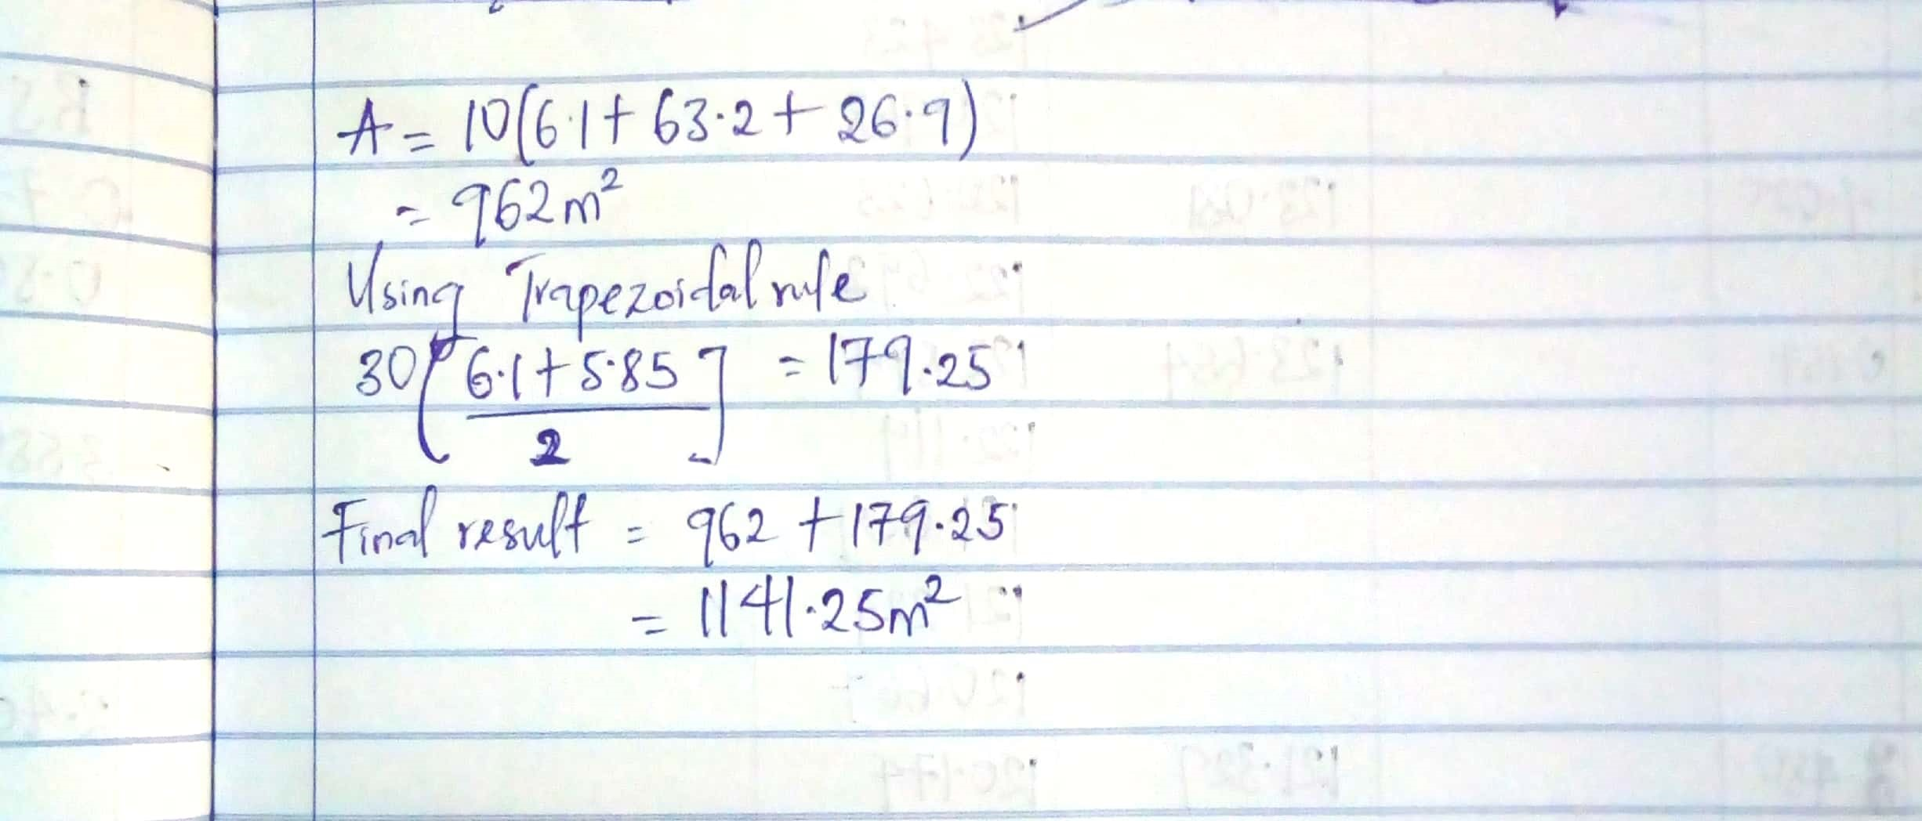
Scanned by CamScanner

- Explain five characteristics of contours with well dimensioned diagrams
A series of closed contour lines on a map represents a hill if the higher values are inside

A series of closed contours on a map indicate a depression if the higher values are outside
Contour lines cannot end anywhere but close on themselves either within or outside the limits of the map.

Contour lines cannot merge or cross one another on a map except in the case of overhanging cliffs
Contour lines never run into one another, except in the case of a vertical cliff. In this case several contours coincide and the horizontal equivalent becomes 0.

