NAME: OSUEKE JANE C.
MATRIC NO: 17/MHS01/276
COLLEGE: MEDICINE AND HEALTH SCIENCES
DEPT: MEDICINE
COURSE: GROSS ANATOMY
QUESTIONS:
- Discuss the anatomy of the tongue and comment on its applied anatomy
- Write an essay on the air sinus
ANSWERS:
The tongue is a muscular organ in the mouth of most vertebrates that manipulates food for mastication and is used in the act of swallowing. It has importance in the digestive system and is the primary organ of taste in the gustatory system.
The tongue's upper surface (dorsum) is covered by taste buds housed in numerous lingual papillae. It is sensitive and kept moist by saliva and is richly supplied with nerves and blood vessels.
A major function of the tongue is the enabling of speech in humans and vocalization in other animals.
The human tongue is divided into two parts:
- An oral part at the front and a pharyngeal part at the back.
- The left and right sides are also separated along most of its length by a vertical section of fibrous tissue (the lingual septum) that results in a groove, the median sulcus, on the tongue's surface.
There are two groups of muscles of the tongue.
- The four INTRINSIC MUSCLES alter the shape of the tongue and are not attached to bone.
- The four paired EXTRINSIC MUSCLES change the position of the tongue and are anchored to bone.
INTRINSIC MUSCLE
- the superior longitudinal muscle
- inferior longitudinal muscle
- transverse muscle
- vertical muscle.
These muscles affect the shape and size of the tongue, for example, in tongue rolling and have a role in facilitating speech, eating and swallowing.
Motor innervation for the intrinsic muscles of the tongue is via the hypoglossal nerve (CNXII).
EXTRINSIC MUSCLES
The extrinsic muscles are as follows:
- Genioglossus
Attachments: Arises from the mandibular symphsis. Inserts into the body of the hyoid bone and the entire length of the tongue.
Function: Inferior fibres protrude the tongue, middle fibres depress the tongue, and superior fibres draw the tip back and down
Innervation: Motor innervation via the hypoglossal nerve (CNXII).
- Hyoglossus
Attachments: Arises from the hyoid bone and inserts into the side of the tongue
Function: Depresses and retracts the tongue
Innervation: Motor innervation via the hypoglossal nerve (CNXII).
- Styloglossus
Attachments: Originates at the styloid process of the temporal bone and inserts into the side of the tongue
Function: Retracts and elevates the tongue
Innervation: Motor innervation via the hypoglossal nerve (CNXII).
- Palatoglossus
Attachments: Arises from the palatine aponeurosis and inserts broadly across the tongue
Function: Elevates the posterior aspect of the tongue
Innervation: Motor innervation via the vagus nerve (CNX).
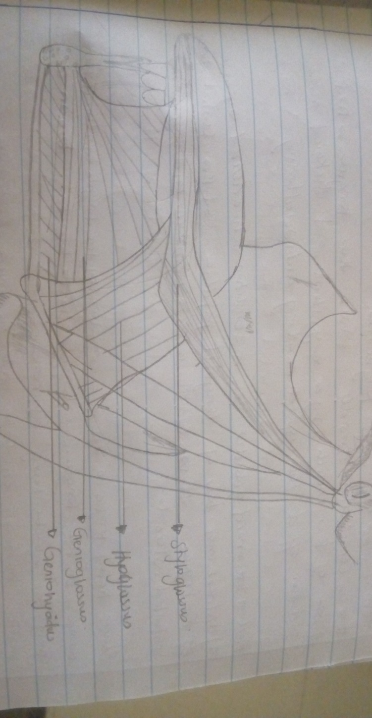
INNERVATION:
In the anterior 2/3, general sensation is supplied by the trigeminal nerve (CNV). Specifically the lingual nerve, a branch of the mandibular nerve (CN V3).
On the other hand, taste in the anterior 2/3 is supplied from the facial nerve (CNVII). In the petrous part of the temporal bone, the facial nerve gives off three branches, one of which is chorda tympani (which supplies the tongue).
The posterior 1/3 of the tongue is slightly easier. Both touch and taste are supplied by the glossopharyngeal nerve (CNIX).
VASCULATURE.
The lingual artery (branch of the external carotid) does most of the supply, but there is a branch from the facial artery, called the tonsillar artery, which can provide some collateral circulation.
Drainage is by the lingual vein which goes into the internal jugular vein.
LYMPHATIC DRAINAGE:
- Anterior two thirds – initially into the submental and submandibular nodes, which empty into the deep cervical lymph nodes
- Posterior third – directly into the deep cervical lymph nodes.
ANKYLOGLOSSIA (tongue tie)
It is congenital disorder where the tongue is tied to the floor of the mouth by a very short and thickened frenulum and this affects the speech, eating and swallowing.
MEDIAN RHOMBOID GLOSSITIS
It is a condition characterized by an area of redness and loss of lingual papillae on the central dorsum of the tongue. It often seen in smokers and people using inhaled steroids.
BLACK HAIRY TONGUE
It is a condition of the tongue in which the small bumps on the tongue elongates with black discoloration giving it a black hairy appearance. Preventive measure should be oral hygiene, especially scraping and brushing the tongue

FISSURED TONGUE
It is a benign condition characterized by deep groove in the dorsum of the tongue

AIR SINUS.
It is also known as Paranasal sinuses.
Paranasal sinuses are a group of four paired air-filled spaces that surround the nasal cavity.
- The maxillary sinuses are located under the eyes
- The frontal sinuses are above the eyes
- The ethmoidal sinuses are between the eyes
- The sphenoidal sinuses are behind the eyes
The sinuses are named for the facial bones in which they are located.
STRUCTURE.
- The maxillary sinuses, the largest of the paranasal sinuses, are under the eyes, in the maxillary bones (open in the back of the semilunar hiatus of the nose). They are innervated by the trigeminal nerve (CN V)
- The frontal sinuses, superior to the eyes, in the frontal bone, which forms the hard part of the forehead. They are also innervated by the trigeminal nerve (CN V)
- The ethmoidal sinuses, which are formed from several discrete air cells within the ethmoid bone between the nose and the eyes. They are innervated by the ethmoidal nerves, which branch from the nasociliary nerve of the trigeminal nerve (CN V).
- The sphenoidal sinuses, in the sphenoid bone. They are innervated by the trigeminal nerve (CN V).
The paranasal air sinuses are lined with respiratory epithelium (ciliated pseudostratified columnar epithelium).
DEVELOPMENT.
Paranasal sinuses form developmentally through excavation of bone by air-filled sacs (pneumatic diverticula) from the nasal cavity. This process begins prenatally (intrauterine life), and it continues through the course of an organism's lifetime.

Studies suggest that the natural ventilation rate of a sinus with a single sinus ostium (opening) is extremely slow. Such limited ventilation may be protective for the sinus, as it would help prevent drying of its mucosal surface and maintain a near-sterile environment with high carbon dioxide concentrations and minimal pathogen access. Thus composition of gas content in the maxillary sinus is similar to venous blood, with high carbon dioxide and lower oxygen levels compared to breathing air
At birth only the maxillary sinus and the ethmoid sinus are developed but not yet pneumatized; only by the age of seven they are fully aerated.
The sphenoid sinus appears at the age of three, and the frontal sinuses first appear at the age of six, and fully develop during adulthood

