NAME: OSUEKE JANE C.
MATRIC NO: 17/ MHS01/ 276
COLLEGE: MEDICINE AND HEALTH SCIENCE
DEPT: MEDICINE
COURSE: GROSS ANATOMY
QUESTIONS:
- Write an essay on the carvenous sinus
- Discuss the walls of the nose.
ANSWERS:
The cavernous sinus, one on each side, situated on the body of the sphenoid bone, extends from the superior orbital fissure to the apex of the petrous temporal bone.
Medially, the cavernous sinus is related to the pituitary gland and the sphenoid sinus. Laterally, it is related to the temporal lobe of the brain. The internal carotid artery and the abducens nerve pass through the cavernous sinus. On its lateral wall from above downwards lie the oculomotor, trochlear and ophthalmic nerves .
The maxillary division of the trigeminal goes through the lower part of the lateral wall or just outside the sinus. The endothelial lining separates these structures from the cavity of the sinus.
Posteriorly, the sinus drains into the transverse/sigmoid sinus through superior petrosal sinus and via the inferior petrosal sinus, passing through the jugular foramen, into the internal jugular vein.
The ophthalmic veins drain into the anterior part of the sinus. Emissary veins passing through the foramina in the middle cranial fossa connect the cavernous sinus to the pterygoid plexus of veins and to the facial veins.
The superficial middle cerebral vein drains into the cavernous sinus from above.
The two cavernous sinuses are connected to each other by anterior and posterior cavernous sinuses lying in front and behind the pituitary.

THE WALL OF THE NOSE.
The nose is an olfactory and respiratory organ. It consists of nasal skeleton, which houses the nasal cavity. The nasal cavity has four functions:

- Warms and humidifies the inspired air.
- Removes and traps pathogens and particulate matter from the inspired air.
- Responsible for sense of smell.
- Drains and clears the paranasal sinuses and lacrimal ducts.
DIVISION
The nasal cavity is the most superior part of the respiratory tract.
It extends from the vestibule of the nose to the nasopharynx, and has three divisions:

- Vestibule – the area surrounding the anterior external opening to the nasal cavity.
- Respiratory region – lined by a ciliated psudeostratified epithelium, interspersed with mucus-secreting goblet cells.
- Olfactory region – located at the apex of the nasal cavity. It is lined by olfactory cells with olfactory receptors.
NASAL CONCHAE.
Projecting out of the lateral walls of the nasal cavity are curved shelves of bone. They are called conchae (or turbinates).
There are three conchae – inferior, middle and superior.
They project into the nasal cavity, creating four pathways for the air to flow. These pathways are called meatuses:
- Inferior meatus – between the inferior concha and floor of the nasal cavity.
- Middle meatus – between the inferior and middle concha.
- Superior meatus – between the middle and superior concha.
- Spheno-ethmoidal recess – superiorly and posteriorly to the superior concha.
The function of the conchae is to increase the surface area of the nasal cavity – this increases the amount of inspired air that can come into contact with the cavity walls. They also disrupt the fast, laminar flow of the air, making it slow and turbulent. The air spends longer in the nasal cavity, so that it can be humidified.

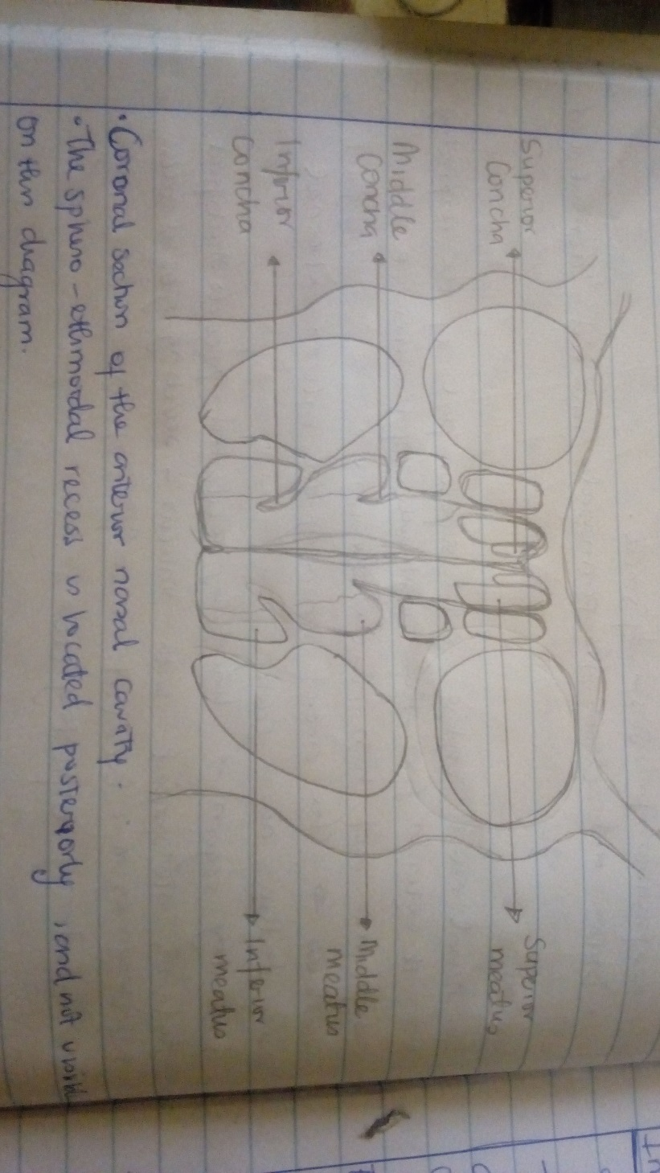
Gateways to the Nasal Cavity
The cribriform plate is part of the ethmoid bone. It forms a portion of the roof of the nasal cavity. It contains very small perforations, allowing fibres of the olfactory nerve to enter and exit.
At the level of the superior meatus, the sphenopalatine foramen is located. This hole allows communication between the nasal cavity and the pterygopalatine fossa. The sphenopalatine artery, nasopalatine and superior nasal nerves pass through here.
The incisive canal is a pathway between the nasal cavity and the incisive fossa of the oral cavity. It transmits the nasopalatine nerve and greater palatine artery.
Vasculature
The nose has a very rich vascular supply – this allows it to effectively change humidity and temperature of inspired air.
The nose receives blood from both the internal and external carotid arteries:
Internal carotid branches:
- Anterior ethmoidal artery
- Posterior ethmoidal artery
- The ethmoidal arteries are branch of the ophthalmic artery. They descend into the nasal cavity through the cribriform plate
External carotid branches:
- Sphenopalatine artery
- Greater palatine artery
- Superior labial artery
- Lateral nasal arteries
In addition to the rich blood supply, these arteries form anastomoses with each other. This is particularly prevalent in the anterior portion of the nose .
The veins of the nose tend to follow the arteries. They drain into the pterygoid plexus, facial vein or cavernous sinus.
In some individuals, a few nasal veins join with the sagittal sinus (a dural venous sinus). This represents a potential pathway by which infection can spread from the nose into the cranial cavity.
Innervation
The innervation of the nose can be functionally divided into special and general innervation.
- Special sensory innervation refers to the ability of the nose to smell. This is carried out by the olfactory nerves. The olfactory bulb, part of the brain, lies on the superior surface of the cribriform plate, above the nasal cavity. Branches of the olfactory nerve run through the cribriform plate to provide special sensory innervation to the nose.
- General sensory innervation to the septum and lateral walls is delivered by the nasopalatine nerve (branch of maxillary nerve) and the nasociliary nerve (branch of the ophthalmic nerve). Innervation to the external skin of the nose is supplied by the trigeminal nerve.

