NAME: OKWONU ESEOGHENE GIFT

MATRIC NUMBER : 18/MHS01/278

DEPARTMENT : MEDICINE AND SURGERY

COURSE: EMBRYOLOGY

- Discuss ovulation
Ovulation
Ovulation is the release of mature secondary oocyte from the ovarian follicles. Few days before ovulation, the secondary follicle grows to a diameter of about 25mm under the influence of the follicle stimulating hormone (FSH) and the luteinizing hormone (LH) to become vesicular follicle coincidental with the final development of the vesicular follicle, there is an abrupt increase in luteinizing hormone that causes the primary oocyte to complete meiosis I and the follicle to enter the preovulatory mature vesicular stage. Meiosis II is then initiated and the secondary oocyte enters into prophase II but it is arrested in metaphase II by a hydrostatic factor approximately 3 hours before ovulation. In the meantime, the surface of the ovary begins to budge locally at the apex, and an avascular spot called the stigma appears. In other for the oocyte to be released, 2 events occurs which are caused due to the luteinizing hormone surge;
- It increase collagenase activity resulting in digestion of the collagen fiber (connective tissue) that surrounds the follicle
- It also increases the level of prostaglandin, which causes local muscular contractions of the ovarian wall.
These contractions, extrude the oocyte along with its surrounding follicular cells from the region of the cumulus oophorus. This then causes ovulation in which the mature secondary oocyte floats out of the ovary. Some of the cumulus oophorus then rearranges themselves around the mature secondary oocyte to form the Corona radiata.

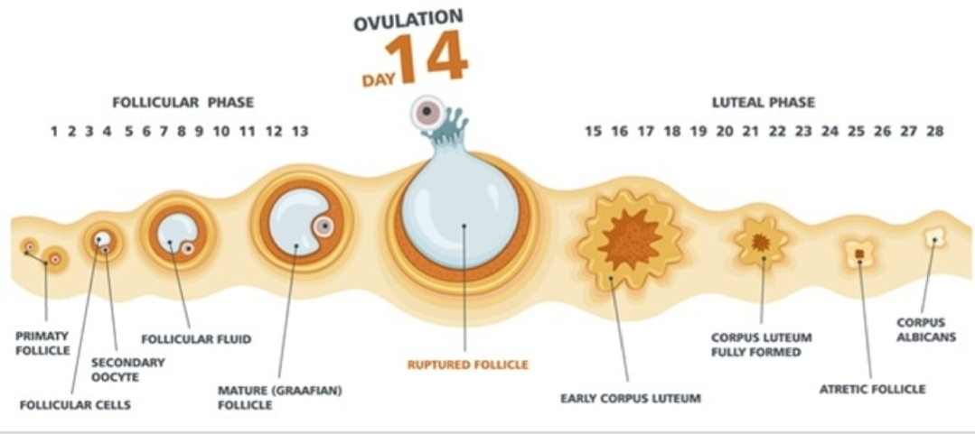
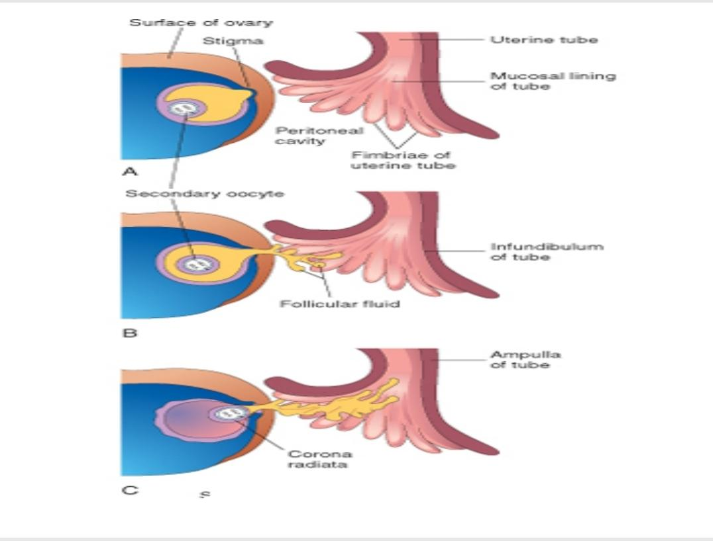
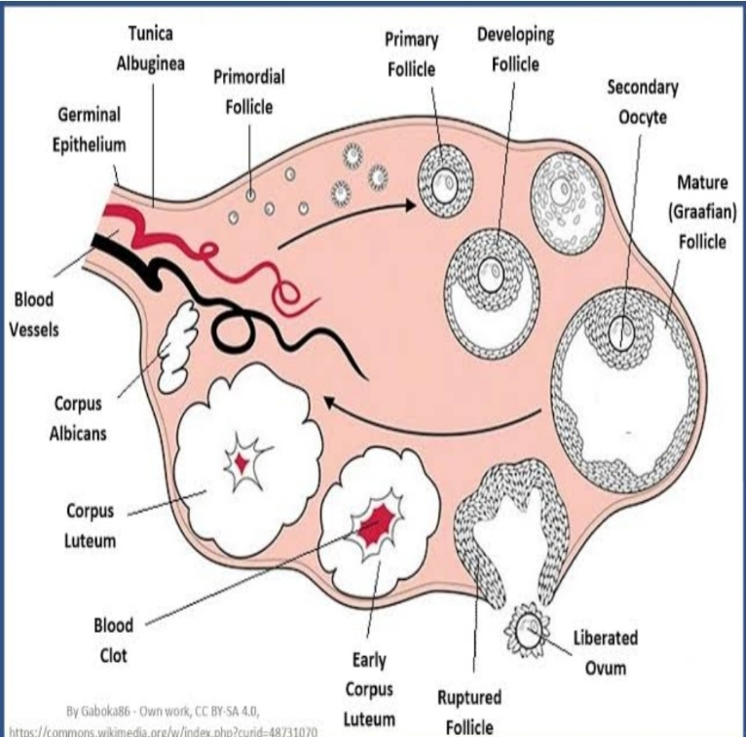
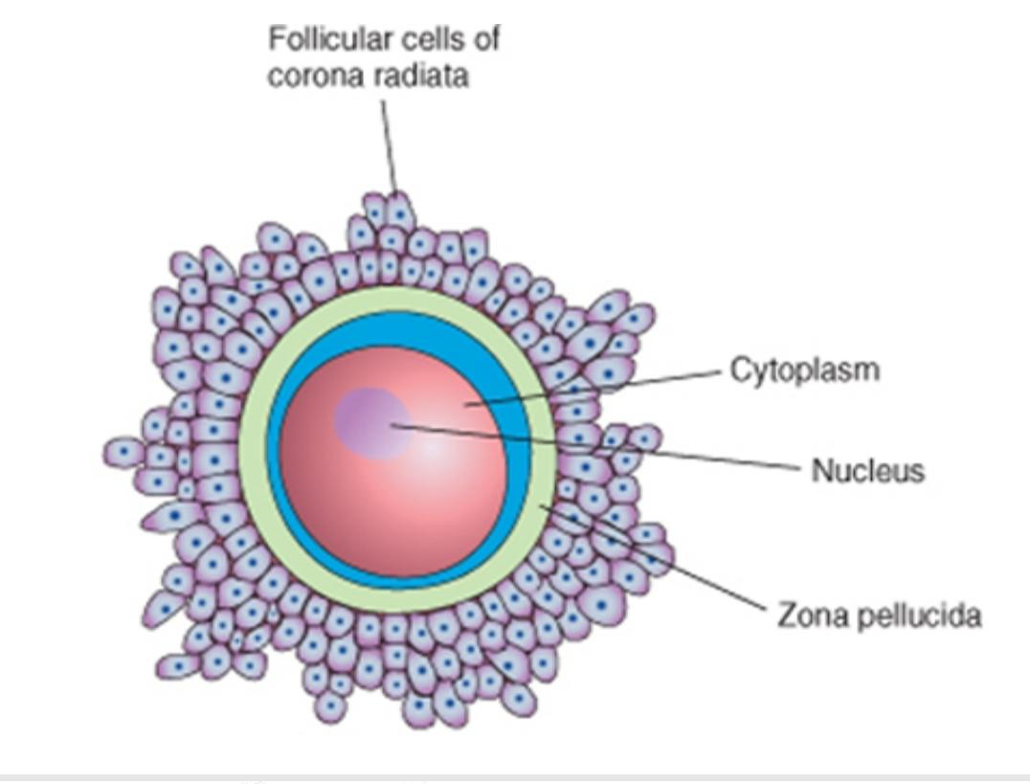
Clinical correlates
During ovulation, some women feel a variable amount of abdominal pain called mittelschmerz also known as middle pain because it normally occurs during the middle of menstrual cycle. In these cases, ovulation results in slight bleeding into the peritoneal cavity, which results in sudden constant pain in the lower abdomen. Mittelschmerz may be used as a symptom of ovulation. Other signs of ovulation include;
- Changes in the cervical mucus: When you're not ovulating, cervical mucus may appear sticky,creamy, or may be entirely absent. As ovulation approaches, cervical mucus becomes more abundant,takes on a watery to raw-egg-white-like consistency (slippery eggwhite looking discharge), and stretches up to an inch or more between your fingers.
- increase libido/ increase urge for sex
- Tenderness of breast
- Swollen vagina or vulva
- Slight drop in basal body temperature
Also the use of ovulation predictor kits (OPKs)help to detect luteinizing hormone surge,which occurs 12 to 36 hours before ovulation. women who fail to ovulate, this is called anovulation, because of a low concentration of gonadotropins. In these cases, administration of an agent to stimulate gonadotropin release and hence ovulation can be employed. Although such drugs are effective, they often produce multiple ovulations, so that the risk of multiple pregnancies is ten times higher in these women than in the general population.

- Differentiate between meiosis I and meiosis II
Meoisis
Meoisis is the type of cell division that results in 4 daughter cells each with half the number if chromosomes of the parent cell, as in the production of gametes.
Meoisis I | Meoisis II
In prophase I | In prophase II
- Synopsis occurs I.e homologous chromosomes lie side by side(pairing)  - Crossing over occurs  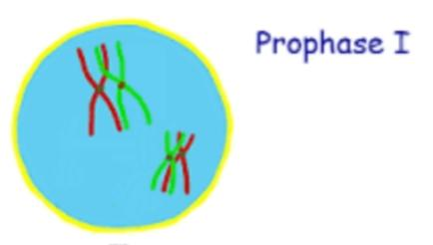  - Chiasma formation | 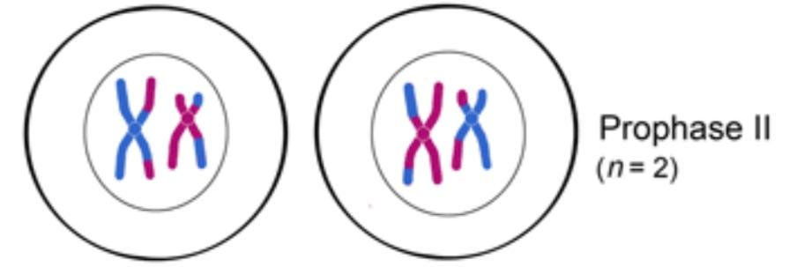  - Synopsis is absent  - Crossing over is absent  - Chiasma formation is absent
In metaphase I | In metaphase II
- Alignment of 46 duplicated homologous chromosomes at the equator  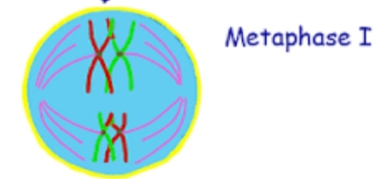 | - Alignment of 23 duplicated homologous chromosomes  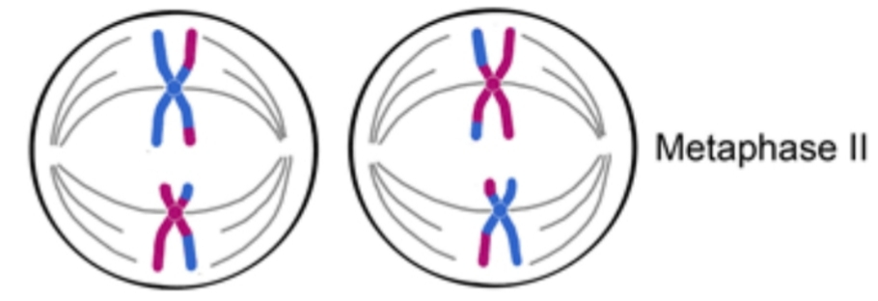
In Anaphase I | In Anaphase II
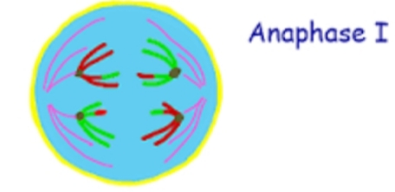  - Separation of 46 duplicated homologous chromosomes. Where each chromosomes move towards the pole and the Centromere doesn’t split | 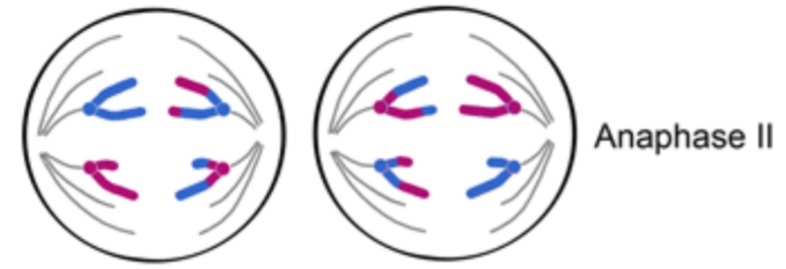  - Separation of 23 duplicated homologous chromosomes and the centromere splits.
In Telophase I | In Telophase II
- Two daughter cells are formed (23 duplicated homologous chromosomes)  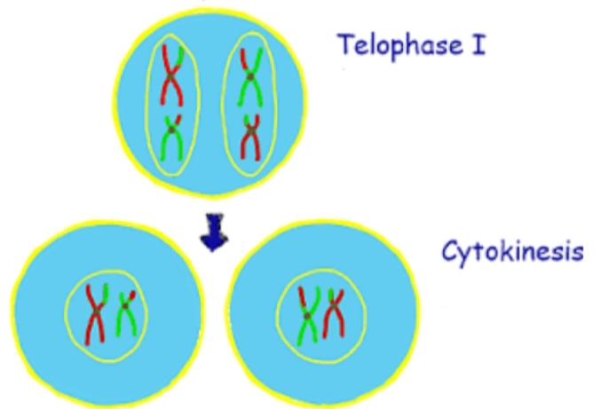 | - Four daughter cells are formed (23 single stranded chromosomes)  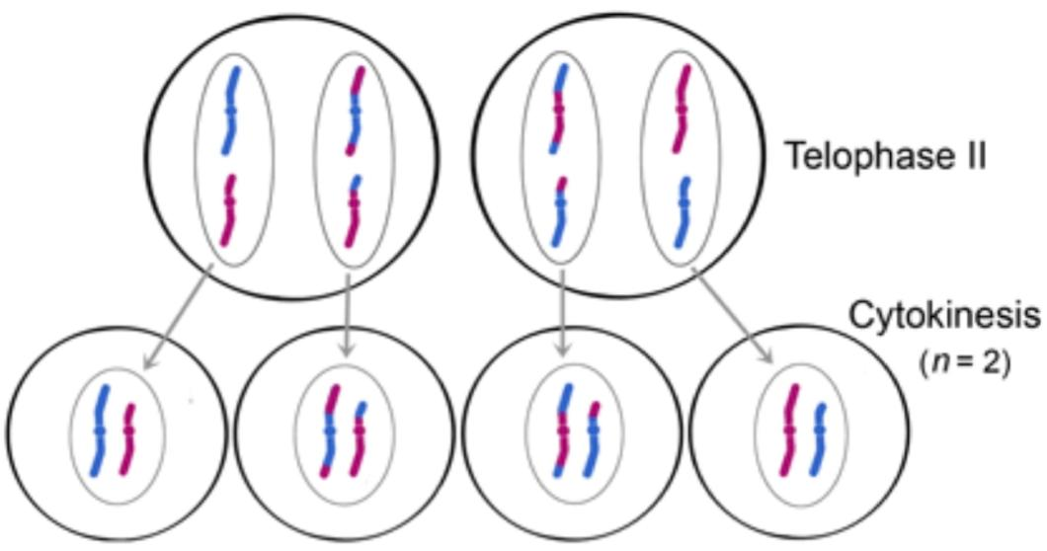

3.Discuss the stages involved in fertilization
Fertilization
Fertilization is the union of the sperm and the oocyte to form a zygote. It usually takes place at the ampulla of the uterine tube which takes place for approximately 24hours.
Stages involved in fertilization include;
- Passage of sperm through the Corona radiate.
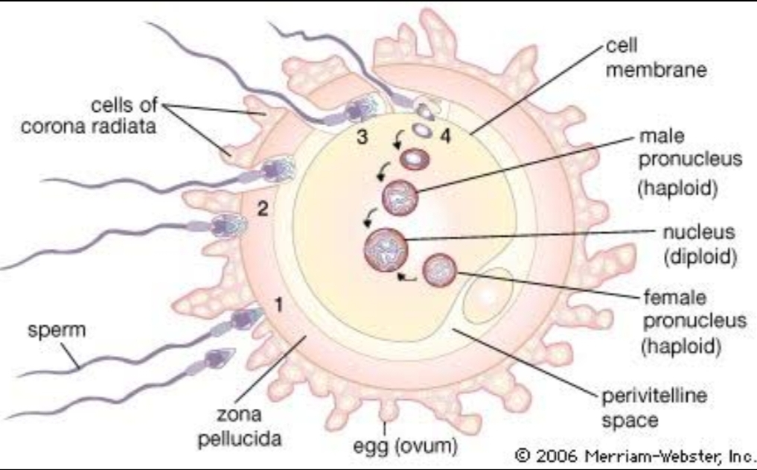
For sperms to pass through the corona radiata, they must have been capacitated and capacitation is the removal of the glycoprotein coat and seminal plasma proteins from the plasma membrane that overlies the acrosomal region of the spermatozoa.
Penetration through the zona pellucida
The zona is a glycoprotein shell surrounding the egg that facilitates and maintains sperm binding and induces the acrosome reaction. The intact acrosome of the sperm binds with a zona glycoprotein (ZP3/ zona protein 3) on the receptive site of the zona pellucida and releases acrosomal enzymes (acrosin) which breaks down the zona wall and allows sperm to penetrate and enter the cytoplasmic region of the oocyte and there after, releases cortical granules that sends message to the zona pellucida to close their binding site to block polyspermy.
- Fusion of plasma membrane of sperm and oocyte
The head and the tail of the sperm enters the cytoplasm leaving behind its plasma membrane which thenn fuses with the plasma membrane of the oocyte and breaks at the area of fusion.

- Completion of 2nd meiotic division and formation of female
pronucleus.
As soon as the head and tail of the sperm enters the cytoplasm of the oocyte, it activates the oocyte into completing the 2nd meiotic division, forming a mature oocyte and a second polar body
The nucleus of the mature oocyte is now called the female pronucleus.
- Formation of Male pronucleus
The tail of the sperm degenerates and the nucleus left within the cytoplasm of the oocyte enlarges to form the Male pronucleus.

- Formation of the zygote
The female pronucleus and the Male pronucleus fuses together to form two haploid pronucleus called the optic and the optic then develops to form the zygote.

Clinical correlates
- In vitro fertilisation (IVF) is a process by which an egg is fertilized by which a sperm outside the body: in vitro (outside) in a glass
The process involves monitoring and stimulating a woman's ovulatory process, removing ovum or ova from the woman’s ovaries and letting sperm fertilise them in a fluid medium in a laboratory. The fertilised egg (zygote) is cultured for 2–6 days in a growth medium and is then implanted in the same or another woman's uterus, with the intention of establishing a successful pregnancy. In vitro fertilization (IVF) of oocytes and transfer of the cleaving zygotes into the uterus have provided an opportunity for many women who are sterile (e.g., owing to tubal occlusion) to bear children

- Intracytoplasmic Sperm Injection
A sperm can be injected directly into the cytoplasm of a mature oocyte. This is used when sperm have difficulty penetrating the egg, and in these cases the partner's or a donor's sperm may be used.This technique has been successfully used for the treatment of couples for whom in vitro fertilization failed or in cases where there are too few sperms available for in vitro insemination.

- Cryopreservation of Embryos
Early embryos resulting from in vitro fertilization can be preserved for long periods by freezing them with a cryoprotectant (e.g., glycerol). Successful transfer of four- to eight-cell embryos and blastocysts to the uterus after thawing is now a common practice.

- Surrogate Mothers
Some women produce mature oocytes but are unable to become pregnant, for example, a woman who has had her uterus excised (hysterectomy). In these cases, in vitro fertilization may be performed and the embryos transferred to another woman's uterus for development and delivery.

4. Differentiate between monozygotic and Dizygotic twins.
Twinning
Twinning is the nurturing of two concept uses at thesame time.
Monozygotic twins | Dizygotic twins
- This occurs when a single sperm fertilizes an oocyte to form a zygote and the zygote thereafter divides during blastocyst formation. | - This occurs when two sperms fertilizes two different oocyte to form two zygote.
- Genetically identical | - Genetically not identical
- Twins are if thesame sex | - Twins are of thesame sex or different sex
- Resemblance is similar | - Resemblance is just like any other two siblings
- Mostly diamniotic, monochoronic, with single placenta | - Mostly have two anions, two chlorions, and two placenta
- They are often seen as conjoined twins | - They are not seen as conjoined twins

