NAME: SEGUN BELLA TESSY
DEPARTMENT: BIOTECHNOLOGY
MATRIC NUMBER: 16/SCI17/002
BTG 406: METABOLIC ENGINEERING
ASSIGNMENT
Discuss the induced fit model of enzyme action.
Enzymes bind with substrates to keep all the necessary biochemical reactions in the body going at the proper pace. But each enzyme can only bind with one particular substrate.
Enzymes are found almost everywhere in the body and do everything from copying DNA to digesting food. They are essential for all life processes. A missing or malfunctioning enzymatic protein characterizes many diseases and disorders, such as albinism, Hunter syndrome, and Tay-Sachs disease.
Enzymes catalyze, or speed up the biochemical reactions required for life. They do so by lowering the activation energy, the energy required for the chemical reaction to start, of all the necessary reactions in your cells. Without enzymes, the essential chemical reactions would not be fast enough to sustain life.
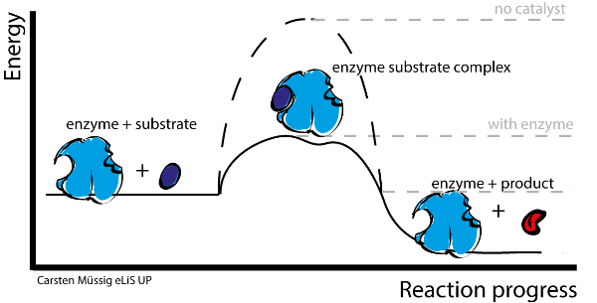
Enzymes lower the activation energies of chemical reactions.

The molecule (or molecules) with which the enzymes bind is referred to as the substrate. The substrate binds to a small section of the enzyme referred to as the active site. The molecule (or molecules) produced at the end of the reaction is referred to as the product. Once the reaction is complete, the enzyme releases the product and is ready to bind with another substrate.
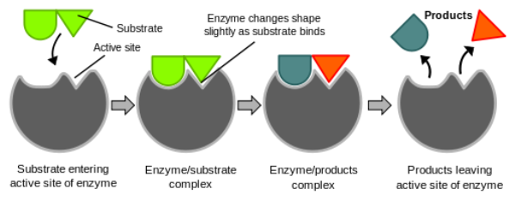
Diagrammatic Illustration of How The substrate binds with the active site of the enzyme to start the reaction. Once the reaction is complete, the enzyme releases the product and is ready to bind with another substrate.

The Induced-Fit Model

The induced-fit model is an elaboration by Daniel Koshland, of an earlier theory proposed by Emil Fischer in 1894, the lock-and-key model. The lock-and-key model states that the substrate acts as a 'key' to the 'lock' of the active site. The active site and substrate are exact matches for each other, similar to puzzle pieces fitting together. In this model, only a single substrate is the precise match for the enzyme. Once the enzyme finds its exact counterpart, the chemical reaction can begin.
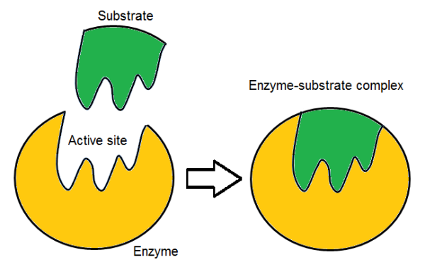
Diagrammatic Representation of The Lock and Key Model.

The induced-fit model is generally considered the more correct version. This theory maintains that the active site and the substrate are, initially, not perfect matches for each other. Rather, the substrate induces a change of shape in the enzyme. This is similar to placing your hand in a glove. Getting the first finger in may be difficult, but, once you complete this initial step, the glove slides on easily because it is now properly aligned for your hand.
The basis of chemical reactions is a change in atom arrangement and bonds between atoms. When the substrate interacts with the enzymes, it undergoes a chemical reaction that allows the atoms to move relative to each other, the bonds possibly lengthen or shorten and most reactive groups move closer to each other, causing a shape change. This shape change makes the substrate mire amenable to alteration as it holds the substrate in a transitional state, which helps speed up the reaction that the enzyme catalyse.

