NAME: HALIMAH ABDULAZIZ
DEPARTMENT: MBBS
MATRIC NUMBER: 17/MHS01/003
LEVEL: 300 LEVEL
ANATOMY OF THE HEAD AND NECK ASSIGNMENT
QUESTION 1: Discuss the anatomy of the tongue and comment on its applied anatomy.
The tongue is a unique organ located in the oral cavity that helps with the sense of tate as well as mastication and deglutition. The tongue is also an essential component of the speech pathway as it helps with articulation.
The tongue is a pink muscular organ and it is kept moist by the major and minor salivary gland, the tongue has an average length of 10cm and it is alos divided into three main parts:
- The tip or apex which is the most anterior and most mobile aspect of the organ.
- The Body bearing a rough superior surface that abuts the palate and is populated with taste buds and lingual papillae and a smooth inferior surface that is attached to the floor of the oral cavity by the lingual frenulum.
- The Base of the tongue is the most posterior aspect and it is populated by lymphoid aggregates known as lingual tonsils.
The tongue is limited anteriorly and laterally by the teeth, superiorly by the hard and soft palates. Inferiorly the root of the tongue is continous with the mucosa of the floor of the oral cavity; with sublingual salivary glands and vascular bundles being located below the mucosa.
The palatoglossal and palatopharyngeal arches (along with the palatine tonsils) have lateral relations to the posterior third of the tongue. Posterior to the base of the tongue is the dorsal surface of the epiglottis and laryngeal inlet, and the posterior wall of the oropharynx. As mentioned earlier, the presulcal and postsulcal parts of the tongue differ not only by anatomical location, but also based on embryological origin, innervation, and the type of mucosa found on its surface.
Anterior two thirds
The presulcal tongue includes the apex and body of the organ. It terminates at the sulcus terminalis; which can be seen extending laterally in an oblique direction from the foramen cecum towards the palatoglossal arch. The mucosa of the dorsal surface of the oral tongue is made up of circumvallate, filiform, and fungiform papillae. There is also a longitudinal midline groove running in an anteroposterior direction from the tip of the tongue to the foramen cecum (frontal bone). This marks the embryological point of fusion of the lateral lingual swellings that formed the oral tongue. It also represents the location of the median lingual (fibrous) septum of the tongue that inserts in the body of the hyoid bone.
On the lateral surface of the oral tongue are foliate papillae arranged as a series of vertical folds. The ventral mucosa of the oral tongue is comparatively unremarkable. It is smooth and continuous with the mucosa of the floor of the mouth and the inferior gingiva. The lingual veins are relatively superficial and can be appreciated on either side of the lingual frenulum. Lateral to the lingual veins are pleated folds of mucosa known as the plica fimbriata. They are angled anteromedially toward the apex of the tongue.
Posterior third
The remainder of the tongue that lies posterior to the sulcus terminalis is made up by the base of the organ. It lies behind the palatoglossal folds and functions as the anterior wall of the oropharynx.
Unlike the oral tongue, the pharyngeal tongue does not have any lingual papillae. Instead, its mucosa is populated by aggregates of lymphatic tissue known as the lingual tonsils. The mucosa is also continuous with the mucosa of the laterally located palatine tonsils, the lateral oropharyngeal walls, and the posterior epiglottis and glossoepiglottic folds.
Muscles
The tongue is chiefly a muscular organ with some amount of fatty and fibrous tissue distributed throughout its substance. All the muscles of the tongue are paired structures, with each copy being found on either side of the median fibrous septum. There are muscles that extend outside of the organ to anchor it to surrounding bony structures, known as extrinsic muscles. The other set of muscles are confined to each half of the organ and contribute to altering the shape of the organ; these are the intrinsic muscles.
Intrinsic tongue muscles
The intrinsic tongue muscles are responsible for adjusting the shape and orientation of the organ. It is made up of four paired muscles, which are discussed below in a dorsoventral manner.
The superior longitudinal muscles are made up of a thin layer of muscle fibers traveling in a mixture of oblique and longitudinal axes just deep to the superior mucosal surface of the organ. These fibers arise from the median fibrous septum as well as the fibrous layer of submucosa from the level of the epiglottis. They eventually insert along the lateral and apical margins of the organ. These muscles are responsible for retracting and broadening the tongue, as well as elevating the tip of the tongue. The net effect of these muscles results in shortening of the organ.
Another set of muscles occupy the dorsoventral plane of the tongue deep to the superior longitudinal muscles. These are the vertical muscles that arise from the root of the organ and genioglossus muscle and insert into the median fibrous septum, along the entire length of the organ. These muscles facilitate flattening and widening of the tongue.
Deep to the ventral muscles is the layer of transverse muscles of the tongue. They take a lateral route, extending from either side of the medial lingual septum (origin) to the fibrous submucosa along the lateral margins of the tongue (insertion). As these muscles contract, they cause the tongue to narrow and elongate.
Finally, the inferior longitudinal muscles travel above the ventral submucosa of the tongue. These fibers travel between hyoglossus and genioglossus as it arises from the base of the tongue and body of the hyoid bone. The fibers end in the apex of the tongue; allowing the muscle to pull the tip of the tongue inferiorly and also shortening the organ.
The intrinsic tongue muscles can operate independently, or in combination with each other to give rise to numerous shapes. This is an important feature of the tongue as it facilitates molding of the food particles into a bolus in preparation for deglutition and speech.
Extrinsic tongue muscles
While the shape of the tongue is determined by the intrinsic muscles of the tongue, movement of the organ within (and out of) the oral cavity is dependent on the extrinsic tongue muscles. There are four pairs of extrinsic muscles, which can be viewed as those arising from above the tongue, and those that originate from below the tongue.
Styloglossus and palatoglossus are the two muscles arising from above. Palatoglossus is anatomically a part of the pharyngeal group of muscles. However, its attachments to the tongue mean that it is also an extrinsic tongue muscle. It originates from the oral part of the aponeurosis of the soft palate. Here, and also at its insertion in the lateral margins of tongue, the muscle is wider than along its middle section. Its role as an extrinsic tongue muscle is to elevate the dorsal surface of the tongue, and (while working synergistically with the contralateral palatoglossus) to act as a sphincter at the oropharyngeal isthmus.
Styloglossus originates from the anterolateral surface of the styloid process. Not only does it contribute to the stylomandibular ligament, but it also assists in retraction of the tongue (moving it posterosuperiorly). It is the smallest and shortest of the three styloid muscles. At the lateral margin of the tongue, the muscle bifurcates into longitudinal and oblique components. The former pierces the tongue on the dorsolateral aspect and integrates with the inferior longitudinal muscle; while the latter crosses over and decussates with hyoglossus.
Genioglossus and hyoglossus arise from below. Genioglossus originates from a slender tendon that is attached to the superior genial tubercle found on the inner surface of the symphysis menti.
This attachment prevents the tongue from falling backward and obstructing the airway when an individual is supine. The lower fibers of the muscle also have indirect attachments to the anterior part of the body of the hyoid bone via its slender aponeurosis.
It is a triangular, midline structure that travels posterosuperiorly at which point the upper fibers of the muscle interdigitate with the intrinsic muscles, before attaching along the length of the inferior surface of the tongue (extending from the root to the tip).
Hyoglossus originates from the entire greater cornu of the hyoid bone as a slender, quadrilateral muscle. It is often accompanied by chondroglossus (may be considered as part of the hyoglossus), which arises from the base of the lesser cornu of the hyoid bone. Hyoglossus takes a vertical course cranially, where it pierces the inferolateral margins of the tongue and subsequently blends between the inferior longitudinal muscles and the styloglossus.
The extrinsic muscles play an important role in pressing and molding the food bolus in preparation for the initial phase of swallowing. Additionally, they are used to move the bolus posteriorly into the oropharyngeal inlet. Furthermore, the action of palatoglossus closes off the oropharyngeal isthmus in order to prevent food from moving cranially during swallowing. Although some of these muscles are able to act in isolation, it is the combined effect of all the intrinsic and extrinsic muscles that allows the tongue to have significant flexibility.
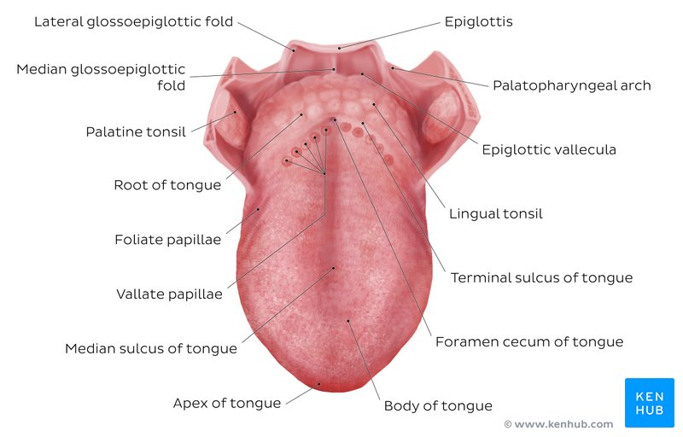
credit: ken hub

QUESTION 2: WRITE AN ESSAY ON THE AIR SINUSES
The paranasal sinuses are air-filled extensions of the respiratory part of the nasal cavity. There are four paired sinuses, named according to the bone in which they are located; maxillary, frontal, sphenoid and ethmoid.
The function of the sinuses is not clear. It is thought that they may contribute to the humidifying of the inspired air. They also reduce the weight of the skull.
Sinuses are formed in childhood by the nasal cavity eroding into surrounding bone. As they are outgrowths of the nasal cavity, they all drain back into it – openings to the paranasal sinuses are found on the roof and lateral walls of the nasal cavity. The inner surface is lined by a respiratory mucosa.

Frontal Sinuses: These are the most superior in location, found under the forehead. The frontal sinuses are variable in size, but always triangular-shaped. They drain into the nasal cavity via the frontonasal duct, which opens out at the hiatus semilunaris on the lateral wall.
Sphenoid Sinuses: The sphenoid sinuses also lie relatively superiorly, at the level of the spheno-ethmodial recess. They are found more posteriorly, and are related superiorly and laterally to the cranial cavity. The sphenoid sinuses drain out onto the roof of the nasal cavity. The relationships of this sinus are of clinical importance – the pituitary gland can be surgically accessed via passing through the nasal roof, into the sphenoid sinus and through the sphenoid bone.
Ethmoidal Sinuses: There are three ethmoidal sinuses; anterior, middle and posterior. They empty into the nasal cavity at different places:
Anterior – Hiatus semilunaris
Middle – Ethmoid bulla
Posterior – Superior meatus
Maxillary Sinuses: The largest of the sinuses. It is located laterally and slightly inferiorly to the nasal cavities. It drains into the nasal cavity at the hiatus semilunaris, underneath the frontal sinus opening. This is a potential pathway for spread of infection – fluid draining from the frontal sinus can enter the maxillary sinus.
CLINICAL ANATOMY: As the paranasal sinuses are continous with the nasal cavity, an upper respiratory tract infection can spread to the sinuses. Infection to the sinuses can cause inflammation particularly pain and swelling of the mucosa and it is known as sinusitis. if more than one sinus is affected it is called parasinusitis.
The maxillary nerve supplies both the maxillary sinus and maxillary teeth and so inflammation of that sinus can present with toothache.
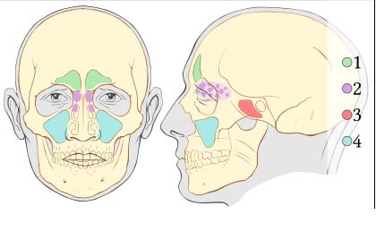
Frontal sinus
Ethmoid sinus
sphenoid sinus
Maxillary sinus

of that sinus Can present with toothache

