GROSS ANATOMY OF THE HEAD AND NECK ASSIGNMENT
NAME: HALIMAH ABDULAZIZ
DEPT: MBBS
LEVEL: 300 LEVEL
MATRIC NO: 17/MHS01/003

QUESTION 1: WRITE AN ESSAY ON CAVERNOUS SINUS

Before we move on to the cavernous sinus, I would like to first mention that cavernous sinus is part of the dura venous sinuses which is a venous channel found in between the external periosteal layer and the inner meningial layer of the outermost dura mater [covering of the brain]. This venous network receives blood from the cerebral vein and drains it into the internal jugular vein. The other venous sinuses include: superior sagittal sinus, inferior sagittal sinus, straight sinus, transverse sinus, sigmoid sinus, occipital sinus, and the inferior petrosal sinus.

The cavernous sinus is found at the region of the middle cranial fossa and it lies on either side of the sella turcica (bears the hypophyseal fossa, tuberculum sella and dorsum sella). There are two cavernous sinuses that lie on either side of the sella turcica and they conisist of a venous plexus.
Each of these sinuses extends anteriorly from the superior orbital fissure to the apex of the temporal bone posteriorly. The cavernous sinus has a size of 1 x 2 cm in size in an adult.
Due to the nature of the cavernous sinus bearing a venous plexus, it makes it important because a lot of structures pass through it.
This cavernous sinus receives blood from the following:
- the great cerebral vein
- the superior and inferior ophthalmic vein
- the emissary vein (transmits from the foramen cecum to the superior sagittal sinus and also through the parietal foramen)
The structures that pass through it also include:
- The carotid siphon of the internal carotid artery,
- occuomotor nerve or CN3
- trochlear nerve or CN4
- trigerminal nerve or CN 5 and its branches the ophthalmic and maxillary branches
- Abducens nerve or CN6

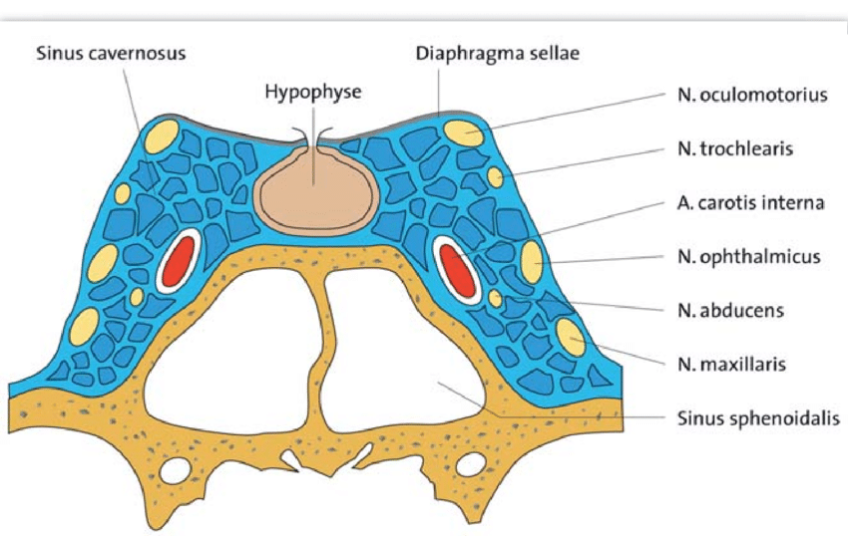credit: research gate
QUESTION 2: DISCUSS THE WALL OF THE NOSE
Before we proceed with the walls of the nasal cavity lets first talk about the nose.
The nose is the body's primary organ of smell and also functions as part of the body's respiratory system,air comes into the body through it and as it passes over the specialized cells of the olfactory system, the brain recognizes and identifies smells.
The nasal cavity on the other hand which we would be focusing on here is the inside of the nose and It is lined with a mucous membrane that helps keep the nose moist by making mucus so you won't get nosebleeds from a dry nose. There are also little hairs that help filter the air you breathe in, blocking dirt and dust from getting into your lungs.
The walls of the nasal cavity are the medial, lateral walls and the floor.
THE LATERAL WALL
The lateral wall of the nasal cavity is a region of the nasopharynx essential for humidifying and filtering the air we breathe in nasally.
Here we can find a structure called agger nasi. The agger nasi is also referred to as the ‘nasoturbinal concha’ or ‘nasal ridge.’ It can be described as a small mound or ridge found in the lateral side of the nasal cavity. The structure is located midway along the anterior aspect of the middle nasal concha. An abnormally enlarged form may restrict the drainage of the frontal sinus by obstructing the frontal recess area.

Nasal septum
The anterior nasal aperture is simply the area where the anterior bony aspects of both the maxilla and the nasal bone terminate and form an opening into the cartilaginous nasal vestibule. The structure is also referred to as the piriform aperture.
Three cartilages contribute to the nasal septum:
- lesser alar cartilages are paired cartilages suspended in the fibro-fatty tissue that forms the lateral aspect of the nostril. The structures lie free from the other cartilages and provide the nostril with stability and form.
- greater alar cartilages are paired cartilages that form part of the antero-superior nostril as well as the nasal tip. The structures give the tip of the nose stability and flexibility and are a crucial element of the cartilaginous apparatus of the nose.
- lateral nasal cartilages are structures that articulate inferiorly with the greater alar cartilages and superiorly with the anterior nasal aperture formed by both the nasal bone superiorly and for a short part of its border with the perpendicular plate of the ethmoid bone. These structures form the cartilaginous part of the bridge of the nose and form in conjunction with the greater alar cartilages, the major structural appearance of the nose.

Nasal conchae
We can find 3 types of nasal conchae in the nasal cavity. Those are:
- Superior nasal conchae

- inferior nasal concha. It is the longest and broadest of the conchae and is formed by an independent bone (of the same name, inferior concha). The concha is covered by a mucous membrane that contains large vascular spaces and is one of the three that work to both humidify and clear the air that passes into the nasopharynx.
- superior and middle nasal conchae arise from the perpendicular plate of the ethmoid bone. The middle nasal concha is found in between the superior and inferior nasal concha and plays a role in humidifying and clearing inspired air of micro-particles such as dirt. The superior nasal concha is a bony shelf located above the middle nasal concha and below the sphenoethmoidal recess. Similar to the middle nasal concha the superior concha is itself part of the ethmoid bone.

Nasal skeleton
Ethmoid bone

The ethmoid bone is located on the roof of the nose between the two orbits and is lightweight and spongy. It has three parts:
- cribriform plate which is pierced by fibres of the olfactory nerve;
- ethmoidal labyrinth which consists of numerous thin walled hollow cavities;
- perpendicular plate which forms part of the posterior nasal septum and gives rise to the superior and middle nasal conchae.
The bone articulates with many others including the frontal and sphenoid bone as part of the neurocranium, and the nasal and lacrimal bones anteriorly as well as the maxilla inferolaterally and the vomer and inferior nasal concha inferiorly. The bone also forms the deep medial part of the orbit.

Frontal bone
The frontal bone overlies the frontal lobe of the brain and lies anteriorly forming the brow, forehead and one third of the anterior scalp. The bone contains the frontal sinus, which in sinusitis and nasal infections can become filled with fluid. The bone articulates with the bones forming the calvaria as well as the zygomatic bone inferolaterally and the nasal and maxilla bones anteroinferiorly.
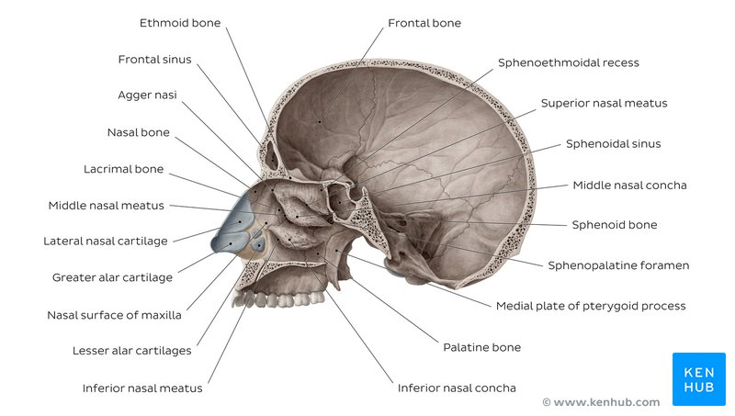

bones of the nasal cavity: credit kenhub

Lacrimal bone

The lacrimal bone is the smallest bone of the face and forms part of the posterior nasal skeleton. The bone has a crest known as the ‘sulcus lacrimalis’ on its lateral surface. This crest gives rise to the aptly named lacrimal part of the orbicularis oculi muscle.
The anterior inner margin of the bone articulates with the frontal process of the maxilla and the upper part of the fossa contains the lacrimal sac, which drains into the nasolacrimal duct. The superior portion articulates with the frontal bone. The inferior border of the bone is divided by the lower edge of the posterior lacrimal crest into an anterior and posterior part. The posterior articulates with the orbital plate of the maxilla, and the anterior extends through a descending process which forms part of the canal for the nasolacrimal duct as well as articulating with the lacrimal process of the inferior nasal concha. The posterior portion of the bone is smooth and forms part of the medial wall of the orbit.

THE MEDIAL WALL
The medial wall of the nasal cavity comprises the nasal septum, the septal catilage and various bones of the skull.

Nasal skeleton
The nasal septum is a structure consisting of both bony and cartilaginous components. The bony components are the:
- perpendicular plate of the ethmoid superoinferiorly
- the vomer posteroinferiorly
- the crests of the maxillary bone anteroinferiorly
- the crest of the palatine bone inferior to the vomer

Ethmoid bone
The medial wall of the nasal cavity is formed by both bony elements and cartilage. Posteriorly the perpendicular plate of the ethmoid bone forms the superoposterior part of the bony nasal septum and articulates superiorly with the cribriform plate. The posterior border articulates superiorly with the sphenoidal crest and with the vomer by its inferior border.
The cribriform plate is found in the midline on the anterior floor of the anterior cranial fossa. It can be descried as a thin bony plate of perforated bone through which the fibres of the olfactory nerve ascend and reach the entorhinal cortex. The plate is divided by the crista galae in the midline.

Maxillary bone
Further posteriorly than the ethmoid bone, the crest of both the maxilla and palatine bone complete the posterior septum. The anterior septum is formed entirely of the quadrangular cartilage which divides the cavity in the midline. The nasal septum can be deviated in some and is a sign of nasal trauma or abnormal growth.

Vomer
The vomer is an unpaired bone of the skull forms the inferior part of the septum. It is located in the mid sagittal plane and articulates with the ethmoid, both palatine bones and both maxillary bones.

Palatine bone
The horizontal plate of the palatine bone is a rectangular shaped bone that projects medially and forms a right angle with the perpendicular plate of the ethmoid. The nasal surface of the bone forms part of the inferior meatus of the nose, while the serrated anterior maxillary surface articulates with the maxilla. Laterally the bone articulates with the perpendicular plate, and superior portion of the plate forms the posterior part of the nasal cavity. The inferior surface of the plate is rough and provides attachment to the oral mucosa of the hard palate.

Nasal cartilage and associated structures
The septal cartilage is approximately 3-4mm thick. It divides the nasal cavity into two halves. The anteroinferior part of the cartilage has an expansion known as the ‘footplate’ which is 4-8mm wide. This foot plate lies in free contact with the membranous septum. The cartilage is expanded in other regions, namely the junction with the lateral nasal cartilage termed the posterior process. The cartilage is firmly adhered to the nasal bone by taut collagen fibres.
The cartilage of the septum is also termed the ‘quadrangular cartilage’ due to its shape. The posterior nasal spine is a sharp pointed projection of the posterior border of the palatine bone. The musculus uvula gains its attachment here.
The pharyngeal tonsil is also known as the adenoid. It is a mass of lymphatic tissue located in the roof of the nasopharynx. The structure degrades with age and is almost entirely absent at puberty. The torus tubarius is also known as the tubar tonsil. It resides at the base of the cartilaginous section of the Eustachian tube.
The choana is an opening at the back of the nasal passage that empties into the nasopharynx, close to where the adenoids are. The passage way forms an outflow from the nasopharynx into the mouth and throat.

Floor of the nasal cavity

Hard palate
The pharyngeal opening of the auditory tube can be described as a triangular opening surrounded by a raised, firm prominence known as the ‘torus’. The most medial end of the cartilage causes the elevation of the mucous membrane. The hard palate is a horizontal plate of bone formed by both the palatine process of the maxilla, which forms 75% of the hard palate, and the horizontal plate of the palatine bone, which forms the remaining 25%.
This bony structure has numerous perforations to allow for the passage of nutrient vessels. Its function is to form a separation between the nasopharynx and oropharynx. Insufficiency in this structure can cause difficulty with swallowing.

Soft palate
The soft palate is also referred to as the ‘velum’. This is a continuation of the hard palate posteriorly but has no bony structure. This structure is constituted of five muscles crucial for swallowing. These are the:
- tensor veli palatini (innervated by the mandibular branch of the trigeminal nerve)
- palatoglossus
- the palatopharyngeus which has a crucial role in breathing
- the levator veli palatini which elevates the soft palate to encompass the bolus of food
- the musculus uvulae which move the uvula

