Name: Ayemobuwa Omotayo
Matric Number: 17/MHS03/007
Course Name: CELLULAR BIOCHEMISTRY
Course Code: BCH 308
Assignment Title: NEUROCHEMISTRY
- NEUROTRANSMITTERS AND SYNTHESIS
- ACETYLCHOLINE
Acetylcholine (Ach) is the neurotransmitter at parasympathetic neuro-effector junctions, all autonomic ganglia, adrenal medulla, somatic neuromuscular junctions, and CNS. Synthesis, Storage and Release of Ach: Ach is synthesized in the cholinergic nerve endings.
After a reaction among acetate, coenzyme A and ATP, acetyl CoA is formed within the mitochondria and released into the cytoplasm. Choline enters into the axoplasm by active transport through the axonal membrane.
Choline acetyltransferase or choline acetylase, which is present in the axonal terminal, helps in acetylation of choline with acetyl CoA to form Ach. The transport of choline from the extracellular fluid into neuron is directly proportional to the concentration of extracellular Na⁺ and is inhibited by hemicholinium.
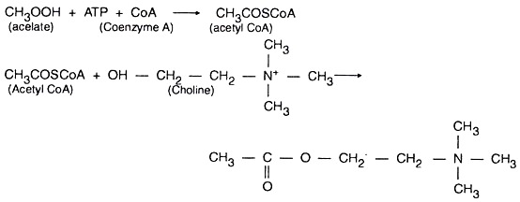
After synthesis, Ach is transported into the synaptic vesicles where it is stored till an action potential (AP) renders its release into the synaptic cleft by exocytosis. Vesamicol inhibits this transport and release systems.
When an action potential arrives at the motor or cholinergic nerve terminal, depolarization of the area opens the voltage-gated Ca²⁺ channels on the axonal membrane, through which Ca²⁺ enters into the axoplasm and helps in fusion of vesicles with axonal membrane, resulting in extrusion of a larger quantity of Ach.
- DOPAMINE
Dopamine is synthesized from the amino acid tyrosine, which is taken up into the brain via an active transport mechanism. Tyrosine is produced in the liver from phenylalanine through the action of phenylalanine hydroxylase. Tyrosine is then transported to dopamine containing neurons where a series of reactions convert it to dopamine. Within catecholaminergic neurons, tyrosine hydroxylase catalyzes the addition of a hydroxyl group to the meta position of tyrosine, yielding L-dopa. This rate-limiting step in catecholamine synthesis is subject to inhibition by high levels of catecholamines (end-product inhibition). Because tyrosine hydroxylase is normally saturated with substrate, manipulation of tyrosine levels does not readily impact the rate of catecholamine synthesis. Once formed, L-dopa is rapidly converted to dopamine by dopa decarboxylase, which is located in the cytoplasm. It is now recognized that this enzyme acts not only on L-dopa but also on all naturally occurring aromatic L-amino acids, including tryptophan, and thus it is more properly termed aromatic amino acid decarboxylase.
