NAME: AYENI OPEYEMI
MATRIC NO: 17/MHS01/075
DEPARTMENT: MEDICINE AND SURGERY
LEVEL: 300L
COURSE: GROSS ANATOMY

CAVERNOUS SINUS
The cavernous sinus is a paired dural venous sinus located within the cranial cavity. It is divided by septa into small “caves”, from which it gets its name. each cavernous sinus has a close anatomical relationship with several key structures in the head, and is arguably the most clinically important venous sinus.

LOCATION AND BORDERS OF THR CAVERNOUS SINUS
The cavernous sinuses are located within the middle cranial fossa, on either side of the sella turcica of the sphenoid bone (which contains the pituitary gland). They are enclosed by the endosteal and meningeal layers of the dura mater.
The borders of the cavernous sinus are as follows:
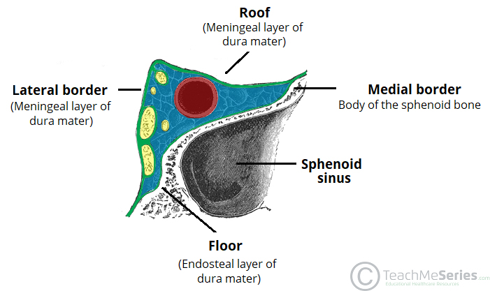
- Anterior- superior orbital fissure.
- Posterior- petrous part of the temporal bone
- Medial- body of the sphenoid bone
- Lateral- meningeal layer of the dura mater running from the roof to the floor of the middle cranial fossa
- Roof- meningeal layer of dura mater that attaches to the anterior and middle clinoid processes of the sphenoid bone.
- Floor- endosteal layer of dura mater that over lies the base of the greater wing of sphenoid bone.

CONTENTS OF TE CAVERNOUS SINUS
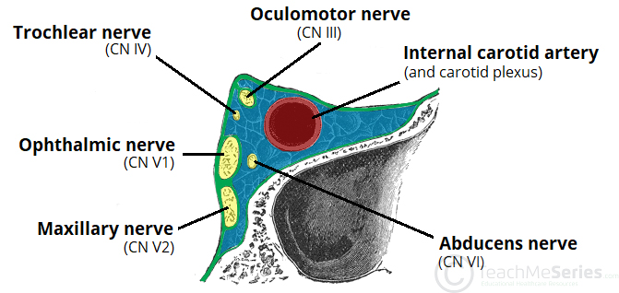
Several important structures pass through the cavernous sinus to enter the orbit. They can be classified whether they travel through the sinus itself, or through its lateral wall.
Structures that travel through the cavernous sinus include;
- Abducens nerve (CNVI)
- Carotid plexus (post-ganglionic sympathetic nerve fibers)
- Internal carotid artery (cavernous portion)
Structures that travel through lateral wall of the cavernous sinus include:
- Oculomotor nerve (CNIII)
- Trochlear nerve (CNIV)
- Ophthalmic (V1) and maxillary (V2) branches of trigeminal nerve (CNV)
The cavernous sinus is the only site in the body where an artery (internal carotid) passes completely through a venous structure. This is thought to allow for HEAT EXCHANGE between warm arterial blood and cooler venous circulation

DURAL VENOUS SINUS SYSTEM
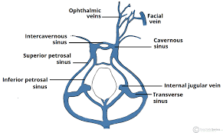
Each cavernous sinus receives venous drainage from;
- Ophthalmic vein (superior and inferior): these enter the cavernous sinus via the superior orbital fissure
- Central vein of the retina: drains into the superior ophthalmic vein, or directly into the cavernous sinus.
- Sphenoparietal sinus: empties into the anterior aspect of the cavernous sinus
- Superficial middle cerebral vein: contributes to the venous drainage of the cerebrum
- Pterygoid plexus: located within the infratemporal fossa.
It is important to note that the superior ophthalmic vein forms an anastomosis with the facial vein. Therefore, the ophthalmic veins represent a potential route by which infection can spread from extracranial to an intra cranial site.
The cavernous sinus empty into the superior and inferior petrosal sinus, and ultimately into the internal jugular vein. The left and right cavernous sinuses are connected in the midline by the anterior and posterior intercavernous sinuses. They travel through the sella turcica of the sphenoid bone.

APPLIED ANATOMY
Cavernous sinus thrombosis: cavernous sinus thrombosis refers to the formation of a clot within the cavernous sinus. The most common cause, is infection which typically spreads from an extracranial location such as orbit, paranasal sinuses, or the ‘danger zone’ of the face. Infection is able to spread in this manner due to anastomosis between the facial vein and superior ophthalmic veins. Common clinical features include headache, unilateral periorbital oedema, proptosis (eye bulging), photophobia and cranial nerve palsies. The abducens nerve (CNVI) is most commonly affected.

WALLS OF THE NOSE
The nose has two wally, a medial wall and a lateral wall.
MEDIAL WALL
The medial wall is formed by the nasal septum. The nasal septum is a structure consisting of both bony and cartilaginous components. The bony components are the
- Perpendicular plate of the ethmoid superoinferiorly
- The vomer posteroinferiorly
- The crests of the maxillary bone anteroinferiorly
- The crest of palatine bone inferior to the vomer
The cartilaginous component and other structures include;
- Septal cartilage
- Pharyngeal tonsil
- Choana

LATERAL WALL
The lateral wall of the nasal cavities is irregular owing to three bony plates, the nasal conchae, which project inferiorly, somewhat like louvers. The lateral wall of the nasal cavity is a region of the nasopharynx essential for humidifying and filtering the air we breathe in nasally.
The nasal conchae include;
- Inferior nasal conchae: it is the longest and broadest of the conchae and is formed by an independent bone (of the same name, inferior concha). The concha is covered by a mucous membrane hat contains large vascular spaces and is one of the three that work to both humidify and clear air that passes into the nasopharynx.
- Superior and middle nasal conchae: arise from the perpendicular plate of the ethmoid bone. The middle nasal concha is found in between the superior and inferior nasal concha and plays a role in humidifying and clearing inspired air of microparticles such as dirt. The superior nasal concha is a bony shelf located above the middle nasal concha and below the sphenoethmoidal recess. Similar to the middle nasal concha, the superior concha is itself part of the ethmoid bone.

