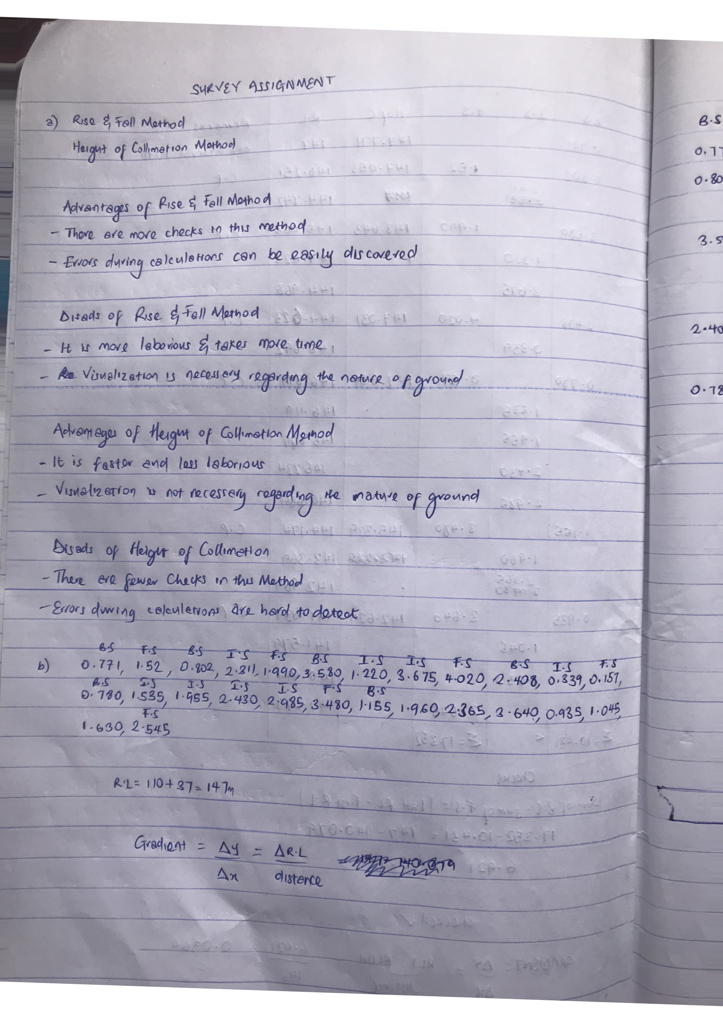
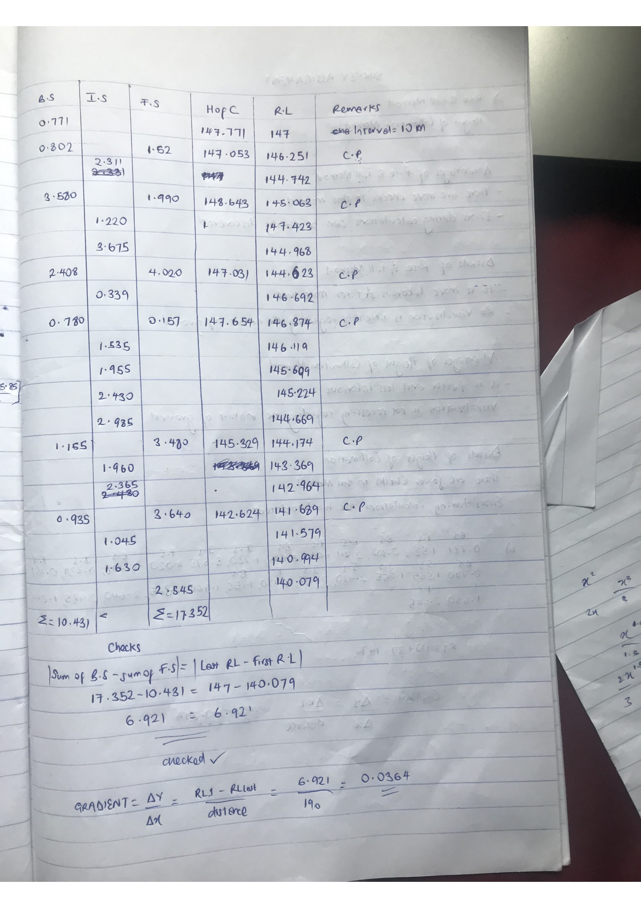

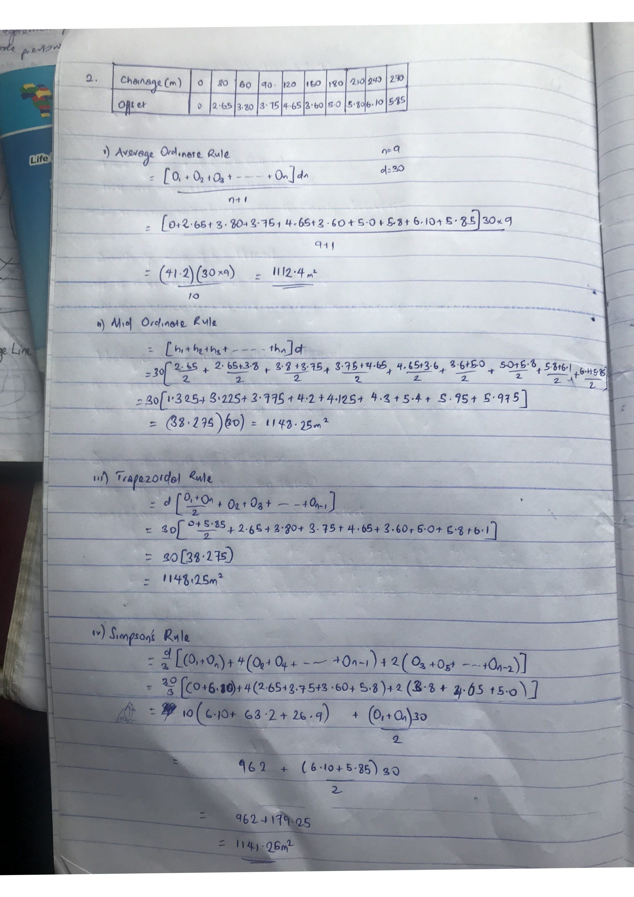
2b. A contour map cannot end anywhere but close on themselves either within or outside the limits of a map.
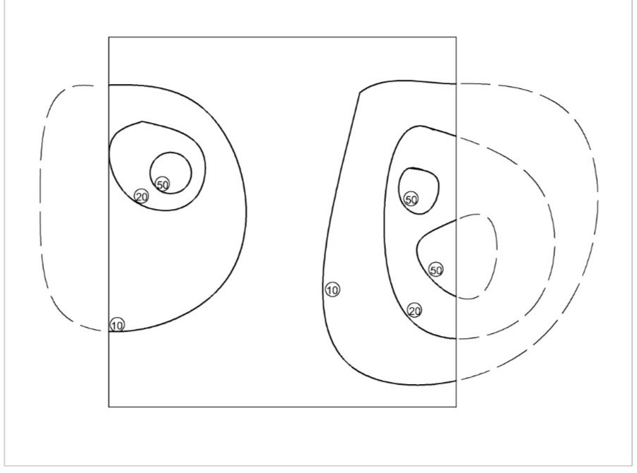

A series of close contours on a map represents a hill if the higher values are inside as shown;
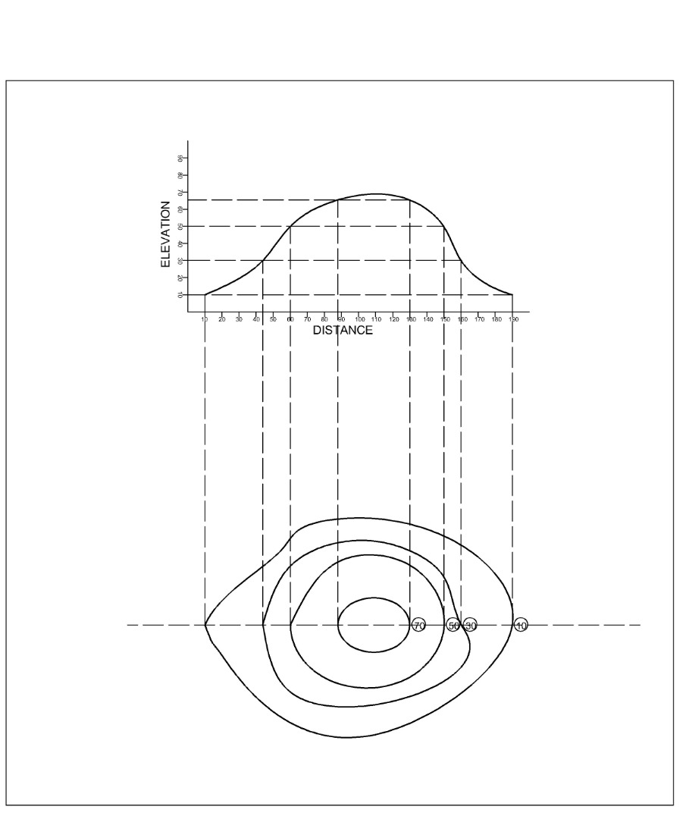

A series of closed contour lines on a map indicates a depression if the higher values are outside as shown below;
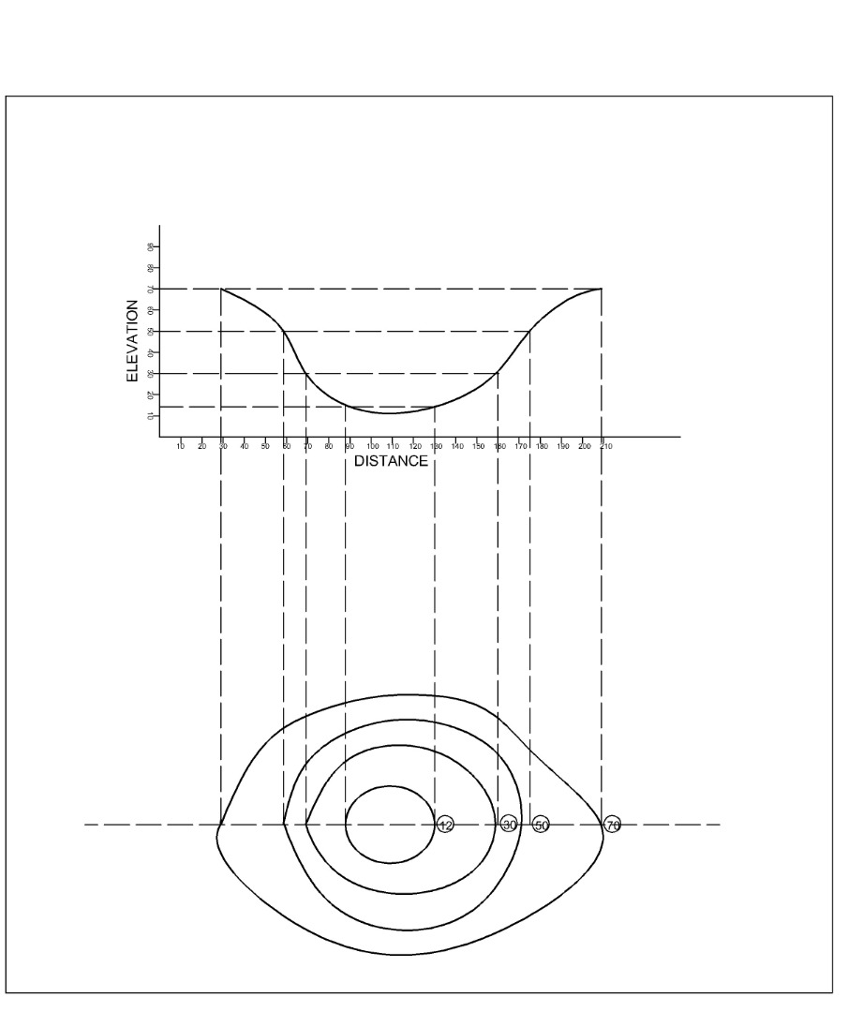
A contour line crfosses a ridge or valley at the right angle. If the higher values are inside the bend or loop in the contour, it represents a ridge but if the higher values are outside, it represents a valley;
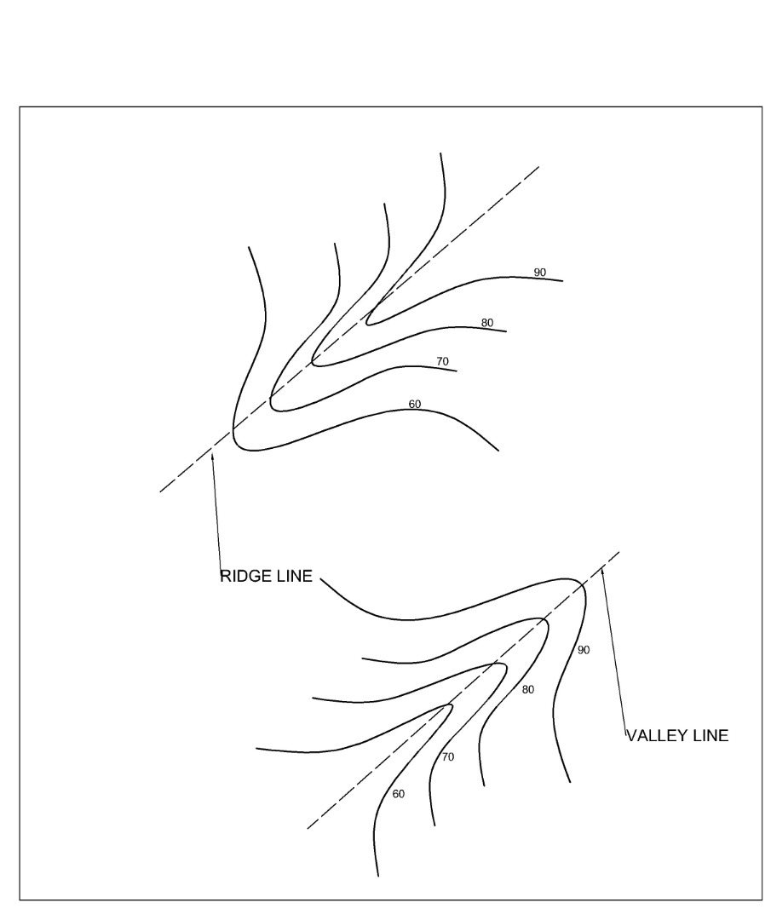
Contour lines cannot merge or cross one another on a map except in the case of an overhanging cliff;
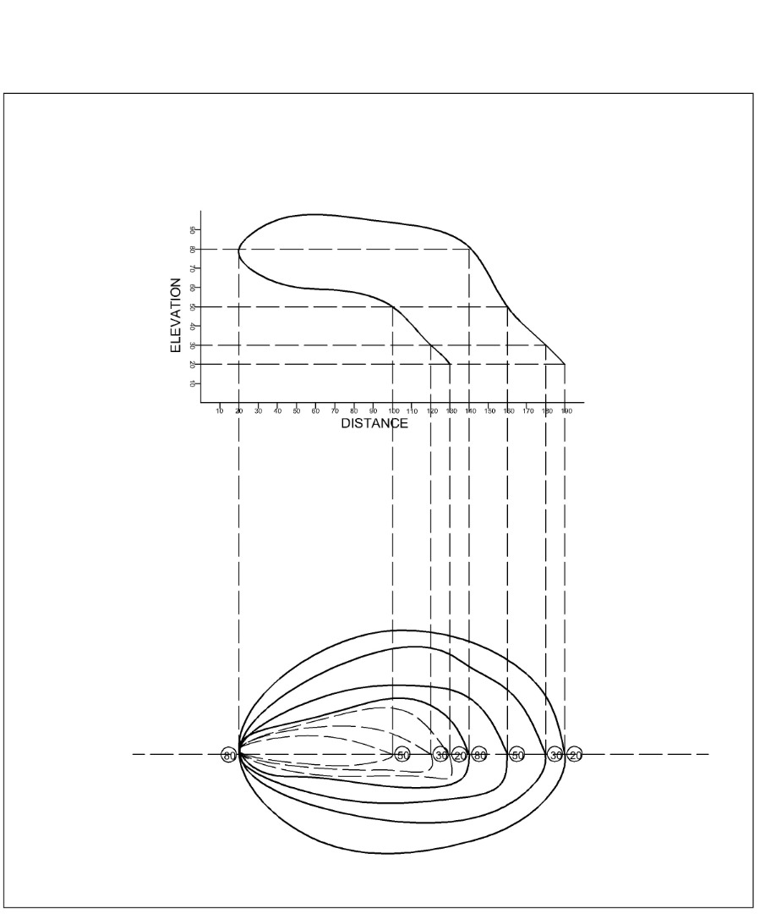

Please zoom in the view pictures clearly.

