Name: Etuk Esther Emmanuel
Matric no.: 17/mhs01/124
Department: Medicine and Surgery
Assignment Title: Assignment 2
Course Title: Gross Anatomy of Head and Neck
Course Code: ANA 301

Question
1). Write an essay on the carvanous sinus.

2). Discuss the walls of the nose.
Answer
1). Write an essay on the carvanous sinus.

CARVANOUS SINUS
The cavernous sinus is a paired dural venous sinus located within the cranial cavity. It is divided by septa into small ‘caves’ – from which it gets its name. The cavernous sinus is located within the middle cranial fossa on either side of the sella turcica of the sphenoid bone(which contains the pituitary gland). They are enclosed by the endosteal and meningeal layers of the dura mater.
Boundaries of the carvanous are the roof, anterior wall, posterior wall, medial wall, lateral wall and floor. The roof is a fold of dura mater attached to the anterior and middle clinoid processes. Anterior wall is made up of the medial end of the superior orbital fissure. posterior wall is made up of the petrous apex. Medial wall is the endosteum overlying the body of the sphenoid bone. Lateral wall is the dura mater from the ridge of the roof to the floor of the middle cranial fossa. Floor is the endosteum overlying the base of the greater wing of the sphenoid bone.
Posteriorly, the sinus drains into the transverse/sigmoid sinus through superior petrosal sinus and via the inferior petrosal sinus, passing through the jugular foramen, into the internal jugular vein. The ophthalmic veins drain into the anterior part of the sinus. Emissary veins passing through the foramina in the middle cranial fossa connect the cavernous sinus to the pterygoid plexus of veins and to the facial veins. The superficial middle cerebral vein drains into the cavernous sinus from above. The two cavernous sinuses are connected to each other by anterior and posterior cavernous sinuses lying in front and behind the pituitary. The cavernous sinus is an important structure because of its location and its contents. Apart from the blood which passes through a venous sinus, several anatomical structures, including some cranial nerves and their branches, also pass through the sinus. Structures within the outer (lateral) wall of the compartment from superior to inferior: Oculomotor nerve, Trochlear nerve ,Ophthalmic and maxillary branches of the trigeminal nerve. Structures passing through the midline (medial) wall: Abducens nerve and Internal carotid artery accompanied by the Internal carotid plexus
Each cavernous sinus receives venous drainage from: Ophthalmic veins (superior and inferior) – these enter the cavernous sinus via the superior orbital fissure, Central vein of the retina – drains into the superior ophthalmic vein, or directly into the cavernous sinus, Sphenoparietal sinus – empties into the anterior aspect of the cavernous sinus, Superficial middle cerebral vein – contributes to the venous drainage of the cerebrum and Pterygoid plexus – located within the infratemporal fossa. It is important to note that the superior ophthalmic vein forms an anastomosis with the facial vein. Therefore, the ophthalmic veins represent a potential route by which infection can spread from an extracranial to an intracranial site.
It is the only anatomic location in the body in which an artery travels completely through a venous structure. If the internal carotid artery ruptures within the cavernous sinus, an arteriovenous fistula is created (more specifically, a carotid-cavernous fistula). Lesions affecting the cavernous sinus may affect isolated nerves or all the nerves traversing through it.
Cavernous sinus syndrome is a medical emergency and life-threatening disorder that presents with different symptoms depending on what structure is affected. A severe lesion involving the entire sinus will present with total ophthalmoplegia, due to CN III, IV, and VI injury, accompanied with fixed and dilated pupils due to compression of the superficial parasympathetic fibers of the CN III. Cavernous sinus syndrome can lead to Horner’s syndrome. Horner’s syndrome occurs when the sympathetic plexus around the internal carotid is damaged. When CN V1 and CN V2 are involved, sensory loss in the face, scalp, maxilla, nasal cavity, sinuses, and palate occurs. There are several causes of cavernous sinus syndrome, including metastatic tumor, meningioma, pituitary tumor, extension of nasopharyngeal tumors, granulomatous diseases, cavernous sinus thrombosis, and aneurysms of the cavernous part of the internal carotid artery. In case of rupture of a cavernous aneurysm, a carotid-cavernous fistula is created, leading to a pulsating exophthalmos on physical examination.
Head trauma resulting in rupture of the cavernous part of the internal carotid artery can produce what is known as a carotid-cavernous fistula. A pulsating exophthalmos can result as the venous pressure in the sinus would increase and reverse the flow of blood in the ophthalmic veins.
Another clinical complication of the cavernous sinus is Cavernous sinus thrombosis. Cavernous sinus thrombosis (CST) refers to the formation of a clot within the cavernous sinus. This most common cause of CST is infection; which typically spreads from an extracranial location such as the orbit, paranasal sinuses, or the ‘danger zone’ of the face. Infection is able to spread in this manner due to the anastomosis between the facial vein and superior ophthalmic veins. Common clinical features include headache, unilateral periorbital oedema, proptosis (eye bulging), photophobia and cranial nerve palsies. The abducens nerve (CN VI) is most commonly affected. Treatment is typically with antibiotic therapy. Where the cause is infection, thrombosis of the cavernous sinus can rapidly progress to meningitis.
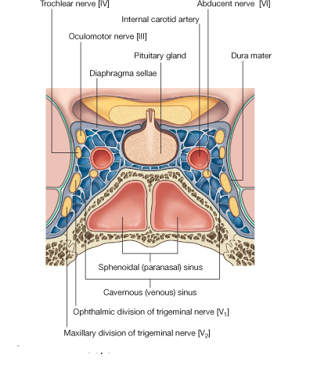
Carvanous Sinus

2). Discuss the walls of the nose.
The walls of the nose is made up of the bony framework which is the ethmoid bone, frontal bone, lacrimal bone, nasal bones, palatine bones and sphenoid bone.
a). Ethmoid bone: The ethmoid bone is located on the roof of the nose between the two orbits and is lightweight and spongy. It has three parts: cribriform plate (which is pierced by fibres of the olfactory nerve), ethmoidal labyrinth (which consists of numerous thin walled hollow cavities) and perpendicular plate (which forms part of the posterior nasal septum and gives rise to the superior and middle nasal conchae). The bone articulates with many others including the frontal and sphenoid bone as part of the neurocranium, and the nasal and lacrimal bones anteriorly as well as the maxilla inferolaterally and the vomer and inferior nasal concha inferiorly. The bone also forms the deep medial part of the orbit.
b). Frontal bone: The frontal bone overlies the frontal lobe of the brain and lies anteriorly forming the brow, forehead and one third of the anterior scalp. The bone contains the frontal sinus, which in sinusitis and nasal infections can become filled with fluid. The bone articulates with the bones forming the calvaria as well as the zygomatic bone inferolaterally and the nasal and maxilla bones anteroinferiorly.
c). Lacrimal bone: The lacrimal bone is the smallest bone of the face and forms part of the posterior nasal skeleton. The bone has a crest known as the ‘sulcus lacrimalis’ on its lateral surface. This crest gives rise to the aptly named lacrimal part of the orbicularis oculi muscle. The anterior inner margin of the bone articulates with the frontal process of the maxilla and the upper part of the fossa contains the lacrimal sac, which drains into the nasolacrimal duct. The superior portion articulates with the frontal bone. The inferior border of the bone is divided by the lower edge of the posterior lacrimal crest into an anterior and posterior part. The posterior articulates with the orbital plate of the maxilla, and the anterior extends through a descending process which forms part of the canal for the nasolacrimal duct as well as articulating with the lacrimal process of the inferior nasal concha. The posterior portion of the bone is smooth and forms part of the medial wall of the orbit.
d). Nasal bones: The paired nasal bones form the bridge of the nose and with the frontal process of the maxilla laterally and the nasal process of the frontal bone superiorly. The inner surface is grooved by the passage of the nasociliary nerve. The surface of the bone is convex anteriorly and is covered by both the compressor naris and procerus muscle. The bone articulates distally with the cartilages of the nose, namely the lateral cartilages and inferiorly with the quadrangular cartilage of the nasal septum in the midline. It also articulates posteroinferiorly in the midline with the perpendicular plate of the ethmoid bone.
e). Palatine bones: The palatine bones are paired ‘L’ shaped bones consisting of a perpendicular and horizontal plate. They are situated at the posterior part of the nasal cavity between the pterygoid process of the maxilla and the sphenoid. Three protruding processes can also be found, namely the pyramidal process directed posterolaterally which can be found between the two parts and the orbital and sphenoidal processes. The bones form the posterior part of the hard palate and form the floor of the nasal cavity and articulate with the maxillae anteriorly. The greater and lesser palatine foramina transmit the greater and lesser palatine nerves and blood vessels respectively. The greater palatine foramen is larger and more lateral than the lesser.
f). Sphenoid bone: The sphenoid bone is a wedge-like, complex bone with many articulations. It is one of the seven bones to form the orbit and also forms part of the mid lateral surface of the skull , anterior to the temporal bone. The bone forms the floor of the middle cranial fossa and contains numerous foramina for the passage of cranial nerves. The median portion of the bone contains the sella turcica or ‘Turkish saddle’ which resembles a four poster bed with its paired anterior and posterior clinoid processes. The pituitary gland sits in the sella turcica. In life, a layer of dura covers this space and its contents. The bone also possesses two greater and two lesser wings. The greater wings curve backward and laterally to articulate with the petrous portion of the temporal bone. The orbital surface of the great wings forms the lateral wall of the orbit.

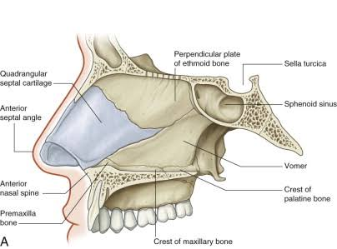
Wall of the nose(lateral aspect)

