Name: Etuk Esther Emmanuel
Matric no.: 17/mhs01/124
Department: Medicine and Surgery
Assignment Title: Nose and Oral cavity
Course Title: Gross Anatomy of Head and Neck
Course Code: ANA 301

Question
1) Discuss the Anatomy of the tongue and comment on its applied anatomy
2) Write an essay on the air sinuses.
Answers
1) Discuss the Anatomy of the tongue and comment on its applied anatomy
THE TONGUE
The tongue is a mobile muscular organ that has some part in the oral cavity and the remaining in the oropharynx. It is kept moist by the products of the major and minor salivary glands, which aids the organ as it facilitates deglutition, speech, and gustatory perception. tongue also serves as a natural means of cleaning the teeth.
The tongue has 3 surfaces: tip, body, and base. The tip or apex of the tongue is the most anterior and most mobile aspect of the organ. The tip is followed by the body of the tongue. It has a rough dorsal (superior) surface that abuts the palate and is populated with taste buds and lingual papillae, and a smooth ventral (inferior) surface that is attached to the floor of the oral cavity by the lingual frenulum. The base of the tongue is the most posterior part of the organ. It is populated by numerous lymphoid aggregates known as the lingual tonsils along with foliate papillae along the posterolateral surface.
The surface of the body of the tongue derives its characteristic appearance from the presence of lingual papillae, which are projections of lamina propria covered with epithelium. The 4 types of lingual papillae are as follows: vallate (circumvallate), foliate, filiform, and fungiform.
1). Vallate papillae are arranged in a V-shape anterior to the sulcus terminalis and studded with numerous taste buds. Innervation is by the glossopharyngeal nerve (CN IX).
2). Fungiform papillae are mushroom-shaped papillae with erythematous domes, located on the lateral aspects and at the apex of the tongue.
3). Filiform papillae are slim, cone-shaped projections organized in rows parallel to the sulcus terminalis.
4). The foliate papillae are small folds of mucosa located along the lateral surface of the tongue. Foliate papillae are rarely found in humans (vestigial).
Note; Each vallate, foliate, filiform and fungiform papilla contains taste buds. All taste buds can perceive the different taste qualities: salt, sweet, bitter and sour. ‘Sweet’ is tasted at the apex, ‘salt’ at the anterolateral part of the tongue, ‘sour’ at the posterolateral part of the tongue and ‘bitter’ at the posterior part of the tongue.
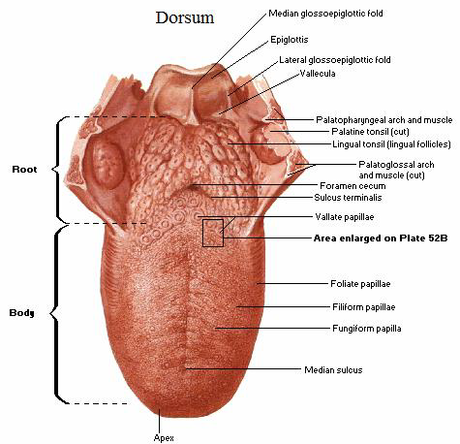
The Tongue

Muscles
There are muscles that extend outside of the organ to anchor it to surrounding bony structures, known as extrinsic muscles. The other set of muscles are confined to each half of the organ and contribute to altering the shape of the organ; these are the intrinsic muscles.
The intrinsic muscles include the following:
a). The superior longitudinal lingual muscle
Origin - submucosa of posterior tongue, lingual septum
Insertion - apex/anterolateral margins of tongue
Innervation - hypoglossal nerve (CN XII)
Blood supply - lingual branch of external carotid artery
Action - retracts and broadens tongue, elevates apex of tongue
b).The inferior longitudinal lingual muscle
Origin - root of tongue, body of hyoid bone
Insertion - apex of tongue
Innervation - hypoglossal nerve (CN XII)
Blood supply - lingual branch of external carotid artery
Action - retracts and broadens tongue, lowers apex of tongue
c).The transverse lingual muscle
Origin - lingual septum
Insertion - lateral margin of tongue
Innervation - hypoglossal nerve (CN XII)
Blood supply - lingual branch of external carotid artery
Action - narrows and elongates tongue

d). The vertical lingual muscle
Origin - root of tongue, genioglossus muscle
Insertion - lingual aponeurosis
Innervation - hypoglossal nerve (CN XII)
Blood supply - lingual branch of external carotid artery
Action - broadens and elongates tongue
The extrinsic muscles include the following:
a).The genioglossus muscle
Origin - Superior mental spine of mandible
Insertion - entire length of dorsum of tongue, lingual aponeurosis, body of hyoid bone
Innervation - hypoglossal nerve (CN XII)
Blood supply - sublingual branch of lingual artery, submental branch of facial artery
Action - depresses and protrudes tongue (bilateral contraction); deviates tongue contralaterally (unilateral contraction)
b). The styloglossus muscle
Origin - anterolateral aspect of styloid process (of temporal bone), stylomandibular ligament
Insertion - blends with inferior longitudinal muscle (longitudinal part); blends with hyoglossus muscle (oblique part)
Innervation - hypoglossal nerve (CN XII)
Blood supply - sublingual branch of lingual artery
Action - retracts and elevates lateral aspects of tongue
c). The hyoglossus muscle
Origin - body and greater horn of hyoid bone
Insertion - inferior/ventral parts of lateral tongue
Innervation - hypoglossal nerve (CN XII)
Blood supply - sublingual branch of lingual artery, submental branch of facial artery
Action - depresses and retracts tongue
d). The palatoglossus muscle
Origin - palatine aponeurosis of soft palate
Insertion - lateral margins of tongue, blends with intrinsic muscles of tongue
Innervation - vagus nerve (CN X) (via branches of pharyngeal plexus)
Blood supply - ascending palatine branch of facial artery, ascending pharyngeal artery
Action - elevates root of tongue, constricts isthmus of fauces
Vasculature
Similar to most of the head and neck region, the tongue derives its arterial blood supply from the external carotid artery. The lingual artery branches off the external carotid artery deep to the stylohyoid muscle. At first, it travels superomedially; after a short distance, it changes direction and moves anteroinferiorly. The hypoglossal nerve (cranial nerve XII) crosses over it laterally before it enters the tongue deep in the hyoglossus muscle. Within the tongue, the lingual artery gives rise to its 3 main branches: the dorsal lingual, deep lingual, and sublingual arteries. The dorsal lingual artery supplies the base of the tongue. The deep lingual artery travels on the lower surface of the tongue to the tip. A branch to the sublingual gland and the floor of the mouth is known as the sublingual artery. The veins of the tongue parallel the lingual artery branches. The deep lingual vein begins at the tip of the tongue and travels posteriorly to join the sublingual vein. This drains into the dorsal lingual vein, which accompanies the lingual artery. Directly or indirectly, this vein empties into the internal jugular vein.
Nerve supply
Motor innervation for all of the muscles of the tongue comes from the hypoglossal nerve--with the exception of the palatoglossus, which is supplied by the pharyngeal plexus (fibers from the cranial root of the spinal accessory nerve carried by the vagus nerve). General sensation of the anterior two thirds of the tongue is supplied by the lingual nerve, a terminal branch of the third division of the trigeminal nerve (V3). Taste sensation for this portion of the tongue is carried by the chorda tympani branch of the facial nerve. The posterior third of the tongue relays general and sensation via the lingual-tonsillar branch of the glossopharyngeal nerve. Some general and taste sensation from the base of tongue anterior to the epiglottis is carried by the internal laryngeal branch of the superior laryngeal nerve (CN X).
Lymphatic drainage
The lymphatic drainage of the tongue is complex. Lymphatics from the tip of the tongue travel to the submental lymph nodes. This can be ipsilateral or bilateral depending on the site of the lesion. Lymph from the medial anterior two thirds of the tongue travels to the deep cervical lymph nodes, and lymph from the lateral anterior tongue goes to the submandibular nodes. The tongue-base lymphatics drain bilaterally into the deep cervical lymph nodes.
Applied Anatomy
1). Thrush (candidiasis): Candida albicans (a yeast) grows over the surface of the mouth and tongue. Thrush can occur in almost anyone, but it occurs more often in people taking steroids or with suppressed immune systems, the very young, and the elderly.
2). Oral cancer: A growth or ulcer appears on the tongue and grows steadily. Oral cancer is more common in people who smoke and/or drink alcohol heavily.
3). Macroglossia (big tongue): This can be broken down into various categories based on the cause. These include congenital, inflammatory, traumatic, cancerous, and metabolic causes. Thyroid disease, lymphangiomas, and congenital abnormalities are among some of the causes of an enlarged tongue.
4). Geographic tongue: Ridges and colored spots migrate over the surface of the tongue, periodically changing its appearance. Geographic tongue is a harmless condition.
5). Burning mouth/burning tongue syndrome: a relatively common problem. The tongue feels burned or scalded, or strange tastes or sensations develop. Apparently harmless, burning mouth syndrome may be caused by a mild nerve problem.
6). Atrophic glossitis (bald tongue): The tongue loses its bumpy texture, becoming smooth. Sometimes this is due to anemia or a B vitamin deficiency.
7). Canker sores (aphthous ulcers): Small, painful ulcers appear periodically on the tongue or mouth. A relatively common condition, the cause of canker sores is unknown; they are unrelated to the cold sores caused by herpes viruses. Canker sores are not contagious.
8). Oral leukoplakia: White patches appear on the tongue that can’t be scraped off. Leukoplakia may be benign, or it can progress to oral cancer.
9). Hairy tongue: Papillae can overgrow the surface of the tongue, giving it a white or black appearance. Scraping off the papillae corrects this harmless condition.
10). Herpes stomatitis: The herpes virus can uncommonly cause cold sores on the tongue. Herpes virus cold sores are usually on the lip.
Tongue Treatments
Steroid gel: Applying a prescription steroid gel like Lidex hastens the resolution of canker sores.
Silver nitrate: Doctors can apply this chemical to a canker sore, speeding healing and relieving pain.
Viscous lidocaine: Applied to the tongue, lidocaine gel provides immediate, though temporary, pain relief.
Antifungal medicines: Antifungal drugs can eliminate Candida albicans, the thrush-causing fungus. Swish-and-spit mouthwash and pills are both effective.
Tongue scraping: Simply scraping the tongue can usually remove the overgrown papillae causing black or white hairy tongue.
B vitamins: B vitamin supplement can correct a vitamin deficiency, if present.
Tongue surgery: Surgery may be required to remove oral cancer or leukoplakia.

2) Write an essay on the air sinuses.
AIR SINUSES
The air sinuses (also known as paranasal sinuses) are air-filled spaces located within the bones of the skull and facial bones. They are centered on the nasal cavity and have various functions such as decreasing the relative weight of the skull, increasing the resonance of the voice, providing a buffer against facial trauma, insulating sensitive structures from rapid temperature fluctuations in the nose, humidifying and heating inspired air and immunological defense. They are all paired and sometimes symmetrical, while always being bilateral. There are four different pairs of air sinuses, namely; maxillary sinuses, frontal sinuses, sphenoidal sinuses and ethmoidal sinuses.
Maxillary sinuses are pyramidal-shaped sinuses occupying the cavity of the maxilla. They are the largest of the all the air sinuses. They have thin walls which are often penetrated by the long roots of the posterior maxillary teeth. Superior wall of maxillary sinuses is made up of the bony orbit, inferior wall of maxillary sinuses is made up of the alveolar bone of the maxilla, medial wall is made up of the nasal cavity, lateral and anterior walls of maxillary sinuses are made up of the cheekbones and posterior wall of maxillary sinuses is made up of the pterygopalatine fossa and infratemporal fossa. It drains into the nasal cavity at the hiatus semilunaris, underneath the frontal sinus opening. This is a potential pathway for spread of infection, fluid draining from the frontal sinus can enter the maxillary sinus. The submandibular lymph nodes are the main destination during lymphatic drainage. The blood supply includes a contribution from the: anterior superior alveolar artery, middle superior artery and posterior superior alveolar artery which are branches of the maxillary artery. Innervations of maxillary sinuses are by anterior superior alveolar nerve, middle superior nerve and posterior superior nerve which are branches of the maxillary nerve.
Frontal sinuses are the most superior in location, found under the forehead. Anteriorly, the frontal sinuses are contained by the forehead and the superciliary arches, superiorly and posteriorly by the anterior cranial fossa and inferiorly by the bony orbit, the anterior ethmoidal sinuses and the nasal cavity. Medially the sinuses face one another, separated by the midline. The frontal sinuses are variable in size, but always triangular-shaped. They drain into the nasal cavity via the frontonasal duct, which opens out at the hiatus semilunaris on the lateral wall. The frontal sinus vasculature consists of the supraorbital and supratrochlear arteries and ophthalmic and supraorbital veins. Similarly, its innervation is provided by the supraorbital and supratrochlear nerves (CNV1). They drain primarily into the ethmoidal infundibulum and the corresponding lymph drainage occurs via the submandibular lymph nodes.
The sphenoid sinuses are located centrally and posteriorly within the sphenoid bone. The anterior wall separates this pair of sinuses from the nasal cavity, as does the hypophyseal fossa, the pituitary gland and the optic chiasm superiorly and the nasopharynx and pterygoid canal inferiorly. The relationships of this sinus are of clinical importance – the pituitary gland can be surgically accessed via passing through the nasal roof, into the sphenoid sinus and through the sphenoid bone. They drain into the sphenoethmoidal recess located within the superior meatus. The sphenopalatine artery supplies the sinus, and venous drainage is via the maxillary vein. Innervation is provided by the sphenopalatine nerve, which is comprised of parasympathetic fibers and CN V2.
Ethmoidal sinuses are located between the eyes. There are three ethmoidal sinuses; anterior ethmoidal sinuses, middle ethmoidal sinuses and posterior ethmoidal sinuses. The anterior ethmoidal sinuses drain into the ethmoid infundibulum, in the middle meatus. The posterior ethmoidal sinuses drain into the sphenoethmoidal recess located in the superior meatus. The ethmoidal sinuses are supplied by the anterior and posterior ethmoidal arteries, respectively. These arteries are branches of the ophthalmic artery, which is a branch off of the internal carotid artery. The anterior and middle ethmoidal sinuses send their lymphatic drainage to the submandibular lymph nodes while the posterior ethmoidal sinus sends its own to the retropharyngeal lymph nodes. Meanwhile the anterior and posterior ethmoidal nerves and the posterior lateral superior and inferior nasal nerves help innervate it.
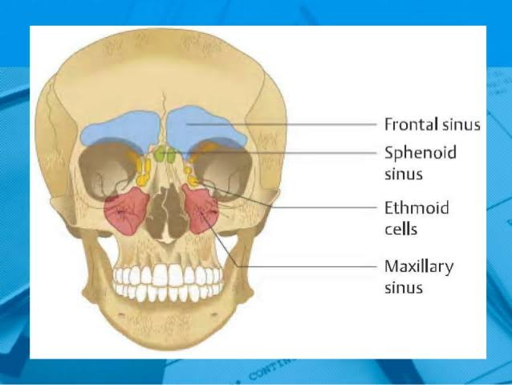
Air sinuses
Paranasal sinuses are prone to inflammation and infection. If the paranasal sinuses become blocked from secretions or a mass, the drainage of mucus is interrupted, and sinusitis can result. If more than one sinus is affected, it is called pansinusitis. The maxillary nerve supplies both the maxillary sinus and maxillary teeth, and so inflammation of that sinus can present with toothache. . The frontal and maxillary sinuses may be involved in allergies. Depending on the cause, sinusitis is treated with corticosteroids, decongestant, nasal irrigation, and hydration. Rarely surgical intervention may be required to enhance drainage.
Malignancies of the paranasal sinuses are rare. The majority of cancers occur in the maxillary sinus and are more common in men than women. Maxillary sinus malignancies occur between ages 45 to 70, and the most frequent is a sarcoma. Even though metastases are rare, these malignancies are locally invasive and destructive. Diagnosis in most cases is delayed, and the prognosis is poor.

