NAME: EMMAN-UGHEOKE ESIRO GENEVIEVE.
MATRIC NO: 17/MHS01/115

- DISCUSS THE GROSS ANATOMY OF THE TONGUE AND COMMENT ON ITS APPLIED ANATOMY
- WRITE AN ESSAY ON AIR SINUSES

- GROSS ANATOMY OF THE TONGUE.
The tongue is a mobile muscular organ covered with mucous membrane. It is partly in the oral cavity and oropharnyx. Its main functions are articulation and squeezing food into the oropharnyx as part of deglutition. The tongue is also involved in mastication, taste and oral cleansing.
- PARTS AND SURFACES.
The tongue has a root, body and apex.
The root of the tongue is the attached posterior portion, extending between the mandible, hyoid, and the nearly vertical posterior surface of the tongue.
The body of the tongue is between the root and apex.
The apex (tip) of the tongue is the anterior end of the body which rests against the incisor teeth.
The tongue has two surfaces:
- The dorsum of the tongue which is the more extensive superior and posterior surface.
- The inferior surface which usually rests against the floor of the mouth.

- MUSCLES OF THE TONGUE.
The tongue is essentially a mass of muscles that is mostly covered by mucosa. There are four intrinsic and four extrinsic muscles in each half of the tongue which are separated by a median fibrous lingual septum that merges posteriorly to with the lingual aponeurosis.
- Extrinsic muscles of the tongue: they include genioglossus, hyoglossus, styloglossus, and palatoglossus. They originate outside the tongue and attach to it. They mainly move the tongue and they can alter the shape too.
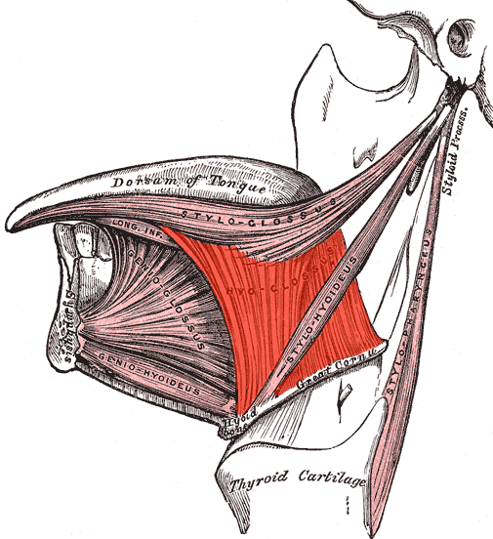

- Intrinsic muscles of the tongue: The superior and inferior longitudinal, transverse, vertical muscles are confined to the tongue. They have their attachment entirely within the tongue and are not attached to bone. The superior and inferior longitudinal muscles acts together to make the tongue short and thick and to retract the protruded tongue.
The transverse and vertical muscles act simultaneously to make the tongue long and narrow, which may protrude the tongue from the open mouth.
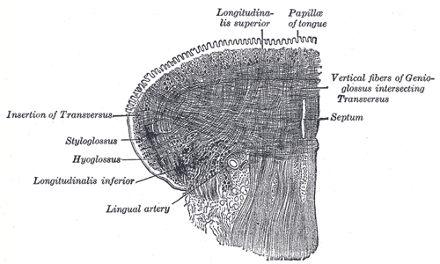

- INNERVATION.
All muscles of the tongue, except the palatoglossus receives motor innervations from the hypoglossal nerve.
The palatoglossus muscle is supplied by the pharyngeal plexus.
For general sensation, the mucosa of the anterior two thirds of the tongue is supplied by the lingual nerve.
For special sensation, this part of the tongue, except for the vallate papillae, is supplied by the chorda tympani nerve, a branch of CN VII.
The mucosa of the posterior third of the tongue and vallate papillae are supplied by the lingual branch of the glossopharyngeal nerve (CN IX) for both general and special sensation.

- VASCULATURE.
Blood supply to the tongue is from the lingual arteries. The dorsal lingual arteries supply the root of the tongue; the deep lingual arteries supply the body of the tongue.
Venous drainage: venous drainage are the dorsal lingual vein and deep lingual vein.

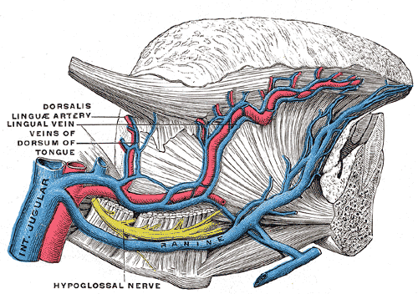

- LYMPHATIC DRAINAGE.
Most of the lymphatic drainage of the tongue converge toward and follows the venous drainage except from the tip of the tongue, frenulum and central lower lip which runs an independent course. Lymph from different areas of the tongue drains via four routes:
- Lymph from the root of the tongue drains bilaterally into the superior deep cervical lymph nodes.
- Lymph from the medial part of the body drains bilaterally and directly to the inferior deep cervical lymph nodes.
- Lymph from the right and lateral parts of body drains to the submandibular lymph nodes on the ipsilateral side.
- The apex and frenulum drain to the submental lymph nodes, the medial portion draining bilaterally.
All lymph from the tongue ultimately drains to the deep cervical nodes and passes via the jugular venous trunks into the venous system at the right and left venous angles.

APPLIED ANATOMY.
- PARALYSIS OF GENIOGLOSSUS.
When the genioglossus muscle is paralyzed, the tongue has a tendency to fall posteriorly, obstructing the airway and presenting the risk of suffocation.
- INJURY TO THE HYPOGLOSSAL NERVE.
Trauma, such as fractured mandible, may injure the hypoglossal nerve, resulting in paralysis and eventual atrophy of one side of the tongue.
- LINGUAL FRENECTOMY.
Frenulum that extends further toward the apex of the tongue interferes with the tongue movement and may affect speech. In unusual cases, a frenectomy in infants may be necessary to free the tongue for normal movements and speech.

- WRITE AN ESSAY ON AIR SINUSES.
The paranasal sinuses are air-filled extensions of the respiratory part of the nasal cavity. There are four paired sinuses, named according to the bone in which they are located; maxillary, frontal, sphenoid and ethmoid. They reduce the weight of the skull. Sinuses are formed in childhood by the nasal cavity eroding into surrounding bone. Since they are outgrowth of the nasal cavity they all drain back into it- openings to the paranasal sinuses are found on the roof and lateral walls of the nasal cavity.
- Frontal sinuses: these are the most superior in location, found under the forehead. They drain into the nasal cavity via the frontonasal duct, which opens out at the hiatus semilunaris on the lateral wall.
- Sphenoid sinuses: the sphenoid sinuses also lie relatively superiorly, at the level of the spheno-ethmoidal recess. They are found more posteriorly, and are related superiorly and laterally to the cranial cavity. The sphenoid sinuses drain out onto the roof of the nasal cavity. The relationship of this sinus is of clinical importance- the pituitary gland can be surgically accessed via passing through the nasal roof, into the sphenoid sinus and through the sphenoid bone.
- Ethmoidal sinuses: there are three ethmoidal sinuses, anterior, middle and posterior. They empty into the nasal cavity at different places:
Anterior – Hiatus semilunaris
Middle – Ethmoid bulla
Posterior – Superior meatus.
- Maxillary sinuses: the largest of the sinuses. It is located laterally and slightly inferiorly to the nasal cavities. It drains into the nasal cavity at the hiatus semilunaris, underneath the frontal sinus opening. This is a potential pathway for spread of infection- fluid draining from the frontal sinus can enter the maxillary sinus. Maxillary nerve supplies booth the maxillary sinus and maxillary teeth, and so inflammation of that sinus can present with toothache.
- 