NAME: EMMAN-UGHEOKE ESIRO GENEVIEVE.
MATRIC NO: 17/MHS01/ 115

- WRITE AN ESSAY ON THE CAVERNOUS SINUS
- DISCUSS THE WALLS OF THE NOSE

- CAVERNOUS SINUS
It is one of the dural venosus sinuses of the head. It is located at the middle cranial fossa on each side of the sella turcica on the upper surface of the body of the sphenoid. It is made up of a lot of venous plexuses. The sinus receives blood from the superior and inferior ophthalmic veins, superficial middle cerebral vein, inferior cerebral veins and sphenoparietal sinus. The venous channels in these sinuses communicate with each other through intercavernous sinuses.
Blood leaves the sinus via superior and inferior petrosal sinuses as well as via the emissary veins through the foramina of the skull. There are also connections with the pterygoid plexus of veins via inferior ophthalmic vein, deep facial vein and emissary veins.

- CONTENTS.
Some structures passes through it and some passes in between the sinus.
Structures passing in between the cavernous sinus includes:
. Abducens nerve
. Internal carotid artery accompanied by the internal carotid plexus.
Structures passing through within its lateral wall includes:
. Occuomotor nerve
. Trochlear nerve
. Ophthalmic and maxillary branches of the trigeminal nerve.

- Clinical significance.
It allows for the cooling of blood before reaching the brain. The internal carotid artery carrying warm blood from the body’s core, traverses the cavernous sinus filled with cooler blood, which allows for heat exchange to conserve or cool the arterial blood.

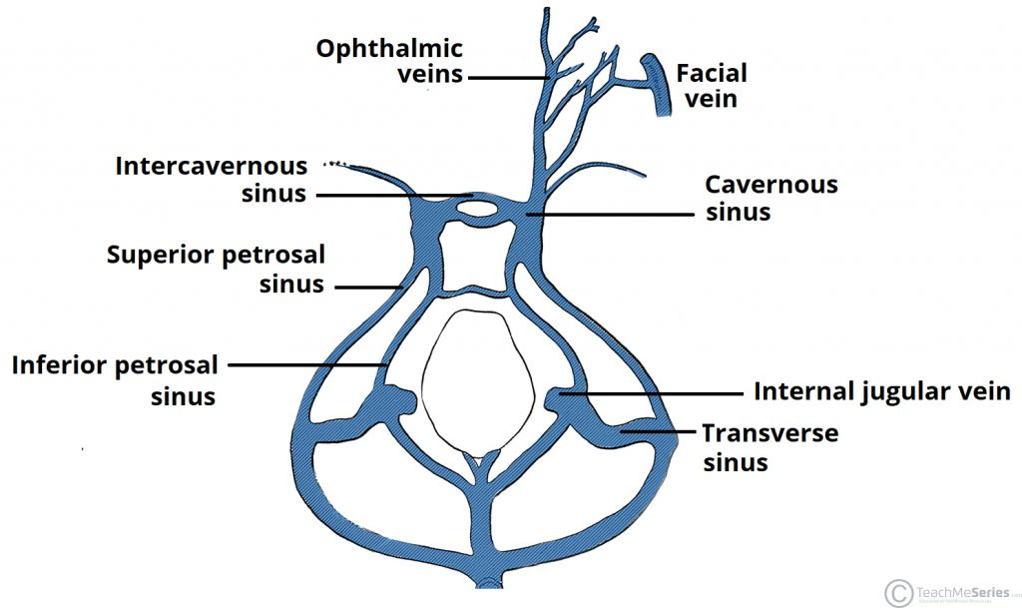

- THE WALLS OF THE NOSE.
The nose has two walls: lateral and middle walls.
Medial wall: it is formed by the nasal septum.
Lateral walls: it is irregular owing to three bony plates, the nasal conchae, which project inferiorly, somewhat like louvers.
Nasal conchae: The conchae is located laterally in the nasal cavities, curling medially and downward into the nasal airway. Each pair is composed of one concha in either side of the nasal cavity, divided by the septum.
The superior conchae is a small structure, connected to the middle conchae by nerve-endings, and serve to protect the olfactory bulb.
The middle conchae is smaller. They project downwards over the openings of the maxillary and anterior and middle ethmoid sinuses, and act as buffers to protect the sinuses from coming in direct contact with pressurized nasal airflow. Most inhaled airflow travels between the inferior concha and the middle meatus.
The inferior conchae is the largest, it is responsible for the majority of airflow direction, humidification, heating, and filtering of air inhaled through the nose.

