NAME: Achigbule Prince M.s
MATRIC NO: 17/SCI01/03
COURSE CODE: CSC 302
ASSIGNMENT
1. 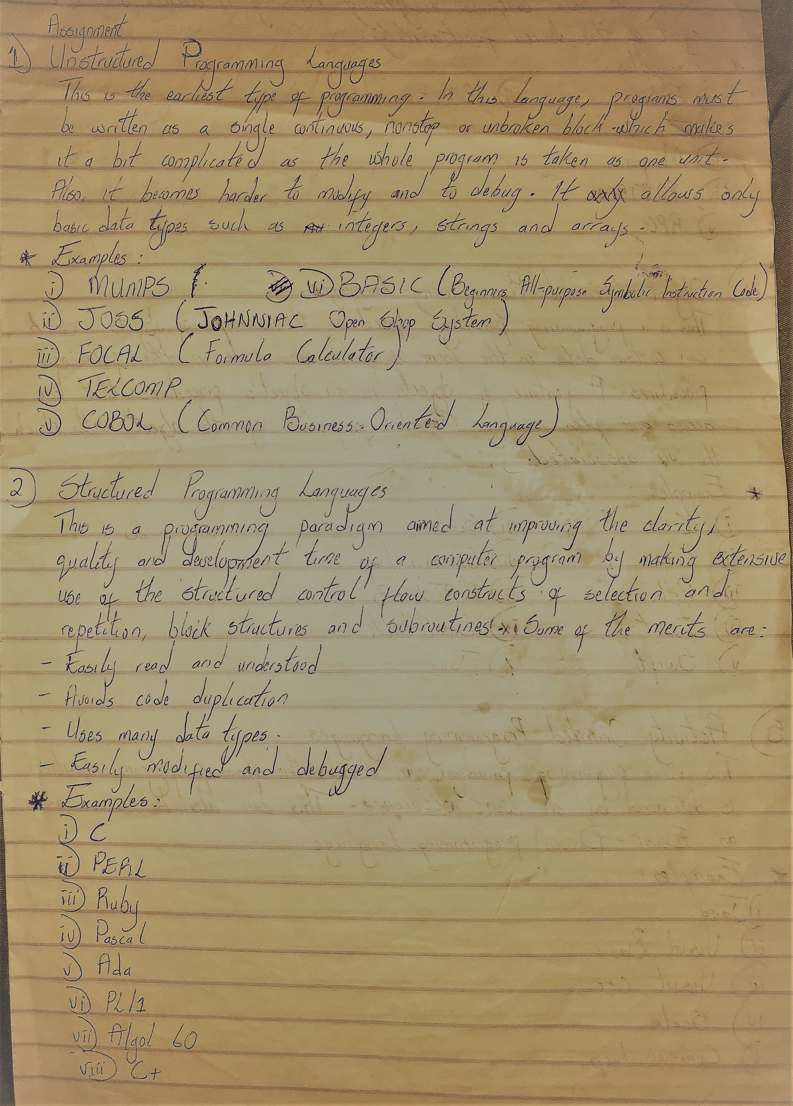
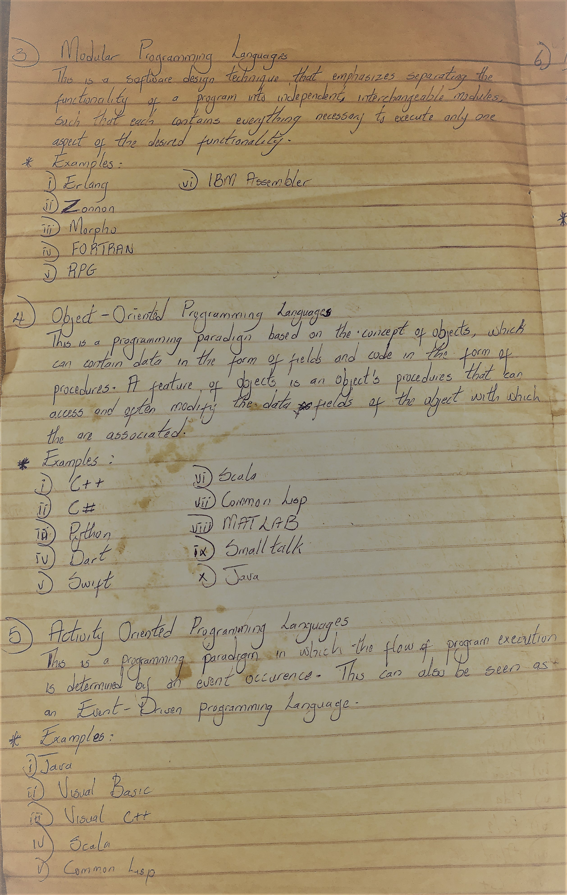
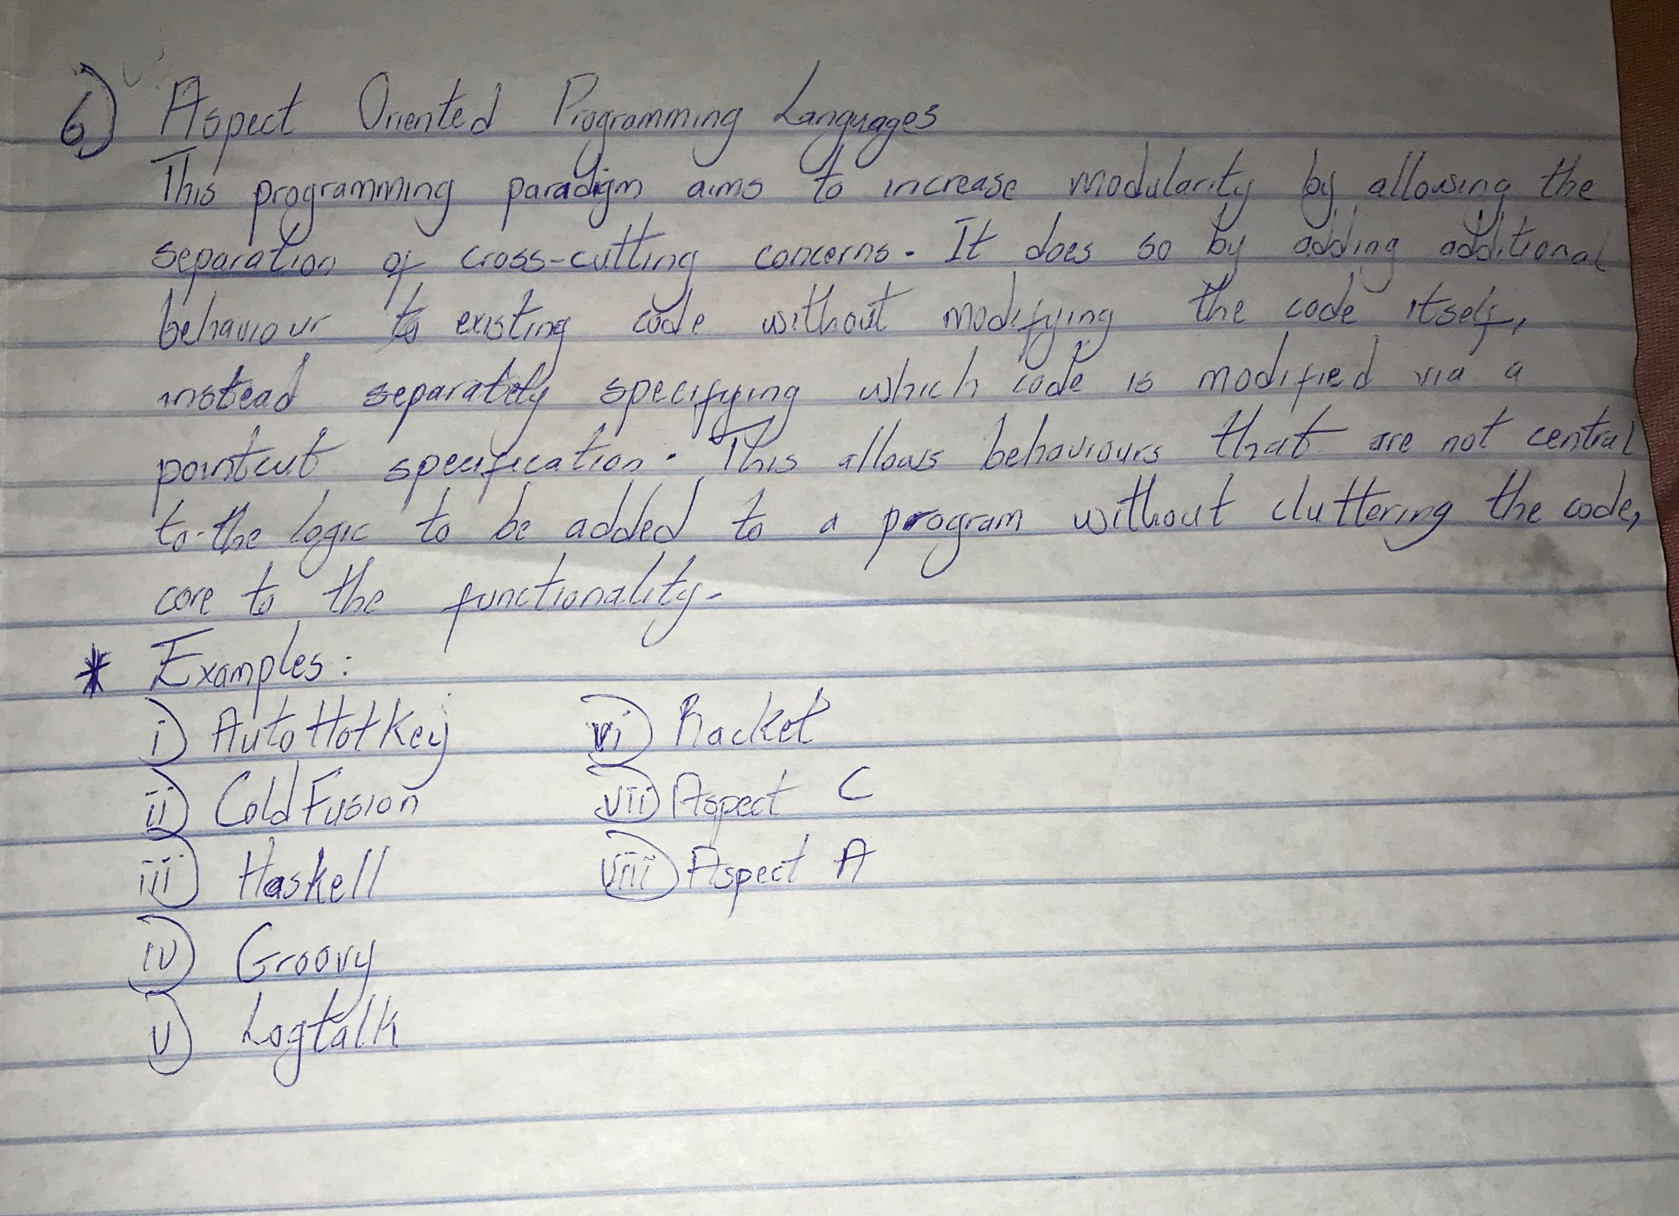
2. Below you’ll find a chronological order of programming languages.
Year | Name | Chief developer, company | Predecessor(s)
1804 | Jacquard Loom | Joseph Marie Jacquard | none (unique language)
1943–45 | Plankalkül (concept) | Konrad Zuse | none (unique language)
1943–46 | ENIAC coding system | John von Neumann, John Mauchly, J. Presper Eckert, Herman Goldstine after Alan Turing. The first programmers of ENIAC were Kay McNulty, Betty Jennings, Betty Snyder, Marlyn Meltzer, Fran Bilas, and Ruth Lichterman. | none (unique language)
1946 | ENIAC Short Code | Richard Clippinger, John von Neumann after Alan Turing | ENIAC coding system
1946 | Von Neumann and Goldstine graphing system (Notation) | John von Neumann and Herman Goldstine | ENIAC coding system
1947 | ARC Assembly | Kathleen Booth^{[1][2]} | ENIAC coding system
1948 | CPC Coding scheme | Howard H. Aiken | Analytical Engine order code
1948 | Curry notation system | Haskell Curry | ENIAC coding system
1948 | Plankalkül (concept published) | Konrad Zuse | none (unique language)
1949 | EDSAC Initial Orders | David Wheeler | ENIAC coding system
1949 | Short Code | John Mauchly and William F. Schmitt | ENIAC Short Code
1950 | Short Code | William F. Schmidt, Albert B. Tonik,[3] J. R. Logan | Brief Code
1950 | Birkbeck Assembler | Kathleen Booth | ARC
1951 | Superplan | Heinz Rutishauser | Plankalkül
1951 | ALGAE | Edward A. Voorhees and Karl Balke | none (unique language)
1951 | Intermediate Programming Language | Arthur Burks | Short Code
1951 | Regional Assembly Language | Maurice Wilkes | EDSAC
1951 | Boehm unnamed coding system | Corrado Böhm | CPC Coding scheme
1951 | Klammerausdrücke | Konrad Zuse | Plankalkül
1951 | OMNIBAC Symbolic Assembler | Charles Katz | Short Code
1951 | Stanislaus (Notation) | Fritz Bauer | none (unique language)
1951 | Whirlwind assembler | Charles Adams and Jack Gilmore at MIT Project Whirlwind | EDSAC
1951 | Rochester assembler | Nat Rochester | EDSAC
1951 | Sort Merge Generator | Betty Holberton | none (unique language)
1952 | A-0 | Grace Hopper | Short Code
1952 | Glennie Autocode | Alick Glennie after Alan Turing | CPC Coding scheme
1952 | Editing Generator | Milly Koss | SORT/MERGE
1952 | COMPOOL | RAND/SDC | none (unique language)
1953 | Speedcoding | John W. Backus | none (unique language)
1953 | READ/PRINT | Don Harroff, James Fishman, George Ryckman | none (unique language)
1954 | Laning and Zierler system | Laning, Zierler, Adams at MIT Project Whirlwind | none (unique language)
1954 | Mark I Autocode | Tony Brooker | Glennie Autocode
1954–55 | FORTRAN (concept) | Team led by John W. Backus at IBM | Speedcoding
1954 | ARITH-MATIC | Team led by Grace Hopper at UNIVAC | A-0
1954 | MATH-MATIC | Team led by Charles Katz | A-0
1954 | MATRIX MATH | H G Kahrimanian | none (unique language)
1954 | IPL I (concept) | Allen Newell, Cliff Shaw, Herbert A. Simon | none (unique language)
1955 | FLOW-MATIC | Team led by Grace Hopper at UNIVAC | A-0
1955 | BACAIC | M. Grems and R. Porter
1955 | PACT I | SHARE | FORTRAN, A-2
1955 | Freiburger Code[4][5] | University of Freiburg | N/A
1955–56 | Sequentielle Formelübersetzung | Fritz Bauer and Karl Samelson | Boehm
1955–56 | IT | Team led by Alan Perlis | Laning and Zierler
1955 | PRINT | IBM
1958 | IPL II (implementation) | Allen Newell, Cliff Shaw, Herbert A. Simon | IPL I
1956–58 | LISP (concept) | John McCarthy | IPL
1957 | COMTRAN | Bob Bemer | FLOW-MATIC
1957 | GEORGE | Charles Leonard Hamblin | none (unique language)
1957 | FORTRAN I (implementation) | John W. Backus at IBM | FORTRAN
1957–58 | UNICODE | Remington Rand UNIVAC | MATH-MATIC
1957 | COMIT (concept) | Victor Yngve | none (unique language)
1958 | FORTRAN II | Team led by John W. Backus at IBM | FORTRAN I
1958 | ALGOL 58 (IAL) | ACM/GAMM | FORTRAN, IT, Sequentielle Formelübersetzung
1958 | IPL V | Allen Newell, Cliff Shaw, Herbert A. Simon | IPL II
1959 | APT | Douglas T. Ross
1959 | FACT | Fletcher R. Jones, Roy Nutt, Robert L. Patrick | none (unique language)
1959 | COBOL (concept) | The CODASYL Committee | FLOW-MATIC, COMTRAN, FACT
1959 | JOVIAL | Jules Schwartz at SDC | ALGOL 58
1959 | LISP (implementation) | John McCarthy | IPL
1959 | MAD – Michigan Algorithm Decoder | Bruce Arden, Bernard Galler, and Robert M. Graham | ALGOL 58
1959 | TRAC (concept) | Calvin Mooers
1960 | ALGOL 60 |  | ALGOL 58
1960 | COBOL 61 (implementation) | The CODASYL Committee | FLOW-MATIC, COMTRAN
1961 | COMIT (implementation) | Victor Yngve | none (unique language)
1962 | FORTRAN IV | IBM | FORTRAN II
1962 | APL (concept) | Kenneth E. Iverson | none (unique language)
1962 | Simula (concept) |  | ALGOL 60
1962 | SNOBOL | Ralph Griswold, et al. | FORTRAN II, COMIT
1963 | CPL | Barron, Christopher Strachey, et al. | ALGOL 60
1963 | SNOBOL3 | Griswold, et al. | SNOBOL
1963 | ALGOL 68 (concept) | Adriaan van Wijngaarden, et al. | ALGOL 60
1963 | JOSS I | Cliff Shaw, RAND | ALGOL 58
1964 | MIMIC | H. E. Petersen, et al. | MIDAS
1964 | COWSEL | Rod Burstall, Robin Popplestone | CPL, LISP
1964 | PL/I (concept) | IBM | ALGOL 60, COBOL, FORTRAN
1964 | BASIC | John George Kemeny and Thomas Eugene Kurtz at Dartmouth College | FORTRAN II, JOSS
1964 | IBM RPG | IBM | FARGO
1964 | Mark-IV | Informatics
1964 | Speakeasy-2 | Stanley Cohen at Argonne National Laboratory | Speakeasy
1964 | TRAC (implementation) | Calvin Mooers
1964 | P′′ | Corrado Böhm | none (unique language)
1964? | IITRAN
1965 | RPG II | IBM | FARGO, RPG
1965 | MAD/I (concept) | University of Michigan | MAD, ALGOL 60, PL/I
1965 | TELCOMP | BBN | JOSS
1965 | Atlas Autocode | Tony Brooker, Derrick Morris at Manchester University | Algol 60, Autocode
1966 | JOSS II | Chuck Baker, RAND | JOSS I
1966 | ALGOL W | Niklaus Wirth, C. A. R. Hoare | ALGOL 60
1966 | FORTRAN 66 |  | FORTRAN IV
1966 | ISWIM (Concept) | Peter J. Landin | LISP
1966 | CORAL66 |  | ALGOL 60
1966 | APL (implementation)[6] | Kenneth E. Iverson | none (unique language)
1967 | BCPL | Martin Richards | CPL
1967 | MUMPS | Massachusetts General Hospital | FORTRAN, TELCOMP
1967 | Simula 67 (implementation) | Ole-Johan Dahl, Bjørn Myhrhaug, Kristen Nygaard at Norsk Regnesentral | ALGOL 60
1967 | InterLisp | D.G. Bobrow and D.L. Murphy | Lisp
1967 | EXAPT | Herwart Opitz, Wilhelm Simon, Günter Spur, and Gottfried Stute at RWTH Aachen University and TU Berlin | APT
1967 | SNOBOL4 | Ralph Griswold, et al. | SNOBOL3
1967 | XPL | William M. McKeeman, et al. at University of California, Santa Cruz  J. J. Horning, et al. at Stanford University | PL/I
1967 | Space Programming Language (SPL) | System Development Corporation | JOVIAL
1968 | ALGOL 68 (UNESCO/IFIP standard) | Adriaan van Wijngaarden, Barry J. Mailloux, John E. L. Peck and Cornelis H. A. Koster, et al. | ALGOL 60
1968 | POP-1 | Rod Burstall, Robin Popplestone | COWSEL
1968 | DIBOL-8 | DEC | DIBOL
1968 | Forth (concept) | Moore
1968 | LOGO | Wally Feurzeig, Seymour Papert, Cynthia Solomon | LISP
1968 | MAPPER | Unisys | CRT RPS
1968 | REFAL (implementation) | Valentin Turchin | none (unique language)
1968 | TTM (implementation) | Steven Caine and E. Kent Gordon, California Institute of Technology | GAP, GPM
1968 | PILOT | John Amsden Starkweather, University of California, San Francisco | Computest
1969 | PL/I (implementation) | IBM | ALGOL 60, COBOL, FORTRAN
1969 | B | Ken Thompson, with contributions from Dennis Ritchie | BCPL
1969 | Polymorphic Programming Language (PPL) | Thomas A. Standish at Harvard University
1969 | SETL | Jack Schwartz at Courant Institute of Mathematical Sciences | ALGOL 60
1969 | TUTOR | Paul Tenczar & University of Illinois at Urbana–Champaign
1969 | Edinburgh IMP | Edinburgh University | Algol 60, Autocode, Atlas Autocode
1970 | Forth (implementation) | Charles H. Moore
1970 | POP-2 | Robin Popplestone | POP-1
1970 | SAIL | Dan Swinehart and Bob Sproull | ALGOL-60
1970 | Pascal | Niklaus Wirth, Kathleen Jensen | ALGOL 60, ALGOL W
1970 | BLISS | Wulf, Russell, Habermann at Carnegie Mellon University | ALGOL
1971 | KRL | Daniel G. Bobrow at Xerox PARC, Terry Winograd at Stanford University | KM, FRL (MIT)
1971 | Sue | Ric Holt et al. at University of Toronto | Pascal, XPL
1971 | Compiler Description Language (CDL) | Cornelis H.A. Koster at University of Nijmegen
1972 | Smalltalk-72 | Alan Kay, Adele Goldberg, Dan Ingalls, Xerox PARC | Simula 67
1972 | PL/M | Gary Kildall at Digital Research | PL/I, ALGOL, XPL
1972 | K&R C | Dennis Ritchie | B, BCPL, ALGOL 68
1972 | INTERCAL | Don Woods and James M. Lyon | none (unique language)
1972 | Prolog | Alain Colmerauer | 2-level W-Grammar
1972 | Structured Query language (SQL) | IBM | ALPHA, Quel (Ingres)
1973 | COMAL | Børge Christensen, Benedict Løfstedt | Pascal, BASIC
1973 | ML | Robin Milner
1973 | LIS | Jean Ichbiah et al. at CII Honeywell Bull | Pascal, Sue
1973 | Speakeasy-3 | Stanley Cohen, Steven Pieper at Argonne National Laboratory | Speakeasy-2
1974 | CLU | Barbara Liskov | ALGOL 60, Lisp, Simula
1974 | MAINSAIL | Stanford University | SAIL
1974 | GRASS | Thomas A. DeFanti | BASIC
1974 | BASIC FOUR | MAI BASIC Four Inc. | Business BASIC
1974 | PROSE modeling language | CDC 6600 Cybernet Services | SLANG, FORTRAN
1975 | ABC | Leo Geurts and Lambert Meertens | SETL
1975 | Irvine Dataflow (concept) | Arvind?, University of California, Irvine
1975 | PROSE modeling language Time-Sharing Version | CDC 6400 Cybernet KRONOS Services | SLANG, FORTRAN
1975 | Scheme | Gerald Jay Sussman, Guy L. Steele, Jr. | LISP
1975 | Altair BASIC | Bill Gates, Paul Allen | BASIC
1975 | CS-4 | James S. Miller, Benjamin M. Brosgol et al. at Intermetrics | ALGOL 68, BLISS, ECL, HAL
1975 | Modula | Niklaus Wirth | Pascal
1976 | Plus | Allan Ballard, Paul Whaley at the University of British Columbia | Pascal, Sue
1976 | Smalltalk-76 | Xerox PARC | Smalltalk-72
1976 | Mesa | Xerox PARC | ALGOL
1976 | SAM76 | Claude A.R. Kagan | LISP, TRAC
1976 | Ratfor | Brian Kernighan | C, FORTRAN
1976 | S | John Chambers at Bell Labs | APL, PPL, Scheme
1976 | SAS | SAS Institute
1976 | Integer BASIC | Steve Wozniak | BASIC
1977 | FP | John Backus | none (unique language)
1977 | Bourne Shell (sh) | Stephen R. Bourne | none (unique language)
1977 | Commodore BASIC | Jack Tramiel | BASIC
1977 | IDL | David Stern of Research Systems Inc | Fortran
1977 | Standard MUMPS |  | MUMPS
1977 | Icon (concept) | Ralph Griswold | SNOBOL
1977 | Red | Benjamin M. Brosgol et al. at Intermetrics for US Dept of Defense | ALGOL 68, CS-4
1977 | Blue | John B. Goodenough[7][8] et al. at SofTech for US Dept of Defense | ALGOL 68
1977 | Yellow | Jay Spitzen et al. at SRI International for US Dept of Defense | ALGOL 68
1977 | Euclid | Butler Lampson at Xerox Parc, Ric Holt and James Cordy at University of Toronto
1977 | Applesoft BASIC | Marc McDonald and Ric Weiland | BASIC
1978 | RAPT | Pat Ambler and Robin Popplestone | APT
1978 | C shell | Bill Joy | C
1978 | RPG III | IBM | FARGO, RPG, RPG II
1978 | HAL/S | designed by Intermetrics for NASA | XPL
1978 | Applesoft II BASIC | Marc McDonald and Ric Weiland | Applesoft BASIC
1975 | Irvine Dataflow (implementation) | Arvind and Gostelow, University of California, Irvine
1978? | MATLAB | Cleve Moler at the University of New Mexico | Fortran
1978? | SMALL | Nevil Brownlee at the University of Auckland | Algol60
1978 | VisiCalc | Dan Bricklin, Bob Frankston marketed by VisiCorp | none (unique language)
1979 | Modula-2 | Niklaus Wirth | Modula, Mesa
1979 | REXX | Mike Cowlishaw at IBM | PL/I, BASIC, EXEC 2
1979 | AWK | Alfred Aho, Peter J. Weinberger, Brian Kernighan | C, SNOBOL
1979 | Icon (implementation) | Ralph Griswold | SNOBOL
1979 | Vulcan dBase-II | Wayne Ratliff | none (unique language)
1980 | Ada 80 (MIL-STD-1815) | Jean Ichbiah at CII Honeywell Bull | Green
1980 | C with classes | Bjarne Stroustrup[9] | C, Simula 67
1980 | Applesoft III | Apple Computer | Applesoft II BASIC
1980 | Apple III Microsoft BASIC | Microsoft | Microsoft BASIC
1980–81 | CBASIC | Gordon Eubanks | BASIC, Compiler Systems, Digital Research
1981 | BBC BASIC | Acorn Computers, Sophie Wilson | BASIC
1981 | IBM BASICA | Microsoft | BASIC
1982? | Speakeasy-IV | Stanley Cohen, et al. at Speakeasy Computing Corporation | Speakeasy-3
1982? | Draco | Chris Gray | Pascal, C, ALGOL 68
1982 | PostScript | Warnock | InterPress
1982 | Turing | Ric Holt and James Cordy, at University of Toronto | Euclid
1983 | GW-BASIC | Microsoft | IBM BASICA
1983 | Turbo Pascal | Hejlsberg at Borland | Pascal
1983 | Ada 83 (ANSI/MIL-STD-1815A) | Jean Ichbiah at Alsys | Ada 80, Green
1983 | Objective-C | Brad Cox | Smalltalk, C
1983 | C++ | Bjarne Stroustrup | C with Classes
1983 | True BASIC | John George Kemeny, Thomas Eugene Kurtz at Dartmouth College | BASIC
1983 | occam | David May | EPL
1983? | ABAP | SAP AG | COBOL
1983 | Korn Shell (ksh) | David Korn | sh
1983 | Clascal | Apple Computer Inc. | Pascal
1984 | CLIPPER | Nantucket | dBase
1984 | Common Lisp | Guy L. Steele, Jr. and many others | LISP
1984 | Coq | INRIA
1984 | RPL | Hewlett-Packard | Forth, Lisp
1984 | Standard ML |  | ML
1984 | Redcode | Alexander Dewdney and D.G. Jones
1984 | OPL | Psion | BASIC
1985 | PARADOX | Borland | dBase
1985 | QuickBASIC | Microsoft | BASIC
1986 | Clarion | Bruce Barrington
1986 | CorVision | Cortex | INFORM
1986 | Eiffel | Bertrand Meyer | Simula 67, Ada
1986 | GFA BASIC | Frank Ostrowski | BASIC
1986 | Informix-4GL | Informix
1986 | LabVIEW | National Instruments
1986 | Miranda | David Turner at University of Kent
1986 | Object Pascal | Apple Computer Inc. | Pascal
1986 | PROMAL |  | C
1986 | Erlang | Joe Armstrong and others in Ericsson | Prolog
1987 | Ada ISO 8652:1987 | ANSI/MIL-STD-1815A unchanged | Ada 83
1987 | Self (concept) | Sun Microsystems Inc. | Smalltalk
1987 | occam 2 | David May and INMOS | occam
1987 | HyperTalk | Apple Computer Inc. | none (unique language)
1987 | Perl | Larry Wall | C, sed, awk, sh
1987 | Oberon | Niklaus Wirth | Modula-2
1987 | Mathematica (Wolfram Language) | Wolfram Research | none (unique language)
1987 | Turbo Basic | Robert 'Bob' Zale | BASIC/Z
1987 | Clean | Software Technology Research Group of Radboud University Nijmegen | none (unique language)
1988 | Octave |  | MATLAB
1988 | Tcl | John Ousterhout | Awk, Lisp
1988 | STOS BASIC | François Lionet and Constantin Sotiropoulos | BASIC
1988 | Actor | Charles Duff, the Whitewater Group | Forth, Smalltalk
1988 | Object REXX | Simon C. Nash | REXX, Smalltalk
1988 | SPARK | Bernard A. Carré | Ada
1988 | A+ | Arthur Whitney | APL
1988 | Hamilton C shell | Nicole Hamilton | C shell
1988-1989 | C90 | C90 ISO/IEC 9899:1990
1989 | Turbo Pascal OOP | Anders Hejlsberg at Borland | Turbo Pascal, Object Pascal
1989 | Modula-3 | Cardeli, et al. DEC and Olivetti | Modula-2
1989 | PowerBASIC | Robert 'Bob' Zale | Turbo Basic
1989 | VisSim | Peter Darnell, Visual Solutions
1989 | LPC | Lars Pensjö
1989 | Bash | Brian Fox | Bourne shell, C shell, Korn shell
1989 | Magik | Arthur Chance, of Smallworld Systems Ltd | Smalltalk
1989 | Python | Guido van Rossum | ABC, SETL
1990 | Sather | Steve Omohundro | Eiffel
1990 | AMOS BASIC | François Lionet and Constantin Sotiropoulos | STOS BASIC
1990 | AMPL | Robert Fourer, David Gay and Brian Kernighan at Bell Laboratories
1990 | Object Oberon | H Mössenböck, J Templ, R Griesemer | Oberon
1990 | J | Kenneth E. Iverson, Roger Hui at Iverson Software | APL, FP
1990 | Haskell |  | Miranda
1990 | EuLisp |  | Common Lisp, Scheme
1990 | Z Shell (zsh) | Paul Falstad at Princeton University | ksh
1991 | GNU E | David J. DeWitt, Michael J. Carey | C++
1991 | Oberon-2 | Hanspeter Mössenböck, Wirth | Object Oberon
1991 | Oz | Gert Smolka and his students | Prolog
1991 | Q | Albert Gräf
1991 | Visual Basic | Alan Cooper, sold to Microsoft | QuickBASIC
1992 | Borland Pascal |  | Turbo Pascal OOP
1992 | Dylan | many people at Apple Computer Inc. | Common Lisp, Scheme
1992 | S-Lang | John E. Davis | PostScript
1993? | Self (implementation) | Sun Microsystems Inc. | Smalltalk
1993 | Amiga E | Wouter van Oortmerssen | DEX, C, Modula-2
1993 | Brainfuck | Urban Müller | P′′
1993 | LiveCode Transcript |  | HyperTalk
1993 | AppleScript | Apple Computer Inc. | HyperTalk
1993 | K | Arthur Whitney | APL, Lisp
1993 | Lua | Roberto Ierusalimschy et al. at Tecgraf, PUC-Rio | Scheme, SNOBOL, Modula, CLU, C++
1993 | R | Robert Gentleman and Ross Ihaka | S
1993 | ZPL | Chamberlain et al. at University of Washington | C
1993 | NewtonScript | Walter Smith | Self, Dylan
1993 | Euphoria | Robert Craig | SNOBOL, AWK, ABC, Icon, Python
1994 | Claire | Yves Caseau | Smalltalk, SETL, OPS5, Lisp, ML, C, LORE, LAURE
1994 | ANSI Common Lisp |  | Common Lisp
1994 | RAPID | ABB Group | ARLA
1994 | Pike | Fredrik Hübinette et al. at Linköping University | LPC, C, µLPC
1994 | ANS Forth | Elizabeth Rather, et al. | Forth
1995 | Ada 95 | S. Tucker Taft, et al. at Intermetrics, Inc. | Ada 83
1995 | Borland Delphi | Anders Hejlsberg at Borland | Borland Pascal
1995 | ColdFusion (CFML) | Allaire
1995 | Java | James Gosling at Sun Microsystems | C, Simula 67, C++, Smalltalk, Ada 83, Objective-C, Mesa
1995 | LiveScript | Brendan Eich at Netscape | Self, C, Scheme
1995 | Mercury | Zoltan Somogyi at University of Melbourne | Prolog, Hope, Haskell
1995 | PHP | Rasmus Lerdorf | Perl
1995 | Ruby | Yukihiro Matsumoto | Smalltalk, Perl
1995 | JavaScript | Brendan Eich at Netscape | LiveScript
1995 | Racket | Matthew Flatt at Rice University | Scheme, Lisp
1996 | Curl | David Kranz, Steve Ward, Chris Terman at MIT | Lisp, C++, Tcl/Tk, TeX, HTML
1996 | Lasso | Blue World Communications Inc.
1996 | Perl Data Language (PDL) | Karl Glazebrook, Jarle Brinchmann, Tuomas Lukka, and Christian Soeller | APL, Perl
1996 | VBScript | Microsoft | Visual Basic
1996 | OCaml | INRIA | Caml Light, Standard ML
1996 | NetRexx | Mike Cowlishaw | REXX
1997 | Component Pascal | Oberon microsystems, Inc | Oberon-2
1997 | E | Mark S. Miller | Joule, Original-E
1997 | Pico | Free University of Brussels | Scheme
1997 | Squeak | Alan Kay, et al. at Apple Computer Inc. | Smalltalk-80, Self
1997 | ECMAScript | ECMA TC39-TG1 | JavaScript
1997 | F-Script | Philippe Mougin | Smalltalk, APL, Objective-C
1997 | ISLISP | ISO Standard ISLISP | Common Lisp
1997 | Tea | Jorge Nunes | Java, Scheme, Tcl
1997 | REBOL | Carl Sassenrath, Rebol Technologies | Self, Forth, Lisp, Logo
1998 | Logtalk | Paulo Moura (then at University of Coimbra) | Prolog
1998 | ActionScript | Gary Grossman | ECMAScript
1998 | Standard C++ | ANSI/ISO Standard C++ | C++, Standard C, C
1998 | M2001 | Ronald E. Prather, Trinity University (Texas) | none (unique language)
1998 | Pikt | Robert Osterlund (then at University of Chicago) | AWK, Perl, Unix shell
1998 | PureBasic | Frederic Laboureur, Fantaisie Software
1998 | UnrealScript | Tim Sweeney at Epic Games | C++, Java
1998 | XSLT (+ XPath) | W3C, James Clark | DSSSL
1998 | Xojo (REALbasic at the time) | Xojo, Inc., Andrew Barry | Visual Basic
1999 | C99 | C99 ISO/IEC 9899:1999
1999 | Gambas | Benoît Minisini | Visual Basic, Java
1999 | Game Maker Language (GML) | Mark Overmars | Game Maker
1999 | Harbour | Antonio Linares | dBase
2000 | Join Java | G Stewart von Itzstein | Java
2000 | DarkBasic | The Game Creators
2000 | C# | Anders Hejlsberg, Microsoft (ECMA) | C, C++, Java, Delphi, Modula-2
2001 | Joy | Manfred von Thun | FP, Forth
2001 | AspectJ | Gregor Kiczales, Xerox PARC | Java, Common Lisp
2001 | D | Walter Bright, Digital Mars | C, C++, C#, Java
2001 | Processing | Casey Reas and Benjamin Fry | Java, C, C++[10]
2001 | Visual Basic .NET | Microsoft | Visual Basic
2001 | GDScript (GDS) | OKAM Studio | Godot
2001 | Shakespeare Programming Language | Jon Åslund and Karl Hasselström.
2002 | Io | Steve Dekorte | Self, NewtonScript, Lua
2002 | Gosu | Guidewire Software | GScript
2002 | Scratch | Mitchel Resnick, John Maloney, Natalie Rusk, Evelyn Eastmond, Tammy Stern, Amon Millner, Jay Silver, and Brian Silverman | Logo, Smalltalk, Squeak, E-Toys, HyperCard, AgentSheets, StarLogo, Tweak, BYOB
2003 | Nemerle | University of Wrocław | C#, ML, MetaHaskell
2003 | Factor | Slava Pestov | Joy, Forth, Lisp
2003 | Scala | Martin Odersky | Smalltalk, Java, Haskell, Standard ML, OCaml
2003 | C++03 | C++ ISO/IEC 14882:2003 | C++, Standard C, C
2003 | Squirrel | Alberto Demichelis | Lua
2003 | Boo | Rodrigo B. de Oliveira | Python, C#
2004 | Subtext | Jonathan Edwards | none (unique language)
2004 | Alma-0 | Krzysztof Apt, Centrum Wiskunde & Informatica | none (unique language)
2004 | FreeBASIC | Andre Victor | QBasic
2004 | Groovy | James Strachan | Java
2004 | Little b | Aneil Mallavarapu, Harvard Medical School, Department of Systems Biology | Lisp
2005 | Fantom | Brian Frank, Andy Frank | C#, Scala, Ruby, Erlang
2005 | F# | Don Syme, Microsoft Research | OCaml, C#, Haskell
2005 | Haxe | Nicolas Cannasse | ActionScript, OCaml, Java
2005 | Oxygene | RemObjects Software | Object Pascal, C#
2005 | Seed7 | Thomas Mertes | none (unique language)
2006 | Cobra | ChuckEsterbrook | Python, C#, Eiffel, Objective-C
2006 | Windows PowerShell | Microsoft | C#, ksh, Perl, CL, DCL, SQL
2006 | OptimJ | Ateji | Java
2006 | Fortress | Guy Steele | Scala, ML, Haskell
2006 | Vala | GNOME | C#
2007 | Ada 2005 | Ada Rapporteur Group | Ada 95
2007 | Agda | Ulf Norell | Coq, Epigram, Haskell
2007 | QB64 | Galleon, QB64Team | QBasic
2007 | Clojure | Rich Hickey | Lisp, ML, Haskell, Erlang
2007 | LOLCODE | Adam Lindsay | none (unique language)
2007 | Oberon-07 | Wirth | Oberon
2007 | Swift (parallel scripting language) | University of Chicago, Argonne National Laboratory
2008 | Nim | Andreas Rumpf | Python, Lisp, Object Pascal
2008 | Genie | Jamie McCracken | Python, Boo, D, Object Pascal
2008 | Pure | Albert Gräf | Q
2009 | Chapel | Brad Chamberlain, Cray Inc. | HPF, ZPL
2009 | Go | Google | C, Oberon, Limbo, Smalltalk
2009 | CoffeeScript | Jeremy Ashkenas | JavaScript, Ruby, Python, Haskell
2009 | Idris | Edwin Brady | Haskell, Agda, Coq
2009 | Parasail | S. Tucker Taft, AdaCore | Modula, Ada, Pascal, ML
2009 | Whiley | David J. Pearce | Java, C, Python
2009 | Dafny | K. Rustan M. Leino | Java, Spec#
2010 | Rust | Graydon Hoare, Mozilla | Alef, C++, Camlp4, Erlang, Hermes, Limbo, Napier, Napier88, Newsqueak, NIL, Sather, Standard ML
2011 | C11 | C11 ISO/IEC 9899:2011
2011 | Ceylon | Gavin King, Red Hat | Java
2011 | Dart | Google | Java, JavaScript, CoffeeScript, Go
2011 | C++11 | C++ ISO/IEC 14882:2011 | C++, Standard C, C
2011 | Kotlin | JetBrains | Java, Scala, Groovy, C#, Gosu
2011 | Red | Nenad Rakocevic | Rebol, Scala, Lua
2011 | Opa | MLstate | OCaml, Erlang, JavaScript
2012 | Elixir | José Valim | Erlang, Ruby, Clojure
2012 | Elm | Evan Czaplicki | Haskell, Standard ML, OCaml, F#
2012 | TypeScript | Anders Hejlsberg, Microsoft | JavaScript, CoffeeScript
2012 | Julia | Jeff Bezanson, Stefan Karpinski, Viral Shah, Alan Edelman, MIT | MATLAB, Lisp, C, Fortran, Mathematica[11] (strictly its Wolfram Language), Python, Perl, R, Ruby, Lua[12]
2012 | P | Vivek Gupta, Ethan Jackson, Shaz Qadeer, Sriram Rajamani, Microsoft
2012 | Ada 2012 | ARA and Ada Europe (ISO/IEC 8652:2012) | Ada 2005, ISO/IEC 8652:1995/Amd 1:2007
2013 | P4 | P4 Language Consortium (P4.org)
2013 | PureScript | Phil Freeman | Haskell
2013 | Hopscotch | Hopscotch Technologies | Scratch
2013 | Cuneiform | Jörgen Brandt | Swift (parallel scripting language)
2014 | Crystal | Ary Borenszweig, Manas Technology Solutions | Ruby, C, Rust, Go, C#, Python
2014 | Hack | Facebook | PHP
2014 | Swift | Apple Inc. | Objective-C, Rust, Haskell, Ruby, Python, C#, CLU
2014 | C++14 | C++ ISO/IEC 14882:2014 | C++, Standard C, C
2015 | MakeCode | Microsoft | TypeScript
2015 | Raku | The Rakudo Team | Perl, Haskell, Python, Ruby
2016 | Reason | Jordan Walke | JavaScript, OCaml[13]
2017 | C++17 | C++ ISO/IEC 14882:2017 | C++, Standard C, C
2017 | Ballerina | WSO2, Open Source[14] | Java, Javascript, Go, Rust, C#
2018 | C18 | C18 ISO/IEC 9899:2018
2018 | Fortran 2018 | ISO/IEC JTC1/SC22/WG5 N2150:2018 | Fortran 2008
2019 | Bosque | Mark Marron, Microsoft | JavaScript, TypeScript, ML

3. An object-oriented program usually contains different types of objects, each corresponding to a particular kind of complex data to manage, or perhaps to a real-world object or concept such as a bank account, a hockey player, or a bulldozer.

Modular programming (also called "top-down design" and "stepwise refinement") is a software design technique that emphasizes separating the functionality of a program into independent, interchangeable modules, such that each contains everything necessary to execute only one aspect of the desired functionality.

