NAME: ABDULSALAM OLAMIDE FAWAZIAT.

MATRIC NUMBER: 18/MHS01/004.

DEPARTMENT: MBBS.

COLLEGE: MEDICINE AND HEALTH SCIENCES.

ASSIGNMENT TITTLE: EMBRYOLOGY.

- Ovulation is the release of a secondary oocyte from the ovarian follicle. It is triggered by the surge of Luteinizing hormone production, and usually follows the Luteinizing hormone peak by 12 to 14 days. Ovulation is a part of your menstrual cycle. It occurs when an egg is released from your ovary. When the egg is released, it may or may not be fertilized by sperm. If fertilized, the egg may travel to the uterus and implant to develop into a pregnancy. If left unfertilized, the egg disintegrates and the uterine lining is shed during your period. Understanding how ovulation happens and when it takes place can help you achieve or prevent pregnancy. It can also help you diagnose certain medical conditions.
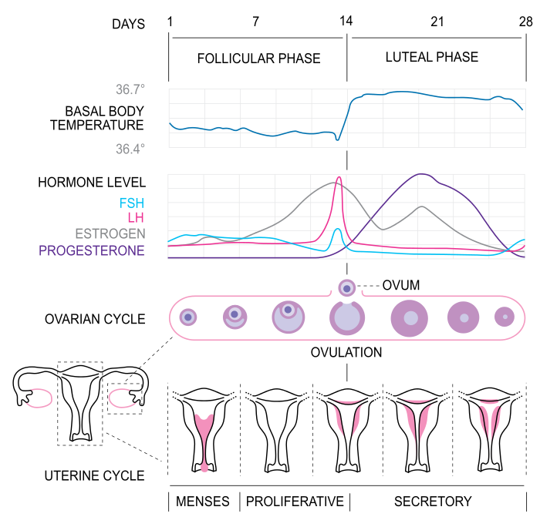

In a few days before ovulation, under the influence of luteinizing hormone and follicle stimulating hormone, the secondary follicle grows rapidly to a diameter of about 25mm to become mature vesicular or graafian follicle. Coincident with final development of the vesicular follicle, there is an abrupt increase in luteinizing hormone that causes the primary oocyte to complete meiosis 1 and the follicle enters the preovulatory mature vesicular stage. Meiosis 2 is also initiated. Note that the secondary oocyte is arrested in metaphase due to cytostatic factor. This factor maintains arrest through preventing loss of in maturation promoting factor. This arrest takes place in approximately 3 hours before ovulation. For the oocyte to be released, two events occur which are caused by luteinizing hormone surge. It increases collagenase activity resulting in digestion of collagen fibers surrounding the follicle. Prostagladin level also increases in response to the luteinizing hormone surge and cause local muscular contractions in the ovarian wall. Those contractions extrude the oocyte, which together with its surrounding follicular cells from the region of the cumulus oophorus. This causes ovulation to occur in which the oocyte floats out of the ovary. Some of the cumulus oophorus rearrange themselves around the zona pellucida to form the corona radiate.

MEIOSIS 1 | MEIOSIS 2
This is divivded into four stages in which the first stage-prophase 1 has three major events, i.e, synapses, crossing over and chiasma formation. | This is divided into four stages in which the first stage-prophase 2 is not involved in any three stages as prophase 1, so therefore, no synapses, no crossing over and no chiasma formation.
In anaphase 1, the 46 duplicated chromosomes separate and the centromere do not split. | In anaphase 2, the 23 duplicated homologous chromosome separate and the centromere splits.
During telophase 1, twp daughter cells are formed and they become 23 duplicated homologous chromosome. | In telophase 2, four daughter cells are formed and they become 23 single stranded homologous chromosome.
Meiosis 1 is a reduction division of 4N to 2N, which is 96 to 46 chromosomes. | Meiosis 2 is a reduction division of 2N to N, which is 46 to 23 chromosomes.
In metaphase 1, 46 duplicated homologous chromosome are aligned at the equator | While in metaphase2 , 23 duplicated chromosomes are aligned at the equator.

- Fertilization is the union of the sperm and oocyte. The usual site of fertilization is the ampulla of the uterine tube. Fertilization process takes approximately 24 hours. It is a sequence of coordinated events which includes the following stages:
- Passage of the sperm through the corona radiata. Only capacitated sperms can pass freely through the corona radiate.
- Penetration of the zona pellucida: The zona pellucida is a glycoprotein shell surrounding the egg that facilitates and maintains sperm binding and induces the acrosome reaction. The intact acrosome of the sperm binds with the zona glycoprotein of the zona pellucid. The release of acrosin allows the sperm to penetrate the zona pelluicda, thereby coming in contact with the plasma membrane of the oocyte. As soon as the head of the sperm comes in contact with the oocyte, the permeability of the zona pellucida changes.
- Fusion of the plama membranes of the sperm and oocyte: The plama membrane of the oocyte and sperm fuse and break down at the area of fusion. The head and tail of the sperm enters the cytoplasm of the oocyte but the sperm’s plasma membrane remains behind.
- Completion of the second meiotic division of the oocyte and formation of the female pronucleus: The penetration of the oocyte activates the oocyte into completing the second meiotic division and forming a mature oocyte and a second polar body.
- Formation of male pronucleus: Within the cytoplasm of the ooocyte, the nucleus of the sperm enlarges to form a male pronucleus and the tail of the sperm degenerates. All mitochondria within the zygote are of maternal origin. Since the oocyte now contains two pronuclei, each having haploid number of chromosomes (23). The oocyte containing two haploid pronuclei is called an ootid. The two pronuclei fuse into a single diploid aggregation of chromosome to become a zygote.

MONOZYGOTIC TWIN | DIZYGOTIC TWIN
Twins are genetically identical. | Twins are genetically not identical
They are usually twins of the same sex | The Twins are not of the same sex or a different sex
They are often called conjoined twins | They are not seen as conjoined twins.
Monozygotic twining incidence is more common in the society. | Dizygotic twining incidence arer less common.
Resemblance is much similar. | Resemblance is just like any other two siblings.
Monozygotic twins are formed from a single zygote. | Dizygotic twins are formed from two zygotes.

