NAME : OBUNADIKE CHINENYE BLESSING
MATRIC NUMBER 17/MHS01/225

ASSIGNMENT
1)DISCUSS OF THE ANATOMY OF THE TONGUE AND COMMENT ON ITS APPLIED ANATOMY.
2)WRITE AN ESSAY ON THE AIR SINUSES.

QUESTION 1
INTRODUCTION
The tongue is a muscular organ found in the vertebrate mouth. It is attached via muscles to the hyoid bone, mandible, styloid process, palate, and pharynx and divided in twoparts by the v-shaped sulcus terminalis. The tongue is a unique organ located in the oral cavity that not only facilitates perception of gustatory stimuli but also plays important role in mastication and deglutition. Additionally, the tongue is an integral component of the speech pathway as it helps with articulation.
The following papillae cover the tongue and are used for taste perception. They include
- Vallate papillae are arranged in a v-shape anterior to the sulcus terminalis and studded with numerous taste buds. Innvervation is by the glossopharyngeal nerve (CNIX).
- Fungiform papillae are mushroom-shaped papillae with erythematous domes, located on the lateral aspects and at the apex of the togue.
- Foliate papillae are rarely found in humans(vestigial)
Another important part of the tongue is the lingual tonsil, a collection of the nodular lymphatic tissues towards the posterior one third of the dorsum of the tongue.
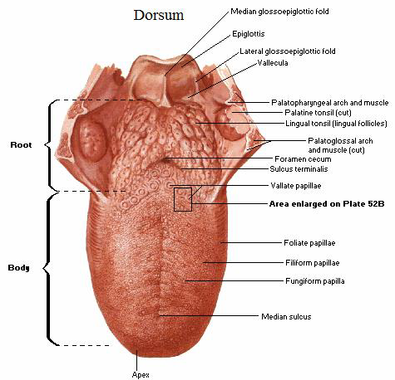
Diagram showing the borders of the tongue and the papillae of the tongue
FUNCTION
The functions of the tongue include taste, speech and food manipulation in the oral cavity.
- Taste function: chemicals interaction with the taste buds in the tongue are referred to as ‘tastants’. Taste buds themselves are found within the various papillae of the tongue. The five categories of taste receptors are sweet, salty, sour, bitter and umani.
- Speech function: speech is produced in the part by manipulation of the tongue in the mouth against the teeth and the palate within the oral cavity. The intrinsic muscles of the tongue are involved primarily in shaping in the shaping the tongue for speech.
- Food manipulation function: the tongue moves food around the mouth within the oral cavity by pressing it against the hard palate and out to the side to enable mastication.it enables the formation of food bolus in the oral preparatory phase of swallowing.
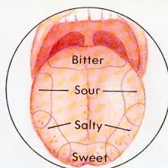
diagram showing the taste buds

EMBRYOLOGY
Tongue developments begins in the embryo at approximately four weeks gestation. Initially, two lateral lingual swelling and one medial swelling called the tuberculum impar, form from the first pharyngeal arch. A second median swelling, known as the copula or hypobrachial eminence, develop from the mesoderm of the second, third, and fourth pharyngeal arches. A final third median swelling forms from the posterior portion of the fourth arch and develops into the epiglottis. Directly posterior to this swelling is the laryngeal orifice, which is accompanied on either side by the arytenoid swellings.The lateral lingual swellings increase in size, eventually merging and overlapping the tuberculum impar. The merger of these two swellings forms the anterior two-thirds of the tongue. The mucosa overlying this part of the tongue originates from the first arch; thus, the sensory innervation to this area is from the mandibular branch of the trigeminal nerve (CN V3). Meanwhile, the second, third, and fourth portions of the pharyngeal arch, which make up the copula, develop into the posterior one-third of the tongue. The mucosa overlying this part of the tongue has sensory innervation from the glossopharyngeal nerve (CN XI), which is a sign that the third arch overlaps that of the second. The third arch derivatives typically are associated with glossopharyngeal sensory innervation.The epiglottis and epiglottic region of the tongue develop from the third median swelling, which arises from the posterior fourth pharyngeal arch. Innervation of this region is by the superior laryngeal nerve, which reflects its development from the fourth pharyngeal arch. The muscles of the tongue predominantly derive from myoblasts that originate in occipital somites and thus are innervated by the hypoglossal nerve (CN XII).
PARTS OF THE TONGUE
The tongue has a root ,a body ,an apex ,a curved dorsum and an inferior surface.
- ROOF OF THE TONGUE: is the part of the tongue that rests on the floor of the mouth
It is usually defined as the posterior third of the tongue
- BODY OF THE TONGUE: is the anterior two thirds of the tongue
- APEX OF THE TONGUE: is the anterior end of the body, which rests against the incisor teethThe body and apex of the tongue are extremely mobile
- DORSUM OF THE TONGUE: is the posterosuperior surface, which is located partly in the oral cavity and partly in the oropharynx .
RELATIONS TO THE TONGUE
Some important organs and structures are in close relation to the tongue.
- Anterior and lateral : teeth
- Superior: hard and soft palate
- Inferior: mucosa of the floor of the oral cavity, sublingual salivary glands, posterior wall of oropharynx
- Posterior: epiglottis, pharyngeal inlet
- Lateral: palatoglossal and palatopharyngeal arches.
MUSCLES OF THE TONGUE
The muscles of the tongue are divided into intrinsic and extrinsic muscles
Intrinsic muscle: The intrinsic muscles only attach to other structures in the tongue. There are four paired intrinsic muscles of the tongue and they are named by the direction in which they travel: the superior longitudinal, inferior longitudinal, transverse and vertical muscles of the tongue. These muscles affect the shape and size of the tongue – for example, in tongue rolling – and have a role in facilitating speech, eating and swallowing. Motor innervation for the intrinsic muscles of the tongue is via the hypoglossal nerve (CNXII).
Extrinsic muscle: they include

Genioglossus
- Attachments: Arises from the mandibular symphsis. Inserts into the body of the hyoid bone and the entire length of the tongue.
- Function: Inferior fibres protrude the tongue, middle fibres depress the tongue, and superior fibres draw the tip back and down
- Innervation: Motor innervation via the hypoglossal nerve (CNXII).

Hyoglossus
- Attachments: Arises from the hyoid bone and inserts into the side of the tongue
- Function: Depresses and retracts the tongue
- Innervation: Motor innervation via the hypoglossal nerve (CNXII).

Styloglossus
- Attachments: Originates at the styloid process of the temporal bone and inserts into the side of the tongue
- Function: Retracts and elevates the tongue
- Innervation: Motor innervation via the hypoglossal nerve (CNXII).

Palatoglossus
- Attachments: Arises from the palatine aponeurosis and inserts broadly across the tongue
- Function: Elevates the posterior aspect of the tongue
- Innervation: Motor innervation via the vagus nerve (CNX).
All of the intrinsic and extrinsic muscles are innervated by the hypoglossal nerve (CN XII), except palatoglossus, which has vagal innervation (CN X).
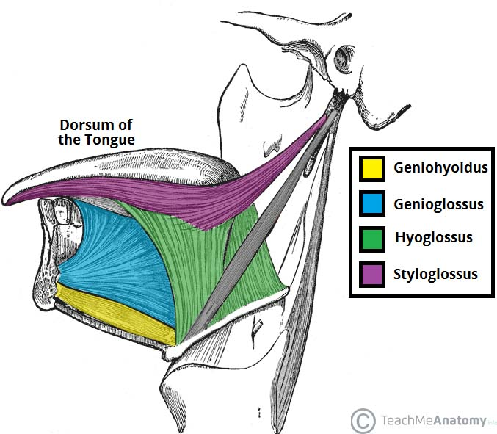
Diagram showing the muscles of the tongue.
BLOOD SUPPLY TO THE TONGUE
Blood supply to the tongue is predominantly from the lingual artery, a branch of the external carotid artery between the superior thyroid artery and the facial artery, which departs at the level of the greater horn of the hyoid bone within the carotid triangle. After branching from the external carotid artery, the lingual artery passes deep to the hyoglossus muscle and superficial to the middle pharyngeal constrictor muscle. It then gives rise to the following four arteries:
- suprahyoid artery supplies the omohyoid, sternothyroid, and thyrohyoid muscles. They anastomose with the corresponding vessels from the opposite side.
- dorsal lingual arteries arise beneath the hyoglossus muscle and pass to the posterior part of the dorsum of the tongue. They supply the mucous membrane of this region as well as the glossopalatine arch, lingual tonsils, soft palate, and epiglottis. They anastomose with their corresponding vessels on the opposite side.
- sublingual artery branches at the anterior border of the hyoglossus muscle before passing between the genioglossus muscle and mylohyoid muscle to the sublingual gland. It supplies the sublingual gland before giving branches to the mylohyoid muscle. One branch from the sublingual artery passes posterior to the alveolar process of the mandible and anastomoses with the corresponding artery from the other side. A second branch of the sublingual artery pierces the mylohyoid muscle and anastomoses with the submental branch of the facial artery.
- deep lingual artery, which is the termination of the lingual artery, passes between the genioglossus muscle and inferior longitudinal muscle.

VENOUS DRAINAGE

The veins of the tongue are the dorsal lingual veins, which accompany the lingual artery;the deep lingual veins, which begin at the apex of the tongue, run posteriorly beside the lingual frenulum to join the sublingual vein. The sublingual veins in elderly people are often varicose (enlarged and tortuous). All these lingual veins terminate, directly or indirectly, in the IJV
LYMPHATIC DRAINAGE

Lymph from the tongue takes four routes .Lymph from the posterior third drains into the superior deep cervical lymph nodes.Lymph from the medial part of the anterior two thirds drains directly to the inferior deep cervical lymph nodes.Lymph from the lateral parts of the anterior two thirds drains to the submandibular lymph nodes. The apex and frenulum drain to the submental lymph nodes. The posterior third and the medial part of the anterior two thirds drain bilaterally
INNERVATION
Motor innervation :All muscles of the tongue, except the palatoglossus (actually a palatine muscle supplied by the vagus nerve(X) of the pharyngeal plexus), receive motor innervation from the hypoglossal nerve (CN XII)
Sensory innervation :
The anterior two thirds of the tongue are supplied by:
- the lingual nerve (CN V₃) for general sensation
- the chorda tympani, a branch of the facial nerve (CN VII) transferring nerve fibers to the lingual nerve, for taste
The posterior third of the tongue and the vallate papillae are supplied by:
- the lingual branch of the glossopharyngeal nerve (CN IX) for both general sensation and taste
- Another contribution is made by the internal laryngeal branch of the vagus (CN X) for general sensation and taste.

CLINICAL ANATOMY
- Aglossia: this is the totall absence of the tongue(failure of the lingual swelling to form)
- Hemiglossia: failure of formation of one side of the ligual swelling
- Bifid tongue: failure of fusion of the lingual swelling
- Double tongue: formation of double pair of lingual swelling
- Ligual thyroid: failure of migration of median thyroid rudiment
- Dysguesia or pure taste disorder, is rare and is usually associated with olfactory disorders.
- Ludwig angina infection: this is an infection that once established, evolves to include the tongue. The tongue may enlarge two or three times its usual size and tend to distend posteriorly into the hypopharynx, superiorly against the palate, and anteriorly out of the oral cavity.
- Pierre robin syndrome: this casuses glossoptosis among other symptoms. This particular defect causes the tongue to be displaced posteriorly and may cause airway obstruction.
- Lingual Carcinoma: A lingual carcinoma in the posterior part of the tongue metastasizes to the superior deep cervical lymph nodes on both sides, whereas a tumor in the anterior part usually does not metastasize to the inferior deep cervical lymph nodes until late in the disease. Because these nodes are closely related to the IJV, metastases from the tongue may be widely distributed through the submental and submandibular regions and along the IJVs in the neck.

QUESTION 2
AIR/PARANASAL SINUSES.

INTRODUCTION
The paranasal sinuses are air-filled extensions of the respiratory part of the nasal cavity. There are four paired sinuses, named according to the bone in which they are located; maxillary, frontal, sphenoid and ethmoid. The function of the sinuses is not clear. It is thought that they may contribute to the humidifying of the inspired air. They also reduce the weight of the skull. Sinuses are formed in childhood by the nasal cavity eroding into surrounding bone. As they are outgrowths of the nasal cavity, they all drain back into it – openings to the paranasal sinuses are found on the roof and lateral walls of the nasal cavity. The inner surface is lined by a respiratory mucosa.
STRUCTURE AND FUNCTION OF PARANASAL SINUSES
There are 4 paired sinuses in humans. They are all in line with pseudostratified columnar epithelium.
- The maxillary sinuses: Largest of the paranasal sinuses, located under the eyes in the maxillary bones.
- The frontal sinuses: Located superior to the eyes within the frontal bone
- The ethmoid sinuses: Formed from several discrete air cells within the ethmoid bone between the nose and eyed
- The sphenoid sinuses: Located within the sphenoid bone
The function of the paranasal sinuses is debated. However, they are implicated in several roles:
- Decreasing the relative weight of the skull
- Increasing the resonance of the voice
- Providing a buffer against facial trauma
- Insulating sensitive structures from rapid temperature fluctuations in the nose
- Humidifying and heating inspired air
- Immunological defense

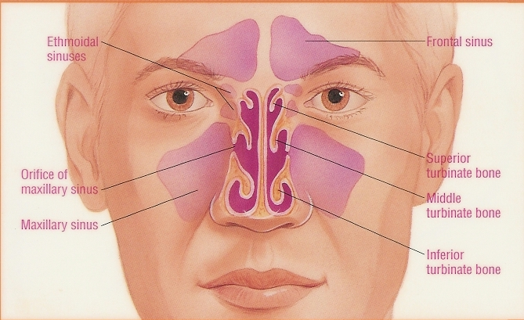
DIAGRAM SHOWING THE PARANASAL SINUSES

MAXILLARY SINUSES
The maxillary sinus is located under the eyes in the maxillary bone. Adjacent structures include the lateral nasal wall, the orbital floor, and the posterior maxillary wall which contains the pterygopalatine fossa. The maxillary sinus is innervated by the infraorbital nerve (CN V2). The maxillary and facial arteries supply the sinus, and the maxillary vein supplies venous drainage. As mentioned already, the maxillary sinus drains into the ethmoid infundibulum. There is typically only one ostium per maxillary sinus; however, cadaver studies have shown 10% to 30% have an accessory ostium. The size of the maxillary sinus at adult stage is approximately 15 mL, making it the largest paranasal sinus.
FRONTAL SINUSES
The frontal sinus is located superior to the orbit and within the frontal bone. The typical volume at the adult stage is 4 to 7 mL. The frontal sinus drains into the frontal recess via the middle meatus. As noted previously, this drainage can be variable, either medial or lateral to the uncinate, depending on its attachment. The frontal sinus vasculature consists of the supraorbital and supratrochlear arteries and ophthalmic and supraorbital veins. Similarly, it's innervation is provided by the supraorbital and supratrochlear nerves (CNV1). Several anatomical spaces/structures are important to frontal sinus anatomy:
- Frontal recess: Drainage space between the frontal sinus and semilunar hiatus that is bounded by the posterior wall of the agger nasi cell, lamina papyracea, and the middle turbinate.
- Frontal sinus infundibulum: Space that drains into the frontal recess that is located superior to the agger nasi cells
- Frontal cells: anterior ethmoid cells that pneumatize the frontal recess. These cells may cause obstruction or persistent sinus disease. They are located posterior and superior to the agger nasi cell, and there are 4 types as classified by Bent and Kuhn:
-Type I: Single cell above the agger nasi cell but below the floor of the frontal sinus
-Type II: Multiple cells above the agger nasi, may extend into the frontal sinus
-Type III: Single large cell that extends supraorbitally through the floor of the frontal sinus, attaches to the anterior table
-Type IV: Single isolated cell that is contained within the frontal sinus
SPHENOID SINUS
The sphenoid sinuses are located centrally and posteriorly within the sphenoid bone. They drain into the sphenoethmoidal recess located within the superior meatus. The sphenopalatine artery supplies the sinus, and venous drainage is via the maxillary vein. Innervation is provided by the sphenopalatine nerve, which is comprised of parasympathetic fibers and CN V2. The typical adult size is 0.5 to 8 mL. Several important structures have a close anatomical relationship to the sphenoid sinus. The carotid artery is located adjacent to the lateral wall of the sinus, and in 25% of patients, it is dehiscent in this area. The optic nerve is also located adjacent to the lateral wall of the sinus and can be dehiscent in up to 5% of individuals.
ETHMOID SINUSES
Superior to the ethmoidal sinus is the anterior cranial fossa and the frontal bone, laterally the orbit can be found, while the nasal cavity is situated medially. The ethmoid sinuses are unique because they are the only paranasal sinuses that are more complex than just a single cavity. On each side of the midline, anywhere from three to eighteen ethmoidal air cells may be grouped together. These air cells are smaller individual sinuses grouped together to form one large one which encompass the anterior, middle and posterior nasal meatuses. The anterior and middle ethmoid sinuses send their lymphatic drainage to the submandibular lymph nodes while the posterior ethmoid sinus sends its own to the retropharyngeal lymph nodes. The anterior and posterior ethmoidal arteries, as well as the posterior lateral nasal branches provide an ample blood supply to this region. Meanwhile the anterior and posterior ethmoidal nerves andthe posterior lateral superior and inferior nasal nerves help innervate it.
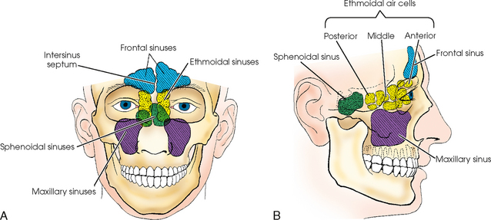
DIAGRAM SHOWING THE PARANASAL SINUSES
CLINICAL ANATOMY
PARANASAL SINUSES
Paranasal sinuses are prone to inflammation and infection. If the paranasal sinuses become blocked from secretions or a mass, the drainage of mucus is interrupted, and sinusitis can result. The maxillary sinus may be involved from any process in the teeth or the gums. The frontal and maxillary sinuses may be involved in allergies. Depending on the cause, sinusitis is treated with corticosteroids, decongestant, nasal irrigation, and hydration. Rarely surgical intervention may be required to enhance drainage.

