OKIEMUTE WATERWAY
17/ENG03/056
CIVIL ENGINERRING
ENGINEERING SURVEY II

QUESTION 1
Height of Collimation | Rise and Fall
- This method is simple and easy.  - Reduction of levels is easy.  - Visualization is not necessary regarding the nature of the ground.  - There is no check for intermediate sight readings  - This method is generally used where more number of readings can be taken with less number of change points for constructional work and profile leveling. | - This method is complicated and is not easy to carry out.  - Reduction of levels takes more time.  - Visualization is necessary regarding the nature of the ground.  - Complete check is there for all readings.  - This method is preferable for check levelling where number of change points are more.

B.S | I.S | F.S | H OF C | R.L | DISTANCE
0.771 |  |  | 166.771 | 166 | 10
0.802 |  | 1.52 | 166.053 | 165.251 | 20
 | 2.311 |  |  | 163.742 | 30
3.580 |  | 1.990 | 167.643 | 164.063 | 40
 | 1.220 |  |  | 166.423 | 50
 | 3.675 |  |  | 163.968 | 60
2.408 |  | 4.020 | 166.031 | 163.623 | 70
 | 0.339 |  |  | 165.692 | 80
0.780 |  | 0.157 | 166.654 | 165.874 | 90
 | 1.535 |  |  | 165.119 | 100
 | 1.955 |  |  | 164.699 | 110
 | 2.430 |  |  | 164.224 | 120
 | 2.985 |  |  | 163.669 | 130
1.155 |  | 3.480 | 164.329 | 163.174 | 140
 | 1.960 |  |  | 162.369 | 150
 | 2.365 |  |  | 161.964 | 160
0.935 |  | 3.640 | 161.624 | 160.689 | 170
 | 1.045 |  |  | 160.579 | 180
 | 1.630 |  |  | 159.994 | 190
 |  | 2.545 |  | 159.079 | 200
$Σ$=10.431 |  | $Σ$=17.352

++

Check=$ΣF.S-ΣB.S$=R.L at first point-R.L at last point
=6.921=6.921

QUESTION 2

Chain age(m) | 0 | 30 | 60 | 90 | 120 | 150 | 180 | 210 | 240 | 270
Offset length(m) | 0 | 2.65 | 3.80 | 3.75 | 4.65 | 3.60 | 5.00 | 5.80 | 6.10 | 5.85

Using Mid-ordinate rule:
A=$Σ$hd

h1= $\frac{0+2.65}{2}$=1.325m

h2= $\frac{2.65+3.80}{2}$=3.225m

h3= $\frac{3.80+3.75}{2}$=3.775m

h4= $\frac{3.75+4.65}{2}$=4.2m

h5= $\frac{4.65+3.60}{2}$=4.125m

h6= $\frac{3.60+5.00}{2}$=4.3m

h7= $\frac{5.00+5.80}{2}$=5.4m

h8= $\frac{5.80+6.00}{2}$=5.9m

h9= $\frac{6.00+5.85}{2}$=5.925m

$$Σh=1.325+3.225+3.775+4.2+4.125+4.3+5.4+5.9+5.925$$
$Σh=$38.175m

d=30m
A=$Σhd$
= $38.175×30$
A= ${1145.25m}^{2}$

Using average ordinate rule

A=$\frac{ndΣO}{n+1}$

n=9

d=30
$$ΣO=0+2.65+3.80+3.75+4.65+3.60+5.00+5.80+6.10+5.85$$
$ΣO=$41.2m

A=$\frac{9×30×41.2}{9+1}$

A=${112.4m}^{2}$

Using trapezoidal rule

A=$d(\frac{0_{1}+0_{n }}{2}+0_{2}+0_{3}+0_{4}............0_{n-1})$

$$d=30$$

A=$30(\frac{0+5.85}{2}+2.65+3.80+3.75+4.65+3.60+5.00+5.80+6.10)$

A=$30(38.275)$
A=${1148.25m}^{2}$

Using Simpson's rule
$$A=\frac{d }{3 }\left[\left(0_{1}+0_{n}\right)+4\left(0_{2}+0_{4}+.........0_{n-1}\right)+2\left(0_{3}+0_{5}........0_{n-1}\right)\right]$$

$$d=30$$

Note: Last offset was removed because number of offsets were even

$$A=\frac{30}{3 }\left[\left(0+6.10\right)+4\left(2.65+3.75+3.60+5,80\right)+2\left(3.80+4.65+5.00\right)\right]$$
$$A={962m}^{2}$$

Calculating for last offset using trapezoidal rule

A=$d(\frac{0_{1}+0_{n }}{2}+0_{2}+0_{3}+0_{4}............0_{n-1})$

$$A=30\left[\frac{6.40+5.85}{2}\right]$$
$$A={183.75m}^{2}$$

Therefore $ΣA=962+183.75$

$$A={1145.75m}^{2}$$

(b)
- Irregular contours indicate uneven surface.
- Approximately concentric closed contours with decreasing values towards center indicate a pond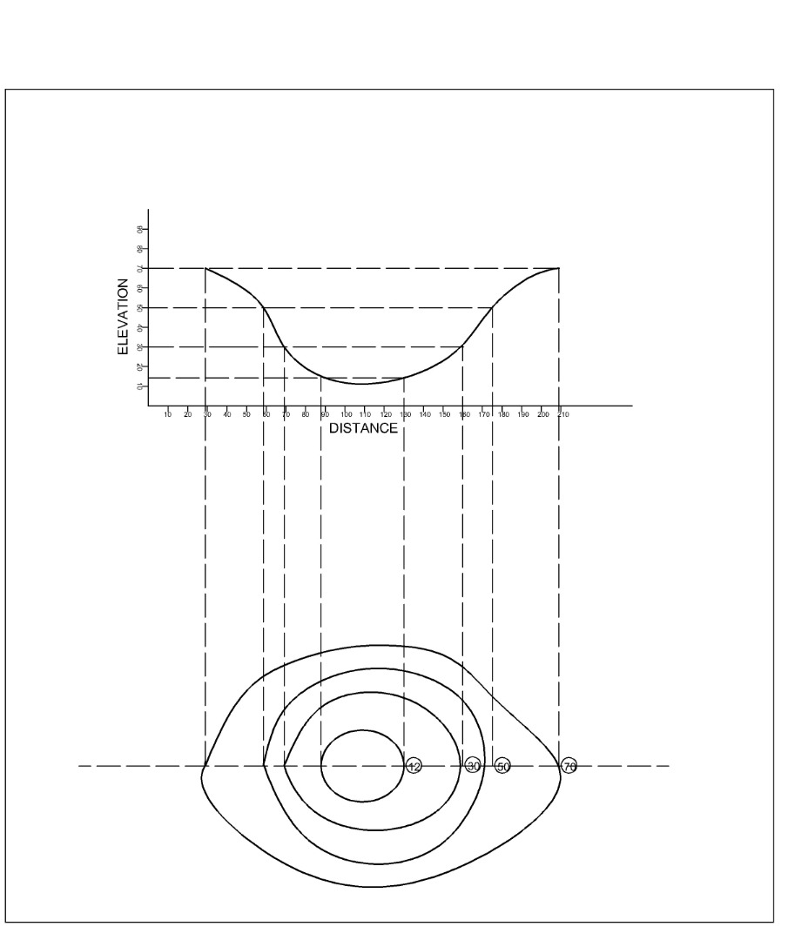

- Contour lines generally do not meet or intersect each other. If contour lines are meeting in some portion, it shows existence of a vertical cliff.

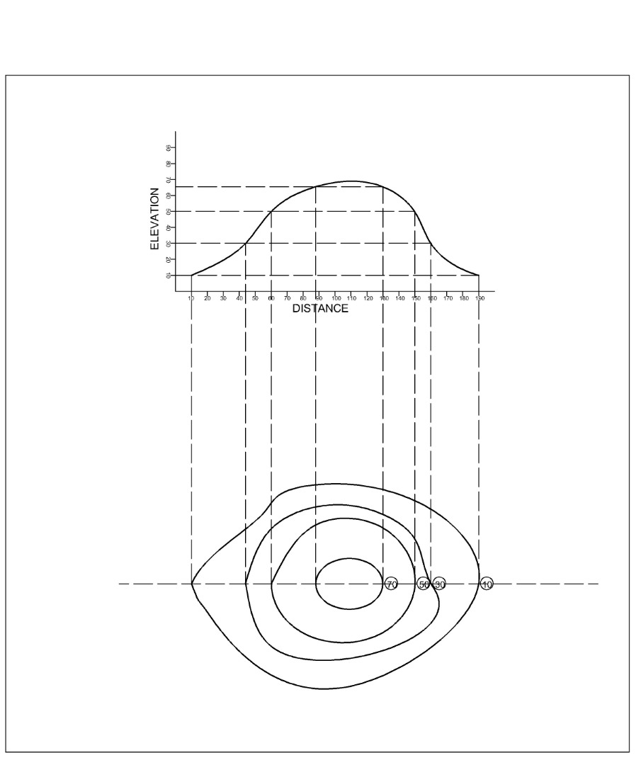

- Contour lines with U-shape with convexity towards lower ground indicate ridge.
- Contour lines with V-shaped with convexity towards higher ground indicate valley.
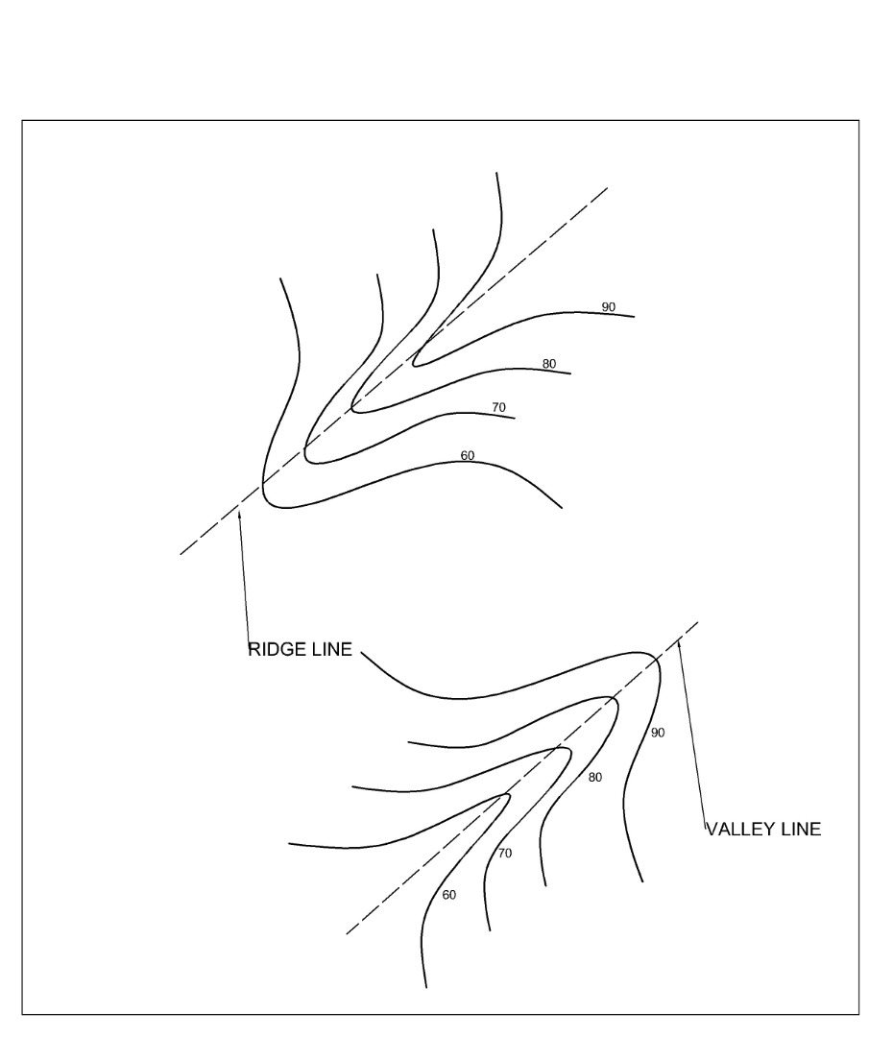

- Contours of different elevations cannot cross each other. If contour lines cross each other, it shows existence of overhanging cliffs or a cave.
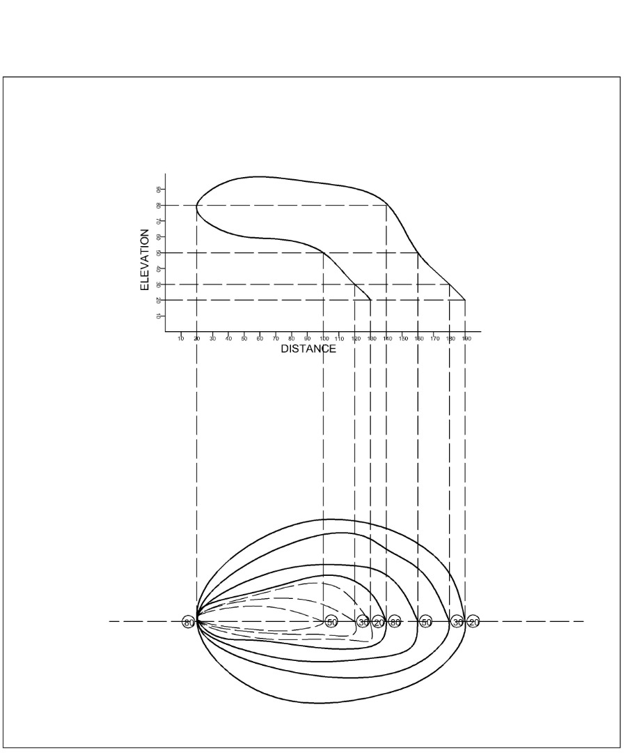

- Contour lines cannot end anywhere but close on themselves either within or outside the limit of the map. 